University of Leeds – Professional & Managerial staff recruitment data - 1 August 2020 – 31 July 2021

Contents

Introduction 1
Caring responsibilities 2
Disability 3
Ethnicity 4
Gender 5
Gender reassignment 6
Religion or Belief 7
Sexual Orientation 8

Introduction
The following information provides Professional and Managerial (P&M) staff recruitment data for the period August 2020 – July 2021. The data are provided by the following protected characteristics: caring responsibilities; disability; ethnicity; gender; gender reassignment; religion or belief; and sexual orientation. For each protected characteristic, the data are broken down by the following three stages of the University’s recruitment process: application; interview; and appointment.
During this period 2,590 applications were received for P&M positions at the University of Leeds. Of these applicants 907 were interviewed and 210 were appointed
For comparison, during the period August 2019 - July 2020, 2,771 applications were received for P&M positions, applicants 815 were interviewed and 185 were appointed.
Data are rounded to the nearest whole percent and therefore may not always total 100%.

Caring responsibilities

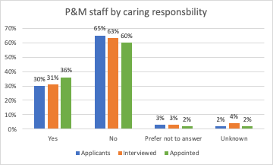
 | Yes | No | Prefer not to answer | Unknown
Applicants | 30% | 65% | 3% | 2%
Interviewed | 31% | 63% | 3% | 4%
Appointed | 36% | 60% | 2% | 2%
Commentary
During the academic year 2020-21, 30% of P&M applicants (28%, 2019-20) and 36% of P&M staff appointed (35%, 2019-20) declared they had caring responsibilities.

Disability

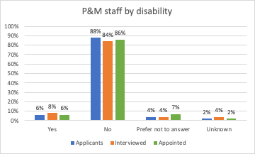
 | Yes | No | Prefer not to answer | Unknown
Applicants | 6% | 88% | 4% | 2%
Interviewed | 8% | 84% | 4% | 4%
Appointed | 6% | 86% | 7% | 2%

Commentary
During the academic year 2020-21, 6% of P&M applicants (5%, 2019-20), 8% of P&M interviewees (5% 2019-20) and 6% of P&M staff who were appointed (4%, 2019-20) declared a disability.

Ethnicity
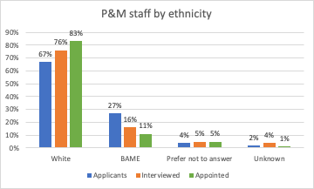
 | White | Black | Asian | Mixed | Other | Prefer not to answer | Unknown
Applicants | 67% | 4% | 18% | 3% | 2% | 4% | 2%
Interviewed | 76% | 2% | 9% | 3% | 2% | 5% | 4%
Appointed | 83% | 1% | 7% | 2% | 1% | 4% | 1%

Commentary
During the academic year 2020-21, 27% of P&M applicants (28%, 2019-20), 16% of those interviewed (24% 2019-20), and 11% of those appointed (12%, 2019-20) were Black, Asian, Mixed or Other ethnicity.

Gender
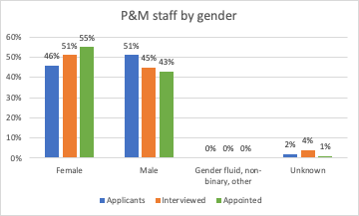
 | Male | Female | Gender fluid | Non binary | Other | Unknown
Applicants | 51% | 46% | 0% | 0% | 0% | 2%
Interviewed | 45% | 51% | 0% | 0% | 0% | 4%
Appointed | 43% | 55% | 0% | 0% | 0% | 1%

Commentary
During the academic year 2020-21, 46% of P&M staff applicants (49%, 2019-20), and 55% of P&M staff who were appointed were female (59%, 2019-20).
51% of P&M staff applicants (54%, 2019-20) and 43% of P&M staff who were appointed were male (41%, 2019-20).
Three applicants were gender fluid – none were interviewed. Eight applicants were non binary: 4 were interviewed and one appointed. There were 8 other applicants, 2 of which were interviewed, none were appointed.

Gender reassignment
“Is your gender identity the same as the gender you were assigned at birth?”
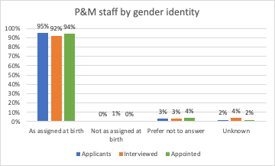
 | As assigned at birth | Not as assigned at birth | Prefer not to answer | Unknown
Applicants | 95% | 0% | 3% | 2%
Interviewed | 92% | 1% | 3% | 4%
Appointed | 94% | 0% | 4% | 2%

Commentary
During the academic year 2020-21 there were 12 P&M staff applicants who declared that their gender identity did not match their gender as assigned at birth. Five of these applicants were interviewed and one was appointed.
Of the 72 P&M staff applicants who preferred not to answer whether their gender identity matched their gender assigned at birth, 30 were interviewed and 8 were appointed.

Religion or Belief

 | Buddhist | Christian | Hindu | Jewish | Muslim | Spiritual | Sikh | Other | None | Prefer not to answer | Unknown
Applicants | 1% | 28% | 6% | 0% | 7% | 2% | 1% | 1% | 44% | 8% | 2%
Interviewed | 0% | 27% | 2% | 1% | 4% | 2% | 1% | 1% | 51% | 8% | 4%
Appointed | 1% | 26% | 0% | 1% | 4% | 2% | 0% | 1% | 54% | 9% | 1%

Commentary
During the academic year 2020-21, 44% of P&M applicants stated that they had no religion (44%, 2019-20), 28% were Christian (28%, 2019-20) and 7% were Muslim (9%, 2019-20).
Of those P&M staff who were appointed, 54% declared that they had no religion (53%, 2019-20), 26% were Christian (25%, 2019-20) and 4% were Muslim (3%, 2019-20).

Sexual Orientation
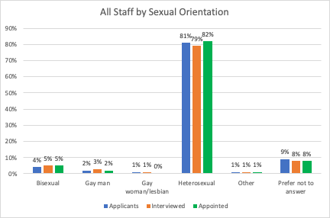
 | Bisexual | Gay man | Gay woman/  lesbian | Heterosexual | Other | Prefer not  to answer | Unknown
Applicants | 4% | 2% | 1% | 81% | 1% | 9% | 2%
Interviewed | 5% | 3% | 1% | 79% | 1% | 8% | 4%
Appointed | 5% | 2% | 0% | 82% | 1% | 8% | 1%

Commentary
During the academic year 2020-21, 7% of P&M staff applicants stated they were either gay, lesbian or bisexual (6%, 2019-20). This included 99 bisexual, 54 gay men and 20 gay women/lesbian.
Nine percent of P&M applicants preferred not answer this question (8%, 2019-20).
Of those appointed, 7% stated they were gay, lesbian or bisexual (7%, 2019-20), comprising 10 bisexual, 5 gay men and one gay woman/lesbian.

Professional & managerial staff’ comprises staff in professional services roles, typically grade 7+.
Defined as: caring for one or more children, one or more disabled children, a disabled adult, an older person, or another adult
Disability is defined under the Equality Act 2010 as a physical or mental impairment that has a substantial and long-term negative effect on a person’s ability to carry out normal daily activities.

