# University of Leeds – Support[1] staff turnover by protected characteristic 1 August 2020 – 31 July 2021

**Contents**

Introduction 1

Age 2

Caring Responsibilities 3

Disability 4

Ethnicity 5

Gender 6

Religion or Belief 7

Sexual Orientation 8

Contract Status 9

Contract Type 10

## Introduction

The following data provide information on support staff across the University who voluntarily resigned during the academic year 2019-20. These data are provided by the following protected characteristic: age; caring responsibilities; disability; ethnicity; gender; religion or belief; and sexual orientation as well as by contract type (permanent or fixed-term) and contract status (full or part time).

During 2020-21, 319 support staff resigned out of a total support staff population of 3633, equating to an 9% staff turnover rate.

For comparison, during 2019-20, 287 support staff resigned out of a total support staff population of 3643, equating to an 8% staff turnover rate.

***Data are rounded to the nearest whole percent* *and therefore may not always total 100%.***

## Age

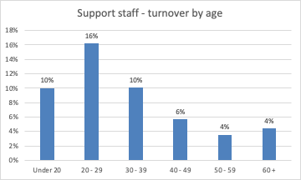

|  |  |  |  |
| --- | --- | --- | --- |
| **Age (Years)** | **Total staff** | **Voluntary Leavers** | **% Turnover** |
| **Under 20** | 20 | 2 | 10% |
| **20 - 29** | 851 | 138 | 16% |
| **30 - 39** | 966 | 97 | 10% |
| **40 - 49** | 744 | 42 | 6% |
| **50 - 59** | 713 | 25 | 4% |
| **60 +** | 339 | 15 | 4% |

**Commentary**

During 2020-21 the highest turnover amongst support staff was in the 20-29 year old age group at 16%. The lowest staff turnover was amongst the 50-59 and 60+ age groups, both at 4%.

## Caring Responsibilities[2]

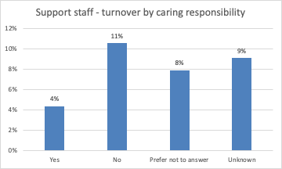

|  |  |  |  |
| --- | --- | --- | --- |
|  | **Total staff** | **Voluntary Leavers** | **% Turnover** |
| **Yes** | 782 | 34 | 4% |
| **No** | 1923 | 203 | 11% |
| **Prefer not to answer** | 190 | 15 | 8% |
| **Unknown** | 738 | 67 | 9% |

**Commentary**

During the academic year 2020-21, turnover was 4% for support staff who declared that they had caring responsibilities (4%, 2019-20). This figure was 11% for staff with no caring responsibilities (8%, 2019-20).

## Disability[3]

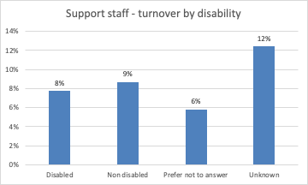

|  |  |  |  |
| --- | --- | --- | --- |
|  | **Total staff** | **Voluntary Leavers** | **% Turnover** |
| **Disabled** | 284 | 22 | 8% |
| **No known disability** | 2753 | 239 | 9% |
| **Prefer not to answer** | 242 | 14 | 6% |
| **Unknown** | 354 | 44 | 12% |

**Commentary**

Turnover was 8% for disabled support staff during the 2020-21 academic year (5%, 2019-20), compared with 9% for support staff with no known disability during the same period (7%, 2019-20).

## Ethnicity

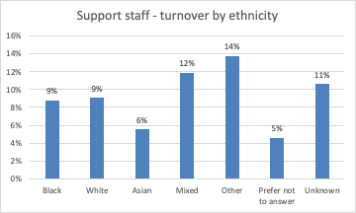

|  |  |  |  |
| --- | --- | --- | --- |
|  | **Total staff** | **Voluntary Leavers** | **% Turnover** |
| **Black** | 136 | 12 | 9% |
| **White** | 2619 | 237 | 9% |
| **Asian** | 216 | 12 | 6% |
| **Mixed** | 84 | 10 | 12% |
| **Other** | 29 | 4 | 14% |
| **Prefer not to answer** | 239 | 11 | 5% |
| **Unknown** | 310 | 33 | 11% |

**Commentary**

For known ethnicity, turnover was highest (12% and 14%) for Mixed and Other ethnicity support staff during 2020-21, and lowest (5%) for Asian support staff.

## Gender

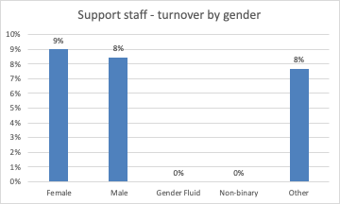

|  |  |  |  |
| --- | --- | --- | --- |
|  | **Total staff** | **Voluntary Leavers** | **% Turnover** |
| **Female** | 2286 | 206 | 9% |
| **Male** | 1325 | 112 | 8% |
| **Gender fluid** | 1 | 0 | 0% |
| **Non binary** | 8 | 0 | 0% |
| **Other** | 13 | 1 | 8% |

**Commentary**

During the academic year 2020-21, turnover was 9% for female support staff (9%, 2019-20) and 8% for male support staff (7%, 2019-20). No gender fluid or non binary staff and one other gender member of staff resigned during this period.

## Religion or Belief

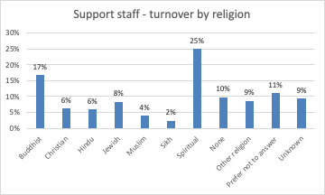

|  |  |  |  |
| --- | --- | --- | --- |
|  | **Total staff** | **Voluntary Leavers** | **% Turnover** |
| **Buddhist** | 18 | 3 | 17% |
| **Christian** | 862 | 54 | 6% |
| **Hindu** | 17 | 1 | 6% |
| **Jewish** | 12 | 1 | 8% |
| **Muslim** | 100 | 4 | 4% |
| **Sikh** | 43 | 1 | 2% |
| **Spiritual** | 16 | 4 | 25% |
| **None** | 1426 | 139 | 10% |
| **Other religion** | 70 | 6 | 9% |
| **Prefer not to answer** | 343 | 38 | 11% |
| **Unknown** | 726 | 68 | 9% |

**Commentary**

During 2020-21, the largest turnover rate at 25% was for Spiritual support staff (0% last year) and for Buddhist staff (17% but only 3 individuals).

## **Sexual Orientation**

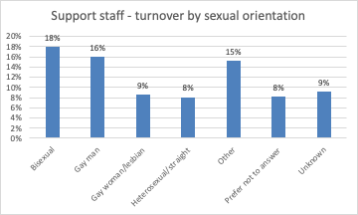

|  |  |  |  |
| --- | --- | --- | --- |
|  | **Total staff** | **Voluntary Leavers** | **% Turnover** |
| **Bisexual** | 128 | 23 | 18% |
| **Gay man** | 50 | 8 | 16% |
| **Gay woman/lesbian** | 47 | 4 | 9% |
| **Heterosexual** | 2308 | 185 | 8% |
| **Other** | 33 | 5 | 15% |
| **Prefer not to answer** | 333 | 27 | 8% |
| **Unknown** | 734 | 67 | 9% |

**Commentary**

During the academic year 2020-21, the highest turnovers amongst support staff (15-18%) were with from staff who stated they were a bisexual, gay man and other. gay woman. The turnover rate for heterosexual support staff increased from 6% in 2019-20 to 8% in 2020-21. No staff with Other sexual orientation resigned during this period.

## Contract Status

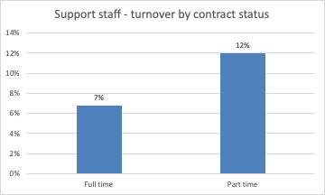

|  |  |  |  |
| --- | --- | --- | --- |
|  | **Total staff** | **Voluntary Leavers** | **% Turnover** |
| **Full time** | 2210 | 149 | 7% |
| **Part time** | 1423 | 170 | 12% |

**Commentary**

During the academic year 2020-21, the turnover for part-time members of support staff was 12% (10%, 2019-20) and 7% for full time members of staff (6%, 2019-20).

## Contract Type

Support staff turnover by contract type 

|  |  |  |  |
| --- | --- | --- | --- |
|  | **Total staff** | **Voluntary Leavers** | **% Turnover** |
| **Fixed term** | 522 | 68 | 13% |
| **Permanent** | 3111 | 251 | 8% |

**Commentary**

During the 2020-21 academic year, turnover for support staff with a fixed term contract was 13% (16%, 2019-20), and 8% for those with a permanent contract (6%, 2019-20).

1. ‘Support staff’ comprises clerical staff, technicians and operational support roles.
2. Defined as: caring for one or more children, one or more disabled children, a disabled adult, an older person, or another adult
3. Disability is defined under the Equality Act 2010 as a physical or mental impairment that has a substantial and long-term negative effect on a person’s ability to do normal daily activities.