University of Leeds – Support staff recruitment data 1 August 2020 – 31 July 2021

Contents

Introduction 1
Caring responsibilities 2
Disability 3
Ethnicity 4
Gender 5
Gender reassignment 6
Religion or Belief 7
Sexual Orientation 8

Introduction

The following information provides support staff recruitment data for the period August 2020 – July 2021. These data are provided by the following protected characteristics: caring responsibilities; disability; ethnicity; gender; gender reassignment; religion or belief; and sexual orientation. For each protected characteristic, the data are broken down by the following three stages of the University’s recruitment process: application; interview; and appointment.
During this period 10,379 applications were received for support staff positions, 2,138 individuals were interviewed and 525 were appointed.
For comparison, during 2019-20 13,790 applications were received for support staff positions, 2,542 individuals were interviewed and 489 were appointed.
Data are rounded to the nearest whole percent and therefore may not always total 100%.

Caring responsibilities

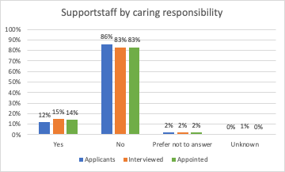
 | Yes | No | Prefer not to answer | Unknown
Applicants | 12% | 86% | 2% | 0%
Interviewed | 15% | 83% | 2% | 1%
Appointed | 14% | 83% | 2% | 0%

Commentary
During the academic year 2020-21, 11% of support staff applicants (11% 2019-20), 15% of support staff interviewees (14% 2019-20) and 14% of appointed support staff (12% 2019-20) declared they had caring responsibilities.

Disability

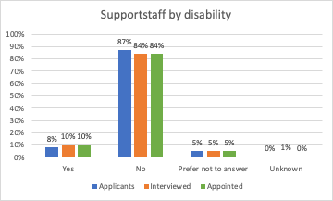
 | Yes | No | Prefer not to answer | Unknown
Applicants | 8% | 87% | 5% | 0%
Interviewed | 10% | 84% | 5% | 1%
Appointed | 10% | 84% | 5% | 0%

Commentary
During the academic year 2020-21, 8% of support staff applicants (7%, 2019-20), 10% of support staff interviewees (8%, 2019-20) and 10% of appointed support staff (6%, 2019-20) declared a disability.

Ethnicity
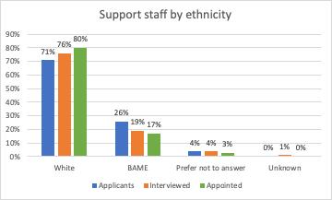
 | White | Black | Asian | Mixed | Other | Prefer not to answer | Unknown
Applicants | 71% | 5% | 14% | 4% | 3% | 4% | 0%
Interviewed | 76% | 4% | 9% | 4% | 2% | 4% | 1%
Appointed | 80% | 3% | 9% | 2% | 3% | 3% | 0%

Commentary
During the academic year 2019-20, 26% of support staff applicants (27%, 2019-20), 19% of support staff interviewees (16%, 2019-20) and 17% of support staff appointments (15%, 2019-20) identified as Black, Asian, Mixed or Other ethnicity.

Gender

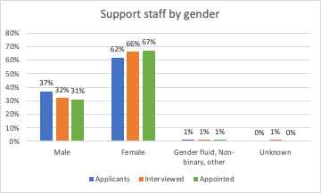
 | Male | Female | Gender fluid | Non binary | Other | Unknown
Applicants | 37% | 62% | 0% | 1% | 0% | 0%
Interviewed | 32% | 66% | 0% | 1% | 0% | 1%
Appointed | 31% | 67% | 0% | 1% | 0% | 0%

Commentary
During the academic year 2020-21, 62% of support staff applicants (62%, 2019-20), 66% of support staff interviewees (64%, 2019-20) and 67% of support staff appointments (69%, 2019-20) were female.
During the same period 37% of support staff applicants (38%, 2019-20) and 31% of support staff appointed during the academic year 2019-20 were male (31%,2019-20).
Twelve applicants were gender fluid of which 2 were interviewed but none appointed. 63 applicants were non binary, with 13 interviewed and 7 appointed. 46 applicants were of other gender, 14 were interviewed, and two appointed.

Gender reassignment
“Is your gender identity the same as the gender you were assigned at birth?”
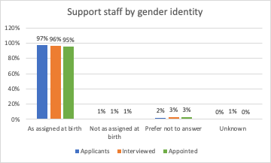
 | As assigned at birth | Not as assigned at birth | Prefer not to answer | Unknown
Applicants | 97% | 1% | 2% | 0%
Interviewed | 96% | 1% | 2% | 1%
Appointed | 95% | 1% | 3% | 0%

Commentary
During the academic year 2021-21, 1% of support staff applicants, 1% of support staff interviewees and 1% of support staff appointments declared that their gender identity did not match their gender as assigned at birth. This corresponds to 100 applicants, 16 interviewees and 7 appointments. The percentages are the same as for last year.

Religion or Belief
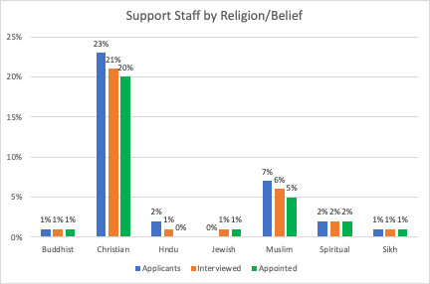
 | Buddhist | Christian | Hindu | Jewish | Muslim | Spiritual | Sikh | Other | None | Prefer not to answer | Unknown
Applicants | 1% | 23% | 2% | 0% | 7% | 2% | 1% | 1% | 54% | 9% | 0%
Interviewed | 1% | 21% | 1% | 1% | 6% | 2% | 1% | 1% | 57% | 10% | 1%
Appointed | 1% | 20% | 0% | 1% | 5% | 2% | 1% | 1% | 62% | 8% | 0%

Commentary
During the academic year 2020-21, 54% of support staff applicants (52%, 2019-20) stated they had no religion, 23% were Christian (23%, 2019-20) and 7% were Muslim (9%, 2019-20).
Of those appointed, 62% declared that they had no religion (56%, 2019-20), 20% were Christian (19%, 2019-20) and 5% were Muslim (6%, 2019-20).

Sexual Orientation

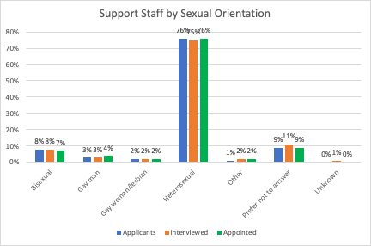
 | Bisexual | Gay man | Gay woman/ lesbian | Heterosexual | Other | Prefer not to answer | Unknown
Applicants | 8% | 3% | 2% | 76% | 1% | 9% | 0%
Interviewed | 8% | 3% | 2% | 75% | 2% | 11% | 1%
Appointed | 8% | 4% | 2% | 76% | 2% | 9% | 0%
Commentary
During the academic year 2020-21, 13% of support staff applicants stated they were either gay, lesbian or bisexual (11%, 2019-20).
Of those support staff appointed during 2019-20, 14% stated they were gay, lesbian or bisexual (11%, 2019-20).

‘Support staff’ is comprised of clerical staff, technicians and operational support roles.
Defined as: caring for one or more children, one or more disabled children, a disabled adult, an older person, or another adult
Disability is defined under the Equality Act 2010 as a physical or mental impairment that has a substantial and long-term negative effect on a person’s ability to carry out normal daily activities.

