University of Leeds – Professional and Managerial staff turnover by protected characteristic 1 August 2020 – 31 July 2021
Contents

Introduction 1
Age 2
Caring Responsibilities 3
Disability 4
Ethnicity 5
Gender 6
Religion or Belief 7
Sexual Orientation 8
Contract Status 9
Contract Type 10

Introduction
The following data provide information on Professional and Managerial (P&M) staff across the University who voluntarily resigned during the academic year 2020-21. These data are provided by the following protected characteristic: age; caring responsibilities; disability; ethnicity; gender; religion or belief; and sexual orientation as well as by contract type (permanent or fixed-term) and contract status (full or part time).
During 2020-21, 89 P&M staff resigned out of a total P&M staff population of 1732, equating to a 5% staff turnover rate. For comparison, during 2019-20, 85 P&M staff resigned out of a total P&M staff population of 1670, equating to a 5% staff turnover rate.
Data are rounded to the nearest whole percent and therefore may not always total 100%.

Age
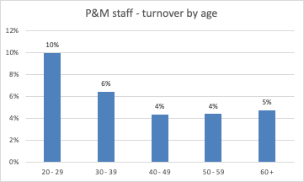
Age (Years) | Total staff | Voluntary Leavers | % Turnover
20 - 29 | 60 | 6 | 10%
30 - 39 | 451 | 29 | 6%
40 - 49 | 641 | 28 | 4%
50 - 59 | 454 | 20 | 4%
60 + | 126 | 6 | 5%

Commentary
The highest P&M staff turnover rate 10%) in the academic year 2020-21 was in the 20-29 age group (9%, 2019-20).

Caring Responsibilities
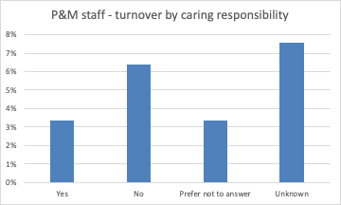
 | Total staff | Voluntary Leavers | % Turnover
Yes | 687 | 23 | 3%
No | 770 | 49 | 6%
Prefer not to answer | 90 | 3 | 3%
Unknown | 185 | 14 | 8%

Commentary
For P&M staff who declared they had caring responsibilities, there was 3% turnover during 2020-21 (4%, 2019-20). This figure was 6% for P&M staff with no caring responsibilities (6%, 2019-20).

Disability
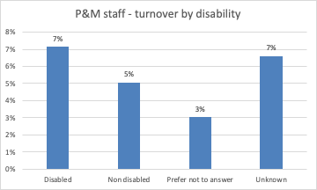
 | Total staff | Voluntary Leavers | % Turnover
Disabled | 98 | 7 | 7%
No known disability | 1444 | 73 | 5%
Prefer not to answer | 99 | 3 | 3%
Unknown | 91 | 6 | 7%

Commentary
For P&M staff who stated they had a disability, there was a 7% turnover during 2020-21 (3%, 2019-20 – 3 individuals). For staff with no known disability this was 5% (5%, 2019-20).

Ethnicity
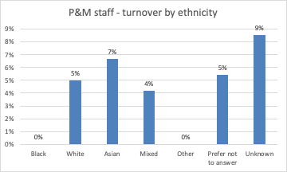
 | Total staff | Voluntary Leavers | % Turnover
Black | 25 | 0 | 0%
White | 1443 | 72 | 5%
Asian | 75 | 5 | 7%
Mixed | 24 | 1 | 4%
Other | 9 | 0 | 0%
Prefer not to answer | 74 | 4 | 5%
Unknown | 82 | 7 | 9%

Commentary
The highest turnover rate was for Asian staff (7%) and staff with Unknown ethnicity (9%). There was no turnover of Black staff or Other.

Gender

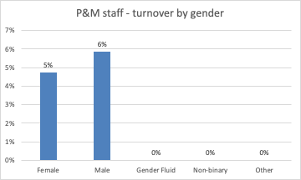
 | Total staff | Voluntary Leavers | % Turnover
Female | 1057 | 50 | 5%
Male | 668 | 39 | 6%
Gender fluid | 1 | 0 | 0%
Non binary | 1 | 0 | 0%
Other | 5 | 0 | 0%

Commentary
Turnover was 5% for female P&M staff (5%, 2019-20) and for 6% male P&M staff (5%, 2019-20). No gender fluid, non binary or other gender P&M staff resigned.

Religion or Belief
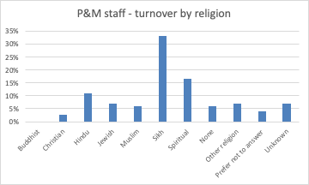
 | Total staff | Voluntary Leavers | % Turnover
Buddhist | 8 | 0 | 0%
Christian | 545 | 15 | 3%
Hindu | 9 | 1 | 11%
Jewish | 14 | 1 | 7%
Muslim | 33 | 2 | 6%
Sikh | 6 | 2 | 33%
Spiritual | 6 | 1 | 17%
None | 749 | 46 | 6%
Other religion | 28 | 2 | 7%
Prefer not to answer | 147 | 6 | 4%
Unknown | 187 | 13 | 7%

Commentary
Although using very small numbers, the highest turnover rate (33%) was amongst Sikh P&M staff. These turnover rates should be used with caution, as many categories contain only a small number of staff.

Sexual Orientation
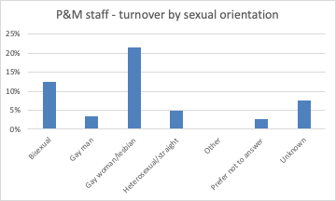
 | Total staff | Voluntary Leavers | % Turnover
Bisexual | 24 | 3 | 13%
Gay man | 29 | 1 | 3%
Gay woman/lesbian | 14 | 3 | 21%
Heterosexual | 1316 | 64 | 5%
Other | 10 | 0 | 0%
Prefer not to answer | 151 | 4 | 3%
Unknown | 188 | 14 | 7%

Commentary
The highest turnover in P&M staff of known sexual orientation during 2019-20 was for gay women/lesbian (21%). The turnover for bisexual staff was 13%. Last year, the highest turnover was for gay men and other.

Contract Status
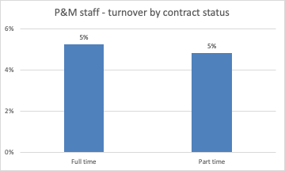
 | Total staff | Voluntary Leavers | % Turnover
Full time | 1276 | 67 | 5%
Part time | 456 | 22 | 5%

Commentary
For P&M staff, turnover was 5% for both part-time and full-time staff during 2020-21.

Contract Type
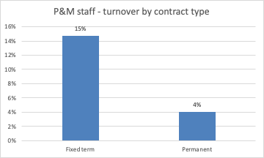
 | Total staff | Voluntary Leavers | % Turnover
Fixed term | 176 | 26 | 15%
Permanent | 1556 | 63 | 4%

Commentary
During the 2020-21 academic year, P&M staff turnover for those on fixed term contracts was 15% (13%, 2019-20) compared to 4% for those on permanent contracts (4%, 2019-20).

Professional & managerial staff’ comprises staff in professional services roles, typically grade 7+.
Defined as: caring for one or more children, one or more disabled children, a disabled adult, an older person, or another adult
Disability is defined under the Equality Act 2010 as a physical or mental impairment that has a substantial and long-term negative effect on a person’s ability to do normal daily activities.

