University of Leeds – all staff promotions data

1 August 2020 – 31 July 2021

Contents
Introduction 1
Up to & including Grade 9 2
Age 2
Disability 3
Ethnicity 4
Gender 5
Religion or Belief 6
Sexual Orientation 7
Grade 10 8
Gender 8

Introduction
The following information provides data for all staff promotions (academic, professional and managerial and support) during the academic year 2020-21. These data are provided by the following protected characteristics: age; disability; ethnicity; gender; religion or belief; and sexual orientation.
Please note that data for staff applying for promotion to grade 10 are presented separately due to the different promotions procedure for this grade, and are presented by gender only due to small numbers.
Data are rounded to the nearest whole percent and therefore may not always total 100%.

Up to & including Grade 9
A total of 192 applications for promotion were made during the period (214, 2019-20), of which 183 (95%) were successful (96%, 2019-20).

Age

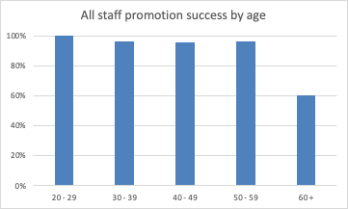

Age (years) | Number of applications | Successful | % Successful
20 - 29 | 19 | 19 | 100%
30 - 39 | 75 | 72 | 96%
40 - 49 | 68 | 65 | 96%
50 - 59 | 25 | 24 | 96%
60 + | 5 | 3 | 60%

Commentary
During the academic year 2020-21, the age group with the lowest success rate was the 60+ category at 60% although based on a small number. In 2020-21 success rates were 100% in the under 20 category (as last year), 96% in the 30-39 category (97% last year), 96% in the 40-49 category (last year 97%), and 96% in the 50-59 category (last year 83%).

Disability
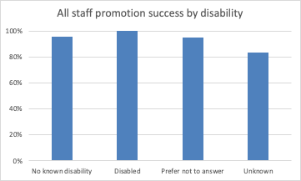
 | Number of applications | Successful | % Successful
No known disability | 151 | 144 | 95%
Disabled | 14 | 14 | 100%
Prefer not to answer | 21 | 20 | 95%
Unknown | 6 | 5 | 83%

Commentary
During the 2020-21 academic year, all 14 applicants who declared a disability were successful. This compares to 9 applicants (all successful) the previous year.

Ethnicity

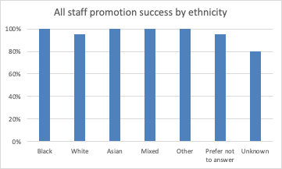
 | Number of applications | Successful | % Successful
Black | 3 | 3 | 100%
White | 139 | 132 | 95%
Asian | 20 | 20 | 100%
Mixed | 3 | 3 | 100%
Other | 1 | 1 | 100%
Prefer not to answer | 21 | 20 | 95%
Unknown | 45 | 4 | 80%

Commentary
During the academic year 2020-21 the success rate of applications from Black, Asian, Mixed and Other staff at these grades remains at 100%, while the success rate for White staff is 95% (96% last year).

Gender
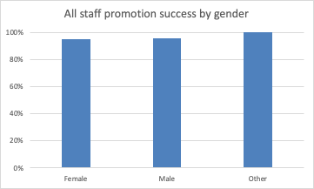
 | Number of applications | Successful | % Successful
Female | 104 | 99 | 95%
Male | 87 | 83 | 95%
Gender Fluid | 0 | 0 | -
Non binary | 0 | 0 | -
Other | 1 | 1 | 100%

Commentary
During the academic year 2020-21, 95% of female staff promotions applications and 95% of male staff promotions applications were successful. This is a 3% decrease in success rate for female staff and a 2% increase in success rates for male staff compared with the previous year.

Religion or Belief

 | Number of applications | Successful | % Successful
Buddhist | 4 | 4 | 100%
Christian | 38 | 34 | 89%
Hindu | 2 | 2 | 100%
Jewish | 3 | 3 | 100%
Muslim | 3 | 3 | 100%
Sikh | 0 | 0 | -
Spiritual | 0 | 0 | -
None | 92 | 90 | 98%
Other religion | 5 | 5 | 100%
Prefer not to answer | 26 | 25 | 96%
Unknown | 19 | 17 | 89%

Commentary

Whilst data are provided for transparency, low numbers in some categories may mean it is not possible to draw meaningful conclusions from comparisons across years. However, the success rates have remained high for most groups.

Sexual Orientation

 | Number of applications | Successful | % Successful
Bisexual | 1 | 1 | 100%
Gay man | 6 | 5 | 83%
Gay woman/lesbian | 0 | 0 | -
Heterosexual | 132 | 127 | 96%
Other | 2 | 2 | 100%
Prefer not to answer | 30 | 29 | 97%
Unknown | 21 | 19 | 90%

Commentary
The success rate for heterosexual promotion applicants was 96% as it was in 2019/20. The success rate for gay, men was 83% and 100% for bisexual staff. There were no applications this year from gay women/lesbian staff.

Marriage and Civil Partnership

 | Number of applications | Successful | % Successful
Co-habiting | 5 | 5 | 100%
Divorced or civil part dissolved | 1 | 1 | 83%
Married/Civil Partnership | 36 | 35 | -
Separated | 1 | 1 | 96%
Single | 7 | 7 | 100%
Widowed/Surviving partner | 0 | - | -
Other | 0 | - | -
Prefer not to answer | 3 | 3 | 100%
Unknown | 139 | 131 | 94%

Commentary
These data are provided for the first time this year in this report so there is no comparison to previous years.

Grade 10
During the academic year 2020-21 there were 30 applications for promotion to grade 10, of which 27 (90%) were successful. In 2019-20, there were 30 applications of which 27 (90%) were successful. Due to the low number of applications for promotion to grade 10, it is only possible to present a breakdown by gender.

Gender
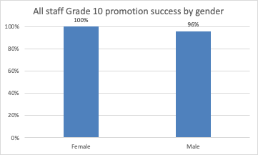
 | Number of applications | Successful | % Successful
Female | 13 | 13 | 100%
Male | 24 | 23 | 96%
Commentary
During the academic year 2020-21, 13 female staff applied for promotion to grade 10, all of which were successful (100%). This compares to 8 applications (100% successful) in the previous year. There were 23 applications made by male staff, of which 23 (96%) were successful (cf 22 applications, 19 (86%) successful in 2019-20). There were no applications to Grade 10 from staff who are gender fluid, non binary or other gender.

Disability is defined under the Equality Act 2010 as a physical or mental impairment that has a substantial and long-term negative effect on a person’s ability to do normal daily activities.
Grade 10 applies to Professional and Managerial and academic staff. For academic staff, grade 10 is above associate professor level.

