# University of Leeds - all staff turnover by protected characteristic 1 August 2020 – 31 July 2021

**Contents**

Introduction 1

Age 2

Caring Responsibilities 3

Disability 4

Ethnicity 5

Gender 6

Religion or Belief 7

Sexual Orientation 9

Contract Status 10

Contract Type 11

## Introduction

The following data provide information on all staff across the University who voluntarily resigned during the academic year 2020-21. These data are provided by the following protected characteristic: age; caring responsibilities; disability; ethnicity; gender; religion or belief; and sexual orientation as well as by contract type (permanent or fixed-term) and contract status (full or part time).

During 2020-21, a total of 635 staff resigned out of a staff population of 9,252, equating to a 7% staff turnover rate. For comparison, during 2019-20, a total of 600 staff resigned out of a staff population of 9,239, equating to a 6% staff turnover rate.   
The previous two years of data are provided for comparison.

***Data are rounded to the nearest whole percent* *and therefore may not always total 100%.***

## Age

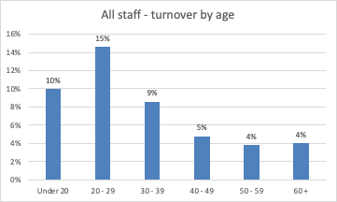

| **Age (years)** | **Total staff** | **Voluntary Leavers** | **2020-21 % Turnover** | **2019-20 % Turnover** | **2018-19 % Turnover** |
| --- | --- | --- | --- | --- | --- |
| **Under 20** | 20 | 2 | 10% | 27% | 7% |
| **20 - 29** | 1191 | 174 | 15% | 15% | 18% |
| **30 - 39** | 2658 | 228 | 9% | 8% | 9% |
| **40 - 49** | 2476 | 119 | 5% | 5% | 5% |
| **50 - 59** | 2033 | 77 | 4% | 3% | 3% |
| **60 +** | 874 | 35 | 4% | 3% | 4% |

**Commentary**

The highest turnover during 2020-21-20 was amongst those aged 20-29 at 15% (the highest in 2019-120 was those under 20 years at 27%). The lowest turnover rate at 4% was amongst staff aged 50-59 and 60+ years (3% in 2019-20).

## Caring Responsibilities[1]

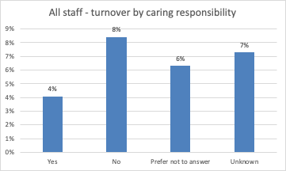

|  | **Total staff** | **Voluntary Leavers** | **2020-21 % Turnover** | **2019-20 % Turnover** | **2018-19 % Turnover** |
| --- | --- | --- | --- | --- | --- |
| **Yes** | 2550 | 104 | 4% | 4% | 5% |
| **No** | 4312 | 363 | 8% | 7% | 10% |
| **Prefer not to answer** | 603 | 38 | 6% | 6% | 8% |
| **Unknown** | 1787 | 130 | 4% | 8% | 6% |

**Commentary**

For staff who declared they had caring responsibilities, there was a 4% turnover during 2020-21 (4%, 2019-20). The turnover was 8% for staff with no caring responsibilities (7%, 2019-20).

## Disability[2]

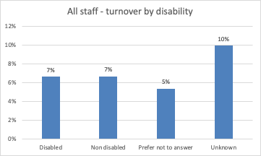

|  | **Total staff** | **Voluntary Leavers** | **2020-21 % Turnover** | **2019-20 % Turnover** | **2018-19 % Turnover** |
| --- | --- | --- | --- | --- | --- |
| **Disabled** | 557 | 37 | 7% | 4% | 10% |
| **No known disability** | 7189 | 480 | 7% | 6% | 8% |
| **Prefer not to answer** | 692 | 37 | 5% | 6% | 7% |
| **Unknown** | 814 | 81 | 10% | 13% | 8% |

**Commentary**

During 2020-21 of the total number of staff who stated they had a disability, 7% resigned, (4%, 2019-20). Of the total number of staff with no known disability, 7% resigned (6%, 2018-19).

## Ethnicity

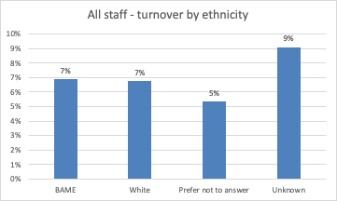

|  | **Total staff** | **Voluntary Leavers** | **2020-21 % Turnover** | **2019-20 % Turnover** | **2018-19 % Turnover** |
| --- | --- | --- | --- | --- | --- |
| **BAME[3]** | 1221 | 82 | 7% | 7% | 8% |
| **-Black** | 219 | 10 | 6% | 5% | - |
| **-Asian** | 689 | 47 | 6% | 7% | - |
| **-Mixed** | 188 | 12 | 9% | 7% | - |
| **-Other** | 125 | 13 | 11% | 11% | - |
| **White** | 6599 | 389 | 7% | 6% | 8% |
| **Prefer not to answer** | 673 | 42 | 5% | 6% | 6% |
| **Unknown** | 759 | 87 | 9% | 13% | 9% |

**Commentary**

During the academic year 2020-21 of the total staff population who declared their ethnicity as White, 7% resigned (6%, 2019-20). Of the total staff population who declared their ethnicity as Black, Asian, Mixed or Other, 7% resigned, (7% 2019-20). Turnover is also shown for Black, Asian, Mixed and Other staff groups separately.

## Gender

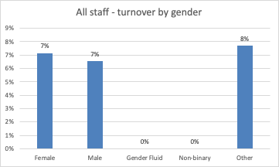

|  | **Total staff** | **Voluntary Leavers** | **2019-20 % Turnover** | **2019-20 % Turnover** | **2018-19 % Turnover** |
| --- | --- | --- | --- | --- | --- |
| **Female** | 5079 | 363 | 7% | 7% | 8% |
| **Male** | 4136 | 270 | 7% | 6% | 7% |
| **Gender fluid** | 2 | 0 | 0% | 0% | - |
| **Non binary** | 9 | 0 | 0% | 0% | - |
| **Other** | 26 | 2 | 8% | 0% | - |

**Commentary**

Turnover was 7% for female staff (7%, 2019-20) and 7% for male staff (6% 2019-20) during 2020-21. No staff who are gender fluid or non binary resigned but 2 Other gender staff (8%) resigned this year.

## Religion or Belief

All staff turnover by religion or belief 

|  | **Total staff** | **Voluntary Leavers** | **2019-20 % Turnover** | **2019-20 % Turnover** | **2018-19 % Turnover** |
| --- | --- | --- | --- | --- | --- |
| **Buddhist** | 56 | 6 | 11% | 7% | 12% |
| **Christian** | 2189 | 107 | 5% | 5% | 7% |
| **Hindu** | 81 | 4 | 5% | 9% | 6% |
| **Jewish** | 50 | 2 | 4% | 4% | 6% |
| **Muslim** | 249 | 16 | 6% | 8% | 7% |
| **Sikh** | 57 | 3 | 5% | 2% | 5% |
| **Spiritual** | 33 | 6 | 18% | 0% | - |
| **None** | 3662 | 278 | 8% | 6% | 9% |
| **Other religion** | 148 | 11 | 7% | 9% | 10% |
| **Prefer not to answer** | 966 | 74 | 8% | 7% | 8% |
| **Unknown** | 1761 | 128 | 7% | 8% | 6% |

**Commentary**

During the academic year 2019-20, the largest turnover rate was amongst Spiritual staff (18% but only 6 individuals – this group had no turnover in 2019-20). There was an 11% turnover for Buddhist staff (again only 6 individuals).

Whilst these data are provided for transparency, it should be noted that due to the low number of staff in some categories, it may be difficult to drawn meaningful conclusions when comparing across academic years.

Sexual Orientation

|  | **Total staff** | **Voluntary Leavers** | **2020-21 % Turnover** | **2019-20 % Turnover** | **2018-19 % Turnover** |
| --- | --- | --- | --- | --- | --- |
| **Bisexual** | 214 | 38 | 18% | 8% | 11% |
| **Gay man** | 147 | 10 | 7% | 9% | 15% |
| **Gay woman/ lesbian** | 97 | 10 | 10% | 9% | 6% |
| **Heterosexual** | 5981 | 381 | 6% | 6% | 8% |
| **Other** | 61 | 5 | 8% | 2% | 5% |
| **Prefer not to answer** | 973 | 62 | 6% | 7% | 8% |
| **Unknown** | 1779 | 129 | 7% | 8% | 6% |

**Commentary**

The turnover for staff disclosing as a gay woman/lesbian was 10% in 2020-21 (9%, 2019-20), 18% for staff disclosing as bisexual (8%, 2019-20), and 7% for staff disclosing as a gay man (9%, 2019-20).

Whilst these data are provided for transparency, it should be noted that due to the low number of staff in some categories, it may be difficult to drawn meaningful conclusions when comparing data across academic years.

## Contract Status

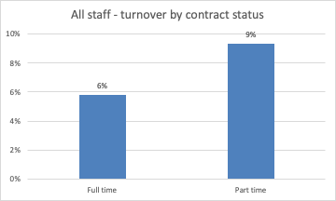

|  | **Total staff** | **Voluntary Leavers** | **2019-20 % Turnover** | **2019-20 % Turnover** | **2018-19 % Turnover** |
| --- | --- | --- | --- | --- | --- |
| **Full time** | 6492 | 377 | 6% | 6% | 7% |
| **Part time** | 2760 | 258 | 9% | 8% | 9% |

**Commentary**

During the academic year 2020-21 the turnover rate for part time members of staff was 9% (8%, 2019-20) compared to a turnover rate for full time members of staff of 6% (6% 2019-20).

## **Contract Type**

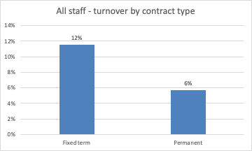

|  | **Total staff** | **Voluntary Leavers** | **2020-21 % Turnover** | **2019-20 % Turnover** | **2018-19 % Turnover** |
| --- | --- | --- | --- | --- | --- |
| **Fixed term** | 1824 | 211 | 12% | 13% | 13% |
| **Permanent** | 7428 | 424 | 6% | 5% | 6% |

**Commentary**

During the academic year 2020-21, the turnover rate for fixed term staff was 12%, (13% in the two previous years). The turnover rate for permanent staff was 6%, (previously 5%).

1. Defined as: caring for one or more children, one or more disabled children, a disabled adult, an older person, or another adult
2. Disability is defined under the Equality Act 2010 as a physical or mental impairment that has a substantial and long-term negative effect on a person’s ability to do normal daily activities.
3. BAME- Black, Asian and minority ethnic