University of Leeds staff maternity, adoption and paternity leave

1 August 2020 – 31 July 2021

Contents

Introduction 1
Maternity/Adoption leave 2
Staff return to work following Maternity/Adoption Leave 3
Paternity leave 4

Introduction
The following data provide information on all staff (academic, professional and managerial, and support) across the University who took maternity, adoption or paternity leave during the 2020-21 academic year. Data from 2018-19 and 2019-20 are also included for comparison.
Data are rounded to the nearest whole percent and therefore may not always total 100%.

Maternity/Adoption leave
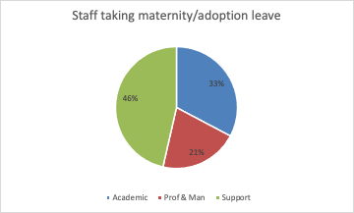
 | Count | 2020-21 % | 2019-20 % | 2018-19 %
Academic | 55 | 33% | 43% | 48%
Professional & Managerial | 35 | 21% | 20% | 20%
Support | 78 | 46% | 36% | 32%
All Staff Total | 168 | - | - | -

Commentary
168 staff took maternity and adoption leave in 2020-21, compared to 168 in 2019-20 and 153 in 2018-19. Academic staff account for 33% of the staff on maternity and adoption leave, with 46% from Support roles, and the final 21% are from Professional and Managerial roles.

Staff return to work following Maternity/Adoption Leave
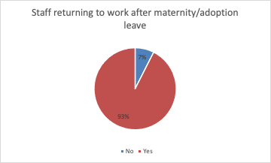
 | No | Yes | Total | % returned 2020-21 | % returned 2019-20 | % returned 2018-19
Return to work | 13 | 161 | 174 | 93% | 87% | 93%

Commentary
93% of staff returned to work after maternity/adoption leave in 2020-21. This is a an increase compared with the return rate in 2019-20 where 87% of staff returned to work after maternity/adoption leave but similar to that in 2018-19.

Paternity leave

 | Count | 2018-19 % | 2019-20 % | 2020-21 %
Academic | 38 | 65% | 67% | 60%
Professional & Managerial | 10 | 10% | 17% | 16%
Support | 15 | 25% | 16% | 24%
All Staff Total | 63 | - | - | -

Commentary
Due to current reporting mechanisms, these data only show staff who have taken a continuous two week block of paternity leave.
63 staff took paternity leave in 2020-21 compared to 81 in 2019-20 and 69 in 2018-19. Of the staff that took paternity leave, the largest job category was academic (60%) although this proportion has fallen over the period and the proportion from P&M staff has increased.

Not all staff taking paternity leave are included; the data only currently show those that take it in a block of two weeks, due to current recording mechanisms in relation to paternity pay. Our recording of these data will be reviewed to investigate capturing paternity leave where days are taken over a longer period.

