University of Leeds - Academic staff turnover by protected characteristic 1 August 2020 – 31 July 2021

Contents

Introduction 1
Age 2
Caring Responsibilities 3
Disability 4
Ethnicity 5
Gender 6
Religion or Belief 7
Sexual Orientation 8
Contract Status 9
Contract Type 10

Introduction
The following data provide information on academic staff across the University who voluntarily resigned during the academic year 2020-21. These data are provided by the following protected characteristic: age; caring responsibilities; disability; ethnicity; gender; religion or belief; and sexual orientation as well as by contract type (permanent or fixed-term) and contract status (full or part time).
During 2020-21, a total of 227 academic staff resigned out of an academic staff population of 3887, equating to a 6% staff turnover rate. For comparison, during 2019-20, a total of 228 academic staff resigned out of an academic staff population of 3926, also equating to a 6% staff turnover rate.
Data are rounded to the nearest whole percent and therefore may not always total 100%.

Age
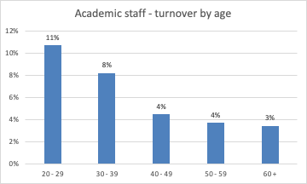
Age (Years) | Total staff | Voluntary Leavers | % Turnover
20 - 29 | 280 | 30 | 11%
30 - 39 | 1241 | 102 | 8%
40 - 49 | 1091 | 49 | 4%
50 - 59 | 866 | 32 | 4%
60 + | 409 | 14 | 3%

Commentary
During the academic year 2020-21, the highest turnover was for staff in the 20-29 age group (11%). This is consistent with academic resignations the previous year.
At 3%, the lowest academic staff turnover rate is in the 60+ age group (3% last year).

Caring Responsibilities
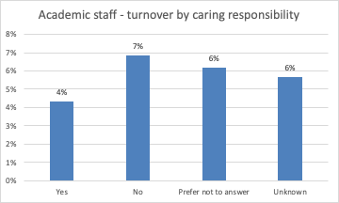
 | Total staff | Voluntary Leavers | % Turnover
Yes | 1081 | 47 | 4%
No | 1619 | 111 | 7%
Prefer not to answer | 323 | 20 | 6%
Unknown | 864 | 49 | 6%
Commentary
During the 2020-21 academic year, there was a 4% turnover for academic staff who declared they had caring responsibilities (also 4%, 2019-20).
This figure was 7% for staff with no caring responsibilities (also 7%, 2019-20).

Disability
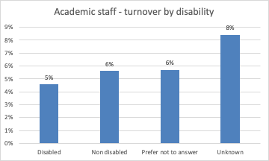
 | Total staff | Voluntary Leavers | % Turnover
Disabled | 175 | 8 | 5%
No known disability | 2992 | 168 | 6%
Prefer not to answer | 351 | 20 | 6%
Unknown | 369 | 31 | 8%

Commentary
Turnover was 5% for disabled staff during 2020-21 (2%, 2019-20) and 6% for staff with no known disability (also 6%, 2019-20).

Ethnicity
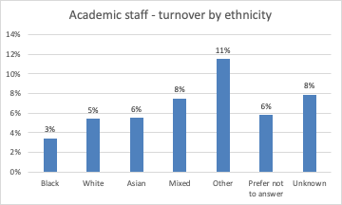
 | Total staff | Voluntary Leavers | % Turnover
Black | 58 | 2 | 3%
White | 2537 | 137 | 5%
Asian | 398 | 22 | 6%
Mixed | 80 | 6 | 8%
Other | 87 | 10 | 11%
Prefer not to answer | 360 | 21 | 6%
Unknown | 367 | 29 | 8%

Commentary
The highest turnover rate is for academic staff with Other ethnicity (11%), while the lowest rate is for academic staff with Black ethnicity (3%).

Gender
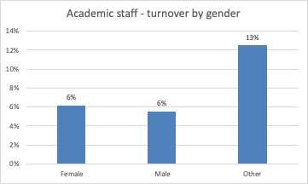
 | Total staff | Voluntary Leavers | % Turnover
Female | 1736 | 107 | 6%
Male | 2143 | 119 | 6%
Gender fluid | 0 | -
Non binary | 0 | -
Other | 8 | 1 | 13%

Commentary
During the academic year 2020-21, turnover was 6% for female academic staff (also 6%, 2019-20) and for male academic staff (5%, 2019-20). There are no gender fluid or non binary academic staff. One member of staff with other gender resigned this year (0 last year).

Religion or Belief
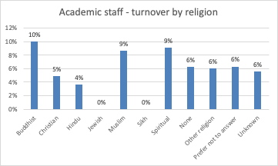
 | Total staff | Voluntary Leavers | % Turnover
Buddhist | 30 | 3 | 10%
Christian | 782 | 38 | 5%
Hindu | 55 | 2 | 4%
Jewish | 24 | 0 | 0%
Muslim | 116 | 10 | 9%
Sikh | 8 | 0 | 0%
Spiritual | 11 | 1 | 9%
None | 1487 | 93 | 6%
Other religion | 50 | 3 | 6%
Prefer not to answer | 476 | 30 | 6%
Unknown | 848 | 47 | 6%

Commentary
During the 2020-21 academic year, the highest turnovers for academic staff were for Buddhist, Muslim and Spiritual staff. Last year, the highest turnover was 14% amongst those declaring that they were Sikh partly due to the small number of staff.

Sexual Orientation
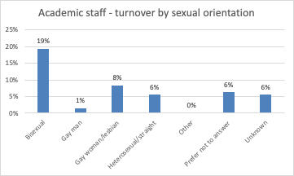
 | Total staff | Voluntary Leavers | % Turnover
Bisexual | 62 | 12 | 19%
Gay man | 68 | 1 | 1%
Gay woman/lesbian | 36 | 3 | 8%
Heterosexual | 2357 | 132 | 6%
Other | 18 | 0 | 0%
Prefer not to answer | 489 | 31 | 6%
Unknown | 857 | 48 | 6%

Commentary
The highest turnover rate during 2019-20 was from academic staff declaring their sexual orientation as bisexual (19% up from 7% last year). For academic staff who disclosed as gay woman/lesbian turnover was 1% (8%, 2019-20). For academic staff who disclosed as gay men turnover was 1% (2%, 2019-20).
It should be noted that some of these categories contain a small number of individuals, hence comparison across years should be completed with caution.

Contract Status
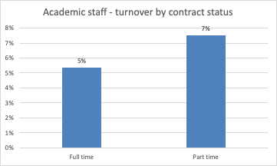
 | Total staff | Voluntary Leavers | % Turnover
Full time | 3006 | 161 | 5%
Part time | 881 | 66 | 7%

Commentary
During the 2020-21 academic year, the lower percentage turnover (5%) in academic staff was from those who worked full-time (6%, 2019-20). Part-time academic staff had a turnover rate of 7% (7%, 2019-20).

Contract Type

 | Total staff | Voluntary Leavers | % Turnover
Fixed term | 1126 | 117 | 10%
Permanent | 2761 | 110 | 4%

Commentary
During the 2020-21 academic year, the highest level of academic staff turnover (10%) was from those who held fixed term contracts (10%, 2019-20). This compared to a turnover rate of 4% for permanent academic staff (also 4%, 2019-20).

‘Academic staff’ includes roles such as: lecturer; senior lecturer; associate professor; professor; research fellow/assistant; teaching fellow; clinical; etc.
Defined as: caring for one or more children, one or more disabled children, a disabled adult, an older person, or another adult
Disability is defined under the Equality Act 2010 as a physical or mental impairment that has a substantial and long-term negative effect on a person’s ability to do normal daily activities.

