University of Leeds – Academic staff recruitment data 1 August 2020 – 31 July 2021

Contents
1
Introduction 1
Caring responsibilities 2
Disability 3
Ethnicity 4
Gender 5
Gender reassignment 6
Religion or Belief 7
Sexual orientation 8

Introduction

The following information provides academic staff recruitment data for the period August 2020 – July 2021. The data are provided by the following protected characteristics: caring responsibilities; disability; ethnicity; gender; gender reassignment; religion or belief; and sexual orientation. For each protected characteristic, the data are broken down by the following three stages of the University’s recruitment process: application; interview; and appointment.
During the period August 2020 - July 2021, 10,932 applications were received for academic positions at the University of Leeds. Of these applicants 2,173 were interviewed and 587 were appointed.
For comparison, during the period August 2019 - July 2020, 10,661 applications were received for academic positions at the University of Leeds. Of these applicants 1,619 were interviewed and 427 were appointed.
Data are rounded to the nearest whole percent and therefore may not always total 100%.

Caring responsibilities
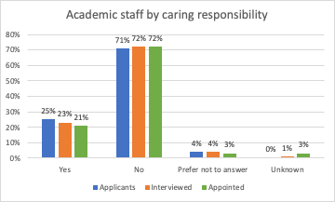
 | Yes | No | Prefer not to answer | Unknown
Applicants | 25% | 71% | 4% | 0%
Interviewed | 23% | 72% | 4% | 1%
Appointed | 21% | 72% | 3% | 3%

Commentary
During the 2020-21 academic year, 25% of academic applicants (26%, 2019-20), 23% of academic interviewees (23%, 2019-20) and 21% of those appointed (22%, 2019-20) declared they had caring responsibilities.

Disability
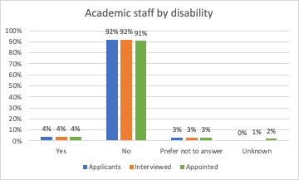
 | Yes | No | Prefer not to answer | Unknown
Applicants | 4% | 92% | 3% | 0%
Interviewed | 4% | 92% | 3% | 1%
Appointed | 4% | 91% | 3% | 2%

Commentary
During the 2020-21 academic year 4% of academic applicants declared a disability (3%, 2019-20), 4% of academic interviewees declared a disability (4%, 2019-20) and 4% of those appointed declared a disability (4%, 2019-20).

Ethnicity
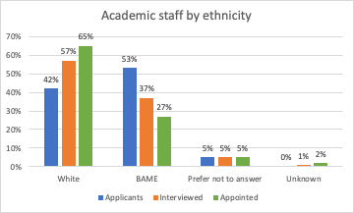
 | White | Black | Asian | Mixed | Other | Prefer not to answer | Unknown
Applicants | 42% | 8% | 31% | 5% | 9% | 5% | 0%
Interviewed | 57% | 4% | 23% | 4% | 6% | 5% | 1%
Appointed | 65% | 3% | 14% | 5% | 5% | 5% | 2%

Commentary
The largest ethnic grouping is White, followed by Asian. During the 2020-21 academic year 53% of academic applicants (56%, 2019-20), 37% of academic interviewees (37%, 2019-20) and those 27% of those appointed (29% 2019-20) declared their ethnicity as Black, Asian, Mixed or Other. The proportion of White individuals grows as the recruitment stages move from application to interview to appointment.

Gender
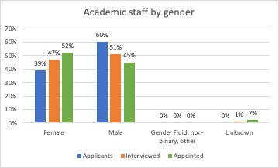
 | Male | Female | Gender fluid | Non binary | Other | Unknown
Applicants | 60% | 39% | 0% | 0% | 0% | 0%
Interviewed | 51% | 47% | 0% | 0% | 0% | 1%
Appointed | 45% | 52% | 0% | 0% | 0% | 2%

Commentary
Through the recruitment cycle, the proportion of female candidates increases and that of male candidates decreases. During the academic year 2020-21, 39% of academic applicants (38%, 2019-20), 47% of academic interviewees (47%, 2019-20) and 52% of academics appointed (53%, 2019-20) were female. 60% of academic applicants (62%, 2019-20), 51% of academic interviewees (52%, 2019-20) and 45% of academics appointed (45%, 2019-20) were male.
Five applicants were gender fluid of which 2 were interviewed but none appointed. Forty applicants were non binary, 10 were interviewed and 2 appointed. Though there were 44 applicants with other gender, 5 of which were interviewed, and one appointed.

Gender reassignment
“Is your gender identity the same as the gender you were assigned at birth?”
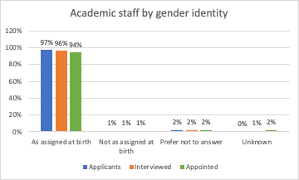
 | As assigned at birth | Not as assigned at birth | Prefer not to answer | Unknown
Applicants | 97% | 1% | 2% | 0%
Interviewed | 96% | 1% | 2% | 1%
Appointed | 94% | 1% | 2% | 2%

Commentary
During the academic year 2020-21 there were 90 academic applicants (51, 2019-20) who declared that their gender identity did not match their gender as assigned at birth. Of these, 19 were interviewed (5, 2019-20) and 5 were appointed (0, 2019-20).

Religion or Belief
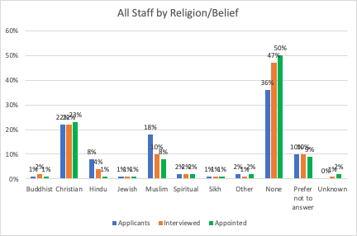
 | Buddhist | Christian | Hindu | Jewish | Muslim | Spiritual | Sikh | Other | None | Prefer not to answer | Unknown
Applicants | 1% | 22% | 8% | 1% | 18% | 2% | 1% | 2% | 36% | 10% | 0%
Interviewed | 2% | 22% | 4% | 1% | 10% | 2% | 1% | 1% | 44% | 10% | 1%
Appointed | 1% | 23% | 1% | 1% | 8% | 2% | 1% | 2% | 50% | 9% | 2%

Commentary
During the academic year 2020-21, 36% of academic applicants (31% 2019-20) stated that they had no religion, 18% were Muslim (22%, 2019-20), 22% were Christian (21%, 2019-20), 8% were Hindu (10%, 2019-20).
Of those academics appointed, 50% declared that they had no religion (50%, 2019-20), 23% were Christian (21%, 2019-20) and 8% were Muslim (9%, 2019-20).

Sexual orientation
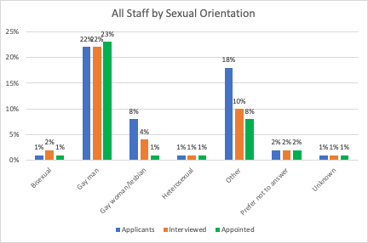
 | Bisexual | Gay man | Gay woman/  lesbian | Heterosexual | Other | Prefer not  to answer | Unknown
Applicants | 5% | 2% | 1% | 79% | 2% | 11% | 0%
Interviewed | 4% | 3% | 1% | 80% | 1% | 10% | 1%
Appointed | 4% | 3% | 1% | 77% | 1% | 11% | 2%

Commentary
During the academic year 2020-21, 8% of academic applicants stated they were either gay, lesbian or bisexual (7%, 2019-20).
Of those academics appointed in 2019-20, 8% stated they were either gay, lesbian or bisexual (3%, 2019-20).
2% of academic applicants (2%, 2019-20), 1% of the interviewees (1%, 2019-20) and 1% of the appointments (1%, 2019-20) declared their sexual orientation as Other.

‘Academic staff’ includes roles such as: lecturer; senior lecturer; associate professor; professor; research fellow/assistant; teaching fellow; clinical; etc.
Defined as: caring for one or more children, one or more disabled children, a disabled adult, an older person, or another adult
Disability is defined under the Equality Act 2010 as a physical or mental impairment that has a substantial and long-term negative effect on a person’s ability to carry out normal daily activities.

