University of Leeds - Support staff in post by protected characteristic – 31 July 2020
Contents

Introduction 1
Age 2
Caring Responsibilities 3
Disability 4
Ethnicity 5
Gender 6
Religion or Belief 7
Sexual Orientation 9

Introduction

The following information provides data on support staff in post at the University of Leeds as at 31 July 2020. The data are provided by the following protected characteristics: age; caring responsibilities; disability; ethnicity; gender; religion or belief and sexual orientation. The total support staff headcount at 31 July 2020 was 3643.
The previous two years of data are provided for comparison.
Data are rounded to the nearest whole percent and therefore may not always total 100%.

Age

Age (years) | 2018 | 2019 | 2020 | % change (2018-2020)
Under 20 | 1% | 1% | 0% | -1%
20 - 29 | 25% | 27%  %% | 24% | -1%
30 - 39 | 27% | 25% | 26% | -1%
40 - 49 | 20% | 20% | 20% | -
50 - 59 | 19% | 19% | 19% | -
60 + | 8% | 8% | 9% | +1%

Commentary
The percentage of support staff across the different age categories remains similar across the period shown, with a 1% increase in the 60+ year old category and a 1% decrease in the under 20, 20-29 and the 30-39 year old categories.

Caring Responsibilities

 | 2018 | 2019 | 2020 | % change (2018-2020)
Yes | 19% | 19% | 22% | +3%
No | 52% | 53% | 53% | +1%
Prefer not to answer | 8% | 7% | 6% | -2%
Unknown | 21% | 21% | 20% | -1%

Commentary
There has been a 3% increase in support staff declaring that they have caring responsibilities and a 1% increase in support staff who declared that they have no caring responsibilities. The level of non-disclosure has decreased by 3% over the period shown, from 29% in 2018 to 26% in 2020.

Disability

 | 2018 | 2019 | 2020 | % change (2018-2020)
Disabled | 6% | 5% | 8% | +2%
No known disability | 77% | 77% | 78% | +1%
Prefer not to answer | 9% | 8% | 7% | -2%
Unknown | 8% | 10% | 7% | -1%

Commentary

The percentage of support staff with no known disability has increased by 1% over the period shown, while the percentage of disabled support staff has increased by 2%. The level of non-disclosure has decreased by 3% over the period, from 17% in 2018 to 14% in 2020.

Ethnicity
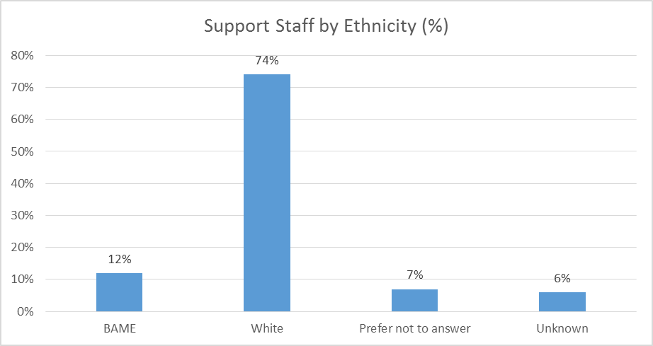
 | 2018 | 2019 | 2020 | % change (2018-2020)
BAME | 11% | 11% | 12% | +1%
-Black | - | - | 4% | -
-Asian | - | - | 5% | -
-Mixed | - | - | 2% | -
-Other | - | - | 1% | -
White | 73% | 72% | 74% | +1%
Prefer not to answer | 9% | 8% | 7% | -2%
Unknown | 7% | 9% | 6% | -1%

Commentary
The percentage of Black, Asian and minority ethnic support staff has increased by 1% over the period shown, as has the percentage of White support staff. There has been a 3% decrease in non-disclosure over the period, from 16% in 2018 to 13% in 2020. Note, this year percentages are also provided for Black, Asian, Mixed and Other staff groups separately.

Gender

 | 2018 | 2019 | 2020 | % change (2018-2020)
Female | 64% | 64% | 63% | -1%
Male | 36% | 36% | 36% | -
Gender fluid | - | - | 0% | -
Non binary | - | - | 0% | -
Other | - | - | 0% | -

Commentary
The percentage of male support staff remains unchanged at 36%, while the percentage of female staff has decreased by 1% to 63%. Note, this year additional reporting categories were available; gender fluid, non binary and other. Two support staff are gender fluid, 2 are non binary and 15 are other gender, although this does not show in the above chart or table due to the rounding of percentages to the nearest whole number.

Religion or Belief

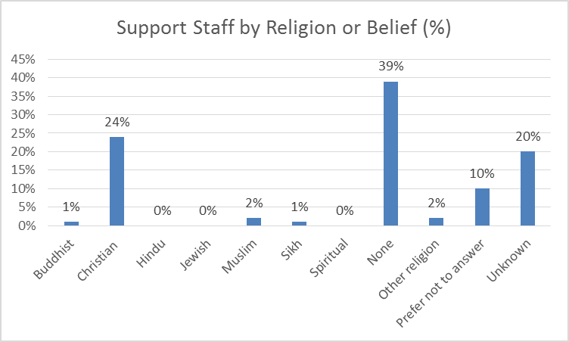

 | 2018 | 2019 | 2020 | % change (2018-2020)
Buddhist | 0% | 1% | 1% | +1%
Christian | 25% | 24% | 24% | -1%
Hindu | 1% | 1% | 0% | -1%
Jewish | 0% | 0% | 0% | -
Muslim | 2% | 2% | 2% | -
Sikh | 1% | 1% | 1% | -
Spiritual | - | - | 0% | -
None | 36% | 37% | 39% | +3%
Other religion | 2% | 2% | 2% | -
Prefer not to answer | 13% | 11% | 10% | -3%
Unknown | 21% | 21% | 20% | -1%

Commentary
There has been a 3% increase in the percentage of support staff declaring they have no religion. The percentage of Buddhist support staff has increased by 1% in this period, while the percentage of Christian and Hindu support staff has decreased by 1%. There were 15 support staff who declared they were Hindu, 12 who were Jewish and 16 who were Spiritual (new category) however, this is not shown in the above chart or table due to rounding of data to the nearest whole percent. There has been a 4% decrease in non-disclosure over the period, from 34% in 2018 to 30% in 2020.

Sexual Orientation

 | 2018 | 2019 | 2020 | % change (2018-2020)
Bisexual | 2% | 3% | 3% | +1%
Gay man | 1% | 1% | 1% | -
Gay woman/lesbian | 1% | 1% | 1% | -
Heterosexual | 62% | 63% | 64% | +2%
Other | 0% | 0% | 1% | +1%
Prefer not to answer | 12% | 11% | 10% | -2%
Unknown | 21% | 21% | 20% | -1%

Commentary
There has been a 2% increase in the percentage of support staff declaring they are heterosexual and a 1% increase in the percentage of staff declaring they are bisexual. There has been a 3% decrease in non-disclosure over the period shown, from 33% in 2018 to 30% in 2020.

‘Support staff’ comprises clerical staff, technicians and operational support roles
Defined as: caring for one or more children, one or more disabled children, a disabled adult, an older person, or another adult
Disability is defined under the Equality Act 2010 as a physical or mental impairment that has a substantial and long-term negative effect on a person’s ability to carry out normal daily activities.
BAME – Black, Asian and minority ethnic

