University of Leeds Registered Students 2020/21 by protected characteristic
Contents

Introduction 2
Age 3
Home Students 3
EU Students 4
Overseas Students 5
Disability 7
Home Students 7
EU Students 8
Overseas Students 9
Ethnicity 11
Home Students 11
EU Students 14
Overseas Students 17
Gender 21
Home Students 21
EU Students 22
Overseas Students 23
Religion or Belief 25
Home Students 25
EU Students 27
Overseas Students 29
Sexual Orientation 32
Home Students 32
EU Students 33
Overseas Students 34

Introduction

The following data provide information on all students (Undergraduate (UG), Taught Postgraduate (PGT) and Research Postgraduate (PGR)) who registered during the academic year 2020-21. Data are provided by the following protected characteristics: age; disability; ethnicity; gender; religion or belief; and sexual orientation.
For the Home cohort 21,617 UG students, 2,371 PGT students and 1,376 PGR students registered during the 2020-21 academic year. For the EU cohort 1,487 UG students, 193 PGT students and 258 PGR students registered during the 2020-21 academic year. For the overseas cohort 4,829 UG students, 1,736470 PGT students and 864 PGR students registered during the 2020-21 academic year.
Home, EU and Overseas data have been presented separately.

Data from the previous years are available on the equality@leeds.ac.uk webpages but not included for comparison as applicants are grouped previously as Home/EU and overseas.

Data are rounded to the nearest whole percent and therefore may not always total 100%.

Age
Home Students
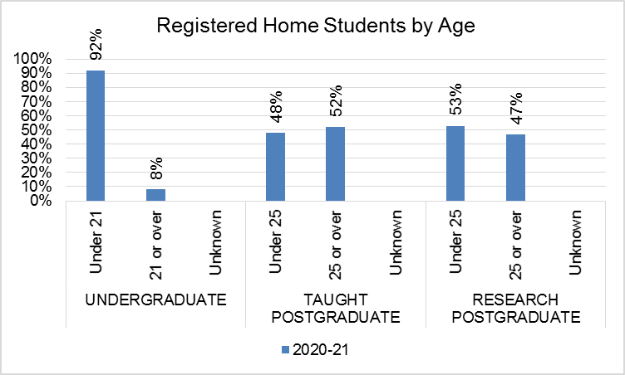
Level of study | Group | 2020/21
 |  | Count | % of Total
Undergraduate | Under 21 | 19850 | 92%
 | 21 or over | 1766 | 8%
 | Unknown | 1
 | Total | 21617
Taught Postgraduate | Under 25 | 1146 | 48%
 | 25 or over | 1225 | 52%
 | Unknown
 | Total | 2371
Research Postgraduate | Under 25 | 727 | 53%
 | 25 or over | 649 | 47%
 | Unknown
 | Total | 1376
EU Students
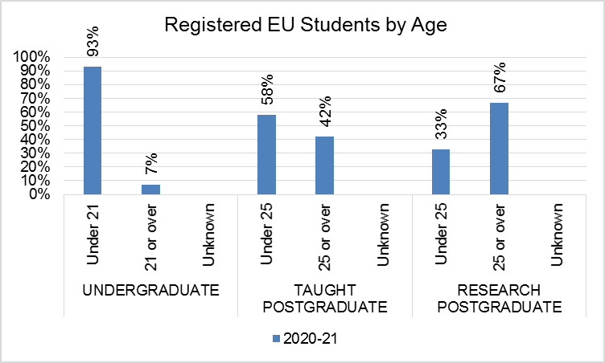
Level of study | Group | 2020/21
 |  | Count | % of Total
Undergraduate | Under 21 | 1385 | 93%
 | 21 or over | 102 | 7%
 | Unknown
 | Total | 1487
Taught Postgraduate | Under 25 | 111 | 58%
 | 25 or over | 82 | 42%
 | Unknown
 | Total | 193
Research Postgraduate | Under 25 | 85 | 33%
 | 25 or over | 173 | 67%
 | Unknown
 | Total | 258
Overseas Students
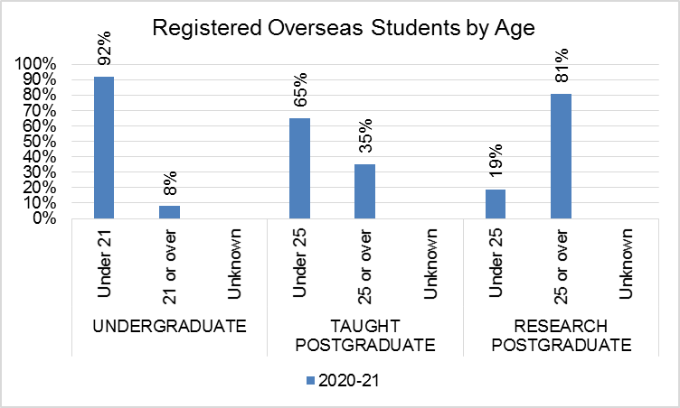
Level of study | Group | 2020/21
 |  | Count | % of Total
Undergraduate | Under 21 | 4418 | 92%
 | 21 or over | 410 | 8%
 | Unknown | 1
 | Total | 4829
Taught Postgraduate | Under 25 | 1128 | 65%
 | 25 or over | 608 | 35%
 | Unknown
 | Total | 1736
Research Postgraduate | Under 25 | 161 | 19%
 | 25 or over | 703 | 81%
 | Unknown
 | Total | 864
Commentary

Undergraduate - The majority of Home UG students are under 21 years (92%), as are EU students (93%) and Overseas students (92%).

Taught Postgraduate - The percentage of Home PGT students under the age of 25 is 48%, compared with 58% of EU students and 65% of Overseas students.

Research Postgraduate - The percentage of Home PGR students under the age of 25 is 53% compared with 33% of EU students and 19% of Overseas students.

Disability
Home Students
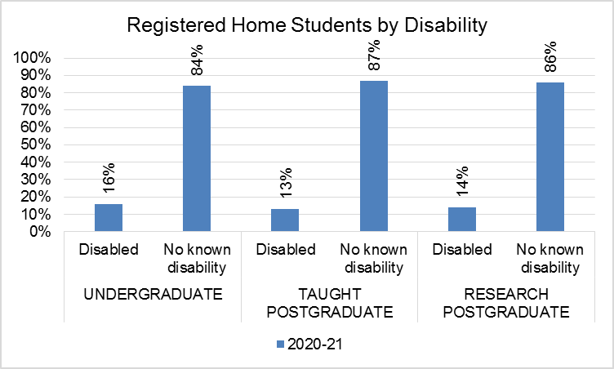
Level of study | Group | 2020/21
 |  | Count | % of Total
Undergraduate | Disabled | 3448 | 16%
 | No Known Disability | 18169 | 84%
 | Unknown
 | Total | 21617
Taught Postgraduate | Disabled | 299 | 13%
 | No Known Disability | 2072 | 87%
 | Unknown
 | Total | 2371
Research Postgraduate | Disabled | 196 | 14%
 | No Known Disability | 1180 | 86%
 | Unknown
 | Total | 1376

EU Students
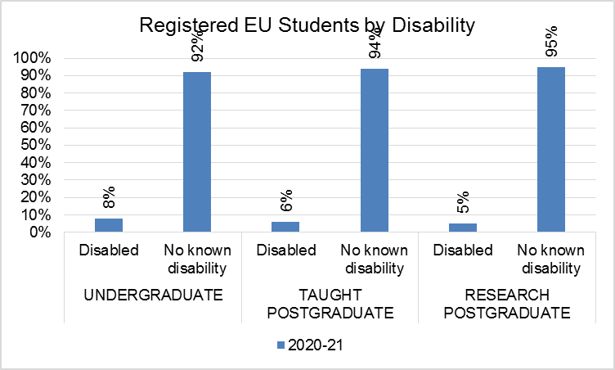
Level of study | Group | 2020/21
 |  | Count | % of Total
Undergraduate | Disabled | 115 | 8%
 | No Known Disability | 1372 | 92%
 | Unknown
 | Total | 1487
Taught Postgraduate | Disabled | 12 | 6%
 | No Known Disability | 181 | 94%
 | Unknown
 | Total | 193
Research Postgraduate | Disabled | 14 | 5%
 | No Known Disability | 244 | 95%
 | Unknown
 | Total | 258

Overseas Students
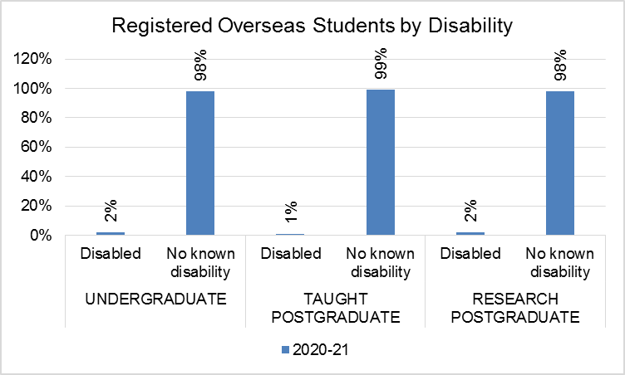
Level of study | Group | 2020/21
 |  | Count | % of Total
Undergraduate | Disabled | 101 | 2%
 | No Known Disability | 4728 | 98%
 | Unknown
 | Total | 4829
Taught Postgraduate | Disabled | 22 | 1%
 | No Known Disability | 1714 | 99%
 | Unknown
 | Total | 1736
Research Postgraduate | Disabled | 20 | 2%
 | No Known Disability | 844 | 98%
 | Unknown
 | Total | 864

Commentary
Undergraduate - The percentage of disabled Home UG students is 16%, compared with 8% of EU students and 2% of Overseas students.

Taught Postgraduate – The percentage of disabled Home PGT students is 13% compared with 6% of EU students and 1% of Overseas students.

Research Postgraduate – The percentage of disabled Home PGT students is 14% compared with 5% of EU students and 2% of Overseas students.

Ethnicity
Home Students
Note, the graphs include Unknown in percentage calculations, whereas tables show percentages for known ethnicity only.

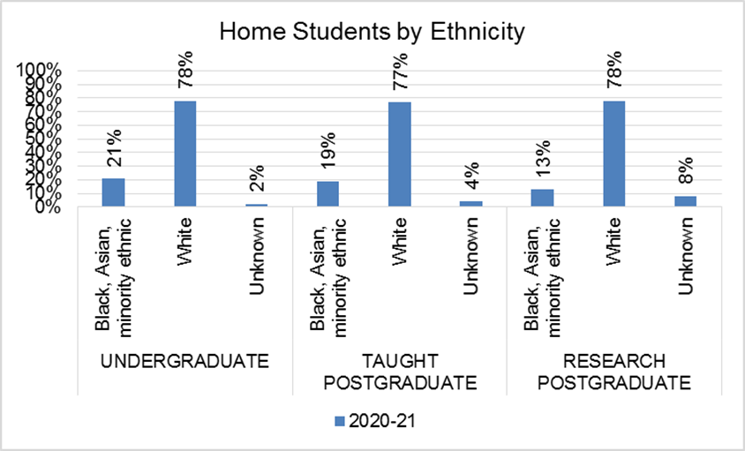

Level of study | Group | 2020/21
 |  | Count | % of Total
Undergraduate | White | 16852 | 79%
 | Black or Black British - Caribbean | 134 | 1%
 | Black or Black British - African | 469 | 2%
 | Other Black background | 26 | 0%
 | Asian or Asian British - Indian | 715 | 3%
 | Asian or Asian British - Pakistani | 954 | 4%
 | Asian or Asian British - Bangladeshi | 162 | 1%
 | Chinese or Other Ethnic Background - Chinese | 200 | 1%
 | Other Asian background | 296 | 1%
 | Mixed - White and Black Caribbean | 255 | 1%
 | Mixed - White and Black African | 129 | 1%
 | Mixed - White and Asian | 566 | 3%
 | Other Mixed background | 280 | 1%
 | Arab | 101 | 0%
 | Other Ethnic background | 146 | 1%
 | Unknown | 332
 | Black, Asian and minority ethnic  Overall Subtotal | 4433 | 21%
 | Total | 21617
Taught Postgraduate | White | 1834 | 81%
 | Black or Black British - Caribbean | 22 | 1%
 | Black or Black British - African | 63 | 3%
 | Other Black background | 2 | 0%
 | Asian or Asian British - Indian | 76 | 3%
 | Asian or Asian British - Pakistani | 116 | 5%
 | Asian or Asian British - Bangladeshi | 10 | 0%
 | Chinese or Other Ethnic Background - Chinese | 17 | 1%
 | Other Asian background | 19 | 1%
 | Mixed - White and Black Caribbean | 19 | 1%
 | Mixed - White and Black African | 9 | 0%
 | Mixed - White and Asian | 24 | 1%
 | Other Mixed background | 36 | 2%
 | Arab | 13 | 1%
 | Other Ethnic background | 13 | 1%
 | Unknown | 98
 | Black, Asian and minority ethnic  Overall Subtotal | 439 | 19%
 | Total | 2371
Research Postgraduate | White | 1077 | 85%
 | Black or Black British - Caribbean | 5 | 0%
 | Black or Black British - African | 24 | 2%
 | Other Black background
 | Asian or Asian British - Indian | 26 | 2%
 | Asian or Asian British - Pakistani | 38 | 3%
 | Asian or Asian British - Bangladeshi | 8 | 1%
 | Chinese or Other Ethnic Background - Chinese | 13 | 1%
 | Other Asian background | 11 | 1%
 | Mixed - White and Black Caribbean | 4 | 0%
 | Mixed - White and Black African | 2 | 0%
 | Mixed - White and Asian | 13 | 1%
 | Other Mixed background | 17 | 1%
 | Arab | 14 | 1%
 | Other Ethnic background | 8 | 1%
 | Unknown | 116
 | Black, Asian and minority ethnic  Overall Subtotal | 183 | 15%
 | Total | 1376

EU Students
Note, the graphs include Unknown in percentage calculations, whereas tables show percentages for known ethnicity only.

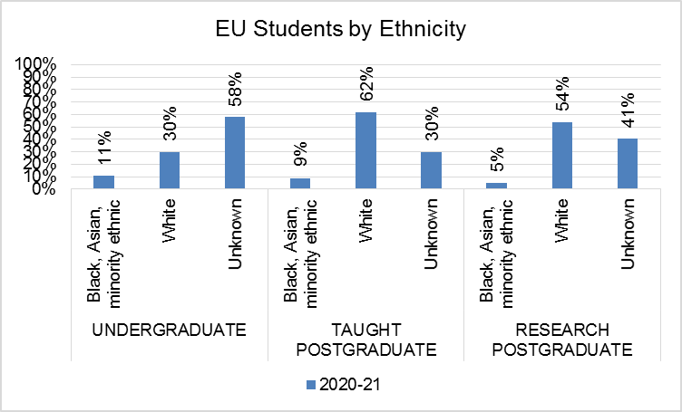

Level of study | Group | 2020/21
 |  | Count | % of Total
Undergraduate | White | 449 | 73%
 | Black or Black British - Caribbean
 | Black or Black British - African | 51 | 8%
 | Other Black background | 7 | 1%
 | Asian or Asian British - Indian | 10 | 2%
 | Asian or Asian British - Pakistani | 17 | 3%
 | Asian or Asian British - Bangladeshi | 6 | 1%
 | Chinese or Other Ethnic Background - Chinese | 3 | 0%
 | Other Asian background | 15 | 2%
 | Mixed - White and Black Caribbean | 3 | 0%
 | Mixed - White and Black African | 7 | 1%
 | Mixed - White and Asian | 7 | 1%
 | Other Mixed background | 17 | 3%
 | Arab | 7 | 1%
 | Other Ethnic background | 19 | 3%
 | Unknown | 869
 | Black, Asian and minority ethnic  Overall Subtotal | 169 | 27%
 | Total | 1487
Taught Postgraduate | White | 119 | 87%
 | Black or Black British - Caribbean
 | Black or Black British - African | 3 | 2%
 | Other Black background
 | Asian or Asian British - Indian | 1 | 1%
 | Asian or Asian British - Pakistani
 | Asian or Asian British - Bangladeshi
 | Chinese or Other Ethnic Background - Chinese | 1 | 1%
 | Other Asian background | 2 | 1%
 | Mixed - White and Black Caribbean | 2 | 1%
 | Mixed - White and Black African | 1 | 1%
 | Mixed - White and Asian | 1 | 1%
 | Other Mixed background | 4 | 3%
 | Arab
 | Other Ethnic background | 3 | 2%
 | Unknown | 56
 | Black, Asian and minority ethnic  Overall Subtotal | 18 | 13%
 | Total | 193
Research Postgraduate | White | 138 | 91%
 | Black or Black British - Caribbean
 | Black or Black British - African | 2 | 1%
 | Other Black background
 | Asian or Asian British - Indian
 | Asian or Asian British - Pakistani | 1 | 1%
 | Asian or Asian British - Bangladeshi
 | Chinese or Other Ethnic Background - Chinese
 | Other Asian background | 1 | 1%
 | Mixed - White and Black Caribbean
 | Mixed - White and Black African | 2 | 1%
 | Mixed - White and Asian | 2 | 1%
 | Other Mixed background | 2 | 1%
 | Arab | 2 | 1%
 | Other Ethnic background | 2 | 1%
 | Unknown | 106
 | Black, Asian and minority ethnic  Overall Subtotal | 14 | 9%
 | Total | 258

Overseas Students
Note, the graphs include Unknown in percentage calculations, whereas tables show percentages for known ethnicity only.

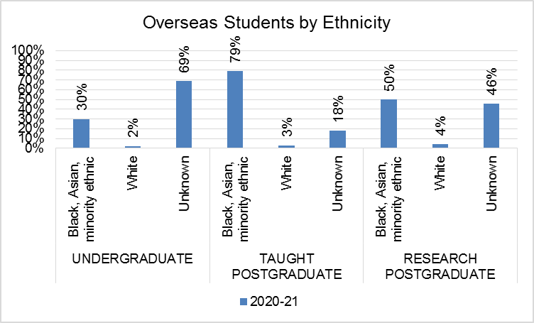

Level of study | Group | 2020/21
 |  | Count | % of Total
Undergraduate | White | 85 | 6%
 | Black or Black British - Caribbean | 3 | 0%
 | Black or Black British - African | 40 | 3%
 | Other Black background | 15 | 1%
 | Asian or Asian British - Indian | 43 | 3%
 | Asian or Asian British - Pakistani | 13 | 1%
 | Asian or Asian British - Bangladeshi | 2 | 0%
 | Chinese or Other Ethnic Background - Chinese | 811 | 54%
 | Other Asian background | 138 | 9%
 | Mixed - White and Black Caribbean | 2 | 0%
 | Mixed - White and Black African | 3 | 0%
 | Mixed - White and Asian | 10 | 1%
 | Other Mixed background | 5 | 0%
 | Arab | 327 | 22%
 | Other Ethnic background | 17 | 1%
 | Unknown | 3315
 | Black, Asian and minority ethnic  Overall Subtotal | 1429 | 94%
 | Total | 4829
Taught Postgraduate | White | 57 | 4%
 | Black or Black British - Caribbean | 2 | 0%
 | Black or Black British - African | 64 | 4%
 | Other Black background | 8 | 1%
 | Asian or Asian British - Indian | 73 | 5%
 | Asian or Asian British - Pakistani | 22 | 2%
 | Asian or Asian British - Bangladeshi | 8 | 1%
 | Chinese or Other Ethnic Background - Chinese | 1003 | 70%
 | Other Asian background | 66 | 5%
 | Mixed - White and Black Caribbean
 | Mixed - White and Black African | 2 | 0%
 | Mixed - White and Asian | 2 | 0%
 | Other Mixed background | 10 | 1%
 | Arab | 100 | 7%
 | Other Ethnic background | 15 | 1%
 | Unknown | 304
 | Black, Asian and minority ethnic  Overall Subtotal | 1375 | 96%
 | Total | 1736
Research Postgraduate | White | 34 | 7%
 | Black or Black British - Caribbean | 1 | 0%
 | Black or Black British - African | 20 | 4%
 | Other Black background | 11 | 2%
 | Asian or Asian British - Indian | 15 | 3%
 | Asian or Asian British - Pakistani | 1 | 0%
 | Asian or Asian British - Bangladeshi | 7 | 1%
 | Chinese or Other Ethnic Background - Chinese | 136 | 29%
 | Other Asian background | 52 | 11%
 | Mixed - White and Black Caribbean | 1 | 0%
 | Mixed - White and Black African | 2 | 0%
 | Mixed - White and Asian | 3 | 1%
 | Other Mixed background | 16 | 3%
 | Arab | 151 | 32%
 | Other Ethnic background | 17 | 4%
 | Unknown | 397
 | Black, Asian and minority ethnic  Overall Subtotal | 433 | 93%
 | Total | 864

Commentary
Undergraduate - The percentage of Black, Asian or minority ethnic Home UG students is 21% compared with 11% of EU students and 30% of Overseas students. There are high proportions of missing data for EU and Overseas students.

Taught Postgraduate - The percentage of Black, Asian or minority ethnic Home PGT students is 19% compared with 9% of EU students and 79% of Overseas students. There are high proportions of missing data for EU and Overseas students.

Research Postgraduate - The percentage of Black, Asian or minority ethnic Home PGR students is 13% compared with 5% of EU students and 50% of Overseas students. There are high proportions of missing data for EU and Overseas students.

Gender

Home Students
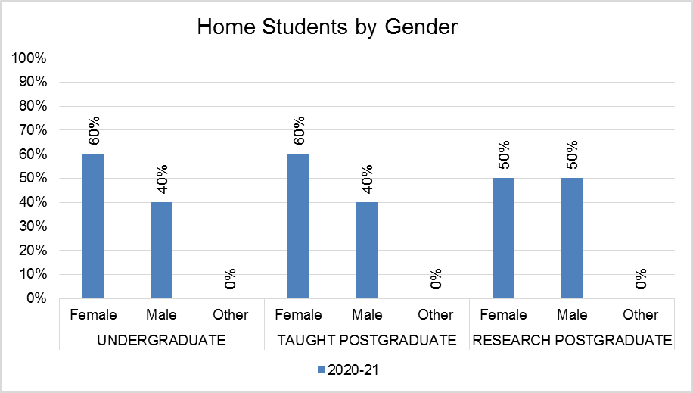
Level of study | Gender | 20120/21
 |  | Count | % of Total
Undergraduate | Female | 12941 | 60%
 | Male | 8652 | 40%
 | Other | 24 | 0%
 | Unknown
 | Total | 21617
Taught Postgraduate | Female | 1423 | 60%
 | Male | 941 | 40%
 | Other | 7 | 0%
 | Unknown
 | Total | 2371
Research Postgraduate | Female | 687 | 50%
 | Male | 686 | 50%
 | Other | 3 | 0%
 | Unknown
 | Total | 1376

EU Students
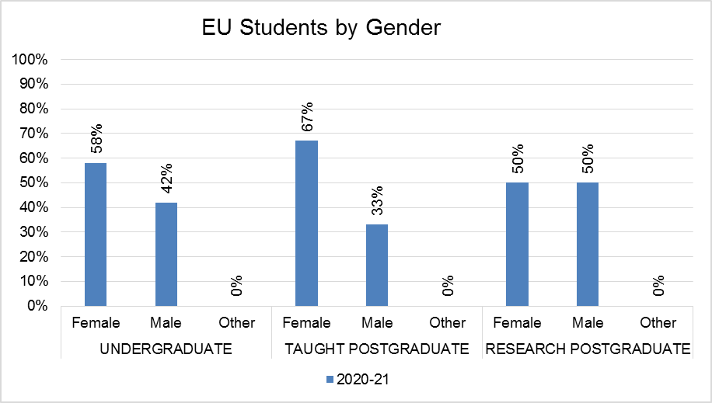
Level of study | Gender | 2020/21
 |  | Count | % of Total
Undergraduate | Female | 865 | 58%
 | Male | 620 | 42%
 | Other | 2 | 0%
 | Unknown
 | Total | 1487
Taught Postgraduate | Female | 129 | 67%
 | Male | 64 | 33%
 | Other
 | Unknown
 | Total | 193
Research Postgraduate | Female | 129 | 50%
 | Male | 129 | 50%
 | Other
 | Unknown
 | Total | 258

Overseas Students
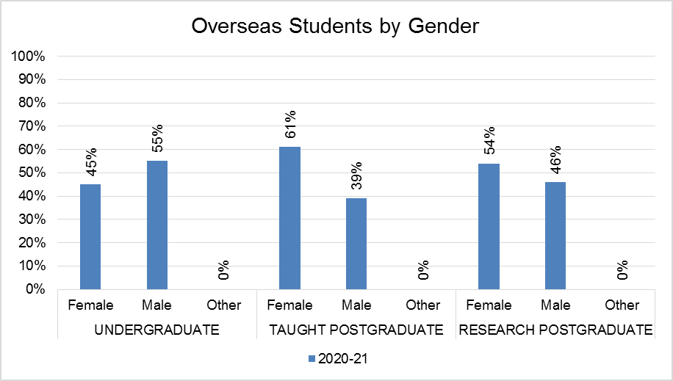
Level of study | Gender | 2020/21
 |  | Count | % of Total
Undergraduate | Female | 2152 | 45%
 | Male | 2667 | 55%
 | Other | 10 | 0%
 | Unknown
 | Total | 4829
Taught Postgraduate | Female | 1059 | 61%
 | Male | 673 | 39%
 | Other | 4 | 0%
 | Unknown
 | Total | 1736
Research Postgraduate | Female | 467 | 54%
 | Male | 397 | 46%
 | Other
 | Unknown
 | Total | 864

Commentary

Undergraduate - The percentage of female Home UG student registrations is 60%, compared with 58% of EU students and 45% of Overseas students.

Taught Postgraduate - The percentage of female PGT Home students is 60% compared with 67% of EU students and 61% of Overseas students.

Research Postgraduate - The percentage of female PGR Home students is 50% compared with 50% of EU students and 54% of Overseas students.

There are some students with Other gender, but these individuals account for less than 1% of the students within their level of study.

Religion or Belief

Home Students
Level of study | Group | 2020/21
 |  | Count | % of Total
Undergraduate | No Religion | 11837 | 60%
 | Christian | 4955 | 25%
 | Muslim | 1518 | 8%
 | Jewish | 409 | 2%
 | Hindu | 263 | 1%
 | Sikh | 148 | 1%
 | Buddhist | 63 | 0%
 | Spiritual | 268 | 1%
 | Any Other Religion | 189 | 1%
 | Unknown/Prefer Not To Say | 1967
 | Have a Religion subtotal | 7813 | 40%
 | Total | 21617
Taught Postgraduate | No Religion | 1212 | 56%
 | Christian | 644 | 30%
 | Muslim | 173 | 8%
 | Jewish | 17 | 1%
 | Hindu | 23 | 1%
 | Sikh | 18 | 1%
 | Buddhist | 8 | 0%
 | Spiritual | 41 | 2%
 | Any Other Religion | 32 | 1%
 | Unknown/Prefer Not To Say | 203
 | Have a Religion subtotal | 956 | 44%
 | Total | 2371
Research Postgraduate | No Religion | 767 | 65%
 | Christian | 288 | 24%
 | Muslim | 76 | 6%
 | Jewish | 10 | 1%
 | Hindu | 10 | 1%
 | Sikh | 0 | 0%
 | Buddhist | 6 | 1%
 | Spiritual | 11 | 1%
 | Any Other Religion | 20 | 2%
 | Unknown/Prefer Not To Say | 188
 | Have a Religion subtotal | 421 | 35%
 | Total | 1376

EU Students
Level of study | Group | 2020/21
 |  | Count | % of Total
Undergraduate | No Religion | 369 | 37%
 | Christian | 513 | 51%
 | Muslim | 58 | 6%
 | Jewish | 12 | 1%
 | Hindu | 9 | 1%
 | Sikh | 2 | 0%
 | Buddhist | 4 | 0%
 | Spiritual | 24 | 2%
 | Any Other Religion | 18 | 2%
 | Unknown/Prefer Not To Say | 478
 | Have a Religion subtotal | 640 | 63%
 | Total | 1487
Taught Postgraduate | No Religion | 67 | 39%
 | Christian | 88 | 51%
 | Muslim | 6 | 3%
 | Jewish | 1 | 1%
 | Hindu | 0 | 0%
 | Sikh | 0 | 0%
 | Buddhist | 0 | 0%
 | Spiritual | 7 | 4%
 | Any Other Religion | 3 | 2%
 | Unknown/Prefer Not To Say | 21
 | Have a Religion subtotal | 105 | 61%
 | Total | 193
Research Postgraduate | No Religion | 96 | 48%
 | Christian | 93 | 46%
 | Muslim | 3 | 1%
 | Jewish | 0 | 0%
 | Hindu | 0 | 0%
 | Sikh | 0 | 1%
 | Buddhist | 1 | 0%
 | Spiritual | 2 | 1%
 | Any Other Religion | 7 | 3%
 | Unknown/Prefer Not To Say | 56
 | Have a Religion subtotal | 106 | 52%
 | Total | 258

Overseas Students
Level of study | Group | 2020/21
 |  | Count | % of Total
Undergraduate | No Religion | 1883 | 53%
 | Christian | 330 | 9%
 | Muslim | 888 | 25%
 | Jewish | 4 | 0%
 | Hindu | 155 | 4%
 | Sikh | 10 | 0%
 | Buddhist | 158 | 4%
 | Spiritual | 20 | 1%
 | Any Other Religion | 79 | 2%
 | Unknown/Prefer Not To Say | 1302
 | Have a Religion subtotal | 1644 | 47%
 | Total | 4829
Taught Postgraduate | No Religion | 1133 | 70%
 | Christian | 154 | 10%
 | Muslim | 203 | 13%
 | Jewish | 2 | 0%
 | Hindu | 64 | 4%
 | Sikh | 3 | 0%
 | Buddhist | 25 | 2%
 | Spiritual | 8 | 0%
 | Any Other Religion | 25 | 2%
 | Unknown/Prefer Not To Say | 119
 | Have a Religion subtotal | 484 | 30%
 | Total | 1736
Research Postgraduate | No Religion | 293 | 36%
 | Christian | 104 | 13%
 | Muslim | 345 | 42%
 | Jewish | 2 | 0%
 | Hindu | 25 | 3%
 | Sikh | 0 | 42%
 | Buddhist | 22 | 3%
 | Spiritual | 9 | 1%
 | Any Other Religion | 15 | 2%
 | Unknown/Prefer Not To Say | 49
 | Have a Religion subtotal | 522 | 64%
 | Total | 864

Commentary

Undergraduate - The two largest groups of UG Home students is those with no religion (60% of known religion) and Christian (25% of known religion). For EU students, the two largest groups remains the same, but with 37% declaring no religion and 51% Christian. The two largest groups differ for Overseas students, with 53% having no religion and 25% Muslim.

Taught Postgraduate - The two largest groups of PGT Home students are those with no religion (56% of known religion) and Christian (30% of known religion). For EU students the two largest groups remains the same, but with 39% declaring no religion and 51% Christian. The two largest groups differ for Overseas students, with 70% declaring no religion and 13% Muslim, although closely followed by 10% Christian.

Research Postgraduate - The two largest groups of PGR Home students are those with no religion (65% of known religion) and Christian (24% of known religion). The two largest groups are the same for EU students, but with 48% having no religion and 46% Christian. The two largest groups differ for Overseas students, with 42% Sikh and 42% Muslim.

Sexual Orientation

Home Students
Note, the graphs include Unknown in percentage calculations, whereas tables show percentages for known sexual orientation only.
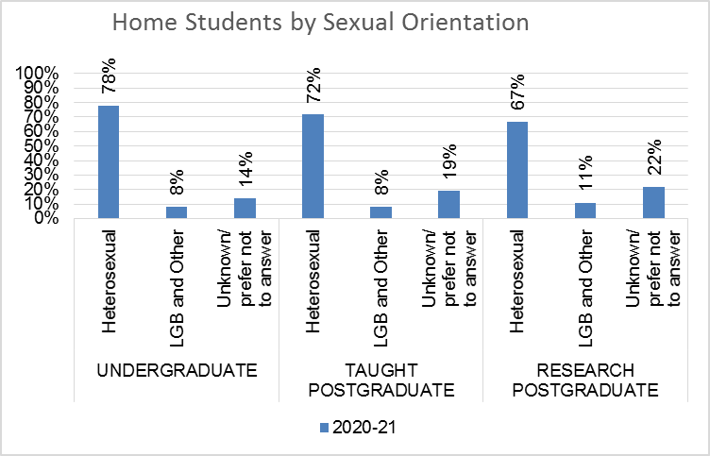
Level of study | Group | 2020/21
 |  | Count | % of Total
Undergraduate | Heterosexual | 16811 | 91%
 | LGB/Other | 1727 | 9%
 | Unknown | 3079
 | Total | 21617
Taught Postgraduate | Heterosexual | 1716 | 90%
 | LGB/Other | 196 | 10%
 | Unknown | 459
 | Total | 2371
Research Postgraduate | Heterosexual | 920 | 86%
 | LGB/Other | 148 | 14%
 | Unknown | 308
 | Total | 1376

EU Students
Note, the graphs include Unknown in percentage calculations, whereas tables show percentages for known sexual orientation only.
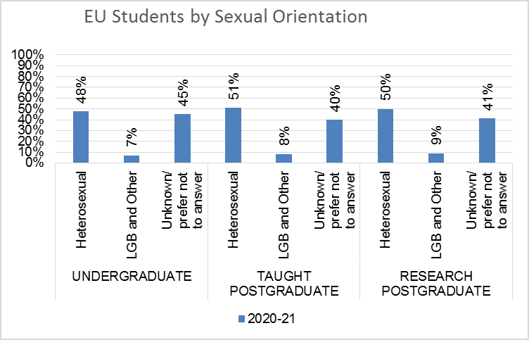
Level of study | Group | 2020/21
 |  | Count | % of Total
Undergraduate | Heterosexual | 719 | 87%
 | LGB/Other | 103 | 13%
 | Unknown | 665
 | Total | 1487
Taught Postgraduate | Heterosexual | 99 | 86%
 | LGB/Other | 16 | 14%
 | Unknown | 78
 | Total | 193
Research Postgraduate | Heterosexual | 129 | 85%
 | LGB/Other | 23 | 15%
 | Unknown | 106
 | Total | 258

Overseas Students
Note, the graphs include Unknown in percentage calculations, whereas tables show percentages for known sexual orientation only.
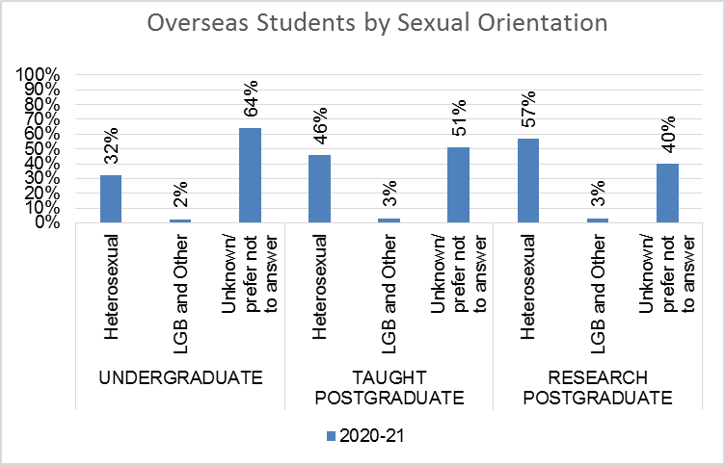
Level of study | Group | 2020/21
 |  | Count | % of Total
Undergraduate | Heterosexual | 1642 | 93%
 | LGB/Other | 120 | 7%
 | Unknown | 3067
 | Total | 4829
Taught Postgraduate | Heterosexual | 794 | 93%
 | LGB/Other | 57 | 7%
 | Unknown | 885
 | Total | 1736
Research Postgraduate | Heterosexual | 491 | 95%
 | LGB/Other | 27 | 5%
 | Unknown | 346
 | Total | 864

Commentary

Undergraduate – 8% of Home UG students are gay, bisexual, lesbian or Other compared with 7% of EU students and 2% of Overseas students.

Taught Postgraduate – 8% of Home PGT students are gay, bisexual, lesbian or Other compared with 8% of EU students and 5% of Overseas students.

Research Postgraduate – 11% of Home PGR students are gay, bisexual, lesbian or Other compared with 9% of EU students and 3% of Overseas students.

There are high non-disclosure rates throughout.

Disability is defined under the Equality Act 2010 as a physical or mental impairment that has a substantial and long-term negative effect on a person’s ability to carry out normal daily activities.

