University of Leeds undergraduate degree classification 2019-20 by protected characteristic

Contents

Introduction 2
Age 3
Home Students 3
EU Students 4
Overseas Students 5
Disability 6
Home Students 6
EU Students 7
Overseas Students 8
Ethnicity 9
Home Students 9
EU Students 10
Overseas Students 11
Gender 12
Home Students 12
EU Students 13
Overseas Students 14

Introduction

The following data provide information on the degree classification of students completing an undergraduate (UG) course, by the following protected characteristics: age; disability; ethnicity; and gender.

During the academic year 2019-20 a total of 5,563 Home UG students, 245 EU students and 771 Overseas students were due to graduate. Of these graduations, classified degrees accounted for 5,287, 242 and 745 students respectively. Unclassified degrees include, for example, Medical and Dental students whose degrees are not graded in the same way. This report considers only classified degrees.
During 2019-20, 89% of those due to graduate with a classified degree were awarded a I or a II(i). For reference, a total of 5,659 students were due to graduate in 2018-19 of which 89% were awarded a I or II(i). In 2017-18 a total of 5,234 students were due to graduate of which 88% were awarded a I or II(i).
Home, EU and overseas data have been presented separately.

Data from the previous years are available on the equality@leeds.ac.uk webpages but not included for comparison as applicants are previously grouped as Home/EU and Overseas.

Data are rounded to the nearest whole percent and therefore may not always total 100%.

Age

Home Students

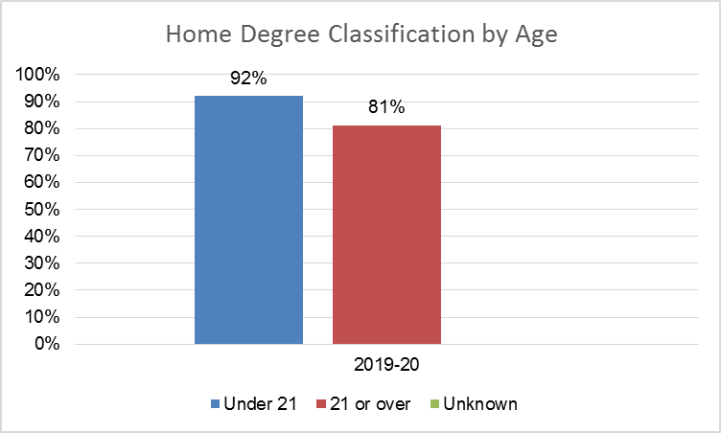

Age (Years) | 2019-20
 | Number of Students Awarded I & II(i) | Number of classified degrees due to graduate | % Students Awarded I & II(i)
Under 21 | 4535 | 4929 | 92%
21 or over | 289 | 358 | 81%
Unknown | 0 | 0

Commentary
The percentage of Home UG students under 21 years who were awarded a I or II(i) is 92%. The percentage of UG students who were 21 or over and who were awarded a I or II(i) was 81%. The awarding gap is currently 11%.

EU Students

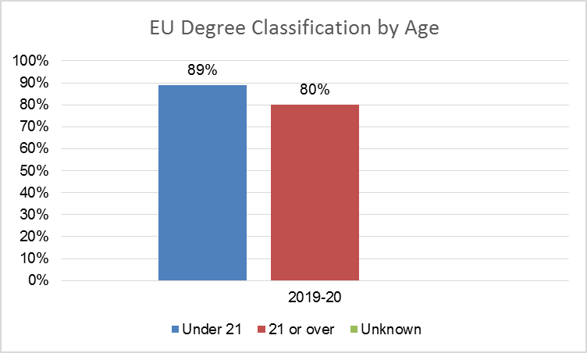

Age (Years) | 2019-20
 | Number of Students Awarded I & II(i) | Number of classified degrees due to graduate | % Students Awarded I & II(i)
Under 21 | 202 | 227 | 89%
21 or over | 12 | 15 | 80%
Unknown | 0 | 0

Commentary
The percentage of EU UG students who were under the age of 21 and awarded a I or II(i) was 89%. The percentage of UG students who were 21 or over and awarded a I or II(i) was 80%. The awarding gap is currently 9%.

Overseas Students

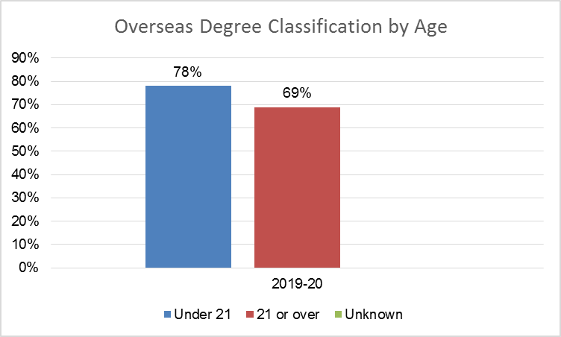

Age (Years) | 2019-20
 | Number of Students Awarded I & II(i) | Number of classified degrees due to graduate | % Students Awarded I & II(i)
Under 21 | 472 | 605 | 78%
21 or over | 97 | 140 | 69%
Unknown | 0 | 0

Commentary
The percentage of Home/EU UG students who were under the age of 21 and awarded a I or II(i) was 78%. The percentage of UG students who were 21 or over and awarded a I or II(i) was 69%. The awarding gap is currently 9%.

Disability

Home Students
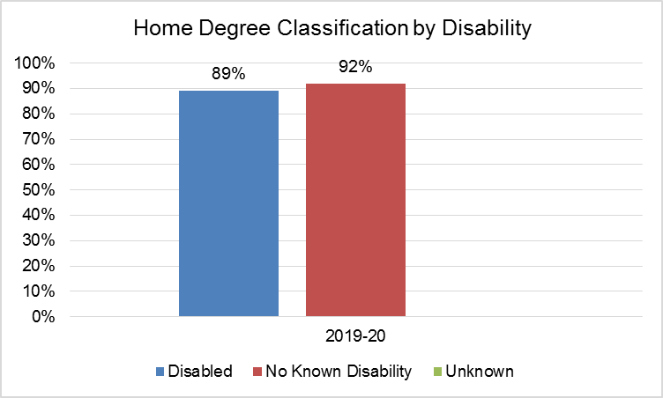

Disability | 2019-20
 | Number of Students Awarded I & II(i) | Number of classified degrees due to graduate | % Students Awarded I & II(i)
Disabled | 740 | 835 | 89%
No known disability | 4084 | 4452 | 92%
Unknown | 0 | 0
Commentary
The percentage of disabled Home UG students who were awarded a I or II(i) was 89%. The percentage of UG students with no known disability who were awarded a I or II(i) was 92%. The awarding gap is currently 3%.

EU Students
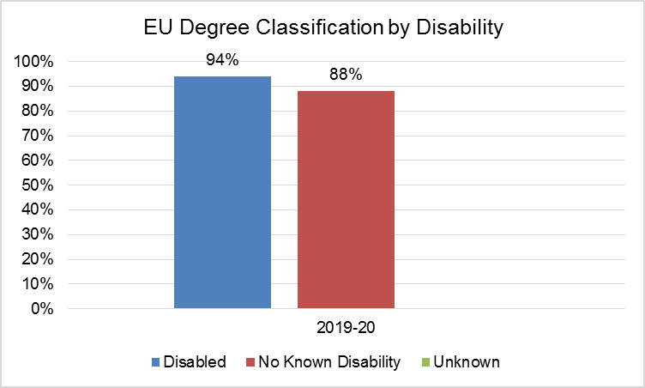

Disability | 2019-20
 | Number of Students Awarded I & II(i) | Number of classified degrees due to graduate | % Students Awarded I & II(i)
Disabled | 17 | 18 | 94%
No known disability | 197 | 224 | 88%
Unknown | 0 | 0

Commentary
The percentage of disabled EU UG students who were awarded a I or II(i) was 94%. The percentage of UG students with no known disability who were awarded a I or II(i) was 88%. The awarding gap is currently 6%.

Overseas Students
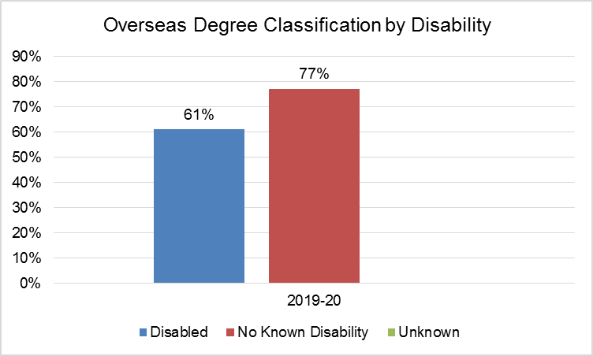

Disability | 2019-20
 | Number of Students Awarded I & II(i) | Number of classified degrees due to graduate | % Students Awarded I & II(i)
Disabled | 14 | 23 | 61%
No known disability | 555 | 722 | 77%
Unknown | 0 | 0

Commentary
The percentage of disabled Overseas UG students who were awarded a I or II(i) was 61%. The percentage of UG students with no known disability who were awarded a I or II(i) was 77%. The awarding gap is currently 16%.

Ethnicity

Home Students
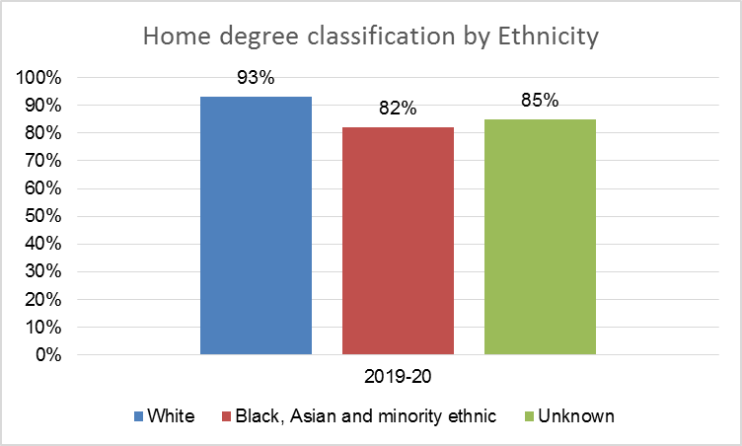

Ethnicity | 2019-20
 | Number of Students Awarded I & II(i) | Number of classified degrees due to graduate | % Students Awarded I & II(i)
White | 4101 | 4410 | 93%
Black, Asian and minority ethnic | 665 | 809 | 82%
Unknown | 58 | 68 | 85%

Commentary
The percentage of White Home UG students who were awarded a I or II(i) was 93%. The percentage of Black, Asian and minority ethnic UG students who were awarded a I or II(i) was 82%. The awarding gap is currently 11%.

EU Students
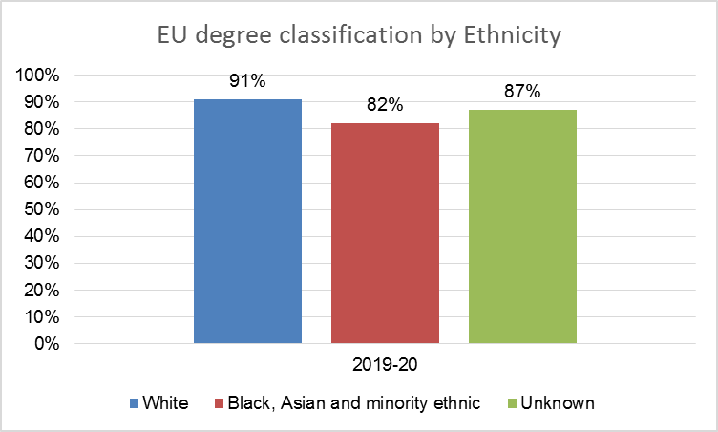

Ethnicity | 2019-20
 | Number of Students Awarded I & II(i) | Number of classified degrees due to graduate | % Students Awarded I & II(i)
White | 73 | 80 | 91%
Black, Asian and minority ethnic | 9 | 11 | 82%
Unknown | 132 | 151 | 87%

Commentary
The data are presented above, but there are low numbers of Black, Asian and minority ethnic students and high rates of non-disclosure.

Overseas Students
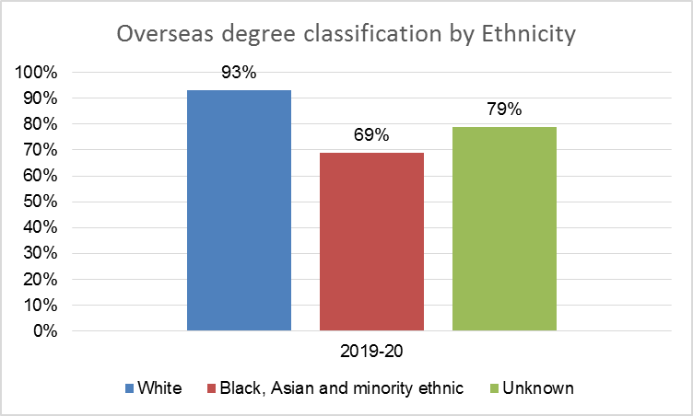

Ethnicity | 2019-20
 | Number of Students Awarded I & II(i) | Number of classified degrees due to graduate | % Students Awarded I & II(i)
White | 25 | 27 | 93%
Black, Asian and minority ethnic | 149 | 215 | 69%
Unknown | 395 | 503 | 79%

Commentary
The data are presented above, but there are low numbers of White students and high rates of non-disclosure.

Gender

Home Students
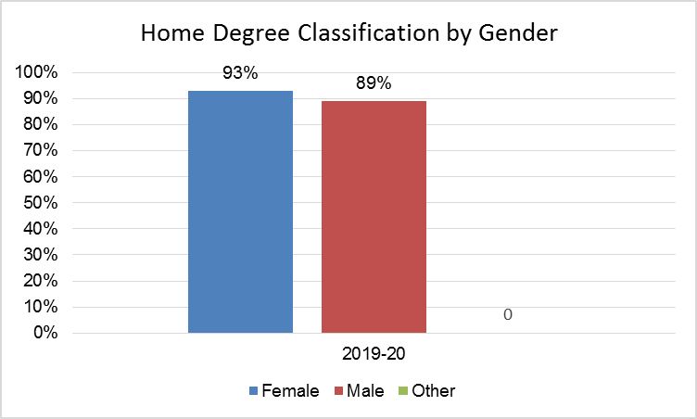

Gender | 2019-20
 | Number of Students Awarded I & II(i) | Number of classified degrees due to graduate | % Students Awarded I & II(i)
Female | 3011 | 3244 | 93%
Male | 1810 | 2038 | 89%
Other | 0 | 0

Commentary
The percentage of male Home UG students who were awarded a I or II(i) was 89%. The percentage of female UG students who were awarded a I or II(i) was 93%. The awarding gap is currently 4%. There were no students with other gender.

EU Students
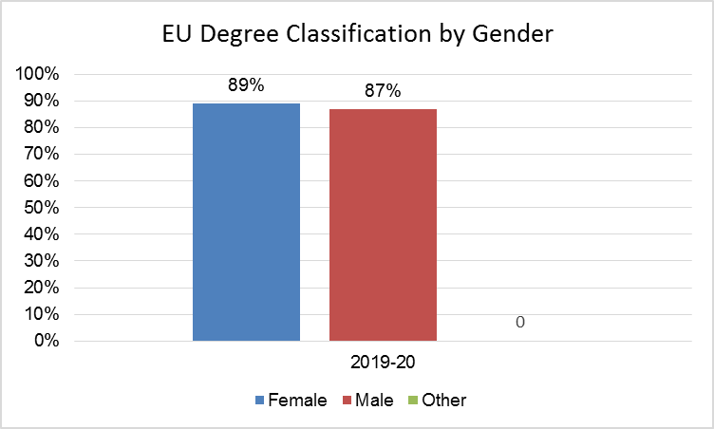

Gender | 2019-20
 | Number of Students Awarded I & II(i) | Number of classified degrees due to graduate | % Students Awarded I & II(i)
Female | 131 | 147 | 89%
Male | 83 | 95 | 87%
Other | 0 | 0

Commentary
The percentage of male EU UG students who were awarded a I or II(i) was 87%. The percentage of female UG students who were awarded a I or II(i) was 89%. The awarding gap is currently 2%. There were no students with other gender.

Overseas Students

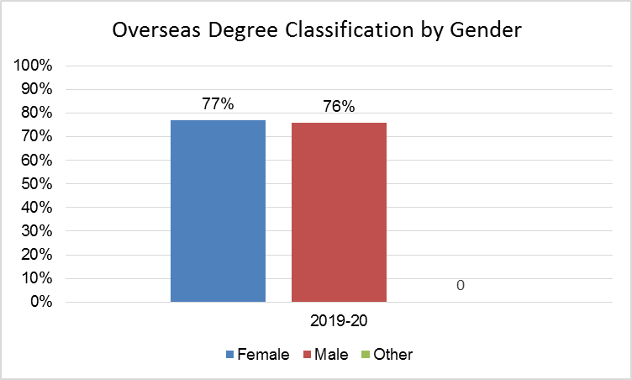

Gender | 2019-20
 | Number of Students Awarded I & II(i) | Number of classified degrees due to graduate | % Students Awarded I & II(i)
Female | 301 | 391 | 77%
Male | 268 | 354 | 76%
Other | 0 | 0

Commentary
The percentage of male Overseas UG students who were awarded a I or II(i) was 76%. The percentage of female UG students who were awarded a I or II(i) was 77%. The awarding gap is currently 1%. There were no students with other gender.

Disability is defined under the Equality Act 2010 as a physical or mental impairment that has a substantial and long-term negative effect on a person’s ability to carry out normal daily activities.

