University of Leeds - Academic staff in post by protected characteristic – 31 July 2020

Contents

Introduction 1
Age 2
Caring Responsibilities 3
Disability 4
Ethnicity 5
Gender 6
Religion or Belief 7
Sexual Orientation 8

Introduction
The following information provides data on academic staff in post at the University of Leeds as at 31 July 2020. The data are provided by the following protected characteristics: age; caring responsibilities; disability; ethnicity; gender; religion or belief and sexual orientation. The total academic staff headcount at 31 July 2020 was 3926.

The previous two years of data are provided for comparison.

Data are rounded to the nearest whole percent and therefore may not always total 100%.

Age

Age (years) | 2018 | 2019 | 2020 | % change (2018-2020)
Under 20 | 0% | 0% | 0% | -
20 - 29 | 8% | 8% | 7% | -1%
30 - 39 | 34% | 33% | 33% | -1%
40 - 49 | 27% | 27% | 28% | +1%
50 - 59 | 21% | 22% | 22% | +1%
60 + | 10% | 11% | 10% | -

Commentary
As outlined by the chart and table above, percentage changes across age ranges over the period shown have been minimal. There has been a 1% decrease in the percentage of academic staff in the 20-29 and 30-39 age categories and a 1% increase in the percentage of academic staff in the 40-49 and 50-59 age categories.

Caring Responsibilities

 | 2018 | 2019 | 2020 | % change (2018-2020)
Yes | 24% | 24% | 27% | +3%
No | 40% | 40% | 39% | -1%
Prefer not to answer | 12% | 11% | 9% | -3%
Unknown | 24% | 25% | 25% | +1%

Commentary

There has been a 1% decrease over the period shown of academic staff declaring they do not have any caring responsibilities and a 3% increase in the percentage of academic staff declaring that do have caring responsibilities. There has been a 3% decreased in staff preferring not to declare their caring responsibilities, and a 1% increase in the percentage of staff with Unknown caring responsibilities.

Disability

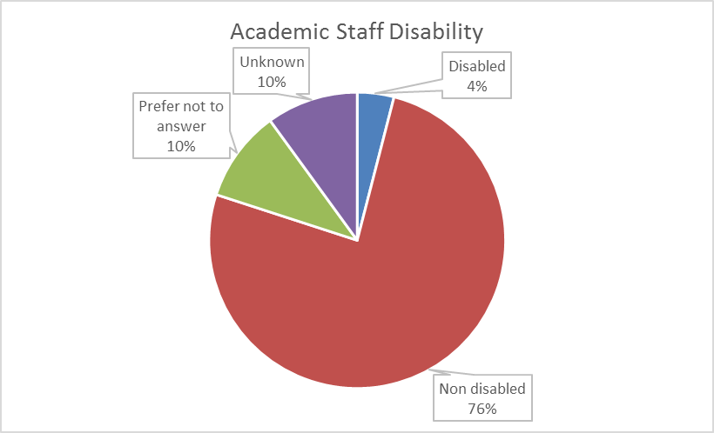

 | 2018 | 2019 | 2020 | % change (2018-2020)
Disabled | 3% | 3% | 4% | +1%
No known disability | 77% | 75% | 76% | -1%
Prefer not to answer | 13% | 11% | 10% | -3%
Unknown | 7% | 11% | 10% | +3%

Commentary
The percentage of academic staff declaring no known disability has decreased by 1% between 2018 and 2020. Over the same period, the percentage of undisclosed data amongst academic staff has remained constant at 20%.

Ethnicity

 | 2018 | 2019 | 2020 | % change (2018-2020)
BAME | 12% | 13% | 14% | +2%
-Black | - | - | 1% | -
-Asian | - | - | 9% | -
-Mixed | - | - | 2% | -
-Other | - | - | 2% | -
White | 68% | 66% | 65% | -3%
Prefer not to answer | 13% | 11% | 10% | -3%
Unknown | 8% | 10% | 10% | +2%

Commentary
The percentage of BAME academic staff has increased by 2% over the period shown, while the percentage of white academic staff has decreased by 3%. The level of non-disclosure has decreased from 21% to 20% throughout the period. Note, this year percentages are also provided for Black, Asian, Mixed and Other staff groups separately.

Gender

 | 2018 | 2019 | 2020 | % change 2018-2020
Female | 43% | 44% | 44% | +1%
Male | 57% | 56% | 56% | -1%
Gender fluid | - | - | 0% | -
Non binary | - | - | 0% | -
Other | - | - | 0% | -

Commentary
The percentage of female academic staff has increased by 1% during the period shown, and the percentage of male academic staff has decreased by 1%. Note, this year additional reporting categories were available; gender fluid, non binary and other. No academic staff are gender fluid or non binary and 9 are other, although this does not show in the above chart or table due to the rounding of percentages to the nearest whole number.

Religion or Belief

 | 2018 | 2019 | 2020 | % change 2018-2020
Buddhist | 1% | 1% | 1% | -
Christian | 21% | 20% | 20% | -1%
Hindu | 1% | 1% | 1% | -
Jewish | 1% | 1% | 1% | -
Muslim | 2% | 2% | 3% | +1%
Sikh | 0% | 0% | 0% | -
Spiritual | - | - | 0% | -
None | 34% | 34% | 37% | +3%
Other religion | 1% | 1% | 1% | -
Prefer not to answer | 15% | 14% | 13% | -2%
Unknown | 24% | 25% | 24% | -

Commentary
From 2018 to 2020 there has been 3% increase in the percentage of academic staff declaring they have no religion. There has also been a 1% decrease in the percentage of academic staff declaring that they are Christian and a 1% increase in the percentage of academic staff declaring that they are Muslim. There were seven academic staff who declared they are Sikh and six who declared they are Spiritual (new category), however, this is not shown in the above chart or table due to the rounding of data to the nearest whole percent. The percentage of non-disclosure has decreased during the period, from 39% to 37%.

Sexual Orientation

 | 2018 | 2019 | 2020 | % change 2018-2020
Bisexual | 1% | 1% | 1% | -
Gay man | 1% | 1% | 2% | +1%
Gay woman/ lesbian | 1% | 1% | 1% | -
Heterosexual | 56% | 56% | 58% | +2%
Other | 0% | 0% | 0% | -
Prefer not to answer | 16% | 15% | 13% | -3%
Unknown | 24% | 25% | 24% | -

Commentary
There has been little change over the period shown. There were 15 staff who declared their sexual orientation as Other, however, this is not shown in the above chart or table due to the rounding of data to the nearest whole percent. The percentage of non-disclosure has decreased by 3% since 2018 to 37%.

‘Academic staff’ includes roles such as: lecturer; senior lecturer; associate professor; professor; research fellow/assistant; teaching fellow; clinical; etc.
‘Defined as: caring for one or more children, one or more disabled children, a disabled adult, an older person, or another adult
Disability is defined under the Equality Act 2010 as a physical or mental impairment that has a substantial and long-term negative effect on a person’s ability to carry out normal daily activities.
BAME – Black, Asian and minority ethnic

