THE UNIVERSITY OF LEEDS
Equality & Inclusion Delivery Group
Council Chamber, Marjorie & Arnold Ziff Building
1:30–3:30pm, Thursday 20 February 2020
Attendees: Stephen Scott (SKS), Linda Mortimer Pine (LMP), Sabiha Patel (SP), Paul Taylor (PT), Sharif Patel (ShP), Ian Holdsworth (IH), Greig Sharman (GS), Amy Jennings (AJ), Simon Thompson (ST), Claire Owen (CO), Lizzie Cutts (LC), Sarah Ward (SW), Charlotte Axon (CA), Laura York (LY), Chloe Elliott (CE), Antonia Frezza (AF), Ian Robertson (IR), Yoselin Benitez Alfonso (YBA), Robert Adams (RA), Gillian Neild (GN), Chloe Elliott (CE), Lucinda Walker (LW), Helena Brown (HB), Chris Warrington (CW), Louise Banahene (LBa), Louise Bryant (LB), Vania Dimitrova (VD).
---------------------------------------------------------------------------------------------------------------
Agenda
- SKS welcomed the group.

- Notes from the previous meeting were discussed and updates on Actions were given. SP reported that the E&I training module completion rates will be shared with Heads of School/Service, since further progress also needs to be made on this in Professional Services. SKS confirmed that the E&I Board had agreed that the University should sign up to the Race at Work Charter and requested that the Delivery Group should now bring forward an action plan for this.

- SKS gave a presentation on the Chair’s report from the E&I Board (see Appendix 1). SKS confirmed that a draft of the new E&I Framework will be prepared by SP and will be presented to the next meeting of the E&I Board.

- Following the E&I Board’s agreement of the Race Equality Framework, the group began to identify specific actions that could be taken to deliver this Framework.
Action: Ideas were captured in the meeting. These will be distributed to the DG via Teams (Appendix 2) and be developed further at next meeting.

- The DG discussed how to further increase colleague engagement with E&I, specifically:
- How can we lead in enabling and supporting an environment in which any member of staff or students has confidence to challenge unacceptable behaviour?
- How can we enable open discussions on E&I issues within UoL?
Action: Ideas were recorded (Appendix 3) and will be distributed via Teams.
Action: All to take these questions to their own individual teams, brainstorm ideas and report back to the DG, in person or via Teams.
Action: EPU Update to be sent to all members of the Delivery Group.
Action: A working group to be established to look at the use of appropriate language and ways of challenging inappropriate behaviour. Initially, this will be co-ordinated by EPU but the expectation is that it will be led by a member/members of the DG. Interested colleagues to email equality@leeds.ac.uk

- AOB
LB invited members of the group to join the Athena SWAN self-assessment team, particularly male colleagues. IH is already a member.
Action: Interested colleagues can email l.d.bryant@leeds.ac.uk
GS highlighted a Women in Tech event on 9 March to be held in Nexus – details are at tinyurl.com/uzyczzd
YBA explained that there is an upcoming event on ‘Breaking Boundaries in STEM: Imposter Syndrome’, on 18 March. Details can be found here: tinyurl.com/qs4k4o4

- Date of the next meeting: Tuesday 31 March, 10am -12 noon.
ACTION POINTS SUMMARY
Action | Who
Ideas to deliver the Race Equality Framework to be put on Teams. | EPU
Ideas to increase colleague engagement with E&I to be put on Teams | EPU
All to take these comments/questions to their own individual teams, brainstorm ideas and report back to the DG, in person or via Teams. | All
EPU Update to be sent to all members of the DG. | EPU
A working group to be established to look at the use of appropriate language and ways of challenging inappropriate behaviour. Initially, this will be co-ordinated by EPU but the expectation is that it will be led by a member/members of the DG. Interested colleagues to email equality@leeds.ac.uk | EPU  All
Members of the DG were invited to join the Athena SWAN self-assessment team, particularly male colleagues. Interested colleagues can email l.d.bryant@leeds.ac.uk | All

APPENDIX 1

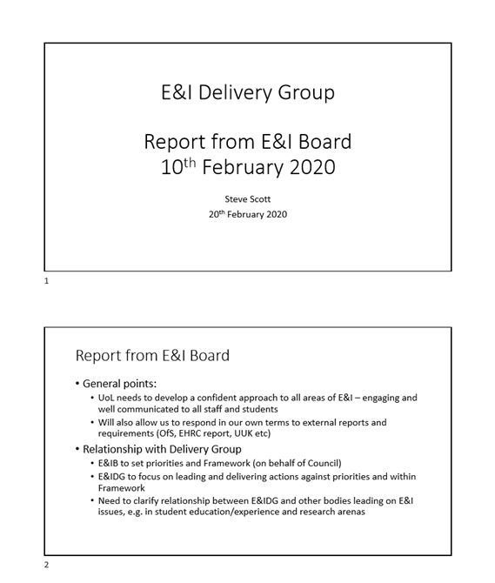

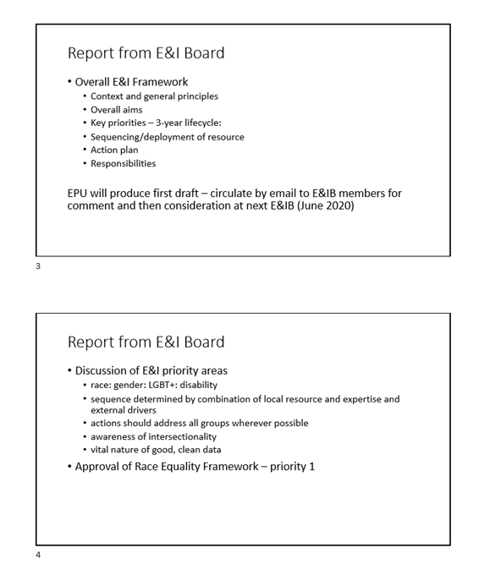

APPENDIX 2 – RACE EQUALITY ACTION PLAN
Embedding inclusion into everyday practice
- Share the Race Equality Framework with local leadership teams and create a local plan to embed the Framework into the way we work
- Gather experiences of our leaders from under-represented groups
- Recognise our responsibility to speak up for others
- Actively support any E&I campaign
- Celebrate diversity across whole of UoL
Staff: recruitment
- Put inclusivity at the heart of the recruitment process.
- Ask people about their values when recruiting for posts/committee membership: ‘What’s your commitment to inclusivity. How do UoL’s values speak to you?’
- Question whether academic recruitment styles disadvantage individuals from professional services backgrounds
Staff: policies and practices
- Create a handbook to guide behaviours, framed in a positive way, which helps people to do the right thing and establishes trust, acknowledging that everyone is on a learning journey and innocent mistakes are sometimes made. It would address difficult conversations; how to be a good ally; how to address poor conduct/offensive language in meetings; guidance on acceptable/appropriate and unacceptable/outdated language
- Harassment/hate crimes – establish clear and effective reporting / feedback mechanisms for sexual and racial harassment and communicate these to staff and students
- Encourage colleagues to report inappropriate behaviours
- Closing the feedback loop in reporting processes, where possible, so the impact of reporting is known
Staff: people development
- Consider how we select people for our leadership programmes
- Ensure that colleagues are aware of personal development opportunities available to them
- Mentoring / reverse mentoring to support greater inclusion
- Lead a workshop for Unison members/colleagues on equality
- Development of a behavioural competency framework
- Move away from the same people always being involved (although not at their exclusion)
Students
- Revisit Partnership Awards with LUU; are they still valid (focus on E&I)?
- Take responsibility for leading on E&I in the student journey/ experience
- Develop inclusivity training for students

APPENDIX 3: How to further increase colleague engagement with E&I
Enabling and supporting an environment in which staff and students have confidence to challenge unacceptable behaviour
- Genuine modelling of behaviours – leading by example. We need to be leaders challenging unacceptable behaviours and being comfortable being challenged ourselves
- Create a handbook to guide behaviours, framed in a positive way, which helps people to do the right thing and establishes trust, acknowledging that everyone is on a learning journey and innocent mistakes are sometimes made. It would address difficult conversations; how to be a good ally; how to address poor conduct/offensive language in meetings; guidance on acceptable/appropriate and unacceptable/outdated language
- Encourage colleagues to report inappropriate behaviours
- Yellow card (pause card) – used in labs, how could it be used in E&I?
- Effectively communicate and promote the reporting mechanisms for sexual and racial harassment to staff and students
Enabling open discussions on E&I issues
- Find ways to bring even more people into the discussion around E&I
- Introduction of an E&I communication strategy
- Put E&I as a standing item on all agendas
- Mutual respect; having an inclusive culture that encourages open discussions around E&I
- Our Values – being more visible, on staff cards/ lanyards
- Be an active listener
- Chairing meetings – provide guidance to chairs to set the tone and check that everyone is comfortable, can hear; encourage ‘check in’ at the beginning of meetings to establish positive, inclusive attitude and atmosphere
- Raise visibility, eg, VC Award for E&I – use H&S model as an example of a good campaign
- We need more engaging E&I material, less formal, more variety, focus on the content, copy and messaging, eg, short 30-second videos, punchy/engaging straplines.
- Actively support any E&I campaign
- Recognise own ability to influence
- Deliver! Take action, don’t wait for perfection

