Department Application

Bronze and Silver Award

**Faculty of Engineering  
University of Leeds**

ATHENA SWAN BRONZE DEPARTMENT AWARDS

Recognise that in addition to institution-wide policies, the department is working to promote gender equality and to identify and address challenges particular to the department and discipline.

# Athena SWAN Silver DEPARTMENT awards

In addition to the future planning required for Bronze department recognition, Silver department awards recognise that the department has taken action in response to previously identified challenges and can demonstrate the impact of the actions implemented.

Note: Not all institutions use the term ‘department’. There are many equivalent academic groupings with different names, sizes and compositions. The definition of a ‘department’ can be found in the Athena SWAN awards handbook.

# Completing the form

Do not attempt to complete this application form without reading the Athena SWAN AWARDS handbook.

This form should be used for applications for Bronze and Silver department awards.

You should complete each section of the application applicable to the award level you are applying for.

|  |
| --- |
| Additional areas for Silver applications are highlighted throughout the form: 5.2, 5.4, 5.5(iv) |
|  |

If you need to insert a landscape page in your application, please copy and paste the template page at the end of the document, as per the instructions on that page. Please do not insert any section breaks as to do so will disrupt the page numbers.

# Word count

The overall word limit for applications are shown in the following table.

There are no specific word limits for the individual sections and you may distribute words over each of the sections as appropriate. At the end of every section, please state how many words you have used in that section.

We have provided the following recommendations as a guide.

|  |  |
| --- | --- |
| Department application | Silver |
| Word limit  *Extra word allowance* | 12,000  1,000\* |
|  |  |
| 1.Letter of endorsement | 600 |
| 2.Description of the department | 416 |
| 3. Self-assessment process | 1,011 |
| 4. Picture of the department | 2,378 |
| 5. Supporting and advancing women’s careers | 7,140 |
| 6. Case studies | 954 |
| 7. Further information  Total used  \* ***Extra words allowance is used in section 4 and section 5 to elaborate discipline/school differences (see email below)*** | 484  **12,983** |
|  |  |

**From:** Athena Swan <Athena.Swan@advance-he.ac.uk>   
**Sent:** 05 March 2019 11:50  
**To:** [Redacted], Athena Swan <Athena.Swan@advance-he.ac.uk>  
**Subject:** RE: application for extended word limit

Dear [Redacted],

Thank you for your email. We are happy to grant an additional 1,000 words for the Faculty of Engineering’s upcoming submission in order to provide discipline/school-specific data and analysis.

Please include this email in your submission as confirmation and state in the submission where the additional words have been used.

Best wishes,

[Redacted]

[Redacted]

Equality Charters Adviser

[Redacted]

C:\Users\imash\AppData\Local\Microsoft\Windows\INetCache\Content.MSO\E635EBB9.tmp

This e-mail along with any attachment(s) is strictly confidential and may contain privileged information. It is intended solely for the intended recipient(s). If you are not the intended recipient, please do not disclose, store, copy, take any action or omit to take any action in reliance of its contents: to do so is strictly prohibited and may be unlawful. If you have received this e-mail in error, please notify the sender and delete the e-mail immediately. Views expressed in this e-mail are those of the author and do not necessarily represent those of Advance HE. Please note that this e-mail has been created in the knowledge that Internet e-mail is not a secure communications medium. We advise that you understand and observe this lack of security and take any necessary measures when e-mailing us. Although we have taken steps to ensure this e-mail and attachment(s) are free from any virus, we advise that in keeping with good computing practice, the recipient should ensure that they are actually virus free as Advance HE will not be liable for any losses as a result of any viruses being passed on by this e-mail and/or any attachment(s). Advance HE. Company limited by guarantee registered in England and Wales no. 04931031. Registered as a charity in England and Wales no. 1101607. Registered as a charity in Scotland no. SC043946.

**From:** [Redacted]   
**Sent:** 05 March 2019 11:30  
**To:** [athenaswan@ecu.ac.uk](mailto:athenaswan@ecu.ac.uk)  
**Subject:** application for extended word limit

Dear Advanced HE,

I am writing to you on behalf of the University of Leeds’ Faculty of Engineering Athena SWAN self-assessment team, to request consideration of an extended word limit. The Faculty of Engineering consists of five different schools, and has in excess of 700 staff. The problems that each school face are very different due to the diversity of cultures and research areas, with female representation across staff and student groups varying significantly as a result. Given our size we also have complex management and communication structures which are integral to the Equality work we do. We believe an extra 1,000 words would help us explain how we consider this variance and complexity in our analysis and action plan to the required level of detail, for example to evaluate school specific issues and appropriate actions in response to these.

Best wishes,

[Redacted]

|  |  |  |
| --- | --- | --- |
| Name of institution | **University of Leeds** |  |
| Department | **Faculty of Engineering** |  |
| Focus of department | STEMM |  |
| Date of application | **April 2019** |  |
| Award Level | Silver |  |
| Institution Athena SWAN award | Date: April 2016 | Level: Bronze |
| Contact for application  Must be based in the department | **Dr Vania Dimitrova** |  |
| Email | **v.g.dimitrova@leeds.ac.uk** |  |
| Telephone | **0113 343 1674** |  |
| Departmental website | **https://engineering.leeds.ac.uk/** |  |

## Letter of endorsement

*An accompanying letter of endorsement from the head of department should be included. If the head of department is soon to be succeeded, or has recently taken up the post, applicants should include an additional short statement from the incoming head.*

AdvanceHE

First Floor, Westminster Tower

3 Albert Embankment

London

SE1 7SP

Dear Athena SWAN assessors,

I am delighted to offer my full support for this application. As Executive Dean, Chair of the Faculty Equality and Inclusion Committee and a member of the Self-Assessment Team (SAT) I have actively promoted the Athena SWAN (AS) agenda since 2010 when I established our first SAT. I sincerely believe that in the three years since receiving our Silver award we have continued to make significant progress: both in embedding AS within our increasingly holistic equality, diversity and inclusivity (EDI) agenda, and in leveraging our AS actions as a catalyst for this broader EDI programme. Furthermore, I have observed a remarkable change in culture across the Faculty as the benefits of diversity have become universally accepted and the considerations required to support this are embraced. I am grateful for the leadership shown by my colleagues on the SAT and on the Faculty Executive team for enabling this culture shift.

Our commitment to attracting girls to take STEM subjects at School and to consider degrees in Engineering and Computing has led us to invest significantly into a wide range of outreach activities – only some of which can be described in the space available here. Combined with extensive use of role models and carefully planned Web and marketing materials, this has helped us to exceed national benchmarks for female UG students. We believe that we can build further on this: to do even better in UG recruitment and to improve our PGT gender balance.

The transition from taught student to researcher was a key priority in our last AS action plan and I am very proud of the progress that we have made in the past three years. Through multiple actions, including sharing best practice from our EPSRC Centres for Doctoral Training (each with substantial female leadership), we have continued to ensure that our proportion of female PGR students exceeds national benchmarks. Furthermore, we have significantly increased the number and proportion of female research staff within the Faculty: both overall and those at more experienced/independent grades. Similarly, the proportion of female Lecturers and Academic Fellows has grown substantially over this period: primarily the result of actions taken to increase the number of women applicants (evidence suggests that our appointing processes are unbiased). Our updated action plan now adds even more focus to supporting the career development of all staff, to ensure that the proportion of females at the highest grades continues to increase.

We have an ambitious action plan for the coming three years, however we have the commitment, leadership, culture and resources to deliver the proposed outcomes. Investment in AS and EDI is supported by a dedicated budget of £6000 (reviewed annually based on demand), which supports caring support (e.g. travel/conferences), events (e.g. Breaking Boundaries in STEM) and materials (e.g. Mutual Respect; Footsteps booklet). In addition a dedicated 11-month internship (data capture and analysis) has been supported and we have further budgets for staff development (e.g. Aurora), outreach and widening participation.

Our action plan builds upon many initiatives and activities already underway: and described in this document. In Section 3(iii) we explain how our Faculty will be expanded over the coming 18 months to include Mathematics and Physical Sciences (MAPS), and our plans for managing AS through this process, supported by an EDI-officer starting September 2019. Both MAPS and Engineering have allocated funding for an AS project support post into the next 5 years (0.5 FTE, Grade 6).

The information presented in the application (including qualitative and quantitative data) is an honest, accurate and true representation of the Faculty.



Professor Peter Jimack

Faculty of Engineering Executive Dean

**Word count: 600**

Glossary of acronyms used within the submission document

|  |  |
| --- | --- |
| AAM = Annual Academic Meeting  ASEI = Athena SWAN, Equality and Inclusion  AS-chair = Faculty Athena SWAN chair  ART = Academic, Research and Teaching  CAPE = School of Chemical Engineering  CDT = Centre for Doctoral Training  CIVE = School of Civil Engineering  COMP = School of Computing  DoRI = Director of Research and Innovation  DoSE = Director of Student Education  ELEC = School of Electrical and Electronic Engineering  EDI = Equality, Diversity and Inclusion  EDI-officer = Equality, Diversity and Inclusion officer  EI-coordinator = Faculty Equality and Inclusion coordinator  E&I = Equality and Inclusion  EPSRC = Engineering and Physical Sciences Research Council  EPU = Equality Policy Unit  FEC = Faculty Executive Committee  FoE = Faculty of Engineering  HoS = Head of School  HR = Human Resources  EAB = External Advisory Board | EPSRC = Engineering and Physical Sciences Research Council  L&M = Leaders and Managers  MAPS = Mathematics and Physical Sciences  MECH = School of Mechanical Engineering  OD&PL= Organisational Development & Professional Learning  PGR = Postgraduate research  PGT = Postgraduate taught  PI = Principal Investigator  CI = co-investigator  PMF = People Management Framework  PMG = Project Management Group  PSS = Professional and support staff  REF = Research Excellence Framework  SAT = Athena SWAN Self-Assessment Team (= FoE Athena SWAN, Equality and Inclusion committee)  SES = Student Education Services  SRDS = Staff Review and Development Scheme  UAF = University Academic Fellow  UG = Undergraduate  UKRI = UK Research and Innovation  UoL = University of Leeds  UTC = University Technical College  WG = Working Group |

Symbols used within the submission document

|  |  |
| --- | --- |
|  | Positive impact of our Athena SWAN actions. |
|  | Possible beacon and the corresponding action set to enable this. |
|  | Further investigation conducted (focus groups/surveys/interviews) to gain deeper understanding |
| Action#.#[C] | Continues from 2016 Athena SWAN silver action plan, positive effect noted |
| Action#.#[N] | New (or significantly revised) action, added to address outstanding issues |
| Silver-2016-Action | 2016 Athena SWAN Silver Action Plan, impact realised, action no longer needed |

## Description of the department

### Recommended word count: Bronze: 500 words | Silver: 500 words

*Please provide a brief description of the department including any relevant contextual information. Present data on the total number of academic staff, professional and support staff and students by gender.*

The Faculty of Engineering (FoE) is one of the eight faculties of the University of Leeds. FoE is amongst the largest engineering groupings in the UK, with over 650 staff and 5,000 students (Table#2.1) from >70 countries, and an annual turnover of ~£100M in 2018/19.

**FOE includes 5 Schools:**

* Chemical and Process Engineering (CAPE);
* Civil Engineering (CIVE);
* Computing (COMP);
* Electronic and Electrical Engineering (ELEC);
* Mechanical Engineering (MECH).

Table 2.1: Staff and student population in the Faculty of Engineering in June 2018.

|  |  |  |  |
| --- | --- | --- | --- |
|  | **Number Female** | **Number Male** | **Percentage Female** |
| **Academic staff** | 38 | 182 | 17.3% |
| **Research staff** | 44 | 133 | 24.9% |
| **Teaching staff** | 3 | 23 | 11.5% |
| **Support staff - P&M** | 33 | 18 | 64.7% |
| **Support staff - Clerical** | 85 | 21 | 80.2% |
| **Support staff - Technical** | 8 | 73 | 9.9% |
| **Total staff** | 211 | 450 | 31.9% |
| **Students – UG** | 835 | 3131 | 21.1% |
| **Students – PGT** | 198 | 616 | 24.3% |
| **Students – PGR** | 162 | 376 | 30.1% |
| **Total students** | 1195 | 4123 | 22.5% |

|  |  |
| --- | --- |
|  |  |

Figure 2.1: Screen shot of the Faculty’s research web page and an image showing the Faculty physical space in late 2020 – completion of UoL capital investment project brining COMP in close physical proximity to the other four schools (CAPE, CIVE, ELEC, MECH).

FoE is led by the Dean, supported by Pro-Deans for Research, Student Education and Internationalisation. Schools have similar management structures, comprising Head of School (HoS), Director of Research and Innovation (DoRI) and Director of Student Education (DoSE). Overarching academic, finance, HR, marketing, research, health-and-safety, and EDI are managed at FoE level. Teaching and research are supported by state-of-the-art FoE facilities, e.g. Leeds Electron Microscopy and Spectroscopy Centre, EPSRC National Facility for Innovative Robotic Systems, Bragg Centre for Materials Research.

**FoE research** covers core engineering disciplines and cross cutting themes such as energy, materials, medical engineering and robotics. Work in all areas combines theoretical, experimental and translational research. Within schools, research areas/sub-disciplines are grouped and led by senior academics. FoE is engaged in cross-university interdisciplinary research with leadership roles in several flagship initiatives, including: water@leeds, Centre for Global Development, Self-Repairing Cities, Leeds Institute for Fluid Dynamics.

**Interdisciplinary doctoral training** is a key strength with EU Initial Training Networks (3 coordinator, 2 partner) and EPSRC Centres for Doctoral Training (CDTs). Currently, FoE is involved in 7 new CDTs (4 coordinator; 3 partner); there are additional 6 CDTs that are still running but no longer recruiting (3 coordinator, 3 partner). All CDTs have EDI strategies, action plans and aspire to be beacons for diversity.

Most **Learning and Teaching** is intra-School, following common approaches and processes. Programme leaders coordinate degree programmes, reporting to DoSE. FoE follows University of Leeds best practice in supporting “students from all backgrounds to achieve consistently outstanding outcomes” (University TEF Gold). A dedicated Employability Team provides businesses with access to our talented engineering and computing students through a free end-to-end, managed recruitment service, as well as supporting all students in their preparations for employment applications. FoE outreach manager unifies the various outreach activities of each school. These FoE-wide structures foster engagement across schools and ensures embedding of the Faculty and University policies and best practice.

**Collaboration with industry and public sector** in research (e.g. Medical Technologies, Robotics, Data Analytics) and teaching (e.g. degree apprenticeship with PWC, industry-supported hackathons, placements), enables experience sharing and effort optimisation to influence the sector.

**Word count: 416**

## The self-assessment process

### Recommended word count: Bronze: 1000 words | Silver: 1000 words

*Describe the self-assessment process. This should include:*

#### a description of the self-assessment team

The Self-Assessment Team (SAT, Table#3.1) comprises **32 (22 female, 10 male) staff and students** from across the FoE and a representative from UoL Equality Policy Unit (EPU) - 12 members have children; 11 have staff management/support responsibilities; 8 have worked part-time or taken career breaks.

**SAT representation was broadened** (Silver-2016-Action) to include:

* representatives with management responsibilities (from Faculty services);
* broad staff and student representation (Table#3.2);
* representation by each school (Table#3.3);
* diverse characteristics to enable integrated AS and Equality & Inclusion (ASEI) (Table#3.4).

Consulting with HoS and SAT members, men and women with a range of experiences, and awareness of challenges faced by underrepresented groups, were nominated. Student representatives were recruited on a voluntary basis, responding to open invitations by DoSEs: all volunteers were invited to the student working group (see below) and two representatives joined the SAT.

Implementing Silver-2016-Action, **SAT participation is recognised in the workload** for those with key roles (20% AS-chair; 10% EI-coordinator; 10% - school ASEI champions); **SAT memberships is recognised in the activities of all SAT members** (e.g. during SRDS, promotion, reward recognition).

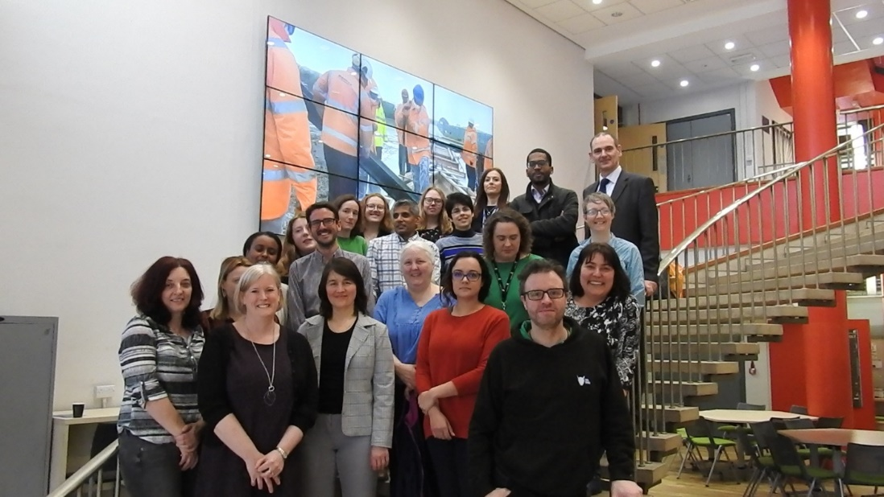

Figure 3.1: Representatives of the Faculty Athena SWAN SAT (Athena SWAN, Equality and Inclusion committee).

Table 3.1: SAT members: SAT is de facto the Faculty’s Athena SWAN, Equality and Inclusion Committee (ASEI), which underpins our integrated ASEI approach.

| **Name  Job title** | **[Gender, Department]**  **Role in SAT** | **Additional information** |
| --- | --- | --- |
| **Andrew Bayly** Professor | [M, CAPE]  CAPE champion | [Redacted] |
| **Emily Bryan-Kinns**  CDT support officer | [F, CAPE] CDT managers representative | [Redacted] |
| **Gaynor Butterwick** Administration Manager | [F, COMP]  PSS representative | [Redacted] |
| **Netta Cohen** Professor | [F, COMP] COMP champion | [Redacted] |
| **Raelene Cowie** Research fellow | [F, MECH] Research staff representative | [Redacted] |
| **Vania Dimitrova** Associate Professor | [F, COMP]  AS-chair,  ASEI committee co-chair | [Redacted] |
| **Fleur Doidge** Administration manager | [F, CAPE]  PSS representative | [Redacted] |
| **Natalie Duffield-Moore** Faculty outreach manager | [F, FoE] Faculty outreach lead | [Redacted] |
| **David Elliott** Technician | [M, CIVE]  PSS WG co-lead | [Redacted] |
| **Victor Enendu** UG Student | [M, MECH] Student representative | [Redacted] |
| **Taisir Elgorashi** Lecture | [F, ELEC] ELEC champion | [Redacted] |
| **Polly Fahey** PGR student | [F, COMP] Student representative | [Redacted] |
| **Emilio Garcia-Taengua** Lecturer | [M, CIVE]  CIVE AS-champion; industry partnership lead | [Redacted] |
| **Penny Hindle** UG student | [F, COMP] Student representative | [Redacted] |
| **Ornella Iuorio** Lecturer | [F, CIVE]  Student WG lead;  CIVE champion | [Redacted] |
| **Louise Jennings** Associate Professor | [F, MECH]  ART staff WG lead;  MECH champion | [Redacted] |
| **Peter Jimack** FoE Executive Dean | [M, FoE/COMP]  ASEI committee co-chair | [Redacted] |
| **Sandra Kitchingman** HR officer | [F, FoE]  HR rep; PMG member | [Redacted] |
| **Beth Lavery** Equality and Inclusion officer | [F, FoE]  Data collection/analysis; organisation support | [Redacted] |
| **Joanna Leng** EPSRC Research Software Engineering fellow | [F, COMP]  Research staff representative | [Redacted] |
| **James McKay** CDT manager | [M, CAPE]  CDT managers representative | [Redacted] |
| **Mohamed Musa** Research fellow | [M, ELEC] Research staff representative | [Redacted] |
| **Cath Noakes** Professor | [F, CIVE]  Faculty research strategy | [Redacted] |
| **Ekaternia Orlova** Researcher Fellow | [F, ELEC]  Research staff representative | [Redacted] |
| **Karen Steenson** FoE Research & Innovation Service Manager | [F, FoE]  PSS WG co-lead | [Redacted] |
| **Paul Steenson** Senior lecturer | [M, ELEC] Union representative | [Redacted] |
| **Heather Swinsco** HR officer | [F, FoE]  HR rep; PMG member | [Redacted] |
| **Briony Thomas** Lecturer | [F, MECH]  EI-coordinator | [Redacted] |
| **Jordan Thomas**  Lead technician | [M, MECH] PSS representative | [Redacted] |
| **Becky Whitaker** Education Service Functional Manager | [F, FoE]  SES rep; PMG member | [Redacted] |
| **Nagitha Wijayathunga** Research Fellow | [M, MECH]  Research staff representative | [Redacted] |
| **Sarah Ward** Equality & inclusion adviser | [F, University EPU]  EPU representative | [Redacted] |

Table 3.2: SAT diversity: number of people in each staff and student category.

|  |  |  |  |  |  |  |  |  |
| --- | --- | --- | --- | --- | --- | --- | --- | --- |
| **Academic and Research Staff** | | | | **Professional and Support staff** | | | **Students** | |
| Prof | Assoc.Prof | Lecturer | Research | Technical | Manag | Clerical | PGR | UG |
| 4 | 3 | 4 | 5 | 2 | 8 | 3 | 1 | 2 |

Table 3.3: SAT diversity: number of members by School.

|  |  |  |  |  |  |
| --- | --- | --- | --- | --- | --- |
| **FoE or EPU** | **School** | | | | |
| CAPE | CIVE | COMP | ELEC | MECH |
| 8 | 4 | 4 | 6 | 4 | 6 |

Table 3.4: SAT diversity: number of people with self-reported protected characteristics.

|  |  |  |  |
| --- | --- | --- | --- |
| **Has caring** | **Identify as** | **Identify as** | **Identify as** |
| **responsibilities** | **BAME** | **LGBT** | **having disability** |
| 12 | 4 | 3 | 4 |

#### an account of the self-assessment process

FoE AS activity started in 2010, aspiring to provide an inclusive working and learning environment, where everybody feels welcome and equally supported to achieve their full potential (**AS-Bronze-2013, AS-Silver-2016**). Consequently, we broadened our inclusive culture across all staff/student categories and in all our activities, and set aspirations to promote our good practice beyond the Faculty. At an **ASEI awayday (Nov-2018)**, we reviewed the impact of our actions, revised the action plan, and decided to apply for **renewal of our silver award**. We have also laid foundations of **potential beacon activities**.

**Since our AS-Silver-2016**, we set to promote/support women along the entire engineering career pipeline, from students to leaders. We enlisted female representation across this pipeline to provide support for the key transition points; we devised and implemented actions to address gender imbalances in all student and staff categories; we engaged students, staff and Faculty/School leadership in the co-creation of a series of activities for inclusive culture and equitable support; we engaged with external partners (University, region, private & public sector) to contribute to diverse engineering.

Following the AS-silver award, a strategic decision was taken by the SAT team, supported by FoE leadership, to **integrate our Athena SWAN and Equality and Inclusion** (ASEI) activities. We use **Athena SWAN as a catalyst** to develop and deliver a sustained EDI agenda targeting gender and other protected characteristics. This improved engagement and adoption of AS by our diverse staff and students. For instance, our student culture survey explored challenges faced by students relating to gender, ethnicity and sexuality. Our Breaking Boundaries in STEM events and the Footsteps booklet include a broad range of inspirational role models. Our Mutual Respect campaign is similarly aimed at benefiting everybody (Section#5.6).

**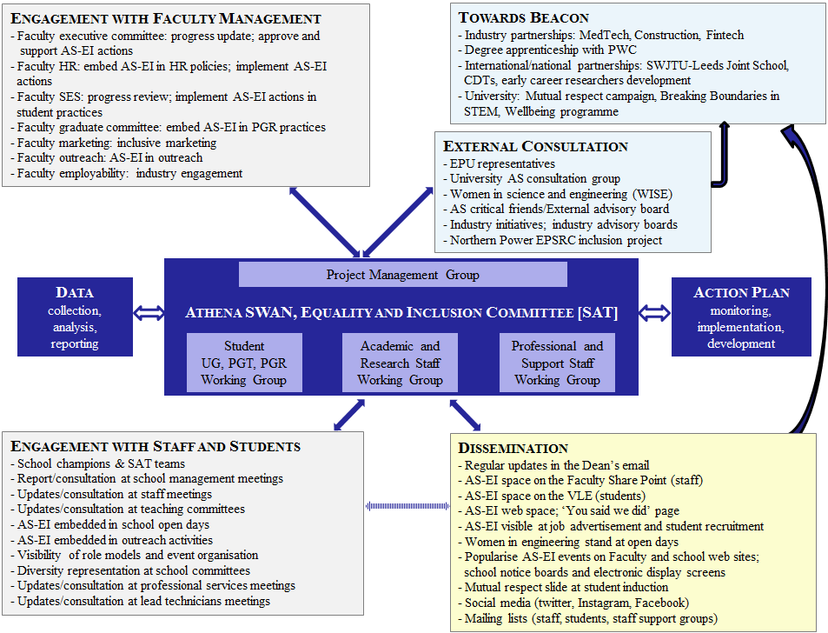**

Figure 3.2: Faculty of Engineering ASEI holistic structure: ASEI committee (SAT) and working groups, internal faculty engagement, external consultation, wide dissemination and influence.

The ASEI Committee, co-chaired by Dean & AS-chair, is structured as follows (Figure#3.2).

**The Project Management Group (PMG) -** provides strategic guidance, overall coordination and concrete steps in progressing actions. PMG ensures actions are taken up appropriately inside and outside the ASEI team, by ASEI team members (for School actions), by dissemination to working groups (via the AS-chair and EI-coordinator, who attend all working group meetings), or by Faculty- or University-level committees. PMG includes Dean, AS-chair, EI-coordinator, SES and HR representatives.

**Three working groups** deal with operational aspects - review action-progress, identify critical delays/omissions, review relevant data in progress and recommend forward steps. Staff/students outside ASEI are invited, when needed.

* **Student Working Group**, lead [Redacted] – focuses on student-related actions; SWG engages all student volunteers (12 students), SES/marketing/admissions/outreach representatives, and the school champions.
* **Academic and Research staff**, lead [Redacted] – focuses on the actions related to academic, research & teaching staff, including early career researchers (postdocs and PGR students); ARWG includes all school champions, postdoc and PGR representatives.
* **Professional and Support staff**, co-leads [Redacted] - analyses issues faced by PS & technical staff (based on their experience, staff data, and focus groups), reviewed/extended the action plan. PSWG includes broad PS & technical staff representation.

The WGs and ASEI committee **meet every three months** (groups meet between ASEI committee meetings), group leads and school champions report at the ASEI committee meetings, meeting minutes are **available to all staff on SharePoint**, further information is provided in **a dedicated EDI SharePoint space**.

**Broad engagement structure** is followed (Figure#3.2):

**Faculty management engagement** is implemented via representatives in ASEI: Executive Dean; HR (implementing/revising staff-related actions and influencing HR policies); SES (implementing/revising student-related actions and influencing student practice). The AS-chair regularly attends FEC to report on key issues and discusses ways to address them at a FoE level with FEC support. The Action Plan was discussed with/approved by FEC and HR management.

**Engagement with schools** is via the School Champions CAPE([Redacted]), CIVE([Redacted]), COMP([Redacted]), ELEC([Redacted]), MECH([Redacted]) to engage with schools, gather staff feedback, and implement actions involving their School. Champions engage with the School Management Teams and discuss ASEI activities at staff meetings.

* **External engagement** with UoL, industry, and broader academic community allow us to seek advice and explore opportunities to **“beacon” our actions**.

A sustained **data collection** approach is implemented (Table#3.3), providing regular reports to the working groups, ASEI committee, Faculty and School management**.**

Table 3.3: Summary of our Athena SWAN, equality and inclusion data collection and analysis used for monitoring and development of our action plan.

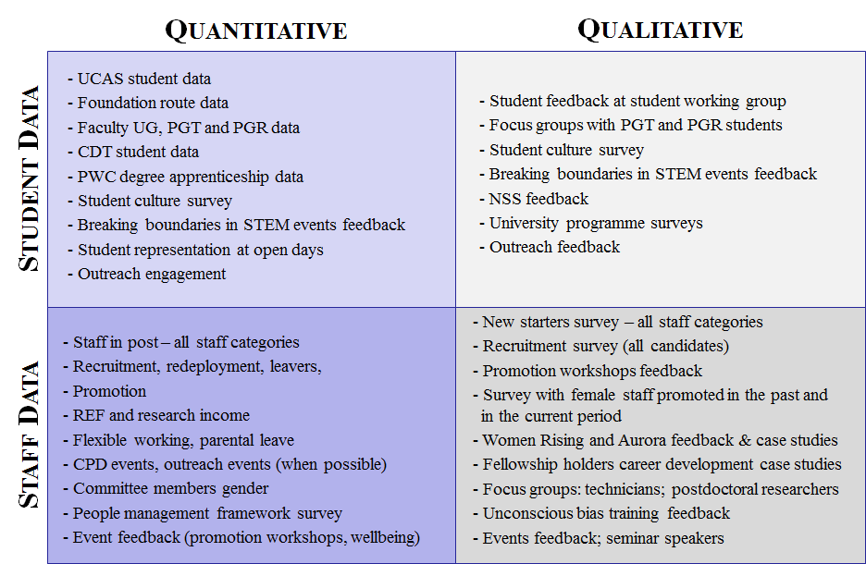

#### Plans for the future of the self-assessment team

From Aug-2019, the five FoE schools and three MAPS schools will create a new Faculty of Engineering and Physical Sciences with a transition year to Aug-2020. An important element of this transition will be the integration of our AS processes and action plans, to create a combined SAT and an aligned Faculty action plan (from 2020-21).

We will follow our existing model, outlined in (ii), until the combined approach is formed, then expect the new model to follow our integrated ASEI approach, implemented by an SAT (=ASEI committee, meeting every 3 months) and working groups (meeting between) to ensure timely response to Faculty-level challenges and sharing experience and best practice between schools. We plan to:

* follow our internal and external engagement model (**Action#5.5[C]**);
* continue regular data collection-analysis-reporting (**Action#5.6[C]**) to support our planned actions;
* review SAT membership annually (**Action#5.8[C]**), expand to ensure diversity (**Action#5.9[N]**);
* form an external advisory board for strategic direction (**Action#5.10[N]**).

**Word count: 1011**

|  |  |
| --- | --- |
| **Action#5.5[C]** | Follow the established engagement model to connect with the relevant structures within the Faculty and University; continuously monitor EIAS engagement to improve effectiveness. |
| **Action#5.6[C]** | Ensure robust data monitoring and reporting processes. |
| **Action#5.7[C]** | Ensure equality activities are adequately resourced. |
| **Action#5.8[C]** | Annually review Faculty SAT membership and activities to ensure effective progress is made with the action plan. |
| **Action#5.9[N]** | Extend School SATs to include diverse staff and students and engage with the appropriate school structures. |
| **Action#5.10[N]** | Establish ASEI external advisory board. |

## 4. A picture of the department

### Recommended word count: Silver: 2000 words

*If courses in the categories below do not exist, please enter n/a.*

## 4.1. Student data

UCAS student data for each School is compared with the national average for the core discipline in the School. The average is used for FoE comparison. Most recent available benchmark 2017/18.

#### Numbers of men and women on access or foundation courses

The FoE does not run our own taught foundation route. University’s Access-to-Leeds offers widening participation students an offer 2 grades lower, on completion of the module, including tailored support to aid transition to University.

Table 4.1: Number of first year students in the FoE who have been admitted via Access-to-Leeds with % Female. Also showing % of Access-to-Leeds compared to all first year students.

|  |  |  |  |  |  |  |  |  |  |  |
| --- | --- | --- | --- | --- | --- | --- | --- | --- | --- | --- |
|  | **2013/14** | | **2014/15** | | **2015/16** | | **2016/17** | | **2017/18** | |
|  | **F+M** | ***% F*** | **F+M** | ***% F*** | **F+M** | ***% F*** | **F+M** | ***% F*** | **F+M** | ***% F*** |
| **FoE** | 26 | 3.8 | 49 | 12.2 | 67 | 17.9 | 60 | 11.7 | 73 | 8.2 |
| *(%All FoE)* | *5.3* |  | *8.2* |  | *11.8* |  | *9.6* |  | *10.1* |  |
| **CAPE** | 10 | 0.0 | 14 | 14.3 | 22 | 18.2 | 17 | 17.6 | 12 | 0.0 |
| *(%All CAPE)* | *7.1* |  | *8.2* |  | *15.8* |  | *12.8* |  | *8.5* |  |
| **CIVE** | 6 | 16.7 | 9 | 0.0 | 12 | 25.0 | 8 | 12.5 | 13 | 15.4 |
| *(%All CIVE)* | *5.7* |  | *9.0* |  | *12.2* |  | *8.2* |  | *11.7* |  |
| **COMP** | 5 | 0.0 | 4 | 50.0 | 14 | 14.3 | 19 | 0.0 | 25 | 0.0 |
| *(%All COMP)* | *9.4* |  | *4.8* |  | *15.1* |  | *13.8* |  | *13.5* |  |
| **ELEC** | 1 | 0.0 | 6 | 0.0 | 10 | 20.0 | 6 | 16.7 | 8 | 0.0 |
| *(%All ELEC)* | *2.2* |  | *7.5* |  | *11.5* |  | *6.3* |  | *8.8* |  |
| **MECH** | 4 | 0.0 | 16 | 12.5 | 9 | 11.1 | 10 | 20.0 | 15 | 26.7 |
| *(%All MECH)* | *2.8* |  | *9.9* |  | *6.0* |  | *6.3* |  | *7.8* |  |

%Access-to-Leeds students in the first-year-cohort increased from 5.3% to 10.1% (Table#4.1), thereby **increasing participation from under-represented groups**. Gender proportion however fluctuates. Although FoE does not run Access-to-Leeds, we can influence by:

* **broad outreach** activities (Section#5.6), which had impact in MECH (Table#4.1);
* **increasing visibility** of role models (**Action#3.2[N]**).

We aim to maintain 10% of first-year UG from Access-to-Leeds in all schools with %Female comparable to %Female UG.

|  |  |
| --- | --- |
| **Action#3.2[N]** | Increase the visibility of students coming from foundational routes (such as Access to Leeds), including relevant online profiles |

#### Numbers of undergraduate students by gender

*Full- and part-time by programme. Provide data on course applications, offers, and acceptance rates, and degree attainment by gender.*

We aim for **%Female to be above the national average for all schools**, Figure#4.1 and Table#4.2 present an overview of our UG population. Note that all of our UG programmes are recruited as full-time (though flexible arrangements are made on a bespoke basis in response to individual student needs that arise during their studies).

|  |  |  |
| --- | --- | --- |
|  |  |  |
|  |  |  |

Figure 4.1: Proportion of full-time female undergraduates in FoE and each School, compared to national benchmarks (see detail in Table#4.2).

Table 4.2: UG student numbers and percentage female compared to national benchmarks.

|  |  |  |  |  |  |  |  |  |  |  |  |  |  |  |
| --- | --- | --- | --- | --- | --- | --- | --- | --- | --- | --- | --- | --- | --- | --- |
|  | **2014/15** | | | **2015/16** | | | **2016/17** | | | **2017/18** | | | **2018/19** | |
| **F+M** | **%F** | ***%N*** | **F+M** | **%F** | ***%N*** | **F+M** | **%F** | ***%N*** | **F+M** | **%F** | ***%N*** | **F+M** | **%F** |
| **FoE** | 2338 | 18.9 | *14.3* | 2516 | 18.3 | *14.5* | 2931 | 20.0 | *15.0* | 3452 | 20.5 | *15.4* | 3966 | 21.1 |
| **CAPE** | 661 | 21.5 | *26.0* | 710 | 23.7 | *26.4* | 753 | 26.0 | *26.7* | 739 | 26.4 | *28.0* | 703 | 25.9 |
| **CIVE** | 484 | 24.8 | *17.9* | 463 | 21.8 | *18.7* | 517 | 25.1 | *20.0* | 589 | 26.8 | *20.7* | 683 | 26.5 |
| **COMP** | 221 | 19.0 | *14.7* | 269 | 15.2 | *14.3* | 387 | 12.9 | *14.5* | 574 | 14.5 | *14.5* | 754 | 16.4 |
| **ELEC** | 283 | 11.3 | *12.3* | 339 | 10.0 | *12.6* | 446 | 12.8 | *13.2* | 589 | 16.6 | *13.1* | 705 | 17.3 |
| **MECH** | 689 | 15.5 | *10.5* | 735 | 15.8 | *10.9* | 828 | 18.6 | *11.4* | 961 | 18.2 | *11.9* | 1121 | 20.2 |

As a result of our inclusive marketing (**Action#3.1[C]**) and female visibility at open and information days (**Action#3.6[C]**), we have achieved:

* %Female of FoE full-time female UG students **consistently higher than the national average** (Table#4.3, Figure#4.3) for the past five years (above 20%).
* **increases in both the number and proportion** of female UG students(19% - 2014/15; 21.1% - 2018/19).

Our actions aimed at maintaining the %Female in MECH, CIVE and COMP, and growing it in ELEC and CAPE.



**%Female in MECH and CIVE** remains strong (notably above the benchmark), which is a result of long standing activities in these schools, including building critical mass of female staff who act as key attractors and role models, and offering degrees (e.g. Medical Engineering, Architectural Engineering) in subject areas which attract a more gender-balanced student population.

**%Female in ELEC is increasing,** following a review of its marketing and admissions process, consistent female visibility at open days, and addressing societal perceptions of female careers in engineering (Silver 2016 Action).

After a dip in 2016 (possibly linked to discontinuation of Information Technology degrees), **COMP** is **increasing %Female** (in-line with sector benchmarks) in a period of growth.

There is notable positive impact of the **COMP degree apprenticeship with PWC** (started 2018/19), including diverse marketing and unbiased admissions process, resulting in a high proportion of female students (31% in 2018/19). With the ambition to provide **national leadership in diverse and inclusive degree apprenticeship** (**Action#5.2[N]**) all mechanisms are carefully monitored and documented; COMP is engaging with The Tech She Can® Charter aimed to increase the female number in UK technology.

|  |
| --- |
|  |
| Figure 4.2: First COMP cohort of PwC technology students who started fully funded computer science degree apprenticeship in 2018/19 – 31% females. |

**CAPE** has maintained above **25% in the last 3 years**, which is **above FoE average**, but **still just below national benchmark** for that particular subject area. Our analysis has detected that CAPE may be disadvantaged with respect to the national average because it does not offer bio-related chemical engineering degrees, which are particularly attractive to female students. We have therefore identified the **need to further analyse our UG %Female in comparison to relevant competitors**, i.e. those offering comparable degrees, in order to better identify what can influence the sector when attracting females in areas which traditionally attract males (**Action#3.18[N]**), and improve female online visibility (**Action#3.1[C]**).

|  |  |
| --- | --- |
| **Action#3.1[C]** | Engage with Faculty marketing to regularly review and improve the inclusive marketing for all student programmes (prioritise CAPE and COMP which do not offer degrees that are generally more attractive to prospective female students). |
| **Action#3.6[C]** | Ensure strong female presence at all open and information days |
| **Action#3.18[N]** | Further comparison of programmes with relevant competitors, taking into account the UG degrees FoE offers (e.g. CAPE) |
| **Action#5.2[N]** | Unify with industry to optimise effort and maximise the impact of our EDI activities on the society and engineering sector (including PWC degree apprenticeship) |

UG recruitment data in presented below (Table#4.3 / Figure#4.3).

Table 4.3: Undergraduate recruitment compared to national benchmarks.

|  |  |  |  |  |  |  |  |  |  |  |  |  |  |  |  |
| --- | --- | --- | --- | --- | --- | --- | --- | --- | --- | --- | --- | --- | --- | --- | --- |
|  | **2014/15** | | | **2015/16** | | | **2016/17** | | | **2017/18** | | | **2018/19** | | |
|  | **F+M** | **%F** | ***%N*** | **F+M** | **%F** | ***%N*** | **F+M** | **%F** | ***%N*** | **F+M** | **%F** | ***%N*** | **F+M** | **%F** | ***%N*** |
| **FoE App** | 5871 | 18.7 | *13.1* | 6272 | 19.9 | *14.3* | 6079 | 19.3 | *15.0* | 6847 | 19.1 | *14.9* | 8222 | 18.9 | *16.1* |
| **Off** | 4127 | 20.5 |  | 4555 | 21.3 |  | 4125 | 20.9 |  | 4782 | 20.7 |  | 6058 | 19.6 |  |
| **Acc** | 784 | 17.6 | *13.1* | 792 | 18.7 | *12.4* | 827 | 18.0 | *14.3* | 1036 | 19.5 | *14.1* | 1043 | 20.0 | *14.9* |
| **CAPE App** | 1811 | 24.0 | *25.8* | 1787 | 24.5 | *26.8* | 1277 | 26.2 | *27.9* | 1140 | 25.0 | *28.2* | 1122 | 25.4 | *30.7* |
| **Off** | 1426 | 24.6 |  | 1355 | 25.8 |  | 913 | 27.4 |  | 808 | 25.4 |  | 825 | 26.7 |  |
| **Acc** | 237 | 21.1 | *25.4* | 197 | 29.4 | *26.5* | 186 | 21.0 | *26.3* | 190 | 23.7 | *28.0* | 171 | 25.7 | *27.3* |
| **CIVE App** | 728 | 26.4 | *16.7* | 785 | 26.5 | *19.0* | 746 | 30.6 | *20.6* | 928 | 28.6 | *20.4* | 1205 | 28.0 | *20.9* |
| **Off** | 582 | 29.2 |  | 584 | 27.9 |  | 540 | 34.6 |  | 675 | 32.7 |  | 868 | 28.7 |  |
| **Acc** | 124 | 25.0 | *16.4* | 130 | 18.5 | *16.4* | 133 | 27.1 | *20.4* | 168 | 25.6 | *19.9* | 157 | 24.8 | *19.2* |
| **COMP App** | 651 | 13.1 | *12.6* | 752 | 14.5 | *13.1* | 990 | 11.7 | *13.9* | 1242 | 14.9 | *13.7* | 1918 | 14.3 | *15.4* |
| **Off** | 428 | 14.5 |  | 555 | 16.0 |  | 757 | 12.2 |  | 853 | 16.1 |  | 1479 | 15.2 |  |
| **Acc** | 88 | 14.8 | *13.1* | 107 | 14.0 | *11.9* | 159 | 6.3 | *13.5* | 210 | 13.8 | *13.2* | 242 | 15.7 | *14.5* |
| **ELEC App** | 698 | 13.0 | *10.7* | 897 | 13.9 | *10.8* | 955 | 13.9 | *11.9* | 951 | 13.4 | *12.0* | 1199 | 12.0 | *13.5* |
| **Off** | 536 | 13.4 |  | 690 | 14.9 |  | 625 | 15.5 |  | 665 | 15.8 |  | 926 | 12.9 |  |
| **Acc** | 128 | 8.6 | *9.8* | 134 | 10.4 | *7.8* | 137 | 8.8 | *11.5* | 184 | 16.8 | *10.3* | 172 | 15.1 | *11.6* |
| **MECH App** | 1983 | 15.0 | *10.0* | 2051 | 18.0 | *11.2* | 2111 | 17.1 | *12.1* | 2586 | 17.2 | *12.3* | 2778 | 18.5 | *13.1* |
| **Off** | 1155 | 16.7 |  | 1371 | 19.3 |  | 1290 | 18.4 |  | 1781 | 18.0 |  | 1960 | 19.2 |  |
| **Acc** | 207 | 15.9 | *10.1* | 224 | 16.5 | *9.0* | 212 | 24.5 | *11.3* | 284 | 19.0 | *11.2* | 301 | 20.6 | *12.4* |

|  |  |
| --- | --- |
|  |  |
|  |  |
|  |  |

Figure 4.3: Undergraduate recruitment (applications, offers, and acceptance), detail in Table#4.3.



The rate of **offers to female candidates is consistently higher** that the rate of female applications across all schools, indicating an unbiased recruitment process.

For all schools the most significant **fluctuations are in female rates of offer acceptance**. The cause of this is likely to be multifaceted for each school, including national ranking, competitor’s activities, and promotional materials sent to offer holders.

In response to the need to better attract/convert diverse UG students, we conducted further analysis via **focus groups with students** who joined the **student working group** (8 people, 3F/5M). This indicated the need to:

* involve diverse students in outreach (**Action#3.4[C]**);
* improve communication of our EDI activities during application-acceptance (**Action#3.7[N]**);
* improve visibility of EDI on our web site (**Action#4.8[C]**).

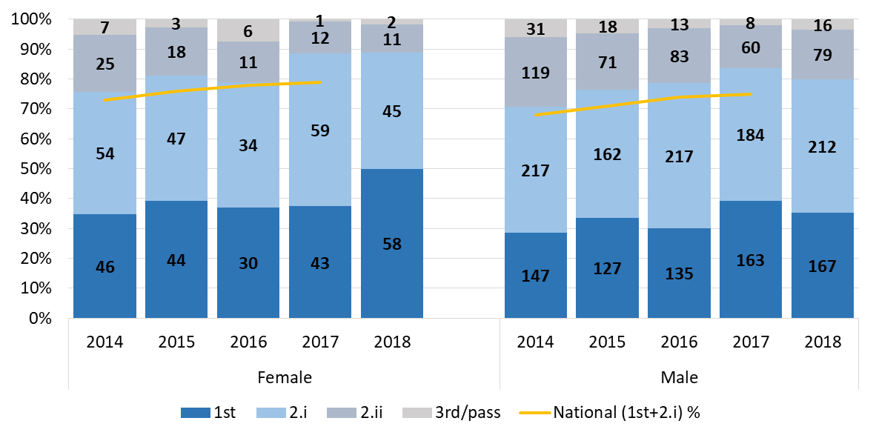

Figure 4.4: Undergraduate attainment compared to national benchmarks.

 As a result of our actions to inspire/motivate (**Action#3.13[C]**) and retain/develop diverse students (**Action#3.8[C]**), **both %Male and %Female students graduating with 1st or 2:1 is higher than national average**, increasing over five years: 70% -> 80% male; 73% -> 88% female (Figure#4.4).

|  |  |
| --- | --- |
| **Action#3.4[C]** | Engage in outreach activities which tackle societal expectations around what careers women can pursue |
| **Action#3.7[N]** | Improve the visibility of our EDI activities in our application-acceptance communications with prospective students |
| **Action#3.8[C]** | Retain and develop students from diverse backgrounds through tailored support provided by their personal tutors and School SES |
| **Action#3.13[C]** | Embed sustained activities to inspire/motivate students from diverse backgrounds |
| **Action#4.8[C]** | Extend visibility of diverse staff and students across FoE |

#### Numbers of men and women on postgraduate taught degrees

*Full- and part-time. Provide data on course application, offers and acceptance rates and degree completion rates by gender.*

Gender ratios of our PGT degrees are shown in Figure#4.5/Table#4.4 (full-time) and Figure#4.6 (part-time).

|  |  |  |
| --- | --- | --- |
|  |  |  |
|  |  |  |

Figure 4.5: Proportion of full-time female postgraduate taught students in FoE and by School compared to national benchmarks (see detail in Table#4.4).

Although %Female increased in 2018/19, **full-time PGT %Female is below benchmarks**. All schools except MECH are increasing %Female while growing student numbers. The **majority of our PGT students are international** (72.7%, excluding EU-students); hence, recruitment is influenced by government policy, international HE trends, and economic factors.

Table 4.4: Postgraduate taught student numbers and percentages of females.

|  |  |  |  |  |  |  |  |  |  |  |  |  |  |  |
| --- | --- | --- | --- | --- | --- | --- | --- | --- | --- | --- | --- | --- | --- | --- |
|  | **2014/15** | | | **2015/16** | | | **2016/17** | | | **2017/18** | | | **2018/19** | |
|  | **F+M** | **%F** | ***%N*** | **F+M** | **%F** | ***%N*** | **F+M** | **%F** | ***%N*** | **F+M** | **%F** | ***%N*** | **F+M** | **%F** |
| **FoE (FT)** | 365 | 26.8 | *23.7* | 315 | 27.6 | *25.3* | 458 | 25.3 | *25.4* | 565 | 22.5 | *26.0* | 736 | 25.8 |
| **FoE (PT)** | 56 | 23.2 | *-* | 69 | 11.6 | *-* | 79 | 8.9 | *-* | 90 | 11.1 | *-* | 78 | 10.3 |
| **CAPE (FT)** | 69 | 23.2 | *27.1* | 52 | 40.4 | *29.5* | 97 | 29.9 | *30.3* | 98 | 22.4 | *30.0* | 110 | 30.0 |
| **CAPE (PT)** | 33 | 30.3 | *-* | 38 | 18.4 | *-* | 31 | 16.1 | *-* | 37 | 13.5 | *-* | 17 | 17.6 |
| **CIVE (FT)** | 107 | 30.8 | *28.6* | 88 | 33.0 | *31.3* | 110 | 34.5 | *31.5* | 147 | 32.0 | *32.6* | 200 | 35.5 |
| **CIVE (PT)** | 17 | 11.8 | *-* | 26 | 3.8 | *-* | 45 | 4.4 | *-* | 50 | 8.0 | *-* | 58 | 6.9 |
| **COMP (FT)** | 16 | 43.8 | *25.8* | 14 | 42.9 | *28.3* | 29 | 41.4 | *26.8* | 45 | 11.1 | *28.2* | 106 | 23.6 |
| **COMP (PT)** | 0 |  | *-* | 0 |  | *-* | 0 |  | *-* | 0 |  | *-* | 0 |  |
| **ELEC (FT)** | 116 | 25.9 | *22.1* | 109 | 22.9 | *23.6* | 113 | 18.6 | *24.7* | 141 | 22.7 | *25.8* | 167 | 24.6 |
| **ELEC (PT)** | 0 |  | *-* | 0 |  | *-* | 0 |  | *-* | 0 |  | *-* | 0 |  |
| **MECH (FT)** | 57 | 21.1 | *18.2* | 52 | 11.5 | *17.9* | 109 | 14.7 | *18.3* | 134 | 15.7 | *17.3* | 153 | 13.1 |
| **MECH (PT)** | 6 | 16.7 | *-* | 5 | 0.0 | *-* | 3 | 0.0 | *-* | 3 | 33.3 | *-* | 3 | 33.3 |

|  |  |  |
| --- | --- | --- |
|  |  |  |
|  |  |  |

Figure 4.6: Proportion of part-time female postgraduate taught students in FoE and by School compared to national benchmarks (COMP and ELEC do not offer part time PGT).

Part-time PGT ratios fluctuate (due to small numbers). In general, part-time PGT degrees are harder, take longer, and can create family/work challenges, which makes them less-attractive for females (**Action#3.19[N]**).

|  |  |  |
| --- | --- | --- |
| **Action#3.19[N]** | Conduct focus groups to gain better understanding of the drivers and barriers to females studying part-time PGT and PGR degrees. | |
|  | |  | |
|  | |  | |
|  | |  | |

Figure 4.7: PGT full-time student recruitment (applications, offers, and acceptances), see Table#4.5 for detail.

Table 4.5: PGT full-time student recruitment.

|  |  |  |  |  |  |  |  |  |  |  |
| --- | --- | --- | --- | --- | --- | --- | --- | --- | --- | --- |
|  | **2014/15** | | **2015/16** | | **2016/17** | | **2017/18** | | **2018/19** | |
|  | **F+M** | **%F** | **F+M** | **%F** | **F+M** | **%F** | **F+M** | **%F** | **F+M** | **%F** |
| **FoE App** | 5025 | 23.2 | 5207 | 26.5 | 5963 | 27.2 | 6609 | 26.7 | 8030 | 29.4 |
| **Off** | 3369 | 24.8 | 3537 | 27.7 | 4406 | 27.5 | 4833 | 27.4 | 5761 | 29.8 |
| **Acc** | 478 | 24.3 | 377 | 27.3 | 523 | 24.3 | 610 | 22.8 | 755 | 27.0 |
| **CAPE App** | 923 | 26.9 | 861 | 31.6 | 1166 | 29.8 | 1171 | 29.4 | 1218 | 34.1 |
| **Off** | 705 | 28.1 | 704 | 32.7 | 984 | 30.3 | 909 | 31.2 | 933 | 34.1 |
| **Acc** | 118 | 22.9 | 78 | 34.6 | 115 | 29.6 | 116 | 23.3 | 130 | 30.0 |
| **CIVE App** | 1446 | 29.5 | 1538 | 34.7 | 1678 | 32.7 | 1944 | 32.9 | 2559 | 35.2 |
| **Off** | 887 | 31.5 | 887 | 37.7 | 1088 | 31.9 | 1311 | 33.6 | 1685 | 35.7 |
| **Acc** | 134 | 32.1 | 101 | 35.6 | 127 | 28.3 | 158 | 32.3 | 212 | 36.3 |
| **COMP App** | 435 | 30.6 | 458 | 30.6 | 588 | 30.8 | 734 | 27.9 | 1180 | 34.3 |
| **Off** | 232 | 40.1 | 254 | 37.4 | 401 | 31.7 | 445 | 30.8 | 737 | 37.2 |
| **Acc** | 18 | 44.4 | 13 | 53.8 | 34 | 32.4 | 51 | 11.8 | 110 | 29.1 |
| **ELEC App** | 1519 | 17.8 | 1535 | 21.9 | 1602 | 23.7 | 1706 | 25.5 | 1864 | 25.5 |
| **Off** | 1112 | 18.6 | 1195 | 21.9 | 1272 | 25.9 | 1422 | 25.7 | 1486 | 26.3 |
| **Acc** | 142 | 19.0 | 120 | 20.0 | 126 | 20.6 | 160 | 22.5 | 157 | 24.8 |
| **MECH App** | 702 | 12.5 | 815 | 12.1 | 929 | 17.5 | 1054 | 13.6 | 1209 | 13.6 |
| **Off** | 433 | 13.2 | 497 | 11.9 | 661 | 16.9 | 746 | 13.1 | 920 | 14.6 |
| **Acc** | 66 | 16.7 | 65 | 13.8 | 121 | 16.5 | 125 | 15.2 | 146 | 11.6 |

**PGT female applications are increasing** at Faculty level – %Female offers is up (sustained), and acceptances are up after a dip in 2017 (Figure#4.7). Relatively small numbers mean we remain cautious about these positive trends however.

Further analysis of the low %Female acceptance in **COMP** and **CAPE** indicated that the student-facing research online did not include strong female images (**Action#4.8[C]**).

We explored what influenced student choices to come to Leeds in our **focus groups with PGT/PGR students** (5F/4M). While FoE would not be able to influence external (national/international) factors, there are areas that we could improve to attract female PGT:

* improved online visibility of student/alumni/staff profiles (**Action#4.8[C]**);
* engage with our alumni abroad (**Action#3.5[N]**);
* improve visibility of EDI in application-accaptance (**Action#3.7[N]**).

|  |  |
| --- | --- |
| **Action#3.5[N]** | Expand our PGT recruitment routes; especially for declining female in COMP, MECH (including engagement with female alumni abroad). |
| **Action#3.7[N]** | Improve the visibility of our EDI activities in our application-acceptance communications with prospective students |
| **Action#4.8[C]** | Extend visibility of diverse staff and students across FoE |

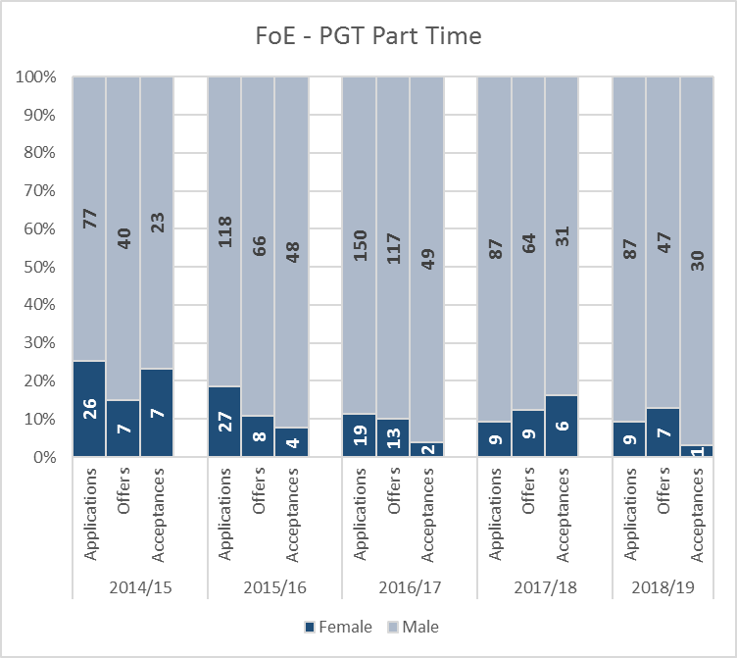

Figure 4.8: Postgraduate taught part-time recruitment (applications, offers, and acceptances), FoE level only due to small numbers (see Table#4.6 for detail).

Table 4.6: Part-time postgraduate taught student recruitment in FoE and the three schools that offer such degrees.

|  |  |  |  |  |  |  |  |  |  |  |
| --- | --- | --- | --- | --- | --- | --- | --- | --- | --- | --- |
|  | **2014/15** | | **2015/16** | | **2016/17** | | **2017/18** | | **2018/19** | |
|  | **F+M** | **%F** | **F+M** | **%F** | **F+M** | **%F** | **F+M** | **%F** | **F+M** | **%F** |
| **FoE App** | 103 | 25.2 | 145 | 18.6 | 169 | 11.2 | 96 | 9.4 | 96 | 9.4 |
| **Off** | 47 | 14.9 | 74 | 10.8 | 130 | 10.0 | 73 | 12.3 | 54 | 13.0 |
| **Acc** | 30 | 23.3 | 52 | 7.7 | 51 | 3.9 | 37 | 16.2 | 31 | 3.2 |
| **CAPE App** | 31 | 19.4 | 47 | 10.6 | 36 | 13.9 | 16 | 18.8 | 4 | 25.0 |
| **Off** | 28 | 21.4 | 39 | 12.8 | 33 | 15.2 | 15 | 20.0 | 4 | 25.0 |
| **Acc** | 21 | 28.6 | 31 | 9.7 | 19 | 10.5 | 12 | 16.7 | 3 | 0.0 |
| **CIVE App** | 60 | 31.7 | 83 | 25.3 | 127 | 10.2 | 67 | 6.0 | 71 | 7.0 |
| **Off** | 12 | 8.3 | 30 | 6.7 | 93 | 8.6 | 52 | 7.7 | 45 | 8.9 |
| **Acc** | 6 | 16.7 | 18 | 5.6 | 31 | 0.0 | 23 | 13.0 | 27 | 3.7 |
| **MECH App** | 12 | 8.3 | 15 | 6.7 | 6 | 16.7 | 13 | 15.4 | 21 | 14.3 |
| **Off** | 7 | 0.0 | 5 | 20.0 | 4 | 0.0 | 6 | 33.3 | 5 | 40.0 |
| **Acc** | 3 | 0.0 | 3 | 0.0 | 1 | 0.0 | 2 | 50.0 | 1 | 0.0 |

While part-time applications are declining, FoE is considering alternative ways to offer part-time PGT. FoE is starting **industry-linked interdisciplinary part-time PGT programmes** (FinTech-2019/20, MedTech-2020/21) which address sector/region needs. We will aim to attract diverse cohorts of students (through our established industry links), and will explore common challenges to attract/retain females (**Action#5.2[N]**).

|  |  |
| --- | --- |
| **Action#5.2[N]** | Unify with industry to optimise effort and maximise the impact of our EDI activities on the society and engineering sector (including part-time PGT degrees). |

**Full-Time completion rates** (Table#4.7) show a **comparable male-female % of awards**. There is no specific reason for the decrease in PGT completion in MECH - will be monitored annually to investigate trend (**Action#5.6[C]**).

|  |  |
| --- | --- |
| **Action#5.6[C]** | Ensure robust data monitoring and reporting processes (including PGT completion decline in MECH; and impact of National MedTech Skills Academy on %Female). |

Table 4.7: Completion rates for full-time PGT students by gender.

|  |  |  |  |  |  |  |  |  |  |  |
| --- | --- | --- | --- | --- | --- | --- | --- | --- | --- | --- |
| Year of commencement: | **2012/13** | | **2013/14** | | **2014/15** | | **2015/16** | | **2016/17** | |
| PGT FT completion rates | **%M** | **%F** | **%M** | **%F** | **%M** | **%F** | **%M** | **%F** | **%M** | **%F** |
| **FoE** | 99.3 | 97.6 | 97.8 | 98.6 | 98.1 | 96.9 | 91.9 | 98.8 | 95.4 | 93.8 |
| **CAPE** | 100.0 | 92.9 | 97.7 | 100.0 | 100.0 | 100.0 | 100.0 | 100.0 | 98.5 | 96.6 |
| **CIVE** | 98.2 | 100.0 | 97.1 | 94.1 | 97.3 | 97.0 | 94.6 | 100.0 | 94.4 | 100.0 |
| **COMP** | 100.0 | 100.0 | 100.0 | 100.0 | 100.0 | 100.0 | 100.0 | 83.3 | 100.0 | 83.3 |
| **ELEC** | 100.0 | 100.0 | 97.4 | 100.0 | 100.0 | 100.0 | 97.6 | 100.0 | 100.0 | 100.0 |
| **MECH** | 100.0 | 100.0 | 100.0 | 100.0 | 92.5 | 80.0 | 71.7 | 100.0 | 88.0 | 73.3 |

Table 4.8: Completion rates for part-time PGT students by gender.

|  |  |  |  |  |  |  |  |  |  |  |
| --- | --- | --- | --- | --- | --- | --- | --- | --- | --- | --- |
| Year of commencement: | **2010/11** | | **2011/12** | | **2012/13** | | **2013/14** | | **2014/15** | |
| PGT PT completion rates | **%M** | **%F** | **%M** | **%F** | **%M** | **%F** | **%M** | **%F** | **%M** | **%F** |
| **FoE** | 83.9 | 100.0 | 77.8 | 75.0 | 80.0 | 100.0 | 68.2 | 87.5 | 71.4 | 50.0 |
| **CAPE** | 88.9 | 100.0 | 71.4 | 100.0 | 80.0 | 100.0 | 53.8 | 80.0 | 77.8 | 50.0 |
| **CIVE** | 93.8 | 100.0 | 80.0 | 100.0 | - | - | 88.9 | 100.0 | 62.5 | - |
| **COMP** | - | - | - | - | - | - | - | - | - | - |
| **ELEC** | - | - | - | - | - | - | - | - | - | - |
| **MECH** | 50.0 | - | 100.0 | 0.0 | - | - | - | 100.0 | 75.0 | - |

Due to **low numbers of** part-time programmes (Table#4.8), comparison is difficult; no specific action.

#### Numbers of men and women on postgraduate research degrees

*Full- and part-time. Provide data on course application, offers, acceptance and degree completion rates by gender.*

We set the ambition **all schools to consistently be above national benchmarks for PGR %Female**. Female ratio and number in our PGR degrees are shown in Table#4.9/Figure#4.9 (full-time) and Figure#4.10 (part-time).

|  |  |  |
| --- | --- | --- |
|  |  |  |
|  |  |  |

Figure 4.9: Proportion of full-time female postgraduate research students in FoE and by School compared to national benchmarks (see Table#4.9 for detail).

Table 4.9: Full-time postgraduate research student numbers and percentages of females compared to national benchmarks.

|  |  |  |  |  |  |  |  |  |  |  |  |  |  |  |
| --- | --- | --- | --- | --- | --- | --- | --- | --- | --- | --- | --- | --- | --- | --- |
|  | **2014/15** | | | **2015/16** | | | **2016/17** | | | **2017/18** | | | **2018/19** | |
|  | **F+M** | **%F** | ***%N*** | **F+M** | **%F** | ***%N*** | **F+M** | **%F** | ***%N*** | **F+M** | **%F** | ***%N*** | **F+M** | **%F** |
| **FoE** | | 501 | 29.3 | *24.1* | 517 | 29.4 | *24.8* | 510 | 30.2 | *25.2* | 519 | 30.3 | *25.7* | 524 | 30.5 |
| **CAPE** | | 196 | 30.1 | *32.7* | 182 | 30.2 | *33.6* | 183 | 29.5 | *34.2* | 174 | 29.3 | *35.9* | 176 | 33.0 |
| **CIVE** | | 52 | 42.3 | *30.6* | 47 | 40.4 | *32.0* | 44 | 36.4 | *32.4* | 49 | 32.7 | *34.2* | 48 | 25.0 |
| **COMP** | | 48 | 31.3 | *24.4* | 59 | 30.5 | *26.1* | 72 | 36.1 | *27.1* | 87 | 36.8 | *27.6* | 92 | 33.7 |
| **ELEC** | | 73 | 20.5 | *20.2* | 70 | 22.9 | *20.3* | 58 | 25.9 | *20.2* | 56 | 21.4 | *19.9* | 70 | 28.6 |
| **MECH** | | 132 | 27.3 | *19.7* | 159 | 27.7 | *19.2* | 153 | 28.1 | *18.9* | 153 | 30.1 | *18.8* | 138 | 28.3 |

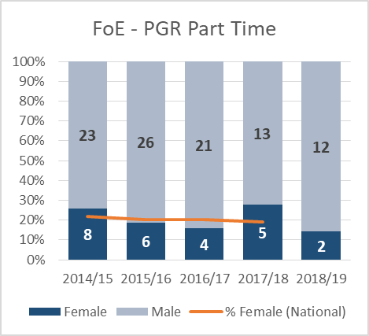  
Figure 4.10: Part-time PGR students in FoE (numbers too small for meaningful School analysis).

**The PGR/PGT focus groups** (5F/3M)indicated **actions with positive impact on attracting diverse PGRs**:

* visibility of role models and diverse supervisors (**Action#4.8[C]**);
* opportunities for training and personal development (**Action#2.6[C]**);
* availability of wellbeing activities (**Action#4.11[C]**);
* cohort-based training via CDTs (**Action#5.3[N])**.

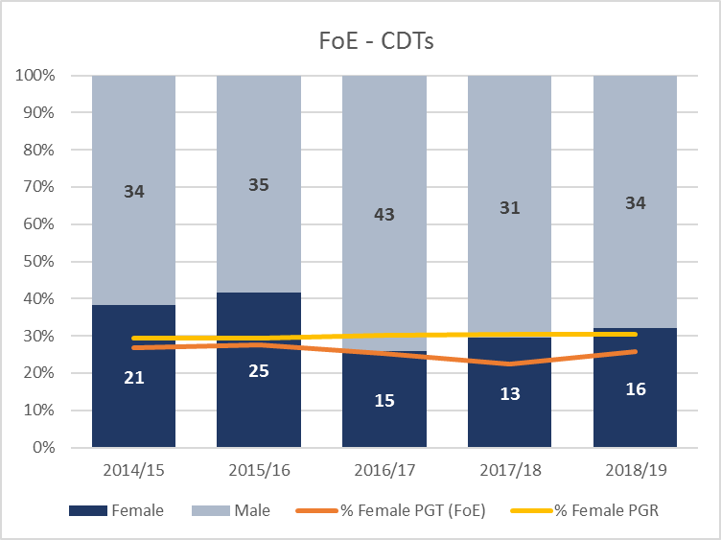

Figure 4.11: Enrolment numbers on CDT courses benchmarked against PGT and PGR cohorts in FoE (CDTs offer joint PGT & PGR degrees).

Our CDTs attract diverse cohort (Figure#4.11) and **cultivate EDI excellence**. 2 of our 4 recently funded **CDT programmes are led by women and all have women on their leadership teams**. Best EDI practices from our CDTs have been adopted at Faculty level:

* proactive inclusive marketing with a notable presence of diversity (alumni/industry);
* established code of practice for PhD recruitment, diverse interview panels;
* growing a diverse pool of supervisors.

We will consolidate best-practices from CDTs to influence across and beyond FoE (**Action#5.3[N]**).

|  |  |
| --- | --- |
| **Action#4.8[C]** | Visibility of diverse staff and students across FoE (including PGR). |
| **Action#2.6[C]** | Promote career development programmes to our PGR students |
| **Action#4.11[C]** | Ensure all students are aware of the extra-curriculum and wellbeing activities available |
| **Action#5.3[N]** | Ensure our CDTs act as beacons for equality and inclusion, influencing the Faculty, University and sector (including newly formed CDT working group, linked to SAT). |

These actions **led to the positive impact on PGR numbers and recruitment**, shown below.

**%Female full-time PGR in FoE is notably above the national benchmark**. Our PGR success rate (influenced by our activities to develop PGRs, Section#5.3(iv)) and best-practice from CDTs (see below) have led to **consistent growth in COMP and MECH** (well-above benchmarks) and in **CAPE & ELEC** (closing gap with benchmarks) ).

The **%Female in CIVE is reducing**, from a peak (40% - 2014/15 to 25% - 2018/19), now below benchmark. CIVE has not hosted a CDT, offers limited school scholarships, and most of the recruitment is through ad-hoc applications rather than cohort-based recruitment (this has led to low applications/acceptance, see below). CIVE will use more proactive marketing (**Action#3.1[C]**), adopting best practice of Water-WISER CDT (starting Sept-2019, CIVE host).

|  |  |
| --- | --- |
| **Action#3.1[C]** | Improve marketing (includes CIVE to improve PGR projects/studentships advertisement and EDI promotion in school to attract more PGR students). |

|  |  |
| --- | --- |
|  |  |
|  |  |
|  |  |

Figure 4.12: Postgraduate research full-time recruitment (applications, offers, and acceptances), see Table#4.10 for detail.

Table 4.10: Full-time postgraduate research student recruitment.

|  |  |  |  |  |  |  |  |  |  |  |
| --- | --- | --- | --- | --- | --- | --- | --- | --- | --- | --- |
|  | **2014/15** | | **2015/16** | | **2016/17** | | **2017/18** | | **2018/19** | |
|  | **F+M** | **%F** | **F+M** | **%F** | **F+M** | **%F** | **F+M** | **%F** | **F+M** | **%F** |
| **FoE App** | 1864 | 23.4 | 1504 | 26.2 | 1620 | 24.1 | 1296 | 22.1 | 1492 | 26.6 |
| **Off** | 668 | 24.7 | 528 | 28.6 | 398 | 26.1 | 364 | 22.0 | 443 | 28.4 |
| **Acc** | 326 | 25.2 | 299 | 27.8 | 223 | 25.6 | 220 | 23.6 | 276 | 28.6 |
| **CAPE App** | 629 | 24.5 | 437 | 30.0 | 416 | 23.6 | 245 | 22.9 | 321 | 30.8 |
| **Off** | 263 | 26.2 | 188 | 33.0 | 120 | 30.0 | 114 | 22.8 | 115 | 33.9 |
| **Acc** | 126 | 24.6 | 113 | 33.6 | 69 | 24.6 | 71 | 22.5 | 79 | 34.2 |
| **CIVE App** | 251 | 18.3 | 204 | 30.4 | 229 | 22.3 | 249 | 24.1 | 214 | 28.0 |
| **Off** | 95 | 26.3 | 73 | 28.8 | 46 | 21.7 | 68 | 26.5 | 61 | 23.0 |
| **Acc** | 41 | 31.7 | 34 | 20.6 | 21 | 19.0 | 29 | 31.0 | 36 | 22.2 |
| **COMP App** | 253 | 31.2 | 262 | 25.2 | 318 | 25.2 | 321 | 21.5 | 337 | 31.2 |
| **Off** | 58 | 39.7 | 42 | 33.3 | 45 | 33.3 | 40 | 35.0 | 52 | 38.5 |
| **Acc** | 40 | 37.5 | 25 | 32.0 | 32 | 34.4 | 33 | 36.4 | 32 | 34.4 |
| **ELEC App** | 350 | 16.0 | 242 | 16.5 | 305 | 19.3 | 259 | 12.7 | 354 | 19.2 |
| **Off** | 124 | 19.4 | 85 | 24.7 | 79 | 25.3 | 66 | 10.6 | 117 | 23.1 |
| **Acc** | 50 | 16.0 | 41 | 19.5 | 36 | 22.2 | 32 | 9.4 | 61 | 21.3 |
| **MECH App** | 381 | 26.5 | 359 | 26.5 | 352 | 29.3 | 222 | 31.1 | 266 | 24.4 |
| **Off** | 128 | 18.8 | 140 | 23.6 | 108 | 21.3 | 76 | 19.7 | 98 | 26.5 |
| **Acc** | 69 | 21.7 | 86 | 25.6 | 65 | 26.2 | 55 | 21.8 | 68 | 29.4 |

Full-time PGR recruitment impact in the Faculty:

* **sustained growth in %Female acceptance**;
* %Female **applications and offers have remained stable**.

Table 4.11: Part-time postgraduate research student recruitment (*Faculty-level only as numbers by School are so small).*

|  |  |  |  |  |  |  |  |  |  |  |
| --- | --- | --- | --- | --- | --- | --- | --- | --- | --- | --- |
|  | **2014/15** | | **2015/16** | | **2016/17** | | **2017/18** | | **2018/19** | |
|  | **F+M** | **%F** | **F+M** | **%F** | **F+M** | **%F** | **F+M** | **%F** | **F+M** | **%F** |
| **FoE App** | 39 | 20.5 | 43 | 20.9 | 25 | 16.0 | 16 | 25.0 | 35 | 8.6 |
| **Off** | 10 | 30.0 | 18 | 22.2 | 9 | 0.0 | 5 | 20.0 | 10 | 0.0 |
| **Acc** | 7 | 28.6 | 13 | 15.4 | 5 | 0.0 | 4 | 25.0 | 5 | 0.0 |

**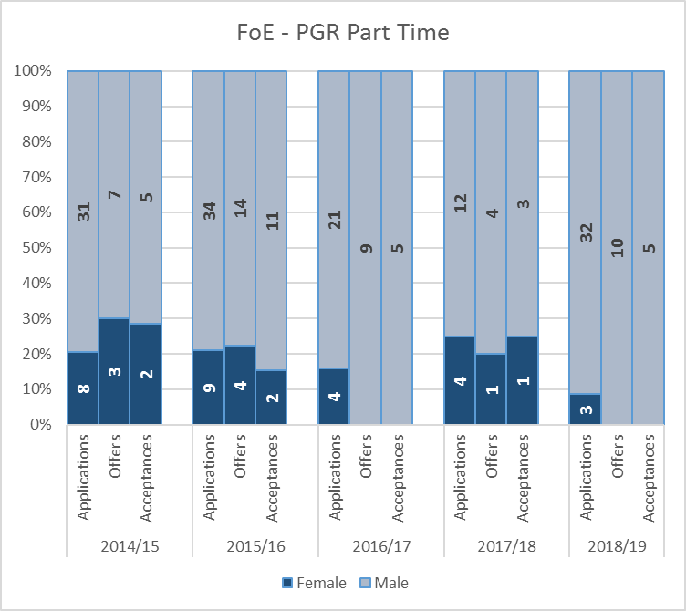**

Figure 4.13: Postgraduate research part-time recruitment (applications, offers, and acceptances).

**%Female part-time PGR is declining**. We will extend our focus groups to specifically target part-time PGR to better understand this group and what would attract females to undertake such studies (**Action#3.19[N]**)

|  |  |
| --- | --- |
| **Action#3.19[N]** | Conduct focus groups to gain better understanding of the drivers and barriers to females studying part-time PGT and PGR degrees. |

The recruitment variations by schools prompted further analysis. We **reviewed our online attractiveness** to diverse PGR students **comparing to selected universities** in the region (Manchester, Sheffield, Newcastle, Durham) and Gold departments (Chemistry in York and in UCL). Consequently, immediate improvement has been made and further is planned.

Table 4.12: PGR full-time completion numbers by gender with mean years taken to complete

|  |  |  |  |  |  |  |  |  |  |  |  |  |  |  |  |  |  |  |  |  |
| --- | --- | --- | --- | --- | --- | --- | --- | --- | --- | --- | --- | --- | --- | --- | --- | --- | --- | --- | --- | --- |
|  | **2013/14** | | | | **2014/15** | | | | **2015/16** | | | | **2016/17** | | | | **2017/18** | | | |
|  | **F** | **Avg Yrs** | **M** | **Avg Yrs** | **F** | **Avg Yrs** | **M** | **Avg Yrs** | **F** | **Avg Yrs** | **M** | **Avg Yrs** | **F** | **Avg Yrs** | **M** | **Avg Yrs** | **F** | **Avg Yrs** | **M** | **Avg Yrs** |
| **FoE** | 16 | *4.3* | 76 | *4.5* | 35 | *4.6* | 73 | *4.4* | 23 | *4.5* | 86 | *4.4* | 40 | *4.8* | 88 | *4.5* | 35 | *4.7* | 99 | *4.4* |
| **CAPE** | 7 | *4.4* | 20 | *4.4* | 18 | *4.5* | 22 | *4.3* | 10 | *4.5* | 42 | *4.2* | 17 | *4.6* | 29 | *4.4* | 11 | *4.4* | 24 | *4.9* |
| **CIVE** | 1 | *4.6* | 12 | *4.6* | 5 | *4.5* | 10 | *4.9* | 4 | *4.8* | 7 | *4.6* | 4 | *5.1* | 12 | *5.0* | 7 | *4.8* | 7 | *3.9* |
| **COMP** | 2 | *3.9* | 6 | *4.4* | 3 | *5.2* | 8 | *4.0* | 2 | *4.1* | 4 | *5.1* | 0 | *-* | 7 | *4.6* | 4 | *4.8* | 11 | *4.5* |
| **ELEC** | 4 | *4.1* | 17 | *4.1* | 4 | *4.4* | 10 | *4.7* | 2 | *4.3* | 11 | *4.2* | 6 | *4.2* | 17 | *4.3* | 6 | *4.6* | 22 | *4.3* |
| **MECH** | 2 | *4.2* | 21 | *4.7* | 5 | *5.1* | 23 | *4.4* | 5 | *4.4* | 22 | *4.5* | 13 | *5.2* | 23 | *4.4* | 7 | *5.0* | 35 | *4.2* |

Table 4.13: PGR part-time completion numbers by gender with mean years taken to complete

|  |  |  |  |  |  |  |  |  |  |  |  |  |  |  |  |  |  |  |  |  |
| --- | --- | --- | --- | --- | --- | --- | --- | --- | --- | --- | --- | --- | --- | --- | --- | --- | --- | --- | --- | --- |
|  | **2013/14** | | | | **2014/15** | | | | **2015/16** | | | | **2016/17** | | | | **2017/18** | | | |
|  | **F** | **Avg  Yrs** | **M** | **Avg  Yrs** | **F** | **Avg  Yrs** | **M** | **Avg  Yrs** | **F** | **Avg  Yrs** | **M** | **Avg  Yrs** | **F** | **Avg  Yrs** | **M** | **Avg  Yrs** | **F** | **Avg  Yrs** | **M** | **Avg  Yrs** |
| **FoE** | 0 | *-* | 6 | *6.0* | 1 | *8.3* | 4 | *7.0* | 1 | *6.0* | 2 | *6.4* | 4 | *7.4* | 2 | *5.2* | 1 | *5.8* | 2 | *5.9* |
| **CAPE** | 0 | *-* | 2 | *6.2* | 0 | *-* | 2 | *7.6* | 0 | *-* | 1 | *5.5* | 0 | *-* | 1 | *5.3* | 0 | *-* | 0 | *-* |
| **CIVE** | 0 | *-* | 0 | *-* | 1 | *8.3* | 0 | *-* | 0 | *-* | 0 | *-* | 1 | *7.2* | 1 | *5.1* | 0 | *-* | 0 | *-* |
| **COMP** | 0 | *-* | 2 | *6.8* | 0 | *-* | 0 | *-* | 0 | *-* | 0 | *-* | 0 | *-* | 0 | *-* | 1 | *5.8* | 0 | *-* |
| **ELEC** | 0 | *-* | 1 | *6.4* | 0 | *-* | 0 | *-* | 0 | *-* | 0 | *-* | 0 | *-* | 0 | *-* | 0 | *-* | 0 | *-* |
| **MECH** | 0 | *-* | 1 | *3.3* | 0 | *-* | 2 | *6.3* | 1 | *6.0* | 1 | *7.3* | 3 | *7.4* | 0 | *-* | 0 | *-* | 2 | *5.9* |

As a result of our inclusive student support (Section#5.3(iv)):

* average **completion time is similar for males and females**;
* number of **female completing their PhD has increased** (Table#4.12/Table#4.13).

#### Progression pipeline between undergraduate and postgraduate student levels

*Identify and comment on any issues in the pipeline between undergraduate and postgraduate degrees.*

Figure 4.14: Percentage of female students across the pipeline.



The impact of our series of actions (as described above) has led to **consistently higher female percentage compared to national benchmarks throughout the whole pipeline**.

The key transitions across the student pipeline are supported:

- **school -> UG** : marketing, online visibility, staff at open days, outreach activities;

- **UG -> PGT/industry** : personal tutorials involving diverse staff (where possible), dissertation projects, employability support;

- **UG/PGT -> PGR** : PGR demonstrators in labs and tutorials, dissertation projects, career events, PGR scholarship & CDT marketing, joint inspiration events.

## 4.2. Academic and research staff data

The staff data is presented using a census date of 31-July. Staff in post is as on that date; redeployment/leavers are during 1-August until 31-July for the corresponding years.

#### Academic staff by grade, contract function and gender: research-only, teaching and research or teaching-only

*Look at the career pipeline and comment on and explain any differences between men and women. Identify any gender issues in the pipeline at particular grades/job type/academic contract type.*

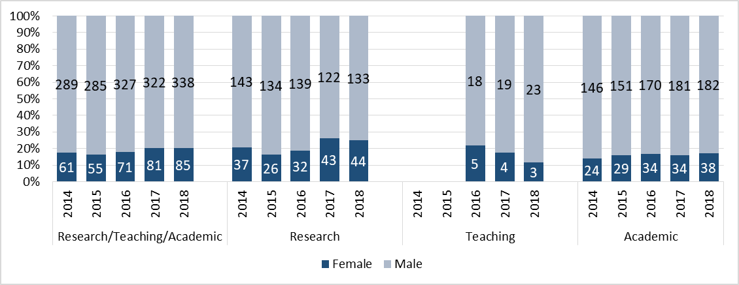

Figure 4.15: Gender proportion for all academic staff in the Faculty: research only, teaching only, and research and teaching. Our past data did not explicitly separate teaching only staff, and therefore we cannot provide such data (hence, the gap for 2014, 2015 in Teaching).

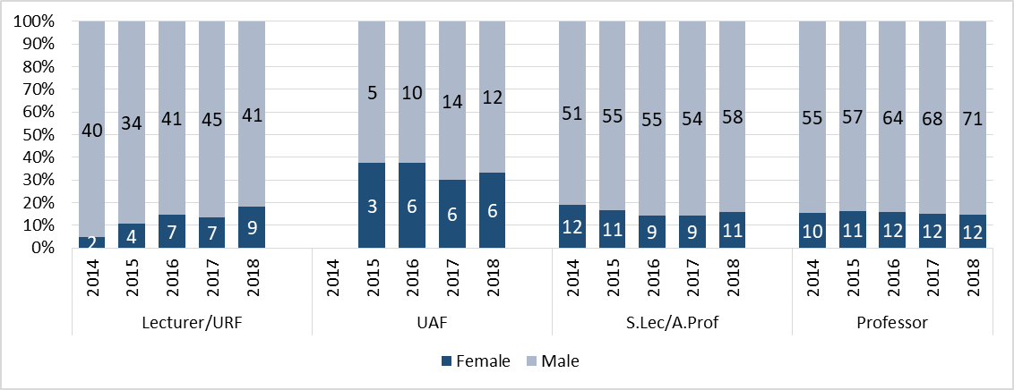

Figure 4.16: Gender proportion for the academic staff in the Faculty.

Table 4.14: Summary of academic staff in FoE by contract function

|  |  |  |  |  |  |  |  |  |  |  |  |
| --- | --- | --- | --- | --- | --- | --- | --- | --- | --- | --- | --- |
|  |  | **2014** | | **2015** | | **2016** | | **2017** | | **2018** | |
|  |  | **F+M** | **%F** | **F+M** | **%F** | **F+M** | **%F** | **F+M** | **%F** | **F+M** | **%F** |
| **Teaching** | | - | - | - | - | 23 | 21.7 | 23 | 17.4 | 26 | 11.5 |
| **Research** | | 180 | 20.6 | 160 | 16.3 | 171 | 18.7 | 165 | 26.1 | 177 | 24.9 |
| **Academic** | Lecturer/URF | 42 | 4.8 | 38 | 10.5 | 48 | 14.6 | 52 | 13.5 | 50 | 18.0 |
| UAF |  |  | 8 | 37.5 | 16 | 37.5 | 20 | 30.0 | 18 | 33.3 |
| S.Lec/A.Prof | 63 | 19.0 | 66 | 16.7 | 64 | 14.1 | 63 | 14.3 | 69 | 15.9 |
| Professor | 65 | 15.4 | 68 | 16.2 | 76 | 15.8 | 80 | 15.0 | 83 | 14.5 |
| **Total Staff** | | **350** | **17.4** | **340** | **16.2** | **398** | **17.8** | **403** | **20.1** | **423** | **20.1** |

Increasing the proportion of female staff in FoE has been a continuous priority. Our past action plan targeted female appointments at researcher and lecturer level, where FoE performed poorly. Through inclusive recruitment campaigns, online visibility of role models and internal career development, we have achieved a notable impact in our researcher recruitment as well as a recent improvement in our %Female lecturers (Table#4.14).

These actions led to positive impact (Figure#4.15/Figure#4.16; Table#4.14):

* **Number and %Female researchers has grown** in the past 5 years(18.7% to 24.9%).
* The overall **academic-research-teaching female percentage has grown** (17.8% to 20.1%).
* There is **increase in %Female in grade 8 and 9 academics** (Figure#4.17).
* **The percentage of female University Academic Fellows** is higher than the average for grade 8 academic (Table#4.15),progression path to Associate Professor after 5 years.

Table 4.15: FoE University Academic Fellows (UAF), recruited at grade 8, versus all grade 8 research staff.

|  |  |  |  |  |  |  |
| --- | --- | --- | --- | --- | --- | --- |
|  | **2016** | | **2017** | | **2018** | |
|  | **All grade 8  academics** | **UAFs** | **All grade 8  academics** | **UAFs** | **All grade 8  academics** | **UAFs** |
| **Male** | 46 | 10 | 52 | 14 | 48 | 12 |
| **Female** | 13 | 6 | 13 | 6 | 15 | 6 |
| **% Female** | **22.0%** | **37.5%** | **20.0%** | **30.0%** | **23.8%** | **33.3%** |
|  |  |  |  |  |  |  |

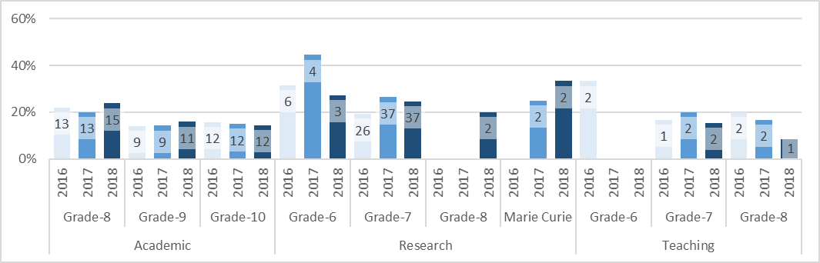

Figure 4.17: FoE - female staff by category and grade.

**Table 4.16: Job roles by grade and category**



During the current period (Figure#4.17):

* **%Female in FoE has sustained** for academic grades;
* **Female researchers are at higher grades** which indicates that we attract strong female researchers;
* **%Female in teaching only roles has decreased** – while this raises concern, the vast majority of academic roles include teaching duties and teaching scholarship among academics is encouraged (e.g. via promotion).

|  |  |  |  |  |  |  |  |  |  |  |
| --- | --- | --- | --- | --- | --- | --- | --- | --- | --- | --- |
| |  |  | | --- | --- | | CAPE |  | | CIVE |  | | COMP |  | | ELEC |  | | MECH |  | |

Figure 4.18: Female staff by category and grade in each school.

|  |  |
| --- | --- |
|  |  |
|  |  |
|  |  |

Figure 4.19: %Female in each school compared to national benchmarking: research, teaching, research and teaching.

There are variations in schools (Figure#4.18/Figure#4.19). In **ELEC** and **CAPE** %Female staff has been consistently below national benchmarks. **ELEC** has increased female researchers, and development through to academic roles is targeted (e.g. case study Elgorashi) and plans academic growth in Medical Technologies, proactively seeking to attract female candidates (c.f. the high %Female in **MECH**, where Medical Engineering is strongly established). **CAPE** is determined to grow critical mass led by their female HoS; it has 2 female UAFs (positions leading to Associate Professor) who proactively act as role models to researchers, with a view to increasing female numbers in the near future. **COMP and CIVE** arebelow the benchmark in teaching-only staff but many academics are involved in teaching scholarship; **COMP** recently appointed a female teaching fellow. **CIVE** and **MECH** have developed critical mass of female researchers and academics, spreading best practice (e.g. visibility of role models, leadership) in FoE.

A **current priority** for FoE is to increase the number of **female professors** (grade 10), which has remained flat since 2016 (though CIVE have made an appointment since the last census date). We have revised our promotion action (**Action#2.3[C]**) to proactively invite academics close to the top of their grade to attend promotion workshops (See 5.1.iii). We are reviewing our recruitment practices (**Action#1.2[N]**), have increased the profile of EDI in our job descriptions through linking them to web pages describing our inclusive culture and showcasing role models (**Action#1.1[C]**), and support our PGR students to apply to researcher positions (**Action#1.5[C]**).

|  |  |
| --- | --- |
| **Action#1.1[C]** | Ensure sustained and improved visibility of equality, diversity and inclusion, in particular related to gender, for all job advertisements, to increase their appeal to a diverse range of candidates, especially from under-represented genders. |
| **Action#1.2[N]** | Review academic recruitment practices to identify what works in different contexts; learn from past experiences to improve our recruitment. |
| **Action#1.5[C]** | Encourage our diverse students to apply to relevant positions to retain our own talent and pro-actively recruit external fellowship candidates to bring new talent. |
| **Action#2.3[C]** | Regularly review the promotion experience and ensure that support is provided to address the needs of diverse staff, running annual promotion refresher workshops for academic staff, and monitoring their impact |

|  |
| --- |
| SILVER APPLICATIONS ONLY  **Where relevant, comment on the transition of technical staff to academic roles.** |
| Feedback from our **technician’s focus groups** (2M/2F) and the technical champions for AS suggests limited desire for transitions to academic roles. However, where there is a desire staff are supported, as evidenced by a female technician’s recent transition to a research role whilst undertaking a PT PhD.  The focus groups did identify an area of best practice: including technical staff as co-authors on papers where appropriate. Whilst technicians may not want to transition to academic roles, they are keen for more progression routes, such as greater opportunities to lead small research facilities (Section#5).   |  | | --- | | *“I don’t think it would have been possible if I had been somewhere else”  (Female, started as technician, just submitted PhD)* | |

#### Academic and research staff by grade on fixed-term, open-ended/permanent and zero-hour contracts by gender

*Comment on the proportions of men and women on these contracts. Comment on what is being done to ensure continuity of employment and to address any other issues, including redeployment schemes.*

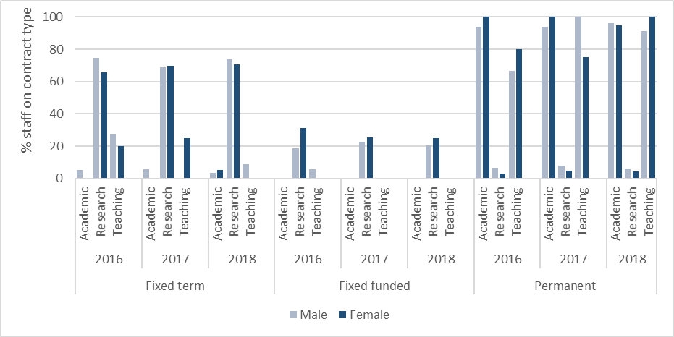

Figure 4.20: FoE academic, research and teaching staff – fixed-term, fixed-funded and permanent – percentage of staff on each category (detail in Table#4.17).

Overall 38.8% of females are fixed-term compared to 31.4% of males (Figure#4.20/Table#4.17). Research roles have the greatest proportion of female staff, but are disproportionately fixed-term due to the nature of grant funding. Gender percentages on permanent academic contracts and fixed-term contracts are comparable. Our career development programmes (e.g. Women Rising and Career Architects) specifically target researchers who are most likely to be on fixed-term, fixed-funded contracts (see Section#5), and our Redeployment scheme is equally effective for women and men (Table#4.18).

Table 4.17: FoE academic, research and teaching staff – fixed-term, fixed-funded and permanent.



Table 4.18: Redeployment of staff on fixed contract by grade.

|  |  |  |  |
| --- | --- | --- | --- |
| **Year** | **Academic Grade** | **All** | |
| **Gender** | **M** | **F** |
| **2015/16** | Redeployed | 5 | 4 |
| Left redeployment\* | 6 | 1 |
| Not redeployed\* | 14 | 2 |
| **% redeployed or left redeployment** | ***44%*** | ***71%*** |
| **2016/17** | Redeployed | 3 | 0 |
| Left redeployment | 7 | 4 |
| Not redeployed | 14 | 0 |
| **% redeployed or left redeployment** | ***42%*** | ***100%*** |
| **2017/18** | Redeployed | 7 | 1 |
| Left redeployment | 7 | 2 |
| Not redeployed | 10 | 3 |
| **% redeployed or left redeployment** | ***58%*** | ***50%*** |

\* Left redeployment indicates the staff member was removed from the redeployment register due to their being contract extended, finding employment outside of the scheme (within the University or externally), or due to resignation. Not redeployed indicates the staff member’s contract ended without alternative employment in place through the redeployment scheme or otherwise.

#### Academic leavers by grade and gender and full/part-time status

*Comment on the reasons academic staff leave the department, any differences by gender and the mechanisms for collecting this data.*

Table 4.19: FoE leavers by grade and category

|  |  |  |  |  |  |  |  |  |  |  |  |  |
| --- | --- | --- | --- | --- | --- | --- | --- | --- | --- | --- | --- | --- |
| **Grade/ category** | **2015/16** | | | | **2016/17** | | | | **2017/18** | | | |
| **Full-time** | | **Part-time** | | **Full-time** | | **Part-time** | | **Full-time** | | **Part-time** | |
| **M** | **F** | **M** | **F** | **M** | **F** | **M** | **F** | **M** | **F** | **M** | **F** |
| **6** | 4 | 1 | 1 | 0 | 4 | 0 | 0 | 0 | 2 | 1 | 0 | 1 |
| **7** | 27 | 7 | 3 | 1 | 25 | 6 | 3 | 1 | 27 | 11 | 1 | 1 |
| **8** | 1 | 1 | 1 | 0 | 1 | 0 | 0 | 0 | 5 | 0 | 0 | 0 |
| **9** | 3 | 1 | 1 | 0 | 1 | 0 | 1 | 0 | 0 | 0 | 1 | 0 |
| **10** | 2 | 0 | 2 | 0 | 0 | 0 | 1 | 0 | 2 | 0 | 1 | 1 |
| **MarieCurie** | 3 | 0 | 0 | 0 | 3 | 0 | 0 | 0 | 1 | 1 | 0 | 0 |
| **All** | 40 | 10 | 8 | 1 | 34 | 6 | 5 | 1 | 37 | 13 | 3 | 3 |
| **Academic** | 5 | 1 | 3 | 0 | 1 | 0 | 2 | 0 | 5 | 0 | 2 | 1 |
| **Research** | 35 | 9 | 4 | 1 | 33 | 6 | 3 | 1 | 31 | 12 | 1 | 2 |
| **Teaching** | 0 | 0 | 1 | 0 | 0 | 0 | 0 | 0 | 1 | 1 | 0 | 0 |

Table 4.20: Reasons for leaving: academic, research and teaching staff

|  |  |  |  |  |  |  |  |
| --- | --- | --- | --- | --- | --- | --- | --- |
|  | **Reason for leaving** | **2015/16** | | **2016/17** | | **2017/18** | |
|  | **%M** | **%F** | **%M** | **%F** | **%M** | **%F** |
| **ALL** | Resignation | 50 | 64 | 36 | 43 | 48 | 56 |
| Expiry of appointment | 40 | 36 | 59 | 57 | 45 | 44 |
| Retirement | 10 | 0 | 50 | 0 | 3 | 0 |
| Voluntary Severance | 0 | 0 | 0 | 0 | 5 | 0 |
| **Academic** | Resignation | 25 | 100 | 33 | 0 | 86 | 100 |
| Expiry of appointment | 13 | 0 | 0 | 0 | 0 | 0 |
| Retirement | 63 | 0 | 67 | 0 | 0 | 0 |
| Voluntary Severance | 0 | 0 | 0 | 0 | 14 | 0 |
| **Research** | Resignation | 54 | 60 | 36 | 43 | 41 | 57 |
| Expiry of appointment | 46 | 40 | 64 | 57 | 56 | 43 |
| Retirement | 0 | 0 | 0 | 0 | 0 | 0 |
| Voluntary Severance | 0 | 0 | 0 | 0 | 3 | 0 |
| **Teaching** | Resignation | 100 |  |  |  | 0 | 0 |
| Expiry of appointment | 0 |  |  |  | 0 | 100 |
| Retirement | 0 |  |  |  | 100 | 0 |
| Voluntary Severance | 0 |  |  |  | 0 | 0 |

Turnover data (Table#4.19) indicates fairly-even gender spread for leavers. Primary reasons (Table#4.20) are resignations (usually due to appointment elsewhere) and expiry of appointment (fixed-term and fixed-funded). Turnover is highest amongst researchers, which is attributable to the nature and funding of the roles. There is no significant difference between the proportion of male and female researcher leavers.

There are **no female leavers at grades 8, 9 and 10** (with exception of one PT professor based primarily in another Faculty); during the past 5 years, several female academics were promoted to these grades. It is reassuring that **we retain and grow our female leadership**: we believe this to be a positive impact of our supportive culture for female staff (Section#5).

All leavers are invited to complete an **“exit” questionnaire** (2018 response rate - 45%-F; 33%-M).

The majority were staff on fixed-term research contracts, and analysis shows **no issues with processes, management or any gender issues**. The most common reasons for leaving, other than end of fixed-term contract, were due to being offered another job or presented with another opportunity. All staff rated their experience at the University as positive.

**Word count: 2378**

## 5. Supporting and advancing women’s careers

### Recommended word count: Bronze: 6000 words | Silver: 6500 words

## 5.1. Key career transition points: academic staff

#### Recruitment

*Break down data by gender and grade for applications to academic posts including shortlisted candidates, offer and acceptance rates. Comment on how the department’s recruitment processes ensure that women (and men where there is an underrepresentation in numbers) are encouraged to apply.*

Faculty-only recruitment data was analysed; School numbers are too small to enable meaningful analysis. However, we have examined recruitment practice within Schools to identify challenges and best practice.

Figure 5.1: Overview of recruitment for academic and research staff – long-term trends\*

\* *Pre-2015 data was collected (Jan-Dec), post-2015 data was collected (Aug-Jul), data for 2015 is 6 months transition (Jan-Jul). We therefore compare proportions rather than absolute numbers. The past data did not explicitly separate teaching only staff, hence trends not possible to show.*

All recruitment is managed through FoE HR applying the University’s recruitment guidance, treating all applicants fairly and transparently at every stage.

To review our recruitment process, related to gender, we conducted:

* **Female recruitment study** - 2016, 8F offered an academic job (Silver-2016-Action).
* The study suggested that women are encouraged to apply for positions if they gain a positive feel for the School’s culture.

We revised the wording of job adverts and ensured associated recruitment images reflect staff diversity (Silver-2016-Action), and implemented several recruitment actions - **Action#1.1[C]**, **Action#1.5[C]**, **Action#1.7[C]**, **Action#1.8[C]**, **Action#4.1[C]**.

**New-Starters Survey –** all new staff since Aug-2017 [Response rate: 53%-female; 33%-male]. Two samples:

* + - **Group-A** (August-2017->January-2018; 7M/7F academic/research/teaching)
    - **Group-B** (August-2018->March-2019; 16M/6F academic/research/teaching)



**Improved interview experience** [evidenced by the new-starters survey]:

**All Group-B** responders agreed that information prior to/during the application process gave them a positive feel for the workplace culture (Group-A 85.7%-female; 100%-male).

**All responders** felt they had positive interview experience.

Table 5.1: Recruitment for academic, research and teaching staff by grade in the last 3 years (U means unspecified gender).

|  |  |  |  |  |  |  |  |  |  |  |  |  |  |
| --- | --- | --- | --- | --- | --- | --- | --- | --- | --- | --- | --- | --- | --- |
|  |  | **2015-2016** | | | | **2016-2017** | | | | **2017-18** | | | |
|  |  | **M** | **F** | **U** | **%F** | **M** | **F** | **U** | **%F** | **M** | **F** | **U** | **%F** |
| **Lecturer** | Application | 392 | 69 | 3 | 14.9 | 239 | 53 | 0 | 18.2 | 234 | 32 | 0 | 12.0 |
| **(gr 7 & 8)** | Interviewed | 60 | 9 | 1 | 12.9 | 19 | 8 | 0 | 29.6 | 38 | 4 | 0 | 9.5 |
|  | Offered | 9 | 3 | 0 | 25.0 | 5 | 2 | 0 | 28.6 | 11 | 1 | 0 | 8.3 |
|  | Appointed | 9 | 3 | 0 | 25.0 | 5 | 2 | 0 | 28.6 | 11 | 1 | 0 | 8.3 |
| **Associate** | Application | 25 | 7 | 0 | 21.9 | 29 | 5 | 1 | 14.3 | 26 | 1 | 0 | 3.7 |
| **Professor** | Interviewed | 8 | 1 | 0 | 11.1 | 6 | 1 | 1 | 12.5 | 8 | 0 | 0 | 0.0 |
|  | Offered | 4 | 0 | 0 | 0.0 | 2 | 1 | 1 | 25.0 | 5 | 0 | 0 | 0.0 |
| **(gr 9)** | Appointed | 3 | 0 | 0 | 0.0 | 1 | 1 | 1 | 33.3 | 3 | 0 | 0 | 0.0 |
| **Professor** | Application | 63 | 6 | 1 | 8.6 | 1 | 0 | 0 | 0.0 | 37 | 7 | 7 | 13.7 |
| **(gr 10)** | Interviewed | 12 | 1 | 0 | 7.7 | 1 | 0 | 0 | 0.0 | 15 | 3 | 4 | 13.6 |
|  | Offered | 6 | 0 | 0 | 0.0 | 1 | 0 | 0 | 0.0 | 5 | 1 | 0 | 16.7 |
|  | Appointed | 5 | 0 | 0 | 0.0 | 1 | 0 | 0 | 0.0 | 4 | 1 | 0 | 20.0 |
| **Academic** | Application | 480 | 82 | 4 | 14.5 | 269 | 58 | 1 | 17.7 | 297 | 40 | 7 | 11.6 |
| **Total** | Interviewed | 80 | 11 | 1 | 12.0 | 26 | 9 | 1 | 25.0 | 61 | 7 | 4 | 9.7 |
|  | Offered | 19 | 3 | 0 | 13.6 | 8 | 3 | 1 | 25.0 | 21 | 2 | 0 | 8.7 |
|  | Appointed | 17 | 3 | 0 | 15.0 | 7 | 3 | 1 | 27.3 | 18 | 2 | 0 | 10.0 |
| **Researcher** | Application | 679 | 180 | 0 | 21.0 | 563 | 147 | 1 | 20.7 | 646 | 142 | 1 | 18.0 |
| **(gr 6, 7, 8)** | Interviewed | 174 | 44 | 0 | 20.2 | 125 | 40 | 1 | 24.1 | 151 | 44 | 1 | 22.4 |
|  | Offered | 70 | 27 | 0 | 27.8 | 50 | 19 | 1 | 27.1 | 61 | 23 | 1 | 27.1 |
|  | Appointed | 60 | 26 | 0 | 30.2 | 42 | 18 | 1 | 29.5 | 54 | 19 | 1 | 25.7 |
| **Teaching** | Application | 138 | 17 | 2 | 10.8 | 58 | 17 | 0 | 22.7 | 78 | 13 | 0 | 14.3 |
| **(gr 6,7,8)** | Interviewed | 22 | 5 | 2 | 17.2 | 14 | 2 | 0 | 12.5 | 14 | 6 | 0 | 30.0 |
|  | Offered | 3 | 1 | 1 | 20.0 | 4 | 0 | 0 | 0.0 | 7 | 1 | 0 | 12.5 |
|  | Appointed | 2 | 1 | 1 | 25.0 | 4 | 0 | 0 | 0.0 | 6 | 1 | 0 | 14.3 |

* %**Female academic applications increased** from <10% 2013 to consistently between 11.6% and 17.7% in the past 5 years (Figure#5.1).
* **%Females interviewed and appointed to academic/research roles has improved** from being substantially below %Female of applications to being comparable; for 3 of the past 5 years the %Female shortlisted and appointed was above the %Female applying
* **%Female researchers shortlisted** is at or above %Female who apply, indicating that we attract strong female candidates.
* **%Female researchers appointed** exceeds %Female interviewed (trend in last 3 years)

Despite these improvements, there are some concerns:

* **Academic staff** data for **2017-18 is slightly concerning** - %Female applicants and shortlisted candidates has declined (though %Female appointed = %Female interviewed). This is predominately due to a drop in lecturer applications (Table#5.1). %Female applications and appointments vary between grade and Schools (Section#4.2). However, conversion rates (application->acceptance) have remained similar for all applicants (5%-female, 6%-male in 2017/18).
* While **researcher applications** have remained between 17%-21% over 7 years (Figure#5.1), this fluctuates and is **falling in 2017/18**.
* %Female recruited to **teaching roles** has been variable, between 0%-25% past 3 years (Table#5.1). Conversion rates (application->acceptance) in 2017/18 were equal (7.7%). This concerns a small recruitment pool; teaching scholarship is encouraged within lectureship roles.

Increasing the number of female applications is the key factor in recruitment of more females. As there was decline in %Staff who thought the **Faculty website gave them a good understanding of the Faculty’s culture (85.7% - Group-A; 66.7% - Group-B)**, we reviewed the visibility of our EDI on the Faculty/School website comparing to main competitors (together with a review for students – Section#4.1). Consequently, we added a new ‘**Working in the Faculty of Engineering**’ section, with information about our structure, people, EDI activities, staff benefits and contacts for all Schools (linked to within all job advertisements). The webpage about women in engineering is extended to include our broad range of EDI activities (**Action#1.1[C]**).

Feedback from recent appointments suggests that using staff networks and contacts to actively encourage more female applicants is likely to have positive impact. Early evidence from recent recruitments, where a diverse search panel was convened to help identify and approach candidates, suggests an increase in female applicants. Nevertheless, it is not clear what works in what contexts. We will therefore review current recruitment practice across schools (**Action#1.2[N]**) to learn from our experience; and will develop a more proactive marketing approach (**Action#1.3[N]**).

We actively monitor the **gender balance of shortlists** and the Dean requests justifications where there are single gender shortlists. Female academic representation is compulsory on all academic recruitment panels (Silver-2016-Action). We manage the pressure on female academic time by involving early-career staff (researchers/lecturers) on recruitment panels (**Action#1.8[C]**).



All staff involved in shortlisting and interview panels **undertake unconscious bias training** (**Action#4.1[C]**). Feedback from these sessions suggests positive impact on recruitment practice.

|  |  |
| --- | --- |
| *“I was not aware of my bias when judging quality of publications. I now keep an open mind and seek objective justification of quality in all recruitment/promotion panels.’’ [Assoc-Prof, F]* | *‘‘I now constantly question myself and try to put in place measures to avoid bias (e.g. through looking at CDT applications without names attached). I now find it very noticeable when others are showing some form of bias.”  [CDT-manager, M]* |

|  |  |
| --- | --- |
| **Action#1.1[C]** | Visibility of EDI, in particular related to gender, for all job advertisements. |
| **Action#1.5[C]** | Encourage PGR students to apply to researcher positions. |
| **Action#1.7[C]** | Consistently presenting a welcoming and inclusive environment. |
| **Action#1.8[C]** | Ensure diversity of recruitment panels for all staff posts in FoE. |
| **Action#4.1[C]** | Encourage all staff to undertake relevant equality and inclusion training (includes unconscious bias training for staff with recruitment responsibilities) |
| **Action#1.2[N]** | Review academic recruitment practices to identify what works in different contexts; learn from past experiences to improve our recruitment. |
| **Action#1.3[N]** | Expand job marketing to provide a more proactive approach for attracting diverse candidates to all jobs. |

#### Induction

*Describe the induction and support provided to all new academic staff at all levels. Comment on the uptake of this and how its effectiveness is reviewed.*

FoE staff induction includes:

* OD&PL course ‘**Introduction to Leeds**’ - all new-starters encouraged to attend.
* Faculty **compulsory induction** (completion monitored) - FoE-focused support to new-starters, awareness of our EDI policies (link with intersectionality).
* **Coffee morning with the Dean -** friendly welcome to the Faculty, informal networking; all new-starters and their line managers are invited.
* **School welcome meetings** with key staff - DoRI, DoSE, research/social groups.

Following feedback in the new-starters survey responses (Group-A), a **new induction checklist** was launched clarifying support and benefits available, including UoL working lives policies & welfare, EDI support and training. Improvement is noted in the New-Starters Survey (Table#5.2).

The New-Starters Survey is used by HR to monitor induction effectiveness and provide guidance to line managers. Following recent feedback about unclear probation targets for academics, we are **developing role specific** **templates** to support managers in setting **probation objectives** (**Action#2.1[C]**).

Table 5.2: New-Starter Survey responses from Academic Staff -   
Group-A (Aug-2017-Jan-2018); Group-B (Aug-2018-Mar-2019); induction list in place Aug-2018.

|  |  |  |  |  |
| --- | --- | --- | --- | --- |
|  | **Male** | | **Female** | |
| **Group-A** | **Group-B** | **Group-A** | **Group-B** |
| My induction was helpful. | 6/7 (85.7%) | 14/16 (88.9%) | 5/7 (71.4%) | 6/6 (100%) |
| I knew who to ask for help and guidance and was provided with sufficient support | 5/7 (71.4%) | 14/16 (88.9%) | 6/7  (85.7%) | 6/6  (100%) |
| I have been given a good initial impression of Faculty | 7/7  (100%) | 16/16  (100%) | 6/7 (85.7%) | 6/6 (100%) |

|  |  |
| --- | --- |
| **Action#2.1[C]** | Develop role specific templates to support managers in setting probation objectives for all staff categories and grades. |

#### Promotion

*Provide data on staff applying for promotion and comment on applications and success rates by gender, grade and full- and part-time status. Comment on how staff are encouraged and supported through the process.*

Table 5.3: Academic staff promotion during the census period.

|  |  |  |  |  |  |  |  |
| --- | --- | --- | --- | --- | --- | --- | --- |
| **Grade applied for** |  | **15/16** | | **16/17** | | **17/18** | |
| **Female** | **Male** | **Female** | **Male** | **Female** | **Male** |
| **All staff** | Applications | 0 | 17 | 2 | 10 | 4 | 15 |
| success rate % | *-* | *76%* | *100%* | *60%* | *100%* | *100%* |
| PT applications | 0 | 0 | 0 | 0 | 2 | 0 |
| PT success rate % | *-* | *-* | *-* | *-* | *100%* | *-* |
| **Grade 10** | Applications | 0 | 4 | 0 | 3 | 1 | 5 |
| success rate % | *-* | *100%* | *-* | *33%* | *100%* | *100%* |
| PT applications | 0 | 0 | 0 | 0 | 0 | 0 |
| PT success rate % | - | - | - | - | - | - |
| **Grade 9** | Applications | 0 | 9 | 0 | 3 | 3 | 6 |
| success rate % | *-* | *78%* | *-* | *67%* | *100%* | *100%* |
| PT applications | 0 | 0 | 0 | 0 | 2 | 0 |
| PT success rate % | *-* | *-* | *-* | *-* | *100%* | *-* |
| **Grade 8** | Applications | 0 | 3 | 0 | 3 | 0 | 4 |
| success rate % | *-* | *33%* | *-* | *67%* | *-* | *100%* |
| PT applications | 0 | 0 | 0 | 0 | 0 | 0 |
| PT success rate % | *-* | *-* | *-* | *-* | *-* | *-* |
| **Grade 7** | Applications | 0 | 1 | 2 | 1 | 0 | 0 |
| success rate % | *-* | *100%* | *100%* | *100%* | *-* | *-* |
| PT applications | 0 | 0 | 0 | 0 | 0 | 0 |
| PT success rate % | *-* | *-* | *-* | *-* | *-* | *-* |

**SRDS** and **AAM with HoS** discuss support available for academic staff to achieve promotion. All staff have access to **one-to-one promotion guidance** from HR before submitting their application and are encouraged to seek **application feedback** from senior academics. Those who are unsuccessful are provided with in-person feedback from the Dean and support from their HoS to identify developmental actions.

Promotions/SRDS workshops took place in Oct-2016 (Silver-2016-Action), although low numbers, an **increase in female promotion applications** followed.

In 2017/18, FoE had **100% promotion success rate** for all academic staff (Table#5.3);

**21% applications from female, same as %Female academic/research/teaching staff (20.1%).**

To maintain trajectory from 2017/18, we held another **series of promotion workshops,** in collaboration with the Faculties of MAPS and Environment. Led by the Faculty Deans, with HR support, these included networking sessions with recently promoted academics (9/15 networkers female).

Female academics were sent an encouraging email from their HoS. (42% female attendees 13/31), over double the %Female academic staff in the Faculty.

Positive feedback from FoE respondents (15):

* 87%- more likely to take practical actions towards achieving promotion (100% for female);
* 87%- following the session felt clear on where they are in the promotions process
* 93%- felt clear on where to find appropriate promotion support.

We will conduct follow-on questionnaires 6 and 12 months after the workshops to review impact (**Action#2.3[C]**).

**Promotion criteria** have been updated to include recognition of outreach and EDI (Silver-2016-Action). For academic progression there are two pathways: (i) Research and Innovation, (ii) Student Education (both routes rewarding “all-rounder” colleagues). Each pathway has core criteria plus additional criteria, which staff select to best reflect their own contributions. This facilitates rewarding external activities, such as “public/educational engagement”, “external collaboration”, and “mentoring/supporting colleagues”.

**Career breaks are explicitly accounted for in promotions**: During 2017/18 two female academic staff gained promotion (grades [Redacted] and [Redacted]) following their return from maternity/shared parental leave, suggesting effective process for staff taking career breaks for caring purposes.

**Feedback from 7 (5M/2F) academics promoted** **recently** indicated a fair/transparent process, encouragement at AAM/SRDS review, and effective support from colleagues. We will extend support available by linking people with a ‘promotion buddy’ (**Action#2.4[C]**).

|  |  |
| --- | --- |
| **Action#2.3[C]** | Regularly review the promotion experience and ensure that support is provided; run annual promotion refresher workshops for academic staff, and monitor their impact. |
| **Action#2.4[C]** | Develop, encourage and support all academic staff to apply for promotion, including all grades and the professorial bands. |

#### Department submissions to the Research Excellence Framework (REF)

*Provide data on the staff, by gender, submitted to REF versus those that were eligible. Compare this to the data for the Research Assessment Exercise 2008. Comment on any gender imbalances identified.*

Submissions to RAE2008 and REF2014 were made to five units of assessment (Table#5.4). **%Female submitted is comparable to %Male**; in all schools but ELEC has increased/remained the same between 2008-2014. ELEC had only 2 female academics. The only concern is REF2014 data for CIVE showing a drop in both men and women submitted, and only 8/19F submitted. This data also includes another academic department (Faculty of Environment, Institute for Transport Studies), hence it is difficult to determine if the lower proportion of women submitted was within CIVE.

Table 5.4: Submission to RAE2008 and REF2014 by gender





The REF2020 staff profile has not yet been compiled, however **provisional data suggests that there are no significant gender differences** in eligible staff or in the number of outputs associated with the staff.

|  |  |
| --- | --- |
| **Action#2.13[N]** | Analyse the FoE REF2020 submissions to identify if there are any potential concerns related to EDI. |

## 5.2. Key career transition points: professional and support staff – 551 words

#### (i) Induction

*Describe the induction and support provided to all new professional and support staff, at all levels. Comment on the uptake of this and how its effectiveness is reviewed.*

All new Faculty staff, whether Professional and Support Staff (PSS) or academic, undergo the **same induction procedures**, including the new (August-2018) induction checklist.



Responses from PSS to our **New-Starters Survey** (Section#5.1) shows early evidence of the **positive impact of the induction check list** on PSS induction (Table#5.5).

Table 5.5: New-Starters Survey responses from PSS   
 Group-A (Aug-2017-Jan-2018; 7M/14F); Group-B (Aug-2018-Mar-2019; 7M/9F).

|  |  |  |  |  |
| --- | --- | --- | --- | --- |
|  | **Male** | | **Female** | |
| **Group-A** | **Group-B** | **Group-A** | **Group-B** |
| My induction was helpful | 6/7 (85.7%) | 7/7  (100%) | 11/14 (78.6%) | 9/9 (100%) |
| I knew who to ask for help and guidance and was provided with sufficient support | 6/7 (85.7%) | 7/7  (100%) | 13/14 (92.8%) | 9/9  (100%) |
| I have been given a good initial impression of Faculty | 7/7 (100%) | 7/7  (100%) | 12/14 (85.7%) | 9/9  (100%) |

#### (ii) Promotion

*Provide data on staff applying for promotion, and comment on applications and success rates by gender, grade and full- and part-time status. Comment on how staff are encouraged and supported through the process.*

There are currently **three progression routes for PSS**: **(i)** successful application for a higher-grade role; **(ii)** a business need for the current role to develop and they can demonstrate the necessary capabilities to gain promotion; **(iii)** appointment at a “training grade” expecting development of the skills to progress to a higher grade over time via promotion. See Table#5.6.

Table 5.6: Promotion data for PSS taking routes (ii) and (iii); route (i) is not possible to monitor as job applications beyond FoE are not known by Faculty HR.

|  |  |  |  |  |  |  |
| --- | --- | --- | --- | --- | --- | --- |
|  | **15/16** | | **16/17** | | **17/18** | |
| **Female** | **Male** | **Female** | **Male** | **Female** | **Male** |
| Applications | 3 | 7 | 1 | 1 | 4 | 1 |
| success rate % | *100%* | *71%* | *100%* | *100%* | *75%* | *100%* |

**Promotion requirements** for all grades are published online and discussed at **annual SRDS meetings** with a prompted item for staff within two increments of the top of their grade. One of the outcomes from SRDS meetings is an agreed set of training activities to be undertaken, with financial support from a dedicated development budget where necessary. As with academic staff, it is **clearly communicated** that **career breaks are explicitly accounted for** in assessing satisfactory progression with additional training needs discussed with (and provided for) all colleagues following return to work. **All staff** are actively encouraged (and supported) to undertake development opportunities through SRDS.

Any unsuccessful PSS applications receive feedback on the unmet criteria, and clear explanation and suggestions how these might be addressed. The applicant is encouraged to further discuss with their SRDS reviewer.

The **People Management Framework** (PMF) survey in Oct-Nov-2017 (response rate 20%), indicated concerns about the **efficacy of SRDS meetings for technical staff** - 40% of technical respondents said they were not provided with helpful annual reviews. The majority of technical staff are male, which suggests that this may be a gendered issue. Consequently, technical line managers have been encouraged to attend: (i) refresher SRDS training that specifically focusses on supporting career development; and (ii) training for promotion panels, to gain a better understanding of how their staff can meet the criteria (**Action#2.2[C]**).

Five technical staff have been **promoted since July 2018** and three are in the process of submitting promotion applications, suggesting early positive impact from this action.

All these staff are male, suggesting further work is required to identify how to support female technical staff through promotion. This was also highlighted in our focus group with technicians (**Action#2.5**).

**Feedback** from recently promoted PSS indicated that **they felt well-supported**, suggesting early positive impact from our actions responding to PMF-survey.

|  |  |  |
| --- | --- | --- |
| *“my Head of School encouraged me to apply for promotion” (female)* |  | *“I had many meetings with the technical officer during the procedure” (male)* |
|  |  | |
| *“I have been supported exceptionally well by my manager, … identifying scope for me to expand my skills and experience… also benefitted enormously from having a mentor…” (female)* | | |

|  |  |
| --- | --- |
| **Action#2.2[C]** | Regularly review the promotion experience and ensure that support is provided to address the needs of diverse staff. |
| **Action#2.5[N]** | Explore issues that may block career progression and promotion for female technicians, and feedback into central UoL SRDS reviewer training and local SRDS refresher training. |

## 5.3. Career development: academic staff

#### (i) Training

*Describe the training available to staff at all levels in the department. Provide details of uptake by gender and how existing staff are kept up to date with training. How is its effectiveness monitored and developed in response to levels of uptake and evaluation?*

Each school has a **staff development budget** which is combined with the Faculty’s central investment in leadership and career progression initiatives. **Total staff training investment: £111,000** (Aug-2015-Jul-2018).

**Staff are kept informed of training opportunities** by their SRDS reviewers, regular advertisement via staff mailing lists, Dean’s email, and nomination/encouragement by senior management.

In the FoE Leavers Survey, **no academic staff reported a lack of development/training** as a contributing factor in their decision for leaving in 2016-17 and 2017-18, while 3 academics reported this as a contributing factor in 2015-16 (1F).

This positive change due to proactive encouragement of all academics to undertake training (**Action#2.11[C]**), is influenced by improved SRDS reviewers’ training and checklist for SRDS meetings. Table#5.7 summarises uptake of career/development training.

Table 5.7: Career development training uptake for academic staff by gender

|  |  |  |  |  |  |  |
| --- | --- | --- | --- | --- | --- | --- |
| **Academic staff training** | **2015/16** | | **2016/17** | | **2017/18** | |
| **F** | **M** | **F** | **M** | **F** | **M** |
| Induction programme | *7* | *24* | *3* | *15* | *5* | *7* |
| Career Architects | *2* | *3* | *-* | *-* | *1* | *4* |
| Springboard (women only) | *2* | *-* | *1* | *-* | *-* | *-* |
| Women Rising (women only) | *-* | *-* | *13* | *-* | *12* | *-* |
| Aurora (women only) | *2* | *-* | *2* | *-* | *3* | *-* |
| Learning to lead | *-* | *-* | *-* | *-* | *0* | *1* |
| Leadership Excellence | *-* | *-* | *1* | *4* | *0* | *1* |



The FoE developed the **Career Architect scheme** (2013) to **help postdoctoral researchers** with their career development (academia/industry). Since 2013, 25 Engineering researchers have been through the programme (**28% female**). Career Architect is now rolled out University-wide (all Faculties), managed by OD&PL.

|  |
| --- |
| *Career Architect**has helped me to understand the support available and where to find it when I start to apply for funding or if I decide to apply for a fellowship” (Female-Researcher)* |

The **Women Rising** programme supports the career development of female PGRs in engineering and physical sciences - funded by EPSRC in 2017; **funded by the Faculties of Engineering, MAPS, and Environment in 2018**. It aims to develop a range of academic skills - grant/fellowship writing, networking and presentation, and tackling issues identified as disproportionately affecting women (e.g. lack of confidence, ‘imposter syndrome’). Training is coupled with follow-up support, professional career coaching and peer learning.

2017-18, **26 (of 38) participants in Women Rising were from FoE** (75%-postdocs, 25%-PGR). All 17 participants who provided feedback from the first cohort of the programme **remain in academia** (Table#5.8). Participant feedback indicated **positive impact on personal development and career progression**.

|  |  |  |
| --- | --- | --- |
| *“...advice about continuing an academic career, helped me gain confidence and inspired me by introducing many role models” (Female-Wellcome-fellow)* |  | *“…covered many areas of academic careers, helped me fill gaps. After that I was developing three networks for technical communities on campus…” (Female-[Redacted] fellow)* |
|  |  |  |

Table 5.8: Career progression following completion of Women Rising (includes only those who responded to a survey on the impact of the programme).

|  |  |  |
| --- | --- | --- |
| **At March 2017** | **At June 2018** |  |
| Teaching Fellow | Associate Professor | 1 |
| From postdoc | Lecturer | 1 |
| From postdoc | Research Fellowship | 2 |
| From postdoc | Continue to external/internal postdoc | 5 |
| From postdoc/postgrad | Complete, return overseas | 4 |
| Current PhD | Continues PhD studies | 4 |

|  |  |
| --- | --- |
| **Springboard** is designed for female staff to help them build their workplace confidence, identify their personal values, and develop their professional networks. The small number of academics who have attended found it very helpful. | ***“****Springboard helped me to be more focussed, and assess situations in a more rounded manner and realistically…”  (Female-Assoc-Prof)* |

**Aurora** is a similar programme to Springboard but targets female leadership skills development. Run by the Leadership Foundation for Higher Education, its goal is to increase the number of women in senior roles in HE through skills workshops and networking opportunities.

We continuously encourage and support female **academics to attend Aurora**, which has **positive impact on their confidence and career development** (see case studies).

|  |  |  |  |
| --- | --- | --- | --- |
| *“…very useful to define my career goals and my strategy and approach to achieve those.’  (Female-UAF)* | |  | *“…I have mixed feelings about Aurora…I gained a formal mentor, who was supportive and had a big impact;…I feel programmes for females only act to widen the gap in terms of equality rather than narrow it” (Female-Professor)* |
|  |  | | | |

Few women have attended the UoL leadership training (*Learning-to-Lead*/*Leadership-Excellence*), missing opportunities for building local networks and gaining better understanding of University management (**Action#2.7[C]**). In our recent promotion survey, two female academics noted that they were encouraged to attend but decided not to enrol as the benefit was not clear (**Action#2.11[C]**).

**E&I training** needs are regularly reviewed, proactively seeking opportunities to provide such training in a timely and effective manner. FoE actively encourages uptake of all E&I training opportunities offered within the University and have contributed to the development of the new online E&I training. A half-day **unconscious bias training** was developed in partnership with the Faculties of MAPS and Environment.

**Unconscious bias training** is completed by **39% of FoE staff**. Whilst all staff are encouraged to attend, it is particularly aimed at staff involved with recruitment (impact on fair recruitment process, Section#4.2) and management responsibilities (impact on culture, Section#5.6)

**All staff** undertake the University’s **online E&I training**, uptake is monitored, regular reminders are communicated via the Dean’s email and direct emails to staff who have not yet completed it. Currently, **63% of FoE staff** have completed at least one in-person or online E&I training course.

|  |  |
| --- | --- |
| **Action#2.7[C]** | Senior management teams will be encouraged to support diverse academics to attend appropriate leadership training, and to provide opportunities for staff at grades 9 and 10 to gain leadership experience. |
| **Action#2.11[C]** | Continue to promote the positive impact of participation in career training programmes and review the effectiveness of these programmes |

#### (ii) Appraisal/development review

*Describe current appraisal/development review schemes for staff at all levels, including postdoctoral researchers and provide data on uptake by gender. Provide details of any appraisal/review training offered and the uptake of this, as well as staff feedback about the process.*

**SRDS** is an opportunity for staff and line managers to set and discuss objectives, and practical steps for their achievement over the upcoming year. All academic staff must also complete an **annual academic meeting (AAM)**, with their HoS to discuss their academic contribution, achievements, and future plans, complementing what is covered in the SRDS.

We **support SRDS reviewers** providing training/refresher sessions to ensure they are aware of promotions processes and are confident to provide advice. FoE made it compulsory all SRDS reviewers to complete E&I training (during 2017/18) and strongly encourages them to also attend the unconscious bias workshop.

The **Dean, supported by HR, ran a series of sessions for managers** covering SRDS, and encouraged managers to consider flexible working when supporting staff development (**Action#2.2[C]**). 32 staff have attended the University SRDS reviewer training course in the past 3 years (12 female and 20 male). Recent promotion of the updated SRDS training (early 2019) led a further **4 academic staff (2 male; 2 female) to sign up**.

Crucial for staff new to academia is the **probation period**. HR have created **role specific templates to assist probation managers** in setting academic probation plans. PMF survey and recent New-Starters survey indicated issues with the clarity of probation objectives (Table#5.8). We are in the process of creating probation templates for all ART roles (**Action#2.1[C]**).

Table 5.8. New-starters survey: ‘My probation and personal development plan was created promptly, with their input, and included arrangements for training’.

|  |  |  |
| --- | --- | --- |
|  | **July 17 – Jan 18** | **Jan 18 – July 18** |
| **Female** | *6/7  (85.8%)* | *4/6*  *(67%)* |
| **Male** | *6/7*  *(85.7%)* | *8/16 (50%)* |

|  |
| --- |
| *“My probation adviser …has helped me to be confident about setting realistic goals considering my academic, research and family commitments.” (Fellowship-holder)* |

We ran a **survey with female academics who were recently promoted (5F)**. Among the questions, we explored whether their review process provided career support.

All survey responders noted that their promotion and professional development was discussed at their SRDS reviews, and found these discussions helpful and encouraging.

|  |  |
| --- | --- |
| **Action#2.1[C]** | Develop role specific templates to support managers in setting probation objectives for all staff categories and grades. |
| **Action#2.2[C]** | Improve SRDS reviewer refresher training to ensure all reviewers show consideration of the individual needs of our diverse staff. |

#### (iii) Support given to academic staff for career progression

*Comment and reflect on support given to academic staff, especially postdoctoral researchers, to assist in their career progression.*

The Faculty’s ambition to grow its **early-career researcher pool** is accompanied with our strong commitment to **retain/develop** our postdoctoral researchers.

The University runs a **UAF scheme** (**FoE currently has 18 UAFs, 6 Female).** This is 5-year career development (networking/training/mentoring), leading to associate professor progression.

In November 2018, we ran a **focus group with postdoctoral researchers** (2M/2F) covering the topic of **career progression**.

* All felt the **support for career progression** was of **excellent quality** and available for all stages, from getting fellowship, towards writing large grants and becoming academic.
* All participants were currently engaging in activities to develop their careers (e.g. visiting fellowships abroad, career architects training).

Female participants identified **work-life balance as a main concern** to pursue an academic career. In response to this, our ‘Breaking Boundaries in STEM’ event (see Section#5.6(i)) for the International Women’s Day was dedicated to **Women in Research: How to have a rewarding career and work-life balance** (Figure#5.2).

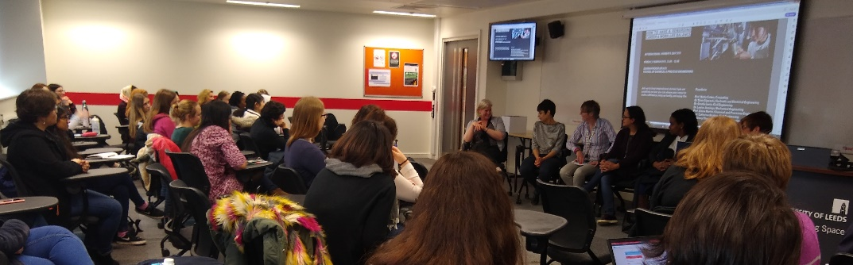

Figure 5.2: Breaking Boundaries in STEM panel on Women in Research: early career researchers discuss with female academics career and work-life balance: raising family, multi-tasking, feeling valued and supported, seeking help.

Highly positive feedback (39 participants, 3M; 69%-FoE, 23%-other faculties)

* **96%** felt it **inspired them** with regard to their research career, **panel discussion very helpful**;
* **92%** are likely to **attend future similar events**.

The Women in Research event was attended by researchers from across the University. We plan to **extend our Breaking Boundaries in STEM** across the University. Following themes identified during events, we will **develop an online space to** channel informal mentoring support to a broad range of people, and reach those unable to attend face-to-face meetings. (**Action#5.1[C]**)

We encourage Staff to become involved in **mentoring both as a mentor and a mentee**, and actively promote the University’s mentoring scheme (participation is shown in Table#5.9).

Table 5.9. Uptake of the University’s mentoring scheme by Engineering staff (dual role includes staff who engaged as both mentors and mentees)

|  |  |  |  |  |  |  |  |  |
| --- | --- | --- | --- | --- | --- | --- | --- | --- |
| **Year** | **Total** | **Academic** | **PSS** | **Male** | **Female** | **Mentors** | **Mentees** | **Dual Role** |
| **2015/16** | 21 | 11 | 10 | 9 | 12 | 13 | 6 | 2 |
| **2016/17** | 11 | 7 | 4 | 4 | 7 | 2 | 8 | 1 |
| **2017/18** | 16 | 9 | 7 | 4 | 12 | 7 | 9 | 0 |

We also encourage **informal mentorship**, many academics at grade 9 and 10 act as informal mentors (recognised in promotion, Section#5.1(iii)).

|  |  |
| --- | --- |
| **Action#5.1[C]** | Actively engage with the University equality and inclusion structures to shape and pioneer new interventions to address key diversity and inclusion issues, focusing on under-represented groups (includes Breaking Boundaries) |

#### (iv) Support given to students (at any level) for academic career progression

*Comment and reflect on support given to students at any level to enable them to make informed decisions about their career (including the transition to a sustainable academic career).*

All **UG/PGT students** have a personal tutor who provides academic support, pastoral care, and is able to refer students to specialist services as required.

Our unique on-site **FoE employability team** (*‘Most Improved commitment to employability 2016’* / *‘Best University placement service in 2018’*) manages regular talks with industry, CV checks, mock-interviews, personalised career consultations (>500 1-to-1 appointments, >100 online-CV-checks per academic year). Selected events **target female engineers**, recently: a trip to the British Gypsum office (Figure#5.3); talks from Sky Betting/the Gaming industry on Digital health and cybersecurity.

|  |
| --- |
| Figure 5.3: British Gypsum female students visit on the International Women in Engineering Day in 2018 (11 attendees). Similar visit took place in 2017 (10 attendees). |

|  |  |
| --- | --- |
|  |  |

Figure 5.4: We use web and social media to actively encourage our female students to undertake summer internships (left) and industrial placements (right).

The employability team supports students to undertake **industry placement** as part of their undergraduate degree. Uptake is encouraged by inviting previous placement students to give talks, organising a poster presentation, and online visibility (Figure#5.4).

Over 4 years, **300% increase in female UG taking up a year in industry** placement

2015/16-2017/18, **177% increase in Access-to-Leeds students** (widening participation) undertaking year in industry placements (**Action#3.10[C]**).

|  |  |
| --- | --- |
| *“… I’ve seen a lot of women here and I was able to talk to them and find out how much they enjoy their jobs. It was really motivating and makes me want to continue doing what I’m doing.” (Female-PGT)* |  |

**UG/PGT transition to research** is supported through **research internships**. FoE promotes: UoL-Laidlaw and EPSRC scholarships. FoE offers own summer internship scheme, funding placements in industry/on campus. Schools encourage female students to apply through their personal tutors and School champions.

**PGR student support** is embedded throughout the whole student journey. Day-to-day support is provided by **supervisors**, however a wide range of **PGR progression support** is offered by the University, signposted via the Faculty graduate office newsletter.

To address challenges for, and provide additional support to, female PGRs academic staff are setting up support groups (**Action#3.11[N]**). PGR students are also eligible for the Women Rising scheme (25%-PGR student participants, Section#5.3(i)).

We conducted a **PGT/PGR student** **focus group (5F/4M)** to find out about their experience and career development.

* Students enjoyed the opportunities that FoE offer to work alongside industry during their studies, with some citing it as a reason for choosing us above other universities.
* **Female students felt overwhelmed at the prospect of pursuing a career in academia**.

In response to this we have tried to demystify the academic career route through increased visibility of role models (Section#5.6), and inspiration through ‘Breaking Boundaries in STEM’ (Figure#5.2/5.5).

|  |
| --- |
| Figure 5.5: Breaking boundaries in STEM: Celebrating Ada Lovelace and Black History month – encouraging students to engage in research, jointly organised by the CDT in Fluid Dynamics, COMP and ELEC. |

The **Women in Engineering society** (student-led) was formed in 2015 with support from FoE, to help foster ‘stronger networking links between women at every level of the career ladder’. It hosts events including industrial presentations, Q&A sessions and skills workshops (**Action3.12[C]**).

Working with the alumni office, we helped develop the gift agreement with the Steel Scholarship Fund. Commencing in 2019/20, FoE will offer **The Steel Innovation Award** providing **£1000** to a **female student (UG/PGT/PGR)** who has an idea/invention they would like to develop with the support of the award (**Action#3.14[N]**).

|  |  |
| --- | --- |
| **Action#3.10[C]** | Continue to work with the employability team to ensure our diverse UG & PGT students are supported in their transition to employment. |
| **Action#3.11[N]** | We will provide additional support for underrepresented PGT/PGR groups run by academic staff with relevant experience (runs in CAPE, forming in COMP, ELEC champion piloting support for PGR with children). |
| **Action#3.12[C]** | We will engage better with student societies to gather feedback on career support offered for students, and to maximise the impact of E&I events. |
| **Action#3.14[N]** | Run the female Steel Innovation Award (in memory of Margaret Steel – female researcher and innovator) and review its impact. |

#### Support offered to those applying for research grant applications

*Comment and reflect on support given to staff who apply for funding and what support is offered to those who are unsuccessful.*

**Grant applications are supported through:**

* local mentoring within Schools from line managers and colleagues;
* School peer review processes for larger grant applications;
* allocation of time in workload for scholarship activities;
* support for networking activities to develop proposals from School research development funds;
* mobility and impact funding supported through Faculty.

University and FoE Research and Innovation Services provide active support to individuals and groups including training, networking, financial/contracts support, assistance with impact plans and coordination of large proposals. Recent **grantsmanship training workshops**, involved **40% female attendees** (10/25). All research staff are encouraged and supported in applying for research grants. Staff who are unsuccessful are offered additional mentoring, typically by staff who have been successful and can share experiences.



Positive impact of our research grant application support is evidenced with **female successes**:

* **Similar %Male & %Female awarded grants** over the past three years (Table#5.10).
* Women associated with **24% of the total value of funding** in FoE (despite the eligible pool of females who could be named on a grant application being between 17.3%-20.1%,).
* Women are more likely to bring in **funding as Principal Investigator**.

Table 5.10: Analysis of grant awards in FoE

|  |  |  |  |  |  |  |
| --- | --- | --- | --- | --- | --- | --- |
|  | % of total FoE grants awarded by value | | % of staff awarded funding | | % of funding (by value) awarded as PI | |
|  | F | M | F | M | F | M |
| 2015-16 | 25% | 75% | 44% | 44% | 49% | 70% |
| 2016-17 | 18% | 82% | 59% | 60% | 82% | 44% |
| 2017-18 | 29% | 71% | 45% | 52% | 93% | 72% |
| Average | 24% | 76% | 49% | 52% | 75% | 59% |

The Faculty runs an inclusive selection process for fellowship nominations, all of whom receive University training and support for **EPSRC/RAEng/Leverhulme Fellowships,** and **EU**/**UKRI Future Leaders Fellowships**.

**Women** represent **73% of fellowship award-holders** over the past three years (Table#5.11). We actively encourage fellowship applications through both open calls and directly approaching staff with appropriate career profiles, offering informal mentoring.

Table 5.11: Fellowships awarded in FoE

|  |  |  |  |
| --- | --- | --- | --- |
|  | **School** | **M/F** | **Fellowship** |
| 2015-16 | SCAPE | [Redacted] | ERC Consolidator Grant |
| 2015-16 | SCAPE | [Redacted] | EU Marie Curie Individual Fellowship |
| 2016-17 | SCAPE | [Redacted] | Leverhulme Early Career Fellowship |
| 2016-17 | CIVIL | [Redacted] | RA Eng Research Fellowship |
| 2016-17 | MECH | [Redacted] | RA Eng Senior Research Fellowship |
| 2016-17 | ELEC | [Redacted] | EU Marie Curie Individual Fellowship |
| 2016-17 | COMP | [Redacted] | Leverhulme Early Career Fellowship |
| 2016-17 | MECH | [Redacted] | ERC Advanced Grant |
| 2016-17 | CIVIL | [Redacted] | EPSRC ECR Fellowship |
| 2017-18 | SCAPE | [Redacted] | Royal Comm Exhib 1851 Fellowship |
| 2017-18 | ELEC | [Redacted] | UKRI Innovation Fellowship |
| 2017-18 | CIVIL | [Redacted] | UKRI Innovation Fellowship |
| 2017-18 | SCAPE | [Redacted] | EPSRC ECR Fellowship |
| 2017-18 | CIVIL | [Redacted] | EPSRC ECR Fellowship |
| 2017-18 | COMP | [Redacted] | EPSRC RSE Fellowship |



As a result of the support mechanisms, **the year-on-year success rate for females has increased** both in the number of grants, %funding by value and number of fellowships. This success helps other women, providing role models and mentoring to support applications.

|  |  |
| --- | --- |
| **Action#2.12[N]** | We will do more detailed analysis to understand funding variation by grade, relate award to application rates, and to evaluate other protected characteristics. |
| **Action#2.12[N]** | Form a Faculty of Engineering Diversity Leadership Forum to understand experiences of people from under-represented groups in leadership positions and develop diverse leadership across the FoE (especially engaging female PI on external grants). |

## 5.4. Career development: professional and support staff

#### (i) Training

*Describe the training available to staff at all levels in the department. Provide details of uptake by gender and how existing staff are kept up to date with training. How is its effectiveness monitored and developed in response to levels of uptake and evaluation?*

**Training needs** for the coming year are identified during the annual **SRDS meeting** for all staff (Section#5.2). This may include external courses where suitable training is not offered by OD&PL. Table#5.12 summarises the main programmes available to PSS, Table#5.13 illustrates positive impact on encouraging PSS females to participate in Springboard and Aurora, see Section#5.3(i).

Table 5.12: Leadership and development training undertaken by PSS.

|  |  |  |  |  |  |  |
| --- | --- | --- | --- | --- | --- | --- |
| **PSS staff training** | **2015/16** | | **2016/17** | | **2017/18** | |
| **F** | **M** | **F** | **M** | **F** | **M** |
| Learning to lead | *-* | *-* | *2* | *1* | *1* | *0* |
| Springboard/Aurora (women only) | *0* | *0* | *1* | *-* | *5* | *-* |
| Aurora (women only) | *-* | *-* | *-* | *-* | *1* | *-* |

Table 5.13: Registrations onto the Springboard scheme by PSS in FoE.

|  |  |  |  |
| --- | --- | --- | --- |
|  | **2015/16** | **2016/17** | **2017/18** |
| Academic staff | 2 | 1 | 0 |
| PSS staff | 0 | 1 | 5 |

The effectiveness of training is monitored at University level, via training evaluation forms. Feedback from PSS staff provides an early indication that enrolling on such courses is worthwhile.

There are several compulsory online courses, including on **E&I/Unconscious Bias** (see Section#5.6). An increased number PSS take part in such sessions.

#### (ii) Appraisal/development review

*Describe current appraisal/development review schemes for professional and support staff at all levels and provide data on uptake by gender. Provide details of any appraisal/review training offered and the uptake of this, as well as staff feedback about the process.*

The **SRDS scheme** has >90% uptake each year (with no discernible difference by gender). Staff are required to reflect on their achievements, to set objectives and agree necessary training for the coming year. All reviewers are required to undertake training (see Section#5.3(ii)). This training is supplemented with sessions run by the Dean whenever there are any significant updates to be rolled out (most recently this was during the 2017/18 year).

#### (iii) Support given to professional and support staff for career progression

*Comment and reflect on support given to professional and support staff to assist in their career progression.*

We provide a **wide range of support** to reflect the needs of PSS colleagues across a broad range of roles.

|  |  |
| --- | --- |
| For technical staff, we provide an award winning **apprenticeship scheme** (Figure#5.6) for progression from Grade 2/3 through to Grade 5, following a programme of training combined with formal external qualifications. There are no female technicians currently on this scheme (though we have had female trainee technicians previously) (**Action#1.4[N]**). | Figure 5.6: University of Leeds (FoE) is awarded Apprenticeship levy employer of the year, 2018. |

Colleagues in higher technical grades benefit from the University-wide Technicians Network to ensure that best practice in support and development is shared. Our AS Technical lead represents the Faculty on the University Technicians’ Commitment working group, which works to increase technicians’ opportunities for visibility, recognition, career development and the sustainability of their skills.

|  |  |
| --- | --- |
| We provide support (**time and funding)** to PSS staff to undertake professional qualifications to support their career development: CIPDs, financial qualifications, external professional development training. | *‘…support included working flexible hours to accommodate classes, and encouragement from colleagues at all levels across the Faculty… The knowledge and skills gained, and the qualification, opened up the range of roles available to me to advance my career.” (Female-PSS)* |

The Faculty re-launched its **mentoring scheme** for all staff (including PSS): the data for staff joining the scheme over the past three years is provided in Table#5.14. Note that we exchange mentors and mentees with other STEM faculties to try to match as many staff as possible.

Table 5.14: PSS mentors and mentees joining the mentoring scheme in each of the past 3 years.

|  |  |  |  |  |  |  |  |  |  |
| --- | --- | --- | --- | --- | --- | --- | --- | --- | --- |
| **Mentoring** | **Total** | **Academic** | **PSS** | **Male** | **Female** | **Not matched** | **Mentors** | **Mentees** | **Dual Role** |
| **15/16** | 21 | 11 | 10 | 9 | 12 |  | 13 | 6 | 2 |
| **16/17** | 11 | 7 | 4 | 4 | 7 | 2 | 8 | 1 |  |
| **17/18** | 16 | 9 | 7 | 4 | 12 |  | 7 | 9 |  |

|  |  |
| --- | --- |
|  |  |

We will seek to increase the engagement in mentor scheme across the full range of PSS (**Action#2.8[C]**).

An important PSS career progression development has been the UoL realignment of professional service teams since Aug-2017, allowing opportunities to be shared more widely. Tangible examples are **secondments to other Faculties** to broaden experience, increased **“acting-up” opportunities** when cover is required (backfill) and **enhanced training opportunities** by working across Faculties.

|  |  |
| --- | --- |
| **Action#1.4[N]** | Develop appropriate mechanisms to increase the number of female applications to technical staff positions. |
| **Action#2.10[N]** | Explore how participation in professional networks can support staff groups, considering the needs of diverse staff. |
| **Action#2.8[C]** | Further increase the engagement in the mentor scheme across the full range of academic, research, teaching, professional, support and technical staff (in terms of grade, departments and Faculty services). |

## 5.5. Flexible working and managing career breaks

***Note: Present professional and support staff and academic staff data separately***

#### (i) Cover and support for maternity and adoption leave: before leave

*Explain what support the department offers to staff before they go on maternity and adoption leave.*

Individuals planning **maternity leave/adoption leave/shared parental leave/career breaks**, are invited to **meet with HR** and provided with relevant support and guidance, including policy clarification and information about reasonable adjustments. Following feedback from line managers, HR devised template emails to send to managers to act as a prompt to the University’s maternity/adoption/SPL checklists (**Action#4.5[C]**). This includes agreeing appropriate levels of contact during leave, promoting local guidance regarding support for those taking leave related to caring responsibilities, and highlighting entitlement to paid time-off for antenatal classes. Pregnant staff complete a detailed risk assessment with their line manager, supported by Faculty Health & Safety.

|  |  |
| --- | --- |
| **Action#4.5[C]** | Ensure staff considering taking maternity leave, adoption leave, shared parental leave, or career breaks are provided with appropriate advice and support. |

#### (ii) Cover and support for maternity and adoption leave: during leave

*Explain what support the department offers to staff during maternity and adoption leave.*

The University maternity leave policy is **more generous than statutory maternity leave**, and all staff with more than 12 months continuous employment are eligible. It also recommends **a reasonable level of contact with between individual and line manager**, and HR prompt managers and staff to agree how best to do this: keeping-in-touch days are encouraged – for which childcare costs are reimbursed. This is both to keep the employee informed of changes within their area, to make the process of returning to work easier, and for managers to put any necessary adjustments in place prior to their return. A key principle of the policy is that cover must be arranged by the HoS to avoid any backlog of work arising whilst the employee is on leave.

#### (iii) Cover and support for maternity and adoption leave: returning to work

*Explain what support the department offers to staff on return from maternity or adoption leave. Comment on any funding provided to support returning staff.*

The FoE introduced new ‘**Guidance to support staff returning from leave related to caring responsibilities**’ in 2018. It applies to all staff, influenced the subsequent University-wide guidance, and **outlines the support provided** to ensure a smooth transition back to work, including:

* phased returns;
* personal development plans
* flexible working
* prioritisation of PhD studentship allocation (for academic staff)
* offering a mentor to support the transition,
* financial support to assist re-connection linked to work activity (e.g. conference and training course attendance, including support to assist with caring costs).
* a review meeting 3 months following return
* an option to extend probation periods for those on maternity leave to ensure adequate time to complete objectives after returning to work.

We will review the impact of the new guidance on retention/development of staff (**Action#4.6[C]**).

The **University also has a policy for carers leave** which provides 5-days pro rata in a rolling 12-month period for staff to take emergency days-off. The University’s **Bright Beginnings Nursery** offers subsidised places to staff and students and free childcare places during open days.

We created **two wellbeing rooms** (Silver-2016-action) to be used for different reasons, including staff returning from maternity leave who need to express milk.

|  |
| --- |
| “…I was given step-by-step guidance throughout the period up to my departure, and had regular check-ins with HR during my time on maternity leave… useful measures such as access to a wellbeing room to express milk, and a clear flexible working policy have helped put my mind at ease...” (Female-research-fellow) |

|  |  |
| --- | --- |
| **Action#4.6[C]** | Promote and monitor uptake and effectiveness of the FoE policy on returning from caring leave and support for conference and training attendance |

#### (iv) Maternity return rate

*Provide data and comment on the maternity return rate in the department. Data of staff whose contracts are not renewed while on maternity leave should be included in the section along with commentary.*

|  |
| --- |
| SILVER APPLICATIONS ONLY  Provide data and comment on the proportion of staff remaining in post six, 12 and 18 months after return from maternity leave. |
|  |

**Table** **5.15: Return rates for maternity leave (all staff, academic staff, and support staff)**

|  |  |  |  |
| --- | --- | --- | --- |
| **All FoE staff** | **2015/16** | **2016/17** | **2017/18** |
| Number taking maternity leave (return date in listed academic year) | 6 | 8 | 8 |
| Number returning after leave | 6 | 8 | 6\* |
| Number in post six months after returning from leave | 6 | 8 | 6 |
| Number in post 12 months after returning from leave | 6 | 8 | 4\* |
| Number in post 18 months after returning from leave | 6 | 7\* | 2\* |
| **Academic, research and teaching staff** | **2015/16** | **2016/17** | **2017/18** |
| Number taking maternity leave (return date in listed academic year) | 4 | 3 | 4 |
| Number returning after leave | 4 | 3 | 3\* |
| Number in post six months after returning from leave | 4 | 3 | 3 |
| Number in post 12 months after returning from leave | 4 | 3 | 1\* |
| Number in post 18 months after returning from leave | 4 | 3 | 0\* |
| **Professional and support staff** | **2015/16** | **2016/17** | **2017/18** |
| Number taking maternity leave (return date in listed academic year) | 2 | 5 | 4 |
| Number returning after leave | 2 | 5 | 3\* |
| Number in post six months after returning from leave | 2 | 5 | 3 |
| Number in post 12 months after returning from leave | 2 | 5 | 3 |
| Number in post 18 months after returning from leave | 2 | 4\* | 2\* |

Explanation to the cases with \* in Table#5.15:

* [Redacted]
* [Redacted]
* [Redacted]
* [Redacted]

|  |
| --- |
| These cases did not highlight any specific issues: an indication of the effectiveness of our mechanisms to support maternity return. |

#### (v) Paternity, shared parental, adoption, and parental leave uptake

*Provide data and comment on the uptake of these types of leave by gender and grade. Comment on what the department does to promote and encourage take-up of paternity leave and shared parental leave.*

**Our HR webpage** gives significant information on policies for shared-parental-leave and paternity/partner leave, and reminders are **communicated to all Faculty staff via emails from the Dean** at regular intervals. Due to low uptake of shared-parental-leave, we acted to increase awareness of this. The recently **revised induction checklist** includes signposting staff to this information and the Faculty HR team are updating the Faculty SharePoint to include key information and benefits to Faculty staff (**Action#4.5[C]**). Our **Footsteps booklet** (Section#5.6) highlights positive shared-parental-leave experiences.

Table#5.16 shows variation in uptake of paternity/partner leave between years. HR meet with all staff considering such leave to ensure they are fully informed on our policies; they also provide template emails for managers to provide support checklists (before, during and after).

Table 5.16: Uptake of paternity/partner leave

|  |  |  |  |
| --- | --- | --- | --- |
| **Paternity/partner Leave** | **2015/16** | **2016/17** | **2017/18** |
| All staff | 9 | 3 | 9 |
| Academic staff | 9 | 2 | 6 |
| Support staff | 0 | 1 | 3 |

Although numbers are low for uptake on shared parental leave two FoE staff members used this, one on a regular basis each year, and one who has a child with learning difficulties, to take further leave during school holidays to support their child care.

|  |  |
| --- | --- |
| Following these actions, **two new fathers** have recently indicated that they will **take shared-parental-leave**, an increase in male uptake from previous years. | *“I took almost half a year of shared parental leave after our son was born in February 2017. It was really fantastic to have that opportunity.” (Male-UAF)* |

No staff have taken adoption leave since 2015.

|  |  |
| --- | --- |
| **Action#4.5[C]** | Ensure staff considering taking maternity leave, adoption leave, shared parental leave, or career breaks are provided with appropriate advice and support. |

#### (vi) Flexible working

*Provide information on the flexible working arrangements available.*

The **University’s flexible working policy**, promoted on the University’s HR intranet,offers a wide range of flexible working options. FoE promotion is through SRDS, Annual Academic Meetings, and via HR colleagues supporting individual needs. Managers meet with individuals to discuss requests, and are expected to actively seek adjustments to make such arrangements work: trial periods are typically used to confirm the practicalities.

|  |
| --- |
| *“I have used the flexible working policy quite regularly to decrease and increase my hours linked to both child care and caring for an elderly relative and my manger has always been supportive which is a great stress relief for me and helped me to maintain a health work life balance.”  (female-PSS- flexible-working)* |

FoE allows managers to agree local arrangement with individuals to work more flexibly, such as differing start and finish times (often linked to school drop-off times/caring for an adult).

Table 5.17: Uptake of flexible working arrangements

|  |  |  |  |  |  |  |
| --- | --- | --- | --- | --- | --- | --- |
| **Flexible working** | **15/16** | | **16/17** | | **17/18** | |
| **F** | **M** | **F** | **M** | **F** | **M** |
| All staff | 3 | 0 | 8 | 0 | 4 | 10 |
| Academic staff | 0 | 0 | 3 | 0 | 2 | 8 |
| Support staff | 3 | 0 | 5 | 0 | 2 | 2 |

All formal flexible working requests over the past three years (Table#5.17) have been approved. The majority (60%) are associated with childcare (two thirds of which followed maternity/paternity/shared parental leave – this is in line with our ‘**Guidance to support staff returning from leave related to caring responsibilities**’, which encourages managers to support such requests. We will continue to promote and collect feedback on shared parental and parental leave, flexible working arrangements, and support policies for carers (**Action#4.5[C]**).

Surveys in other Faculties at UoL have shown that staff can sometimes feel disadvantaged when working flexibly: missing staff meetings and social events on the days they do not work, or with meeting deadlines (e.g. marking or setting exams) when less time is available for this. We will conduct further analysis of flexible working with a view to improving FoE policies and practice (**Action#4.7[N]**).

|  |  |
| --- | --- |
| **Action#4.7[N]** | Gain better understanding of experiences of diverse staff undertaking flexible working, focusing on gender and disability |
| **Action#4.5[C]** | Ensure staff considering taking maternity leave, adoption leave, shared parental leave, or career breaks are provided with appropriate advice and support |

#### (vii) Transition from part-time back to full-time work after career breaks

*Outline what policy and practice exists to support and enable staff who work part-time after a career break to transition back to full-time roles.*

Our ‘**Guidance to support staff returning from leave related to caring responsibilities**’ encourages managers to support staff returning from career breaks through a range of options from phased return through to flexible working. On request, we have put staff who have taken a career break in touch with others who have had similar circumstances, so that they can provide peer mentoring support. We will review the effectiveness of mentoring support for those returning from career break and will explore other forms of support such as staff support groups (**Action#4.6[C]**).

|  |  |
| --- | --- |
| **Action#4.6[C]** | Promote and monitor uptake and effectiveness of the FoE policy on returning from caring leave and support for conference and training attendance |

## 5.6 Organisation and culture

#### (i) Culture

*Demonstrate how the department actively considers gender equality and inclusivity. Provide details of how the Athena SWAN Charter principles have been, and will continue to be, embedded into the culture and workings of the department.*

Integrated within the broader FoE EDI strategy, **Athena SWAN is embraced as a major E&I enabler** for developing FoE as a place where everyone is valued and supported to realise their potential. Following our broad engagement model (Section#3), AS principles are embedded in all major Faculty structures. Our action plan is regularly reviewed and we pro-actively seek inputs to monitor our progress.

We conducted a **student culture survey** in 2018, open to all UG, PGT, and PGR students to explore issues including gender, ethnicity, and sexual orientation (**Action#3.15[C]**). The findings were acted on with FEC and HoS.

* Almost all respondents to the survey felt they were **encouraged to develop** regardless of gender (96.3%), ethnicity (95.6%), or sexual orientation (100%).
* Students generally agreed that **there is no difference in the way that students are treated** because of their gender (75.9%), ethnicity (71.1%), or sexual orientation (77.3%).

The study indicated **two major challenges**.

Firstly, female students (especially intersection with ethnicity) felt they had **less chances for career realisation**. In response we launched the series ‘**Breaking Boundaries in STEM**’ to challenge societal assumptions of who can be an engineer and increase visibility of diverse role models (examples given earlier). Invitations to these events are sent to all staff and students; three events held to-date:

* Intersection of ethnicity and gender in engineering careers (~40/F+M)
* Empowering people with disabilities (~20/F+M)
* Work-life balance as a female academic (~50/F+M)

82% of feedback indicated attendees felt inspired with regard to their own career.

Secondly, 36% of females did not know how to report **inappropriate behaviour**; concerns were raised that such behaviour happens in social settings. We therefore developed a **Mutual Respect campaign** aimed to emphasise the FoE E&I values, with reference to reporting avenues for inappropriate behaviour/harassment.

The **Mutual Respect campaign** was designed in partnership with EPU (**Action#3.16[C**). It makes the University’s policy on Dignity and Mutual Respect more accessible for all students, and gives FoE’s mutual respect values broad visibility. The campaign includes:

* Promotion of values through posters/electronic boards/flyers;
* Updated student inductions (currently in PGR, UG/PGT induction from 2019);
* Guidance to staff through emails and staff meetings;
* An online space for students and staff with details of University’s Dignity and Mutual Respect policy, available support, and relevant events.

|  |  |
| --- | --- |
| Figure 5.7: Mutual Respect Campaign poster | Figure 5.8: Virtual Athena SWAN, Equality and Inclusion space for students available on the Virtual Learning Environment |

ASEI is a driver for **wellbeing activities** (in 2016, 60% of FoE mental health related absences were women). We created a **Wellness Programme** for staff experiencing mental health issues. In the 2017-2018 trial 9 of 11 participants were female. Participants reported high levels of satisfaction with the programme and data suggests a significant increase in wellbeing and a reduction in average absence levels.

The positive impact is such that the **Wellness Programme** is being rolled out University-wide. Male uptake of this scheme will be monitored following low male uptake in FoE.

|  |  |
| --- | --- |
| In 2018 the FoE launched our ‘**Wellbeing for All**’ sessions (Figure#5.9), delivered by staff counselling, aiming to give staff a toolkit for self-resilience. Attendance to-date is 83% female (need to better engage males), 90% found sessions helpful and would attend again. We are planning to expand our Wellbeing-for-All to address health-related issues, such as menopause, pregnancy and disability (**Action#4.12[C]**). | Figure 5.9: Wellbeing for All flyer. |

Our ASEI awayday raised concerns about work-life balance and email culture, which was taken to the FEC. This resulted in a decision to develop **FoE guidance on email responses and out-of-working-hours availability**, providing best practice (e.g. email signatures, postponing emails) on the ASEI SharePoint space (**Action#4.13[N]**).

|  |  |
| --- | --- |
| **Action#3.15[C]** | Conduct periodically student culture survey to understand experiences of our diverse UG, PGT, PGR students and address any challenges they may experience. |
| **Action#3.16[C]** | Develop a Mutual Respect campaign for students to support them in dealing effectively with inappropriate behaviour or unconscious bias. |
| **Action#4.12[C]** | Proactively respond to staff wellbeing needs and monitor the effectiveness of the current Wellbeing For All activities |
| **Action#4.13[N]** | Develop and pilot FoE guidance on out-of-working-hours availability for potential roll out across the University |

#### (ii) HR policies

*Describe how the department monitors the consistency in application of HR policies for equality, dignity at work, bullying, harassment, grievance and disciplinary processes. Describe actions taken to address any identified differences between policy and practice. Comment on how the department ensures staff with management responsibilities are kept informed and updated on HR polices.*

We follow the University of Leeds **policies to support staff** including; flexible working, carers leave and maternity/adoption/shared parental leave. While our policies align with the University, we actively drive new policies, practices and guidance.

FoE HR and academic staff have helped to shape the **revised promotions criteria**, and developed schemes to **support staff returning from caring leave,** and **support conference and training course attendance support**, that are being adopted University-wide.

Guidance on policies and support is available to staff through the **Faculty HR Sharepoint**. Policy updates are shared through the Dean’s and HoS emails, school management teams and annual SRDS reviewer briefings. Fortnightly HR casework meetings are key in maintaining equality policy and practice and to monitor uptake of online E&I training. HR are responsive to issues raised by individuals, Heads of School and through surveys. For example, feedback from our student culture survey and focus group with postgraduate students resulted in HR developing an **unconscious bias training session** specifically for technicians in their student-facing role.

The **UoL’s code of conduct on professional behaviour and relationship** explains the appropriate procedures for staff reporting unprofessional behaviour/concerns (including unacceptable behaviour). HR policies relating to dignity and respect are assessed via responses to the PMF survey (every 2 years), with all complaints being investigated with HR support to ensure policy is adhered to. The recent PMF survey (Jan-Mar-2019), 78.5% of the 186 respondents felt FoE provided supporting and inclusive environment.

Mechanisms for gathering feedback from staff are in place (**Action#4.4[C]**).

|  |  |
| --- | --- |
| **Action#4.4[C]** | Maintain ‘You said, we did’ space for equality and inclusion to gather feedback from all students and staff and to report our actions; explore broader mechanisms (e.g. PMF survey/staff culture survey) |

#### (iii) Representation of men and women on committees

*Provide data for all department committees broken down by gender and staff type. Identify the most influential committees. Explain how potential committee members are identified and comment on any consideration given to gender equality in the selection of representatives and what the department is doing to address any gender imbalances. Comment on how the issue of ‘committee overload’ is addressed where there are small numbers of women or men.*

Membership of most of FoE committees (Table#5.18) is determined by job role (only Faculty Board and ASEI openly call for self-nomination). School committees are partially determined by job role (leadership staff), but also have members who are elected staff and/or students. Leadership roles (DoRI/DoSE) and research institute/group leads are openly advertised with a transparent appointment process, period of tenure and workload allowance. Senior roles (Dean/Pro-Dean/HoS) involve a formal recruitment process. In all cases senior leaders actively encourage appropriate nominations and support those applying.

We **aim for at least 20% female membership** in all committees (**Action#4.9[C]**).

|  |  |
| --- | --- |
| **Action#4.9[C]** | Increase female membership in all committees, when the %Female staff allows this. CIVE and ELEC to extend the female membership in teaching committees. Adopt CAPE best practice in engaging diverse students in student-staff forum in other schools. |

**Table** **5.18: Faculty and School Committee Membership**



#### (iv) Participation on influential external committees

*How are staff encouraged to participate in other influential external committees and what procedures are in place to encourage women (or men if they are underrepresented) to participate in these committees?*

The numbers of staff on strategic national research committees (Table#5.19) is small however %Female is higher than %Female staff in FoE. The %Female EPSRC peer review college full membership (Table#5.20) is comparable to the %Female in FoE, although is variable by school,and the %Female associate members is low (**Action#2.14[N]**).

|  |  |  |  |  |  |  |  |  |  |  |  |  |  |  |  |  |  |  |  |  |  |  |  |  |  |  |  |  |  |  |  |  |  |  |  |  |  |  |  |  |  |  |  |  |  |  |  |  |  |  |  |  |  |  |  |  |  |  |  |  |  |  |  |  |  |  |  |  |  |  |
| --- | --- | --- | --- | --- | --- | --- | --- | --- | --- | --- | --- | --- | --- | --- | --- | --- | --- | --- | --- | --- | --- | --- | --- | --- | --- | --- | --- | --- | --- | --- | --- | --- | --- | --- | --- | --- | --- | --- | --- | --- | --- | --- | --- | --- | --- | --- | --- | --- | --- | --- | --- | --- | --- | --- | --- | --- | --- | --- | --- | --- | --- | --- | --- | --- | --- | --- | --- | --- | --- | --- |
| Table 5.19: Membership of national strategic research committees and societies over the past three years (includes current and previous members)   |  |  |  | | --- | --- | --- | | **Committee** | **M** | **F** | | UKRI strategy | 4 | 4 | | Royal Academy of Engineering strategy | 7 | 2 | | REF 2021 panels | 2 | 1 | | REF 2014 panels | 3 | 1 | | Fellow Royal Society | 0 | 1 | | Total UK influential committees | 16 | 9 | | % on UK influential committees | 64% | 36% | | Table 5.20: Membership of EPSRC peer review college   |  |  |  |  |  | | --- | --- | --- | --- | --- | |  | **Full** | | **Associate** | | |  | **M** | **F** | **M** | **F** | | CAPE | 12 | 3 | 6 | 1 | | CIVIL | 5 | 2 | 6 | 1 | | COMP | 13 | 1 | 0 | 1 | | ELEC | 7 | 1 | 6 | 0 | | MECH | 9 | 3 | 4 | 0 | | FoE | 46 | 10 | 22 | 3 | | %Members | 82% | 18% | 88% | 12% | |

Examples of female (varying career levels/roles) participation on **national/international discipline-related committees** are provided in Table#5.21.

Table 5.21: Illustrative examples of committee participation for female

|  |
| --- |
| **Prof. Elaine Martin, CAPE, OBE FREng FIChemE CEng** |
| * Chair of Heads of Chemical Engineering UK (2015 – 2017) * EPSRC Capital and Equipment Strategic Advisory Team * Steering Group Member of RAEng Industrial Secondment Scheme * EPSRC Peer Review College Full Member * Trustee Board of the Royal Academy of Engineering |
| **Prof. Ruth Wilcox, MECH** |
| * Royal Academy of Engineering Panel for Biomedical Engineering * EPSRC peer review college full member * Chaired panels for various grants/fellowships/mid-term reviews * Advisory Board member Versus Arthritis Biomechanics and Bioengineering Research Centre, Cardiff |
| **Dr. Vania Dimitrova, Assoc. Prof, COMP** |
| * Executive committee of International AI in Education Society; Steering committee of ECTEL * Horizon 2020 evaluation and review panels * Program chair for AIED, UMAP, ECTEL, chair of >20 international workshops; Doctoral consortium chair UMAP, Industry engagement chair AIED/ICLS * EPSRC ICT diversity working group member |
| **Dr. Louise Jennings, Assoc. Prof, MECH** |
| * Chair of International Standards committee for Bone & Joint Replacements ISO/TC150/SC4 * Convenor of ISO/TC150/SC4/WG3 – Wear * BSI committee CH150/SC4 and CH150/SC2 * ASTM International Standards F04.22 Arthroplasty Subcommittee |
| **Dr Lisa-Dionne Morris, Senior Teaching Fellow, MECH** |
| * Honorary Trustee ‘The Board of Trustees of Bradford Girls’ Grammar School’, UK * Global Chief Examiner - Design Technology, Global International Baccalaureate The Hague & Singapore * Executive Advisor; Global Innovation & Digital Technology, Leonard Cheshire Disability, UK/Asia/Africa |
| **Dr. Isolde Adler, Lecturer, COMP** |
| * External assessor, selection of a new professor in Mathematical Logic at the University of Helsinki * Member of the Steering Committee of ReLaX, an Indian-French Research Lab in Computer Science * Co-organiser of the 45th International Workshop on Graph-Theoretic Concepts in Computer Science * PC member of CIAC, ICDT, ISAAC, CSR, STACS, WG |
| **Dr. Claire Brockett, University Academic Fellow, MECH** |
| * Engagement Officer for the British Orthopaedic Research Society * Member of BSI committee CH150/SC4 |
| **Dr Fleur Loveridge, University Academic Fellow, CIVE** |
| * EDI Committee, UK Institution of Civil Engineers * Int. Society for Soil Mechanics and Geotechnical Engineering, Technical Committee Energy Geotechnics * Geotechnique Advisory Panel Member * EPSRC Peer Review college, Associate Member |
| **Dr. Joanna Leng, Research Software Engineering Fellow, COMP** |
| * Visiting Scientist at Diamond Light Source * Archer Champion – UK National Supercomputing Service / RSE leaders network * Workshop organiser at RSE 2018 conference called “Implicit None” on unconscious bias * EPSRC Peer Review college, Associate Member |

**Influencing EDI**: EPSRC diversity working groups (2xF); AS panel member (M); Institution of Civil Engineers ED&I committee (F); The Technician Commitment (M); ISIAQ ED&I founder/co-chair (F); Google Women Techmakers panel (F); Women in academia committee (4F); University LGBT (M&F); Building equality (M&F); UoL AS consultation group (3F); AS adviser (2F).

**Participation on external committees is recognised** through the promotions process (Section#5.1), criterion “external collaboration” recognises external engagement. We encourage participation through AAM/SRDS, and directly encouraging people to apply when opportunities are advertised. Staff who sit on strategic national or discipline-related committees receive a workload allowance and travel support. However, we have identified that the level of encouragement/support varies between schools (**Action#2.14[N]**).

|  |  |
| --- | --- |
| **Action#2.14[N]** | Actively encourage women and men to participate in external influential committees, and continue to support applications |

#### (v) Workload model

*Describe any workload allocation model in place and what it includes. Comment on ways in which the model is monitored for gender bias and whether it is taken into account at appraisal/development review and in promotion criteria. Comment on the rotation of responsibilities and if staff consider the model to be transparent and fair.*

We provide workload allocation for AS/E&I activities (Section3):

* AS chair (20%);
* E&I coordinator (10%);
* School champions (5%) and working group leads (5%)
* Outreach coordination at School level is recognised on a case-by-case basis.

The Faculty provides a set of workload principles that are adopted by each School in its detailed workload allocation. These include:

* Time paid for on external grants/funding is allocated in full;
* T**i**me allocation for teaching should reflect staff workload (preparation, delivery, feedback/assessment).
* Time is allocated for “University and professional service” (reflecting the volume of agreed activity).
* Time is allocated for PhD student supervision, scholarship and own-funded research.

Academic staff workload is agreed at AAM meetings with their HoS/DoRI/DoSE, and accounts for changes to teaching teams, research grants and admin roles. We have not identified any differences in teaching and admin workload between male and female staff.

#### (vi) Timing of departmental meetings and social gatherings

*Describe the consideration given to those with caring responsibilities and part-time staff around the timing of departmental meetings and social gatherings.*

We hold School/Faculty meetings, activities and social gatherings on varying days and times throughout the academic year, as appropriate. These are planned and announced well-ahead of time to support staff with a part-time or flexible work pattern. We schedule all staff and committee meetings/key events within core hours (10:00-16:00). Seminars vary with some during core hours, and others early evening to enable external industry participation (**Action#4.7[N]**).

|  |  |
| --- | --- |
| **Action#4.7[N]** | Extend visibility of diverse staff and students across FoE (priority on visibility of PSS and researchers; also includes expanding Footsteps booklet). |

#### (vii) Visibility of role models

*Describe how the institution builds gender equality into organisation of events. Comment on the gender balance of speakers and chairpersons in seminars, workshops and other relevant activities. Comment on publicity materials, including the department’s website and images used.*

Visibility of diverse role models is embedded into our communications, practices and physical spaces (Figure#5.10). We are working to increase representation of postdoctoral researchers and technicians (**Action#4.8[C]**).

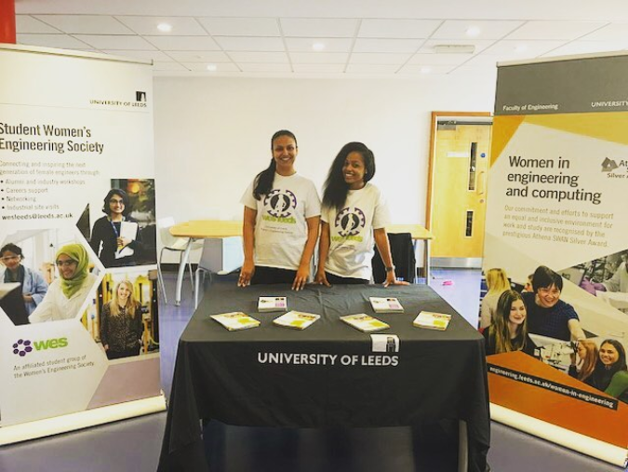

Figure 5.10: Women in Engineering stand at open days.

We created a **Footsteps booklet** (**Action#4.8[C]**) which showcases the diversity of our staff though detailed profiles of male and female colleagues - a celebration of our staff diversity (Figure#5.11).

**Visibility online** is vital to our inclusive culture. FoE/School websites recognise significant achievements of all staff and students, including underrepresented groups (Figures#5.12/5.13/5.14).

|  |  |
| --- | --- |
|  |  |
|  |  |

Figure 5.11: Example screenshots from the FoE Footsteps booklet.

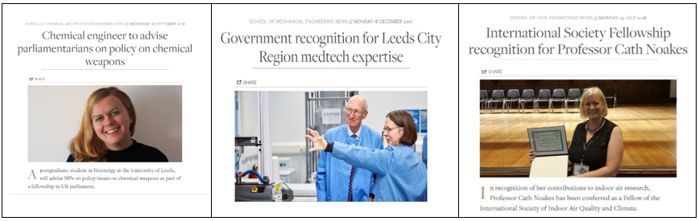

Figure 5.12: Online visibility of role models – recognising achievements of our diverse students and staff.

**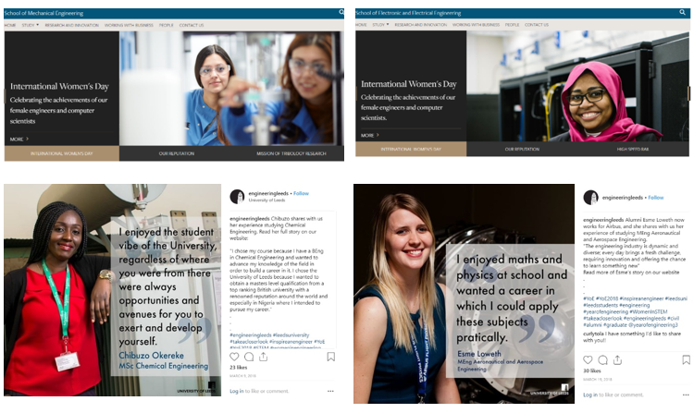**

Figure 5.13: Annual online campaign on the International Women’s Day to celebrate the success of our students and alumni.

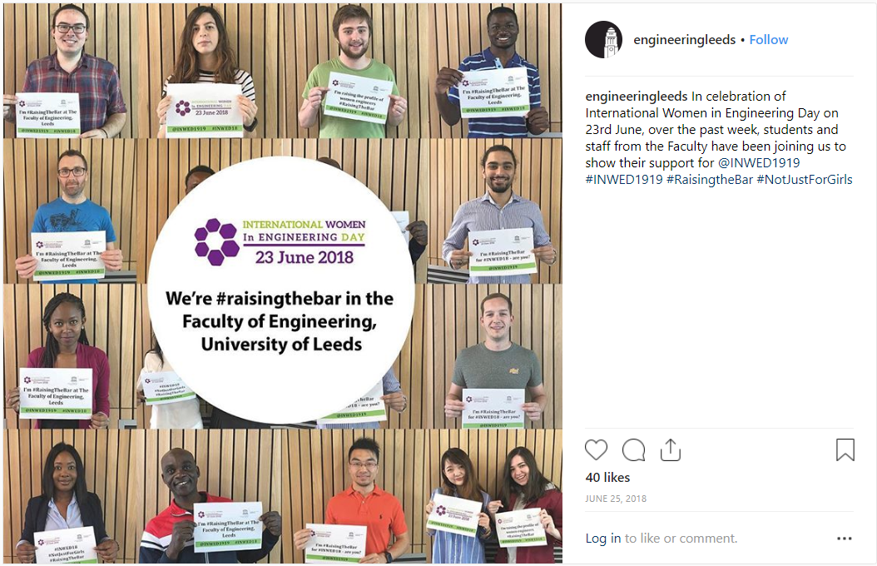

Figure 5.14: Women in Engineering day campaign to celebrate the diversity in our Faculty.

We have **audited seminar speakers** across FoE by school and gender (**Action#4.10[C]**). This prompted schools to take immediate action to improve their %Female speakers which is evident in Table#5.22.



%Female speakers at **our School seminars** has increased to well above the proportion of women in the Faculty (Table#5.22)

**Table 5.22: The proportion of seminar speakers who are female, across the Faculty.**

|  |  |  |  |  |
| --- | --- | --- | --- | --- |
|  | **15/16** | **16/17** | **17/18** | **18/19** |
| **% female speakers** | 15% | 14% | 17% | 37% |

|  |  |
| --- | --- |
| To support diversity in student-facing events, COMP compiled a “top tips” list on organising inclusive events; piloted in a recent “hackathon” organised by COMP (Figure#5.15) - %**Female increased from 7%-2017 to 19%-2018.** | Figure 5.15: FinTech hackathon organised by COMP, sponsors PWC, YBS, and HSBC. |

**Table 5.23: the proportion of female speakers and delegates at our CPD events.**

|  |  |  |  |
| --- | --- | --- | --- |
|  | **15/16** | **16/17** | **17/18** |
| **% female speakers** | 18% | 18% | 21% |
| **% female delegates** | 29% | 28% | 32% |

Continuous monitoring of gender balance, proactive search for speakers, and wide promotion is leading to an increase of the proportion of female speakers and attendees at external-facing **CPD programmes** (1050 speakers/4807 delegates over the past 3 years).

|  |  |
| --- | --- |
|  |  |

|  |  |
| --- | --- |
| **Action#4.8[C]** | Extend visibility of diverse staff and students across FoE (priority on visibility of PSS and researchers; also includes expanding Foosteps). |
| **Action#4.10[C]** | Ensure that the gender balance of speakers in School/Institute seminar programmes, conferences and CPD events is at least comparable to the proportion of female academics in the School/discipline (includes seminar speaker audits). |

#### (viii) Outreach activities

*Provide data on the staff and students from the department involved in outreach and engagement activities by gender and grade. How is staff and student contribution to outreach and engagement activities formally recognised? Comment on the participant uptake of these activities by gender.*

Each School is involved in outreach activities, to raise awareness of, and aspirations towards, higher education, engineering and STEM (**Action#3.4[C]**). Participation is encouraged via SRDS/AAM, recognised at all staff meetings, and included in staff workload (whenever responsibilities involve substantial contributions). Researchers’ engagement in outreach is frequently part of their research project/fellowship activities. UG/PG students understand how engagement strengthens their career portfolio. Contributions of staff and students are recognised via annual nominations for the Faculty Partnership Award.



We collected data about typical outreach activities in each school (sample size: **39 different activities** - not including regular open days), Table#5.24/Figures#5.16-5.22.

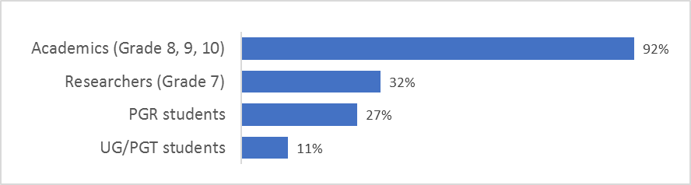

Figure 5.16: Involvement of staff in outreach activities (% of events that have a representative from the corresponding category).

|  |  |  |
| --- | --- | --- |
|  | |  |
| Figure 5.17: Percentage of activities in each category (left) and audience coverage (right – note an event can target more than one audience type, hence % does not add up to 100%). | | |

Table 5.24: Example outreach evens which run annually in FoE, not including open days (Staff indicates both Researchers and Academics).

|  |  |  |
| --- | --- | --- |
| **Event: description** | | **FoE Participants** |
| **Headstart**: on-campus; week long; engaging primarily girls, age 16-17, widening participation (being replaced with FoE widening participation summer school) | | Acad. Gr 8, 9 (M) |
| **Annual Nuffield Training Events:** on-campus; mixed gender, widening participation; activities to inspire career in STEM | | Researchers (M/F) Acad. Gr 9(F), Gr 10(M) |
| **Visits:** on-campus, visits by students, teachers, parents, various activities to inspire career in engineering; mixed gender; various times by all FoE schools | | Staff (M/F) Gr7-10 PGR students (M/F) |
| **The transformation trust campus visits:** on-campus; mixed gender, widening participation; 1 week activities to develop employability skills | | Acad. Gr 8, 9 (M/F) |
| **Work/research placements:** on-campus, opportunities to engage in career-related activities; secondary school & A-level students, mixed gender | | Staff (M/F) Gr 7-10 |
| **Network Rail career event:** on-campus, girls, secondary school, career in STEM | | Acad. Gr 8 (F) |
| **Code First Girls:** on-campus, female, university students, digital skills training | | UG stud. (M/F), Gr9 (F) |
| **BlackFemTech:** on-campus, girls, BAME, university students | | UG stud. (F) |
| **Career talks:** in-school, mixed gender, secondary school and A-levels | | Staff (M/F) Gr 7-10 |
| **Discover Robo Maths:** in-school (UTC), mixed gender, engineering career skills | | PGR stud (F) |
| **Engineering workshop:** in-school/on-campus; to inspire engineering careers | | Staff (M/F) Gr 7-10 |
| **Leeds Festival of Science:** external; various places around Leeds, general public | | Staff/PGR stud. (F/M) |
| **Be Curious:** on-campus; day activity to popularize science to general public | | Staff/PGR stud. (F/M) |
| **Science fair exhibits:** external; various places in the region and country | | Staff/PGR stud. (F/M) |
| **Leeds Digital Festival:** external, various places around Leeds, industry | | Staff (M/F) Gr 7-10 |
| **Leeds women in ICT town event:** external, female-only, industry/general public | | Staff Gr 7(F), Gr 9 (F) |
| **PubHD:** external, monthly, PGR students present their work to general public | | PGR stud (M/F) |
| **Pint of Science:** external, annual science talks, general public, 18+ | | Staff Gr 7+ (M/F) |
| FoE outreach spans **across the whole pipeline** (Figure#5.16), the majority involves mixed gender (Figure#5.17), with **female-only events** focused around key points influencing transitions (secondary school -> HE; university -> career). | | Figure 5.18: Audience gender for FoE outreach activities (% indicates proportion of events with the corresponding gender category) | | |

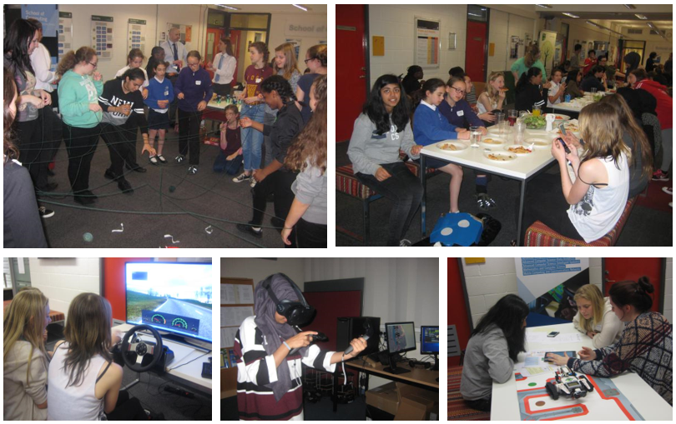

Figure 5.19: Ada Lovelace day outreach event 2017, on-campus – students participate in various activities a combination of light games and technical activities.

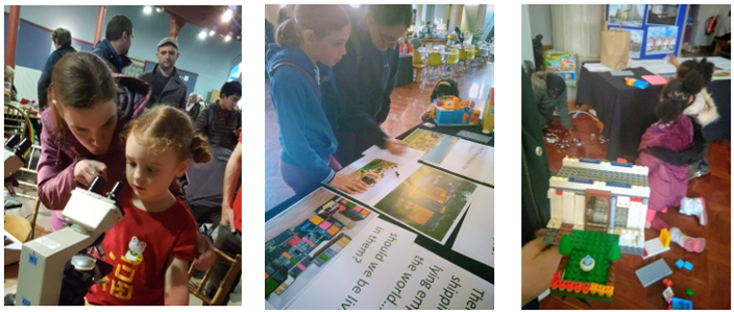

Figure 5.20: Example ‘Be Curious’ 2019 FoE stands: inspire curiosity and interest in STEM.

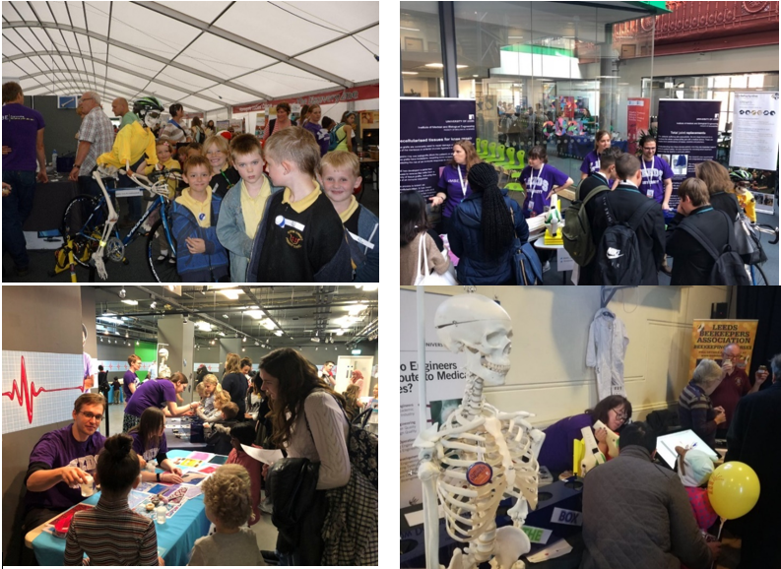Figure 5.21: Institute of Medical Engineering general public outreach: (top to right) Festival of Science; Leeds City College; Otley Science festival; Operation Ouch Half Term, Media Museum.

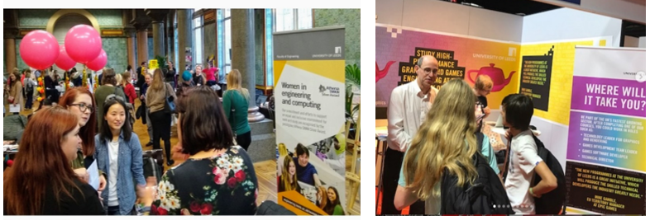

Figure 5.22: Outreach activities with industry: women in technology Leeds town meeting (left); staff and UG students present at national gaming and graphics event (right).

|  |  |
| --- | --- |
| **Action#3.4[C]** | 3.4[C] Engage in outreach activities which tackle societal expectations around what careers women can pursue. |

Word count: 7140

To insert a landscape page, please copy from the first red marker down to here and paste into the document where the landscape page is required.

## 6. Case Studies

|  |  |
| --- | --- |
|  | **Dr. Taisir Elgorashi**  SAT-member  ELEC-Champion |

I arrived in Leeds in 2007 to pursue my PhD in optical communication networks in ELEC. After finishing my PhD, Professor Jaafar Elmirghani encouraged me to apply for a postdoctoral research fellow position in an EPSRC program grant. This gave me the opportunity to build strong links with key industrial and academic players in my research area resulting in a fellowship at British Telecom labs, collaboration with BBC, and grant proposals.

In 2012 I took a six-month maternity leave. During that time, I was kept informed by my line manager of the project developments and was given the opportunity to attend meetings and contribute to discussions through keeping in touch (KIT) days. This facilitated my reintegration into the project activities when I returned. My transition back to full-time work was made easier for me and my baby with the flexible hours and working from home arrangements.

At the end of the fourth year of my postdoctoral position, I felt ready for the next step in my career. With the support of my line manager, I applied for a lectureship position in the School. As a new lecturer, I received close support and guidance from colleagues in my new teaching and research responsibilities. Contributing with senior colleagues to project proposals as a co-investigator prepared me for establishing my independent research leadership. My teaching duties have also evolved since I started to take on more influential roles. In 2018/19 I began leading the MSc project modules giving me membership of the School Student Education Committee and exposing me to the making of teaching strategies. My line manager and colleagues in the School and Faculty continued their support during my subsequent maternity leaves in 2015 and 2018.

In 2016 I was nominated by the Faculty to take part in the Aurora leadership development programme. The programme helped me realise my leadership potential and identify areas for improvement. I currently co-supervise a group of PhD students in ELEC with 40% female representation from different ethnic backgrounds. In co-supervising female PhD students, I focus on building their confidence to achieve their full potential during their PhD and future careers. Engaging with staff and students as member of the Faculty Athena SWAN SAT has given me the opportunity to extend my support to female researchers and students across the School and Faculty. By ensuring female staff presence in ELEC open & UCAS days, I aim to set inspiring role models for candidate students and grow female student representation in our school. Actively participating in the highly successful “Breaking the Boundaries in STEM” events gave me the opportunity to be part of activities to inspire students and staff. In appreciation of the support I was given after my maternity leaves and drawing on my experience of having a new born while overseas and away from my extended family, I am leading the forming of a support group for PhD students with family caring responsibilities.

|  |  |
| --- | --- |
|  | **Prof. Sophie Williams**  Medical Engineering MECH |

I arrived in Leeds in 1999 to purse my PhD in Medical Engineering (MECH), after which I held a postdoctoral position in the school. My PhD supervisor and postdoctoral line manager, Professor John Fisher, supported my career development by involving me in research with industry and giving me opportunities to represent him at international events. In 2006 I was awarded my first fellowship from the Royal Academy of Engineering. From 2009 my role had increasing aspects involving student education, including leadership of modules with design and delivery of all aspects of teaching. I led taught student Medical Engineering programmes (BEng/MEng from 2007, MSc from 2012).

The Aurora leadership development programme I attended in 2015 exposed me to different perspectives of the obstacles hindering women’s career advancement in higher education. In association with the Aurora programme, the formal mentoring I received from Professor Peter Jimack helped me to realise gaps in my career development. He strongly encouraged me to apply for a Royal Academy of Engineering DePuy Synthes Senior Research Fellowship supporting me through the application writing and interview process. My application was successful and enabled me to demonstrate my independent leadership of hip replacement research at the University.

Throughout my career I have invested in building strong industrial links supported by my international exposure. This aided my career progression through consultancy with medical organisations, regular invitations to surgical conferences and collaborations on research grant proposals. In 2017 my application to the EPSRC Healthcare Technologies Challenge Awards call was successful in securing £1M enabling me to further build my research group developing methods to assess surgical interventions in the hip joint. I successfully applied to promotion to full professorship in 2018.

I took maternity leave in 2012 and 2018, each for around six months. My return to work full-time from both periods of leave was supported by the School through reduced teaching workload and flexible use of annual leave. Additionally, my husband took extended shared parental leave. I was able to resume my travel-based research activities (including organising and chairing an international symposium) while still nursing through the Faculty’s conference and training course attendance support scheme, which funded the travel and accommodation expenses of my baby and husband.

My leading role in the Institute of Medical and Biological Engineering, with a high female representation of students and researchers, puts me in an excellent position to inspire, influence, and mentor females at different stages of their career. In striving to achieve a good work-life balance I hope to be a role model for both men and women and also to challenge existing attitudes so that parents feel confident in sharing caring responsibilities as suits their family, rather than conforming to historical expectations of woman predominantly fulfilling this role.

**Word count: 954**

## 7. Further information

*Please comment here on any other elements that are relevant to the application.*

Moving forward, we will strengthen our **integrated ASEI approach**, using gender as a catalyst to better understand and support underrepresented groups (bringing more emphasis on intersectionality). The next round of our **annual student culture survey** (including gender, ethnicity, sexual orientation) will run May-June-2019. In addition to exploring the challenges faced by these groups, we will monitor the effect of our Mutual Respect campaign, with intention to extend University-wide (**Action#4.3[C]**).

Our **action plan,** based onSilver-2016-Action-Plan, was reviewed and **accepted by the Faculty Executive Committee**, indicating the **strong management support and commitment.** Key priorities include:

* *Recruitment:* increase FoE staff diversity in all categories (with specific focus on gender imbalances);
* *Career Development:* provide equitable career support, development and progression empowering all;
* *Student Diversity*: attract, retain and develop diverse student cohorts in all Schools and across all levels;
* *Culture*: inclusive, supportive and balanced culture in all Schools;
* *Engagement and Support*: ensure wider engagement (towards beacons) and support for all actions.

There are:

* **Continuous-actions** that brought positive effect in the census period. Some of these actions are now ‘*business as usual*’ in FoE (e.g. inclusive marketing, visibility of role models, diversity of recruitment panels, inclusive HR policies, regular data gathering and analysis). Others are *revised implementation* to improve effectiveness and better address challenges faced in the current period (e.g. promotion, student support, training, external committees), or to ensure priority is given to specific Schools where challenges remain.
* **New-actions** devised in response to: (i) *recent challenges*, e.g. female widening participation students, gender balance in PGT students, staff recruitment, staff career development and promotion, internal/external committee representation; (ii) *review of current practice* to better shape interventions, e.g. recruitment approaches, flexible working experience, comparison with competitors, PGR support, visibility of EDI during application-acceptance; (iii) *towards beacon* to ensure FoE acts as a beacon for gender diversity in engineering and STEM by influencing the University, academia, and industry.

We will continue to be an **active driver for ASEI at UoL** (**Action#5.1[C]**). We have already influenced interventions rolled out at UoL (e.g. wellbeing, return from career break guidance), and pilot new tools (e.g. Mutual Respect, Breaking Boundaries in STEM). Our **diversity leadership forum**, inspired by FoE female leadership but including gender and other under-represented groups, will aim at engaging a broad audience at UoL and beyond (**Action#2.15[N]**).

We will channel and consolidate our **partnerships with industry** addressing the leaking pipeline of women in engineering and challenging societal perceptions of female engineers (**Action#5.2[N]**). Our joint-outreach activities enable broader audience-reach to inspire females. We will extend further through our established industrial collaborations and the UoL innovation hub Nexus (e.g. Women in Leeds Digital).

FoE is an active partner in the **EPSRC inclusion project Northern Power** to pilot and evaluate new mechanisms **for developing and retaining a diverse research workforce** (**Action#5.10[N]**). We lead the creation of an online space to support researchers from underrepresented groups, and contribute to same characteristics mentoring, reverse mentoring and leadership development.

**Word count: 484**

|  |  |
| --- | --- |
| **Action#2.15[N]** | Form a Faculty of Engineering Diversity Leadership Forum to understand experiences of people from under-represented groups in leadership positions and develop diverse leadership across the FoE. |
| **Action#4.3[C]** | Extend the FoE Mutual respect campaign (includes extending visibility of Faculty mutual respect values and annual student culture survey to monitor impact). |
| **Action#5.1[C]** | Actively engage with the University equality and inclusion structures to shape and pioneer new interventions to address key diversity and inclusion issues, focusing on under-represented groups. |
| **Action#5.2[N]** | Unify with industry to optimise effort and maximise the impact of our EDI activities on the society and engineering sector. |
| **Action#5.10[N]** | Actively engage in the EPSRC Inclusion project Northern Power (Dec-2018-Nov-2020); 7 universities and several industrial partners; led by the University of Durham; University of Leeds leads two work-packages – online platform (led by FoE) and same characteristics mentoring (led by MAPS). |

## Action plan

The action plan should present prioritised actions to address the issues identified in this application.

Please present the action plan in the form of a table. For each action define an appropriate success/outcome measure, identify the person/position(s) responsible for the action, and timescales for completion.

The plan should cover current initiatives and your aspirations for the next four years. Actions, and their measures of success, should be Specific, Measurable, Achievable, Relevant and Time-bound (SMART).

See the awards handbook for an example template for an action plan.

|  |  |
| --- | --- |
| Disclaimer_Logo.png | This guide was published in May 2015. ©Equality Challenge Unit May 2015.  Athena SWAN is a community trademark registered to Equality Challenge Unit: 011132057.  Information contained in this publication is for the use of Athena SWAN Charter member institutions only. Use of this publication and its contents for any other purpose, including copying information in whole or in part, is prohibited. Alternative formats are available: pubs@ecu.ac.uk |

To insert a landscape page, please copy from here down to the next red marker and paste into the document where the landscape page is required.

To insert a landscape page, please copy from the first red marker down to here and paste into the document where the landscape page is required.

|  |
| --- |
| LeedsUniWhite |
| **Faculty of Engineering**  **ATHENA SWAN SILVER ACTION PLAN**  **2019-2022**  **The Action plan was approved by the Engineering Faculty Executive Committee on 16 April 2019 and was confirmed with the University group of senior HR managers  .**  The progress with the action plan will be closely monitored by the **ASEI Project Management Group (PMG)**, reporting to the **ASEI committee**. The PMG will review progress of actions, assess achievement of targets, and consider any additional support.  The PMG will consult the corresponding **working groups** (academic & research staff; professional and support staff; students) which will undertake in-depth review of progress with actions and ensure the needs of all categories of staff and students are taken into account.  This is **a working document** which continues from our Silver-2016-Action-Plan.  Hence, we have listed several **continuing actions** (indicated with **[C]**) as well as **new actions** (indicated with **[N]**) planned for the next 3 years. |

|  |  |  |  |  |  |  |
| --- | --- | --- | --- | --- | --- | --- |
| **Glossary of Acronyms used within the action plan** | | | | | | |
| **AAM** = Annual Academic Meeting  **ASEI** = Athena SWAN, Equality and Inclusion  **AS-chair** = Athena SWAN chair, co-chair of ASEI committee (Faculty-based)  **ARWG** = Academic and Research Staff Working Group (part of SAT)  **CAPE** = School of Chemical Engineering  **CDT** = Centre for Doctoral Training  **CIVE** = School of Civil Engineering  **COMP** = School of Computing  **DoRI** = Director of Research and Innovation (School-based)  **DoSE** = Director of Student Education (School-based)  **ELEC** = School of Electrical and Electronic Engineering  **EDI** = Equality, Diversity and Inclusion  **EDI-officer** = Equality, Diversity and Inclusion officer (Faculty-based)  **EI-coordinator** = Equality and Inclusion coordinator (Faculty-based)  **EPU** = Equality Policy Unit (University-based)  **FEC** = Faculty Executive Committee  **FHRM** = Faculty Human Resources Manager  **FMM** = Faculty Marketing Manager  **FoE** = Faculty of Engineering  **GSO** = Graduate School Office (Faculty-based)  **HoS** = Head of School  **HR** = Human Resources  **EAB** = External Advisory Board  **L&M** = Leaders and Managers  **MAPS** = Mathematics and Physical Sciences (cognate Faculty at UoL)  **MECH** = School of Mechanical Engineering  **OD&PL** =Organisational Development and Professional Learning  **PGR** = Postgraduate research  **PGRT** = Postgraduate research tutor | | **PGT** = Postgraduate taught  **PI** = Principal Investigator  **CI** = co-investigator  **PMF** = People Management Framework  **PMG** = Project Management Group (part of SAT)  **PSS** = Professional and support staff  **PSWG** = Professional and Support Staff Working Group (part of SAT)  **SA** = School Administrator  **SAT** = Athena SWAN Self-Assessment Team (= FoE Athena SWAN, Equality and Inclusion committee)  **School SAT** = School Self-Assessment Team (School-based)  **SC-ASEI** = School Champions for Athena SWAN, Equality and Inclusion (School-based)  **SES** = Student Education Services  **SMT** = School Management Team  **SRDS** = Staff Review and Development Scheme  **SWG** = Student Working Group (part of SAT)  **UAF** = University academic fellow  **UG** = Undergraduate  **UoL** = University of Leeds  **UTC** = University Technical College  **#.#[C]** = Continuous action from Silver-2016 Action Plan.  *Note that some actions refer to EDI practice embedded in  ‘business as usual’; we keep them here to ensure our best  practices with impact on gender balance are preserved.*  **#.#[N]** = New action responding to new challenges | | | | |
| **Priority 1: Recruitment- increase the overall diversity of staff across the Faculty of Engineering, with a specific focus on gender imbalances** | | | | | | | |
| *Our overall proportion of staff diversity is below our aspiration. Through actions focusing on attracting diverse candidates, fair recruitment process, and supporting transitions to academic roles by our PhD students, we aim to* ***increase the gender balance in all staff categories and grades****, both at Faculty level and in each individual school, achieving average gender proportion above the national average by 2022. Through our holistic equality and inclusion process, we expect improvement not just for gender but* ***also an overall increase in the number of staff with protected characteristics*** *(e.g. BAME, LGBT, disability).* | | | | | | | |
| **Area of need** | **Specific actions** | | **Responsible person/group** | **Timescale & Deliverables** | **Current Progress** | **Target** | |
| **1a**  **Increase the gender balance of applications to all job categories** | **1.1[C]** Ensure sustained and improved visibility of equality, diversity and inclusion, in particular related to gender, for all job advertisements, to increase their appeal to a diverse range of candidates, especially from under-represented genders.  We will continue to use the web page which includes information about our EDI initiatives, and profiles of women and men from diverse backgrounds working in a range of academic, research, professional, support and technical roles. This web page will be linked to from all job adverts for FoE jobs. We will continue to review the representative nature of the FoE web presence in relation to gender and other characteristics (e.g. BAME). COMP will pilot the inclusion of commitment to EDI in person specifications for the jobs advertised in the school. | | **ARWG & PMG** to monitor impact of web presence on gender  **SAT** to input into decision-making  **FMM** to ensure prompt changes to website | Annual review of web presence, including feedback from job applicants  **Jan 2019-2022**  Amend annually  **Mar 2019-2022**  COMP to report pilot **Jun 2020** | Feedback from job applicants reviewed in 2018. Web presence reviewed in Jan 2019; improved in March 2019  Feedback gathered from job applicants and new-starters in place for all FoE jobs | Feedback from 90% of applicants to jobs responding to  i) the interview questionnaire and  ii) the new starter survey, stating that they are aware of our inclusive culture and EDI commitment | |
| **1.2[N]** Review academic recruitment practices to identify what works in different contexts; learn from past experiences to improve our practice.   The review will focus on the mechanisms used for proactively seeking candidates to all academic positions, e.g. forming informal search panels, engaging a broad range of staff, invitations to give talks, social media use, professional networks, and the impact on gender. We will use partnerships with other universities (White Rose and the EPSRC Northern Power project) to share practices and learn from each other.  Create a list of recruitment methods for attracting diverse groups, including gender and other protected characteristics. | | **ARWG** to conduct the review;  **SC-ASEI** to monitor membership and review impact  **AS-chair** to report to **FEC** | Review of recruitment practices in each school  **Dec 2019**  Extend/sharing practice with other universities  **-2020-2021** | Recruitment practices for recent academic jobs are being reviewed by ARWG – initial feedback fed into Action 1.3[N] |
| **Area of need** | **Specific actions** | | **Responsible person/group** | **Timescale & Deliverables** | **Current Progress** | **Target** | |
| **1a**  **(cont.)**  **Increase the gender balance of applications to all job categories** | **1.3[N]** Expand job marketing to provide a more proactive approach for attracting diverse candidates to all jobs.  The ARWG and PSWG have identified that a more proactive approach is needed to attract diverse candidates to our FoE positions. Following the review in Action 1.2[N], we will encourage adoption of appropriate mechanisms. For example, broader involvement of staff, forming informal search committees, advertisement to relevant professional networks, and more strategic use of social media to promote job opportunities to those from underrepresented groups, with particular focus on gender. | | **SA & SMT** to implement as appropriate for each job  **ARWG/PSWG** to review impact  **AS-chair** to report to **FEC/HoS** | Review social media used for advertisement **by March 2020**  Implement changes **early 2020**  Review the effect **by  Mar 2021** | COMP used informal search committees for Jubilee chairs – senior female interviewed  PSWG identified relevant forums for technicians | Increased applications from under-represented genders and other protected characteristics groups (e.g. BAME) via informal search panels, appropriate field-specific media and networks, including social media (reviewed using Stonefish recruitment software reporting tools):  Female applications to academic roles over 20%  Female applications to chair/senior positions routinely at 15% or higher  Technician female applications at 15% | |
| **1.4[N]** Develop appropriate mechanisms to increase the number of female applications to technical staff positions.  Attracting female candidates to technical support roles is a major challenge. The PSWG has reviewed the potential obstacles (via a focus group with technicians) and has recommended several mechanisms:  - Work with the UoL “Technicians Commitment” network via our Technicians Commitment Champion (member of SAT) to promote technical careers as rewarding for all genders, for example by highlighting growth opportunities.  - Promote the apprentice and trainee scheme, encouraging females into technical apprentices, to “grow our own” female technical staff, who we aim to develop to higher grades at a later date.  - Encourage current female technicians to be involved in Nuffield experience days, during which school children take part in work experience with technical staff, to present a technical role as a rewarding career path.  - Consult with technical staff, including those from areas in the University with a higher proportion of female technical staff, regarding how to advertise technical roles in order to attract more female candidates. | | **Technicians Commitment Champion** (in SAT) to coordinate, working with **Technical Officer** to liaise with colleges and UTC, regarding increasing female applications  **PSWG** (supported by **EDI-officer**) to consult staff and review impact | Nuffield experience day, **annually**  Apprenticeship gender review **annually**  Feedback from review with technicians regarding how to attract greater numbers of female staff **December 2019**  Proposals from “Technicians Commitment” network to SAT by **March 2020** | New Action  The mechanisms suggested have been identified from a focus group with technicians |

|  |  |  |  |  |  |
| --- | --- | --- | --- | --- | --- |
| **Area of need** | **Specific actions** | **Responsible person/group** | **Timescale & Deliverables** | **Current Progress** | **Target** |
| **1a**  **(cont.)**  **Increase the gender balance of applications to all job categories** | **1.5[C]** Encourage our diverse students to apply to relevant positions to retain our own talent and pro-actively recruit external fellowship candidates to bring new talent into the Faculty.  We will continue to proactively encourage and support our PhD students to apply for researcher jobs, which has positive impact on retaining and developing our pool of talented researchers (e.g. our case studies). A review of effectiveness will also consider broader EDI beyond gender (which we are already looking at). FoE is successful at securing external research fellowships and can capitalise on this to encourage researchers to come to Leeds. We are currently developing this approach in the research centres. We will monitor the impact on diversity and if positive will recommend adoption at Faculty level. | **SAT** (**ARWG & PSWG**) to prepare guidelines and monitor effect | Guidelines  **Sep 2019**  Implementation **2020-2021**  Review effect on broad protected characteristics **2021-2022** | Internal advertisement, encouragement of diverse PhD students to undertake research jobs is in place.  Positive impact on retaining female researchers | Female applications to researcher roles over 30%  Applications to FoE research positions from our diverse PhD student cohort  Clerical positions male applications 15% |
| **1.6[N]** Gain a better understanding of what attracts male candidates to clerical support positions, including leadership positions, and improve job descriptions and marketing.  We will conduct a focus group with male clerical staff to better understand what attracts males to these positions, e.g. our PSWG has identified best practices in rewording the responsibilities to better indicate independence and initiative. | **EDI officer** to conduct focus groups.  **PSWG** to recommend mechanisms. | Focus group  **by end 2019**.  Guidance developed **by June 2020**.  Implementation **2020-2021** | New Action  PSWG identified the need of a focus group which is planned for autumn 2019 |
| **1b**  **Increase the likelihood that jobs are offered to diverse candidates and they accept** | **1.7[C]** Ensure that we are consistently presenting a welcoming and inclusive environment, including gender as well as other under-represented groups, at the job interviews for all job categories.  For all roles, where there are additional activities, such as a department tour or meeting with staff, gendered representation should be explicitly considered. While this is implemented for academic posts, it was noted that this was not the case for other categories, e.g. technical and support roles. We will extend our best practice to all jobs now. | **SMT** and **SA** to agree process  **SA** to implement  **SAT** with help of **EDI-officer** to monitor impact on recruitment | Gender considered in all aspects of interview days  Norm for all FoE job interviews **by 2020** | Implemented for academic posts  Positive feedback in our academic job experience survey and in % increase in applications and offers | Maintain the good conversion rate between application, short list, offer and acceptance |
| **Area of need** | **Specific actions** | **Responsible person/group** | **Timescale & Deliverables** | **Current Progress** | **Target** |
| **1b**  **(cont.)**  **Increase the likelihood that jobs are offered to diverse candidates and they accept** | **1.8[C]** Ensure diversity of recruitment panels for all staff posts in FoE  All interview panels currently have male and female panel members, and academic interview panels contain both male and female academic staff. We are trialling ensuring that all technical interview panel contain female and male technical staff, and all support panels contain male and female support staff (excluding HR). We build on this by ensuring that all interview panels have at least 25% of panellists from under-represented genders (excluding HR).  We will also encourage involvement of early career staff (postdocs or lecturers) from under-represented groups, including gender, in recruitment panels for lecturer or senior lecturer positions, respectively. ARWG identified this as an opportunity to show our diversity to prospective academic candidates, as well as to encourage our postdoctoral researchers to apply to lecturer positions and to develop our lecturers to apply for promotion (see Priority 2). | **HoS/SA/Dean**  identify opportunities/ implement, as appropriate for the job  **SAT (EDI officer)** to monitor impact on recruitment | Academic/ research **ongoing**  Professional & support – **by end 2019**  Reporting **annually** | All academic recruitment panels contain male and female academic staff  CIVE routinely have female postdocs on panels for other postdocs and sometimes for early career academic roles. | Interview panels to contain at least 25% of staff from under-represented gender groups (excluding HR representation) (e.g. male support staff, female technical staff)  80% of jobs offered to candidates from under-represented genders are accepted |

|  |  |  |  |  |  |
| --- | --- | --- | --- | --- | --- |
| **Priority 2: Career Development - equitable career support, development and progression for everyone, in all staff categories and at all career stages** | | | | | |
| *Despite improvement in our career support and available opportunities, we have several significant challenges. Female academic promotion is below our aspirations, female leadership is in a small number of senior roles, but the majority of senior management post holders are male. Through actions focusing on promotions, leadership development and career support we aim to have* ***women in 25% of L&M roles, and sustained growth of female in academic leadership roles.*** *Career support and progression for professional, support and technical staff should better address gender imbalance. We aim to have a* ***coherent strategy for supporting our diverse PSS so that they feel valued and encouraged to realise their full potential****.* | | | | | |
| **Area of need** | **Specific actions** | **Responsible person/group** | **Timescale &**  **Deliverables** | **Current Progress** | **Target** |
| **2a**  **Ensure fair and inclusive probation and career progression processes, addressing the individual needs of diverse staff from both genders** | **2.1[C]** Develop role specific templates to support managers in setting probation objectives for research and academic staff.  Following the successful implementation of templates for G8 academic roles, we will roll this out to G7 research and G9 academic roles. We will measure the success of the new role templates through continuous monitoring of the new starters survey, which is sent to all new staff three months after joining FoE. | **FoE HR**  Review by **SAT** (**ARWG & PSWG**) to support monitoring/ improvement | New probation templates introduced **by end 2019**.  Monitor impact - **ongoing** | Templates for G8 academic roles implemented, this led to improvement of staff satisfaction with induction and probation | Over 90% positive feedback about probation process by staff categories with new probation objective templates, across all genders (new starter survey)  Over 90% of SRDS reviewers report feeling equipped to address the needs of diverse staff (survey of SRDS reviewers)  Over 90% of staff find SRDS effective (PMF survey) |
| **2.2[C]** Improve SRDS reviewer refresher training to ensure all reviewers show consideration of the individual needs of our diverse staff.  We will continuously review, through PMF/culture survey, the effectiveness of SRDS in relation to whether SRDS meetings take into account diverse individual needs (considering a broad range of protected characteristics, e.g. gender, and disability). This will inform local refresher training for SRDS reviewers to provide career progression support and advice tailored to the needs of staff (e.g. consideration of signposting to support with menopause, mental health, chronic illness, if these issues are highlighted by an individual during review meetings). Possible relationship with gender and intersectionality (e.g. ethnicity, disability, sexual orientation) will be reviewed by conducting a survey with people acting as SRDS reviewers. | **FHRM** with support from **SAT** (**ARWG & PSWG**).  **EDI-officer** to conduct SRDS reviewer survey | Refresher training to be developed by **end 2019**  SRDS reviewer survey by **Mar 2020**  Review and improvement SRDS training – **ongoing** | We are reviewing best practices to identify what training is needed to improve the SRDS process |

|  |  |  |  |  |  |
| --- | --- | --- | --- | --- | --- |
| **Area of need** | **Specific actions** | **Responsible person/group** | **Timescale &**  **Deliverables** | **Current Progress** | **Target** |
| **2a**  **(cont.)**  **Ensure fair and inclusive probation and career progression processes, addressing the individual needs of diverse staff from both genders** | **2.3[C]** Regularly review the promotion experience and ensure that support is provided to address the needs of diverse staff, running annual promotion refresher workshops for academic staff, and monitoring their impact  We ran a post-promotion application survey aimed at female staff to understand the experience and identify areas for improvement. With our broader inclusion agenda, the survey will be extended to all promotion applications and all staff categories, and will include EDI related questions to assess whether diverse staff feel supported and have a positive promotion experience. Any obstacles will be fed into the SRDS training (see 2.2), promotion refresher workshops and review of local promotion criteria. Academic promotion workshops ran in conjunction with the Faculties of MAPS and Environment. Following the feedback received, we will explore similar workshops, adding more informal support and interaction between attendees and successful candidates. We will run a follow-up questionnaire (in 6 and 12 months) with workshop attendees to measure the impact on their promotion journey. | **FHRM**  **SAT** (**ARWG & PSWG**) to conduct review  **Dean and HoSs** to review local promotion criteria, with support from **HR** | Annual review of promotion experience **Feb 2019**.  Annual promotion workshops **in Dec 2019-2022**  Monitor impact - **ongoing** | We ran a survey in Feb 2019 with candidates who have applied for promotion which indicated a fair process and positive experience  Workshops ran in Dec 2018; high attendance by female staff; initial post-workshop feedback is very positive | Applications for promotions from both men and women at a rate expected for the gender balance and career stage in FoE  Promotion success rate above 80% for both male and female applicants  PMF survey indicating over 90% of staff (all categories and grades) feel supported in applying for promotion |
| **2.4[C]** Develop, encourage and support all academic staff to apply for promotion, including all grades and the professorial bands  Our survey with recently promoted female staff indicated that the process was triggered by encouragement from their SRDS reviewer, as well as from a senior colleague or encouragement from the HoS. The promotion workshops channel this encouragement. Via SMT and staff review processes (e.g. SRDS) we will ensure all staff are provided with opportunities to grow and apply. We will explore expanding available support by linking staff with a “promotion buddy” – someone separate to their SRDS reviewer/mentor (e.g. a colleague who was recently promoted or who sits on promotion panels), who can give advice on promotion application. Our analysis showed that informal promotion buddies exist and have had positive impact on the application process. We will encourage this as opportunity for everyone, especially for female academics in order to increase their confidence. | **SMT/HoS** to review and action,  **SC-ASEI** to ensure EDI considered  **ARWG** to pilot and review promotion buddy approach, and feedback to | Annual review of promotion applications and support provided – **Sept 2019-2022**  PMF survey - **annually** | We identified females at top of their grade and sent emails encouraging them to attend the promotion workshop; will monitor the impact on applications. |
| **Area of need** | **Specific actions** | **Responsible person/group** | **Timescale &**  **Deliverables** | **Current Progress** | **Target** |
| **2a (cont.)**  **Ensure fair and inclusive probation and career progression processes, addressing the individual needs of diverse staff from both genders** | **2.5[N]** Explore issues that may block career progression for female technicians, and feedback into central UoL SRDS reviewer training and local SRDS refresher training.  This action is a result of our recent focus group with female technicians. We will conduct a follow-on focus group with technicians, and interviews with SRDS reviewers for technical staff. We will explore experiences from other universities, e.g. the EPSRC inclusion project STEMM CHANGE (led by the University of Nottingham), which considers ways for supporting and developing technicians. | **SAT** (**PSWG**) to explore issues  Technicians Commitment Champion to work with University Technicians Commitment Network | Focus group by **end 2019**  Monitor progress – **ongoing** | New Action | PMF/culture survey indicates that all technical staff feel supported in progressing in their career  [progression could be via ability to move to a different job] |
| **2b**  **Encourage all, especially staff from under-represented groups, to take advantage of opportunities to develop their career** | **2.6[C]** Increase the promotion of University OD&PL career development programmes to our PGR students and postdoctoral researchers.  The female PGR/PGRA focus group participants reporting feeling overwhelmed by the prospect of pursuing a career in academia despite wanting to, which would suggest that it would be helpful to increase the amount of material available about how to do this.  The Faculty EDI SharePoint space will be extended to include references to career development programmes and their positive impact on under-represented groups. We will make sure that line managers and supervisors are aware of these (through regular updates in Dean’s email). We will use further mechanisms to promote opportunities and their benefit: PGR/postdoc forums, Graduate School communications, workshops, posters, encouragement by staff. | **SAT** (**ARWG**) to update SharePoint space with list of career development opportunities  **Dean/GSO** to notify staff/PGR  EDI-officer to liaise with OD&PL to review attendance at career development opportunities | Career development list for PGR and postdocs available on SharePoint space – **Sept 2019**  Regular updates – **ongoing** | The Faculty GSO provides regular email updates, and a poster for development opportunities. This broad approach ensures visibility; to review effectiveness. | 50% increase in the number of participants (male & female) in OD&PL career development training  50% increase of females taking advantage of OD&PL career training; attendance by other under-represented groups, where possible to monitor |
| **Area of need** | **Specific actions** | **Responsible person/group** | **Timescale &**  **Deliverables** | **Current Progress** | **Target** |
| **2b**  **(cont.)**  **Encourage all, especially staff from under-represented groups, to take advantage of opportunities to develop their career** | **2.7[C]** Senior management teams will be encouraged to support diverse academics to attend appropriate leadership training, and to provide opportunities for staff at grades 9 and 10 to gain leadership experience.  We will increase the availability of case studies that indicate the value of leadership training. Schools will be encouraged (via FEC) to consider strategies for involving more staff from under-represented groups in leadership (especially women), for example via job shares and deputy roles. | **FEC, Dean/HoS**  **SAT** (**ARWG**) to support with data review and sharing best practices | Feedback from HoS annually - Feb **2019-2022** | Deputy roles have been introduced for a number of leadership opportunities, we will review effectiveness and identify where else this can be adopted | Female staff in 25% of L&M roles in FoE and making up at least 30% of committee membership  25% of people recommended for leadership opportunities to be from under-represented gender groups |
| **2.8[C]** Further increase the engagement in the mentor scheme across the full range of academic, research, teaching, professional, support and technical staff (in terms of grade, departments and Faculty services).  The University encourages involvement in the central mentoring activities to optimise effort and costs. We will encourage diverse staff to take part in mentoring and will gather feedback on its effectiveness, focusing on under-represented groups for staff each category.  For academic research and teaching staff, we will extend this through the ESPRC inclusion project Northern Power, where UoL leads the work package on same characteristics mentoring, including gender, BAME, LGBT and disability. Several early career and senior academics from the FoE have volunteered to take part in the pilot, starting summer 2019.  Based on the findings from the project, same characteristics mentoring will be extended beyond the project, to include all staff categories. | **SAT/OD&PL** to review uptake & experience  **SC/HoS/Dean** to encourage staff to attend  **AS-chair** (involved in EPSRC inclusion project) to ensure links with the project and regular updates | Annual review of mentoring uptake and experience – **May 2020-2022**  SC, HoS, Dean’s email - **ongoing**  EPSRC inclusion project mentoring,  6-monthly updates on progress –  **2019-2020**  Follow on uptake at FoE –  **2020-2022** | Staff from all categories involved in the University mentor scheme, effectiveness of the scheme being reviewed by the University |

|  |  |  |  |  |  |
| --- | --- | --- | --- | --- | --- |
| **Area of need** | **Specific actions** | **Responsible person/group** | **Timescale &**  **Deliverables** | **Current Progress** | **Target** |
| **2b**  **(cont.)**  **Encourage all, especially staff from under-represented groups, to take advantage of opportunities to develop their career** | **2.9[N]** Prepare a list with best practices to address progression and career development of diverse professional, support and technical staff.  Our analysis of career progression for professional, support and technical staff indicated that many staff were unaware of the opportunities that exist at Faculty and University levels (e.g. secondments, part-sharing, role swap). We will run further focus groups for professional, support and technical staff to find out what their needs/barriers are in terms of progression and career development. HR is reviewing the best practices. Based on the focus group and the HR review, we will compile a list for managers and SRDS reviewers for career opportunities to discuss with PSS. | **Technical, Professional & Admin leads** supported by **HR** to review current opportunities  **SAT** (**PSWG**) to conduct focus group to understand needs | Career development needs focus group **by Feb 2020**.  List prepared **by** **May 2020** | New Action  HR is analysing existing practices for career progression for professional, support and technical staff;  SAT (PSWG) identified opportunities | 90% of feedback on opportunities for career development positive for all staff  List of career development opportunities for all staff developed and publicised within Faculty and part of SRDS discussion including the possible benefits for staff from under-represented genders |
| **2.10[N].** Explore how participation in professional networks can support staff groups, considering the needs of diverse staff.  In addition to the formal support through SRDS and personal development plans, we will explore how engaging in professional support networks at Faculty and University level can address the needs of specific staff categories (e.g. apprenticeship training, expanding use of the UoL technicians’ network, high performance computing). We will specifically look at the effect of such groups on gender (considering the imbalances for specific categories), involving our staff who actively participate in these networks. | **SAT** to review existing professional support groups  **SC-ASEI** to popularise to staff | Regular updates of active professional support groups – **ongoing** | New Action  Identified by PSWG as important for career development |
| **2.11[C]** Continue to promote the positive impact of participation in career training programmes and review the effectiveness of these programmes  We will continuously review the effect of these programmes on developing diverse staff across all grades and categories via feedback from attendees (focus groups/interviews). We will also review what opportunities are provided for growth in the workplace where the training has been undertaken. This will result in guidelines and proactive encouragement from management, e.g. via SRDS meetings. | **HR** – update SRDS check list  **Dean**’s email  **HoS** – support staff  **EDI Officer** – review effect of career programmes | Annual review of the impact of career training programmes and recommend what to popularise – **June 2019-2022** | We are conducting such analysis annually |

|  |  |  |  |  |  |
| --- | --- | --- | --- | --- | --- |
| **Area of need** | **Specific actions** | **Responsible person/group** | **Timescale &**  **Deliverables** | **Current Progress** | **Target** |
| **2c**  **Ensure all male and female academic staff, including those from under-represented groups (e.g. BAME, disability) develop strong research and leadership portfolios and teaching excellence** | **2.12[N]** We will do more detailed analysis to understand funding variation by grade, relate award to application rates, and to evaluate other protected characteristics.  We have identified that women have strong contribution to FoE grant income as PIs. Building on this success, we need to better understand gender and PIs (interviews with female with high & low grant income), as well as other protected characteristics (e.g. BAME and disability). We will form a diverse pool of research grant advisers who can be critical friends in grant preparation. We want to ensure that all staff are equally supported, including mentoring men and women who are less successful. We will review the FoE benchmark criteria for promotion to ensure such informal mentoring support is recognised. | **SAT** (**ARWG**) to review and recommend actions  **FEC** to consider & implement actions | Conduct interviews with female high and low PI grant income  **by Nov 2019**.  Recommend actions to FEC – **Feb 2020** | New Action | 20% increase in grant applications from diverse teams including female/BAME leadership  Understanding how REF has impacted our diverse academic staff across FoE and in the individual Schools and identify EDI concerns requiring action  20% increase number of both men and women on UKRI influential committees |
| **2.13[N]** Analyse the FoE REF2020 submissions to identify if there are any potential concerns related to EDI.  We will consider the gender balance of publications and case study profiles (also BAME, where appropriate); and will also review how the needs of diverse staff are taken into account. | **FEC/DoRI** | Initial analysis  **by Oct 2019**  Post submission  **2021** | New Action |
| **2.14[N]** Actively encourage women and men to participate in external influential committees, and continue to support applications  We have an under-representation of both men and women in UKRI influential committees and EPSRC peer review college. All staff will be actively encouraged to join such committees. Clearer guidance will be provided on the SRDS reviewers’ checklist and to School leadership on encouragement and citizenship workload allowance. | HoS/DoRI to encourage participation  **FEC** (supported by SAT) to form guidelines | Encourage participation – **ongoing**  Guidelines –  **early 2021** | New Action |
|  | **2.15[N]** Form a Faculty of Engineering Diversity Leadership Forum to understand experiences of people from under-represented groups in leadership positions and develop diverse leadership across the FoE  We have women who have significant leadership roles in research, either through heading up an institute/centre, research group, industry partnerships, or through their status in their field. Starting with gender, we will expand to include BAME, LGBT, and disability. We will engage people in different leadership roles to provide opportunity for networking, best practice sharing, and career development. | **FEC** with the support of  **SAT (ARWG)** to establish the forum | Forum to be launched at International Women in Engineering Day – **Jun 2019** | New Action  The University-wide leadership forum, this does not capture specific FoE/STEM aspects. |  |

|  |  |  |  |  |  |
| --- | --- | --- | --- | --- | --- |
| **Priority 3: Student Diversity - attract, retain and develop diverse student cohorts in all Schools and across all levels, focusing on gender and other protected characteristics such as BAME, disability, and LGBT** | | | | | |
| *We have increased the proportion of female on our PGR and UG programmes and improved female proportion in ELEC. Despite these successes, the diversity of our student cohorts is below our ambition. We also see variation, particularly in PGT programmes across FoE which have significant overseas intake. By focusing on recruitment and improving the student experience we aim to* ***ensure all Schools and programmes are consistently above the national average by 2022,*** *and embed* ***sustained activities for developing diverse students (including gender and other under-represented groups).*** | | | | | |
| **Area of need** | **Specific actions** | **Responsible person/group** | **Timescale &**  **Deliverables** | **Current Progress** | **Target** |
| **3a**    **Attract students from diverse backgrounds (including female, BAME, disability, under-represented neighbourhoods) to our UG, PGT and PGR programmes** | **3.1[C]** Engage with Faculty marketing to regularly review and improve the inclusive marketing for all student programmes  Revise marketing material to improve the female student image onto UG/PGT programmes with lower gender balance (e.g. CAPE, Robotics). Our current analysis identified that some programmes that need improvement (e.g. Robotics in COMP, the UG degrees in CAPE). CIVE to improve PGR projects/studentships advertisement and EDI in school to attract more PGR students. | **FMM** with **DoSE**  **SAT** & **SC** to help with reviewing the web presence | Revamp COMP and CAPE web presence **by end 2019**.  Revamp all other **2019-2020** for **2020-2021** entry. | Web presence reviewed; SAT working with FMM to revamp web presence in all Schools, prioritising COMP and CAPE | All UG and PGT programmes in all Schools with female recruitment at or above the national average**.**  Diverse cohort of students, including other under-represented characteristics which we can monitor (e.g. BAME) |
| **3.2[N]** Increase the visibility of students coming from foundational routes (such as Access to Leeds), including relevant online profiles  Our analysis identified that profiles of students and alumni coming from foundation routes were not easily seen, which is crucial for our ambition to grow the numbers and diversity of our foundation routes. We will work with SES to identify such students and FMM to create profiles on the web (with their permission). We provide a rich set of example profiles of male and female students from foundation routes. | **FMM** and **SAT** (**SWG**)  supported by student **SES** to identify relevant students. | List of names composed by  **Sep 2019**.  Profiles prepared by **June 2020** | New Action  There are several student portfolios available online, we need to expand and to make these more prominent |
| **3.3[C]** Diversify courses, training, and research programmes to ensure they are attractive to female students  FoE offers several such programmes that relate to the societal value of engineering which attract more diverse students, e.g, link with medicine (MECH, ELEC, COMP) or with sustainability (CIVE, CAPE). We will monitor diversity of these programmes, at the same time ensuring that all our programmes attract diverse cohort of students. | **SAT** (**SWG**) supported by **SES** | Annual review of student diversity - **ongoing** | Link with medicine has impact on MECH/ELEC, will review for COMP. Sustainability courses new - will review in due time. |
| **Area of need** | **Specific actions** | **Responsible person/group** | **Timescale &**  **Deliverables** | **Current Progress** | **Target** |
| **3a**  **(cont.)**    **Attract students from diverse backgrounds (including female, BAME, disability, under-represented neighbourhoods) to our UG, PGT and PGR programmes** | **3.4[C]** Engage in outreach activities which tackle societal expectations around what careers women can pursue  The student focus group conducted by SWG identified three major obstacles to attracting diverse students to engineering degrees – societal image of what engineering is, visibility of students and alumni, and inspiring career destinations. We will continue to channel our outreach activities to address these obstacles, and will grow a body of students who actively engage in outreach consolidating the students who already actively engage (e.g. STEM ambassadors, MedTech). | **SAT (SWG)** working with **SC-ASEI** and **DoSE**  Liaise with **FoE outreach manager** | Compile list of students engaged in outreach by **end of 2019**  Review, identify and grow best practice – **annually**  **2019-2022** | We are consolidating the students engaged in outreach (COMP, CIVE, MECH). This will be integrated and channelled by SWG. | Community of students engaged in outreach (at least 20 students from each school)  50% increase in number of students who continue their studies with us  25% increase in number of female overseas students on PGT |
| **3.5[N]** Expand our PGT and PGR recruitment routes; especially for declining %female in PGR (CIVE) and in PGT (COMP, MECH).  We will expand the mechanisms to grow our own talent (transitions from UG to PGT/PGR and from PGT to PGR) by proactively marketing our PGT/PGR opportunities. For example, the Water-WISER CDT (CIVE), AI-Health (COMP) and Fluid Dynamics (COMP/FoE) CDTs are likely to recruit a more balanced PGR cohort. MechTech (MECH/ELEC) & FinTech (COMP) will proactively target female. We will engage with female alumni abroad to market our diversity. | **SES** & **FMM** & **CDT** managers  **SAT** to support | Marketing of opportunities to our students – **ongoing**  Strategy for engagement with alumni abroad – by **end of 2020** | New Action  Marketing of all our CDTs to all UG & PGT students in place and ongoing |
| **3b**    **Ensure visibility of our inclusive culture and EDI activities during the admissions process** | **3.6[C]** Ensure strong female presence at all open and information days  Following our Siver-2016-actions, we established a Women in Engineering stand at all open and information days which gives candidates an opportunity to engage with our female students and staff. Our recent audit of female presence at open & information days indicated that in some schools (CIVE, MECH) there were occasions with insufficient female. Where there are no volunteers, increase presence by taking volunteers from other schools; and monitor effect. | **SES** with **DoSE** and **Admissions** Directors.  **SAT (SWG)** to monitor female presence | Annual review of female presence in open days - **ongoing** | We have reviewed in Feb 2019, information fed to the admissions teams via SES representative in SAT | At least 2 female staff and students are present at each open or information day  Each prospective student is aware of our EDI activities |
| **3.7[N]** Improve the visibility of our EDI activities in our application-acceptance communications with prospective students  SWG identified that our communication with prospective students during admissions-acceptance did not include EDI. We will extend the information packs to refer to our inclusive learning/teaching culture. | **SES** supported by **SAT** to expand the information pack | Information packs developed for **2019-2020 information days** | New Action  Student communication was reviewed. |
| **Area of need** | **Specific actions** | **Responsible person/group** | **Timescale &**  **Deliverables** | **Current Progress** | **Target** |
| **3c**    **Inspire, support and develop diverse students to succeed in their studies and realise their potential** | **3.8[C]** Continue to retain and develop students from diverse backgrounds through tailored support provided by their personal tutors and School SES  The focus groups with students indicated that female students were encouraged and supported by female personal tutors. We will further review this to identify best practice and feedback to schools. For example, where possible, priority should be given to offering support from a tutor, or a school contact, from the same protected characteristics (e.g. gender, BAME). We will present our EDI and Mutual Respect materials at Induction to ensure all students are aware of our policy and support from the start of their programme. | **SAT (SWG)** to review and ensure sharing of best practices  **SES** with **DoSE/School SAT** to devise school-specific approaches | Report on tutor/school support –  **end of 2019**  Best practice pilot and monitoring – **2020-2022** | We identified varied practices in each school, SWG is consolidating these in a report to present to DoSE. | NSS student support above 90% for all schools  80% or above in student culture survey feel supported and confident in further career development  Each student cohort (year, degree programme) has engagement with diverse teaching staff |
| **3.9[N]** Ensure all staff involved in teaching to act as champions for EDI, encouraging and motivating students from diverse backgrounds and supporting those from under-represented groups such as gender  - We will encourage both male and female staff involved in teaching to be advocates for EDI, challenge behaviours that do not align with our mutual respect values and support diverse students. This will be done via regular updates at staff meetings, discussions at school awaydays, discussions at student-staff forums.  - Although there is a decline in teaching females, most academic positions include both research and teaching. It was identified as crucial to ensure that each student cohort has exposure to female teaching staff. We will review whether this is the case and will make recommendations of ways to improve visibility of females in teaching. | **EI-coordinator** to lead  **SAT** to provide information on mutual respect values  **SC-ASEI/DoSE** to implement  **SES & DoSE** to review gender proportion of teaching staff | Mutual respect values & support discussed with staff –**early 2019, ongoing**  Review of staff involved in teaching - by  **Jun 2020**  Best practices integrated  **2020-2022** | New Action  CAPE included EDI at their staff awayday; culture survey and Mutual Respect values discussed at staff meetings and SMT. We will include in all student-staff forums and teaching committees |
| **3.10[C]** Continue to work with the employability team to ensure all UG & PGT students are supported in their transition to employment, specifically focusing on under-represented groups of gender and intersection with other protected characteristics (e.g. ethnicity).  One of our strengths is the portfolio of diverse activities offered to all our students. We will review the effectiveness of the mechanisms by following our alumni and will identify what other activities can be included for other under-represented groups (e.g. BAME). | **Employability team** to implement  **SAT** (**SWG**) to review impact on diverse students | Review completed **Mar 2020**  Improve employability support (as needed) –  **2020-2022** | Employability team integrates a range of activities to support female students |
| **Area of need** | **Specific actions** | **Responsible person/group** | **Timescale &**  **Deliverables** | **Current Progress** | **Target** |
| **3c**  **(cont.)**    **Inspire, support and develop diverse students to succeed in their studies and realise their potential** | **3.11[N]** We will provide additional support for underrepresented PGT/PGR groups run by academic staff with relevant experience.  - This action was shaped at school level, e.g. the CAPE Head of School (female) holds meeting with female PGRs, the same is planned by the COMP champion.  - At FoE level, the ELEC SC is in a process of establishing informal support sessions for students with parental responsibilities.  - We will involve local community groups to broaden the cultural awareness of international students (COMP pilot).  - In addition, we will conduct a focus group with international female/male PGT and PGR students to understand whether any specific support is needed (e.g. decline in female PGT progression). | For school-based support groups - **SC-ASEI** & **School SAT**  **SAT (SWG)** – Faculty support groups  **EDI-officer** to conduct focus group with international students | Set up support groups by  **end 2019**  Review and improve –  **2020-2021** | New Action  CAPE female PGR students support group started, feedback on effectiveness will be gathered to inform forming the other groups | Establish support groups for diverse students (at least one group available for the students in each school)  Every student is aware of the relevant societies and the support they offer  At least two events available annually to each student group (UG/PGT/PGR) |
| **3.12[C]** We will engage better with student societies to gather feedback and share information on student experience and support (e.g. study and career support) offered for students  Societies to engage include:  Faculty of Engineering (Women in Engineering, PGR forums, School societies) and Leeds University Union (FemSoc, Black Feminist, LGBT, MindMatters). This will allow us to maximise the impact of our E&I events, as well as to ensure every student has access to the available support. | **SAT** (**SWG**) to compose list of societies and identify engagement routes | Identify societies via Union – by **end of 2019**  Promote to students & explore joint events – **ongoing** | We have engaged with the PGR reps and Women in Engineering societies, two FoE students are members of the Leeds University Union executive team. |
| **3.13[C]** Embed sustained activities to inspire/motivate students from diverse backgrounds  Regularly organise networking events, panel discussions, alumni visits to provide role model visibility and inspire diverse students. Combine with Ada Lovelace (Oct), Black History month (Oct), disability history month (Dec), mental health week (May), LGBT history month (Feb), National Women in Engineering Day (Jun) | **SAT**, involving all **SC**, liaise with **CDTs** and **FMM** | Regular activities in place, feedback gathered to monitor impact and identify further needs  **Ongoing** | Already running Breaking Boundaries in STEM, will expand to engage alumni |

|  |  |  |  |  |  |
| --- | --- | --- | --- | --- | --- |
| **Area of need** | **Specific actions** | **Responsible person/group** | **Timescale &**  **Deliverables** | **Current Progress** | **Target** |
| **3c**  **(cont.)**    **Inspire, support and develop diverse students to succeed in their studies and realise their potential** | **3.14[N]** Run the Steel Innovation Award (in memory of Margaret Steel – female researcher and innovator) and review its impact.  The award was set up by the University alumni office, with the active involvement of the FoE AS-chair. FoE will offer The Steel Innovation Award providing £1000 for a female student (UG, PGT, or PGR) who has an innovative idea or invention they would like to develop with the support of the award. We will ensure the Steel Innovation Award is popularised with female students and will proactively encourage our female students to apply. | **AS chair** to coordinate  **SC-ASEI, HoS** to encourage students to apply  **FMM** to popularise | Award will run annually, starting  **2019-2020**  Review impact – **annually** | New Action  We actively engage with alumni to promote EDI. This award resulted from our EDI visibility, and the proactive help of the alumni office | Annual delivery of the Steel Innovation Award |
| **3d**  **Provide positive an inclusive student experience** | **3.15[C]** Conduct periodically student culture survey to understand experiences of our diverse UG, PGT, PGR students and address any challenges they may experience.  We will gather feedback on the effectiveness and need for improvement of our actions aimed at inclusive student experience. Based on the survey, we will revise the actions, and propagate actions to the relevant Faculty structures, such as FEC, GSO, SES. We plan to also conduct focus groups with female students understand their experiences and develop resources to provide clear reporting lines. | **EI-coordinator** **& AS-chair**  to lead  **SAT (SWG)** to support and implement actions | Survey conducted annually –  **May-Jun**  Analysis, revision of existing actions or introduce new actions - **Oct**  **Annually** | Survey ran in 2018, new actions identified (3.7, 3.9, 3.11), existing actions extended (3.10, 3.12, 3.13), confirmed with FEC, GSO, SES, and implemented | Regular feedback from the student culture survey, review and update actions  100% of responders to student culture survey aware of Mutual Respect values and how to report inappropriate behaviour  CDT student support events benefitting other students in the FoE |
| **3.16[C]** Develop a Mutual Respect campaign for students to support them in dealing effectively with inappropriate behaviour or unconscious bias.  The student culture survey identified that some students did not know how to report inappropriate behaviour. Initial focus group evidence suggests that we don’t have a widespread problem with this, but there are occasional isolated incidents. Our Mutual Respect campaign is developed to make the University’s policy on Dignity and Mutual Respect more accessible to students, and to make our Faculty’s mutual respect values visible to all. | **EI-coordinator** to lead  **SAT (SWG)** to support | Focus groups in **2019-2020**.  Development of the Mutual Respect campaign  **Ongoing** | Campaign was launched in Feb 2019, will monitor impact in student culture survey responses. |
| **3.17[C]** Proactively support networking and peer support activities in the CDTs and beyond.  This will be through utilising the CDTs EDI budgets and facilitating joint events, as well as helping with industry contacts, speakers etc. | **SAT (SWG)** to liaise with  **CDT managers** | Identify joint activities - **Sep**  **annually** | CDTs were involved in Breaking Boundaries in STEM – Oct 2018 and Mar 2019 |
| **Area of need** | **Specific actions** | **Responsible person/group** | **Timescale &**  **Deliverables** | **Current Progress** | **Target** |
| **3e**  **Gain deeper understanding of the appeal of our programmes to diverse student groups** | **3.18[N]** Further comparison of programmes with relevant competitors, taking into account the UG degrees FoE offers.  In order to better understand trends in female numbers on our UG (COMP, CAPE) and PGT (all schools) programmes we have identified the need for further comparison with relevant competitors, taking into account the UG degrees FoE offers align with our research strengths (e.g. CAPE does not offer bio-related chemical engineering which traditionally attract females; COMP does not offer degrees related to information systems or human-computer interaction which are popular to females). This will allow us to influence the sector attracting females in areas which traditionally do not attract females. | **EDI officer** and **SAT** to review diversity and competitors | Review **by end 2019**.  Compare **annually** | New Action | Develop appropriate benchmarking mechanisms to enable more reliable interpretation of student diversity trends  Identify specific actions that would encourage greater uptake of part-time PGT/PGR degrees by female students |
| **3.19[N]** Conduct focus groups to gain better understanding of the drivers and barriers to females studying part-time PGT and PGR degrees.  There is a decline in female part-time PGR/PGT. It is notoriously difficult to complete a part-time PGR part-time students are often mature, with caring or other responsibilities, without funding that makes full time study possible. We will extend our focus group analysis to specifically target part-time PGR in order to better understand this student group and whether there are specific actions that would encourage and support female students. PGT will be linked with the new National MedTech Skills Academy (to start 2020-2021). | **EDI officer** and **SAT** to review diversity and competitors | Focus group conducted by  **end 2020** | New Action |

|  |  |  |  |  |  |
| --- | --- | --- | --- | --- | --- |
| **Priority 4: Inclusive Culture - Building an inclusive, supportive and balanced culture in all Schools** | | | | | |
| *Our culture is already positive with clear processes and procedures. We aim to share and embed best practice across FoE to build a* ***culture that encourages creativity, recognises and rewards individual and team contributions, and promotes wellbeing.*** | | | | | |
| **Area of need** | **Specific actions** | **Responsible person/group** | **Timescale &**  **Deliverables** | **Current Progress** | **Target** |
| **4a**    **Ensure awareness and wide adoption of our mutual respect values for inclusive culture where everyone is valued and supported** | **4.1[C]** Encourage all staff to undertake relevant equality and inclusion training  - Those with recruitment responsibilities were encouraged to take the University workshop on unconscious bias training, we are now encouraging all staff involved in management and supervision to undertake such training.  - New online training was developed by the UoL equality policy unit in 2018. All FoE staff are required to undertake this training. Following our student culture survey, we now require all PGR students and postdoctoral researchers involved in teaching to undertake the online equality and inclusion training.  - PGR supervisors are encouraged to attend culture sensitivity training how to address the needs of diverse research students | **Dean**’s email and **GSO** newsletter to encourage staff, PGR students and PGR supervisors to undertake relevant equality and inclusion training | **Ongoing** | 63% of FoE staff have completed at least one of in-person or online equality and inclusion training  39% of FoE staff attended the unconscious bias half day workshop (positive feedback on recruitment noted) | 100% of staff involved in recruitment, management, supervision and teaching to have done one of in-person or online equality and inclusion training  80% of the respondents to effectiveness of equality and inclusion training report positive impact on their practice |
| **4.2[C]** Continuously review staff needs for equality and inclusion training, and ensure these are addressed appropriately  We will review the training needs for equality and inclusion training, further addressing intersection between gender and other protected characteristics, considering a broad spectrum of staff categories and responsibilities, identifying what works in what context.  Recommendations will be provided to complement the SRDS meetings, recommending relevant equality and inclusion training. | **EDI-officer** to conduct survey with staff to identify impact of training  **HR** to include broad equality and inclusion training in SRDS check list | Survey of impact of equality and inclusion training  **Mar 2020**.  Update of SRDS check list  **ongoing** | New Action  Although immediate feedback from the training is positive, we need to ensure long term effect and impact on practice is monitored |
| **Area of need** | **Specific actions** | **Responsible person/group** | **Timescale &**  **Deliverables** | **Current Progress** | **Target** |
| **4a**  **(cont.)**    **Ensure awareness and wide adoption of our mutual respect values for inclusive culture where everyone is valued and supported** | **4.3[C]** Expand the FoE Mutual Respect campaign  Our Mutual Respect raising awareness campaign was launched with students, providing visibility of the Faculty mutual respect values, an online space with information on equality and inclusion, clear routes for reporting inappropriate behaviour and harassment, and induction materials for all students. We will review the impact (e.g. responses in student culture survey), and improve upon the campaign as a result.  We will extend the visibility of the Faculty mutual respect values, ensuring that all staff engaging with students act as ambassadors. Information will be provided on the FoE SharePoint EDI space, linking to the UoL professional boundaries procedure, which is specific for staff and compliments our Mutual Respect campaign for students. | **EI-coordinator & AS-chair** to lead and ensure alignment with University policies  **SAT** to review and suggest improvement | Extend Mutual Respect all students **by end 2019**  Continuously monitor and improve  **ongoing** | Online EDI space for students (Minerva) and for staff (SharePoint) | 100% of students responding to culture survey and staff responding to PMF - aware of our mutual respect values, know how to report inappropriate behaviour and where to find support |
| **4.4[C]** Maintain ‘You said, we did’ space for equality and inclusion to gather feedback from all students and staff and to report our actions  HR maintains ‘You Said, We Did’ space on the HR SharePoint space where current issues raised by staff receive prompt response from HR. We will create ‘You Said, We Did’ EDI space for students, using the EDI space on Minerva. We will explore broader instruments – student culture survey, staff PMF survey, which is being expanded as UoL staff culture survey | **EI-coordinator** to maintain student space  **HR** to maintain staff space | Create student space - **by end 2019**  Maintain both spaces  **ongoing** | Currently, HR maintains ‘You Said, We Did’ space for HR policies |
| **4b**    **Provide all staff with equal opportunities and appropriate support to undertake flexible working and career break** | **4.5[C]** Ensure staff considering taking maternity leave, adoption leave, shared parental leave, or career breaks are provided with appropriate advice and support  - HR to ensure line managers understand what support is required from them for staff taking leave/career breaks (checklist). - Update the FoE HR SharePoint to include key information about maternity/paternity/shared parental/adoption/parental leave as well as flexible working and support for careers.  - Promote maternity/paternity/shared parental/adoption/parental leave through increased visibility of staff who have used the policies. - Continue to collect feedback on staff experiences of different types of leave, flexible working, our support for careers and for those returning from career breaks (focus groups or HR feedback collection). | **FoE HR** to extend SharePoint and checklist  **SAT** to ensure visibility of staff in the Footsteps booklet  **EDI-officer** to conduct focus group | Update of SharePoint and manager checklist **by end 2019**  Focus group – by **Jun 2020**  Promote and ensure visibility – **ongoing** | The FoE Footsteps booklet published in Mar 2019 includes several examples of maternity leave and career break  HR updates information for managers and  gathers feedback | 90% of staff responding to PMF survey feel aware of the opportunities and arrangements for flexible working |
| **Area of need** | **Specific actions** | **Responsible person/group** | **Timescale &**  **Deliverables** | **Current Progress** | **Target** |
| **4b (cont.)**    **Provide all staff with equal opportunities and appropriate support to undertake flexible working and career break** | **4.6[C]** Promote FoE policies on returning from caring leave, the support available for conference and training attendance, and monitor effectiveness  FoE developed ‘Guidance to support staff returning from leave related to caring responsibilities’ which was adopted in 2018 and informed the UoL policy. Support focuses on preparing for leave and re-integration from leave. The policy is advertised via the Dean’s email and the HR SharePoint space. We will monitor the effectiveness of the mechanisms for re-integration and transition to work (e.g. mentoring). | **HR** supported by SAT to review uptake and feedback from staff  **Dean**’s email and SRDS checklist to promote | **Ongoing**  Survey staff who have used caring leave and conference attendance support by **Mar 2020** | Feedback from staff who have taken caring leave is gathered via HR; SAT has reviewed case studies. Further monitoring, e.g. survey, will be developed | 90% of staff returning from leave or career break feel supported  Regular uptake of support for attending conferences and training  Staff working flexible hours and part-time feel engaged in the School/Faculty life |
| **4.7[N]** Gain better understanding of experiences of diverse staff undertaking flexible working, focusing on gender and disability  The analysis shows that there is no notable difference in the proportion of men and women working flexibly or part-time. Surveys in other faculties at UoL have shown that staff can sometimes feel disadvantaged: missing staff meetings and social events on the days they do not work, and meeting deadlines (e.g. marking, exam papers set) when less time is available for this.  We will conduct a survey with all staff to explore flexible working experiences, focusing on gender and disability, in order to propose improvement of the FoE policies. | **SAT (ARWG & PSWG)** to conduct the survey  **PMG** to recommend improvement of FoE policies  **FEC/FHMR** to consider improvement | Flexible working survey  **Jun 2020**  Review of policies and recommend changes –  **by end 2020** | New action  Follows experience in other faculties at UoL |
| **4c**    **Promote a good gender balance in role model visibility, FoE committees, and external speakers** | **4.8[C]** Extend visibility of diverse staff and students across FoE  Our review of visibility of diverse role models indicated limited visibility of professional, support and technical staff, and postdoctoral researchers. We will expand the staff case studies in the Footsteps booklet and will feature Footsteps cases on the electronic boards. We will create similar a Footsteps booklet for students and recent alumni to show diversity across our programmes. We will make all Footsteps cases available on the ASEI web site. | **EI-coordinator** to lead  **SAT** to support | Review visibility/  and update/print Footsteps - **annually**  Student Footstep **– Dec 2019** | Visibility reviewed annually  Footsteps booklet include men and women from all staff categories | Students and staff from diverse backgrounds visible  At least 20% female participation in all committees |
| **4.9[C]** Increase female membership in all committees, when the %Female staff allows this  CIVIL and ELEC to extend the female membership in teaching committees. Adopt CAPE best practice in engaging diverse students in the student-staff forum in other schools. | HoS supported by **School SAT** and **SC-ASEI** | **Ongoing**  Annual audit of committee membership – **Mar 2020-2022** | Continuously monitor committee membership |
| **Area of need** | **Specific actions** | **Responsible person/group** | **Timescale &**  **Deliverables** | **Current Progress** | **Target** |
| **4c (cont.)**  **Promote a good gender balance in role model visibility, FoE committees, and external speakers** | **4.10[C]** Ensure that the gender balance of speakers in School/Institute seminar programmes, conferences and CPD events is at least comparable to the proportion of female academics in the School/discipline  Conduct annual audit of speaker diversity. Encourage adoption of best practice from COMP and CDTs where a list of speakers and gender balance is monitored by all staff. For higher profile events (e.g. conferences), ensure session chairs/committees have gender balance. | **SAT** to review and prepare a list of best practices | Speaker gender audit  - **annually**  Recording of speaker gender **– ongoing** | Audit in early 2019, imbalances noted, more female speakers invited, gender improved (from 17% in 17/18 to 37% in 18/19); % varies per events | At least 30% female speakers in all FoE events |
| **4d**  **Promote work-life balance and wellbeing for all** | **4.11[C]** Ensure all students are aware of the extra-curriculum and wellbeing activities available  Compile and regularly update a list of extra-curriculum and wellbeing activities for UG/PGT/PGR students, especially beneficial for female STEM students. Popularise to students, tutors, and supervisors via regular update by HoS and Dean emails, Graduate School newsletter. | **SAT** to liaise with **SES**/**GSO** to compile & update list  **Dean**, **HoS**, **GSO** to promote | Speaker gender audit  - **annually**  Recording of speaker gender **– ongoing** | List with wellbeing activities for PGR students compiled. We will extend to PGT and UG, and will ensure regular updates. | 90% of student culture responders are aware of available wellbeing support  100% of staff responding to feedback from wellbeing for all events find events useful  Faculty policy on out-of-working hours availability announced at staff meetings and adherence to policy monitored by HoS and HR |
| **4.12[C]** Proactively respond to staff wellbeing needs and monitor the effectiveness of the current Wellbeing For All activities  Responding to needs of female staff, we have created Wellbeing For All activities where everyone can benefit. This include FoE wellbeing rooms and self-resilience sessions. We will monitor the effect of these activities and will ensure these activities are beneficial for all staff. We are currently reviewing how to address health-related issues, such as menopause, pregnancy and disability. Support will include both manager training (via HR) and informal staff support groups. | **SAT** to review and expand wellbeing for all activities  **Dean**’s email to promote  **FHRM** to explore training needs | Monitoring wellbeing activities - **ongoing**  Promote support groups – **ongoing**  Address health-related issues **– by Mar 2020** | Wellbeing For All activities launched – wellbeing rooms and self-resilience sessions.  Initial feedback positive – 90% found self-resilience session useful |
| **4.13[C]** Develop and pilot FoE guidance on out-of-working-hours availability for potential roll out across the University  Faculty guidance will be created to cover email responses and out-of-working-hours availability, examples of best practice (e.g. email signatures, delay/scheduling emails) will be provided on the EDI SharePoint space. | **Dean & FHRM**  FEC  SAT to improve SharePoint | SharePoint update  **– by Dec 2019**  Faculty policy in place - **2020** | SAT reviewed current practice; raised at FEC which took decision to create FoE guidance |

|  |  |  |  |  |  |
| --- | --- | --- | --- | --- | --- |
| **Priority 5: Engagement and Support – ensure wider engagement and support for effective actions that influence the Faculty and beyond** | | | | | |
| *The actions proposed in this section aim to* ***embed data monitoring and feedback processes as “business as usual” and establish the processes to broaden our Athena SWAN activities in the future.*** *We will engage with* the wider engineering community to ***influence the diversity agenda beyond the Faculty***. | | | | | |
| **Area of need** | **Specific actions** | **Responsible person/group** | **Timescale &**  **Deliverables** | **Current Progress** | **Target** |
| **5a**    **Engage with the wider community and act as beacon for diversity and inclusion** | **5.1[C]** Actively engage with the University equality and inclusion structures to shape and pioneer new interventions to address key diversity and inclusion issues, focusing on under-represented groups  The suitability of new mechanisms developed to address FoE challenges are regularly explored for extension at UoL level. Currently, we have informed UoL Wellbeing Programme and policy on return from career breaks due to caring responsibilities. There is interest in running the Mutual Respect campaign and Breaking Boundaries in STEM event series at UoL level. We also expect our Diversity Leadership Forum to provide space for broader involvement.  We also adopt practices from other faculties (e.g. student culture survey was adapted from the Faculty of Medicine, flexible working survey will be adapted from Psychology & Medicine, and inclusive events tips was adopted from Faculty of Biological Sciences). | **AS-chair** &  **EI-coordinator**  **EPU representative**  to liaise with UoL EPU  **SAT & FoE HR** to implement  and monitor  **PMG** to ensure resourcing | **Ongoing** | We identify possible mechanisms that can influence the University and ensure rigour in implementation and monitoring. | Adoption of mechanisms developed by FoE in other faculties at UoL and beyond  COMP/PWC apprenticeship provides best practice, contributes to reports that influence policies on diversity in ICT  At least two joint outreach activities with industry per year |
| **5.2[N]** Unify with industry to optimise effort and maximise the impact of our EDI activities on the society and engineering sector  We will build on our strong partnership with industry to shape sustained EDI initiatives. Current activities include: Building Equality (with construction sector), diverse degree apprenticeship (PWC/COMP), Medical Technologies hub (MECH/ELEC). We will explore obstacles leading to leaky pipeline affecting females and other under-represented groups and will pilot activities to retain talent.  Working together with industry (e.g. currently with Ahead Partnership) we will develop joint outreach events to challenge societal views about engineering and inspire future female engineers. | **SAT industry links** **coordinator**  **SAT** to implement and monitor  **PMG** to ensure resourcing | Industry EDI partnerships formed  **2019-2020**.  Realising impact of actions  **2020-2021** | New Action  We will channel our ongoing links with industry and expand with EDI activities |

|  |  |  |  |  |  |
| --- | --- | --- | --- | --- | --- |
| **Area of need** | **Specific actions** | **Responsible person/group** | **Timescale &**  **Deliverables** | **Current Progress** | **Target** |
| **5a**  **(cont.)**    **Engage with the wider community and act as beacon for diversity and inclusion** | **5.3[N]** Ensure our CDTs act as beacons for equality and inclusion, influencing the Faculty, University and sector.  In 2019, FoE is involved in 7 new CDTs (4 coordinated by FoE and 3 in which FoE is a partner). There are also 6 existing CDTs that are still running but no longer recruiting (3 coordinated by FoE, 3 as a partner). All CDTs have EDI strategies, action plans and aspire to be beacons for diversity. To consolidate these strategies and to maximize the impact of our CDTs, we will create a working group dedicated to CDTs involving members of SAT as well as the managers and EDI co-directors of each CDT. This will optimise effort and cost, and maximise the impact of CDT activities. | **SAT**  to form CDT working group  **SAT/PMG** to ensure EDI activities embed best practices in FoE | Forming CDT working group  **- Sep 2019**  Consolidating activities -  **Ongoing** | New Action  We consult with CDT managers and directors about best practices (e.g. seminar speakers) and engage in joint activities (e.g. Breaking Boundaries in STEM, outreach). | Active involvement of CDTs in FoE equality and diversity activities  CDTs to pioneer new tools that can be adopted more broadly  FoE actively involved in the EPSRC inclusion project Northern Power; developing the online platform and key contributor in mentoring, leadership and networking activities |
| **5.4[N]** Actively engage in the EPSRC Inclusion project Northern Power  The project commenced in Dec 2018 and will run 2 years, involving 7 universities in Northern England (Durham lead) and several industry partners. It will pilot and evaluate new mechanisms for developing and retaining a diverse research workforce in the region.  FoE leads the work package on creating an online space (including resources, training, online discussions) to support researchers from under-represented groups, including gender, ethnicity, sexual orientation, disability. The platform aims to provide a forum for sharing experiences, best practices, and resources.  We will encourage researchers to engage in other project activities: same characteristics mentoring (led by MAPS, University of Leeds), reverse mentoring (led by University of Durham) and leadership development (led by the University of Newcastle). Working closely with the University of Durham team (project PI), we will evaluate the effectiveness of these activities to shape a sustained researcher support across Northern institutions. | **AS-chair** academic Co-I on project and work package lead  **UoL Northern Power project manager** to report to SAT  **SAT** (ARWG) to explore links | Platform set up  **Sep 2019**.  Same characteristic mentoring pilot –  **May-Sep 2019**  Deployment of platform and involvement in project activities  **2019-2020**  Report on adoption and sustain  **2020-2022** | New Action  We have been actively involved in shaping the project, and are now key participants in the implementation |

|  |  |  |  |  |  |
| --- | --- | --- | --- | --- | --- |
| **Area of need** | **Specific actions** | **Responsible person/group** | **Timescale &**  **Deliverables** | **Current Progress** | **Target** |
| **5b**  **Ensure sustained engagement, data monitoring and reporting with appropriate resourcing** | **5.5[C]** Follow the established engagement model to connect with the relevant structures within the Faculty and University; continuously monitor EIAS engagement to improve effectiveness.  Following our Siver-2016-award, we established a communication and engagement structure with FoE management structures (FEC, HR, SES, FMM, GSO, HoS), to ensure ASEI underpins FoE practice. We will expand this to engage with interdisciplinary institutes/centres. We will continue to engage with staff through staff meetings and will extend ASEI presence at school awaydays and student-facing committees. Feedback will be used to improve process.  We will continue to use the Faculty SharePoint to make the minutes of the SAT available and will maintain EDI space as a one-stop space for all staff, providing links to relevant EDI information and activities. | **AS-chair** to coordinate  **SAT**  to implement | **Ongoing** | Regular reporting and discussions with FoE management structures, presentation at staff meetings. CAPE included EDI in their awayday. | Athena SWAN, equality and inclusion considered in all Faculty management activities  EDI SharePoint space includes up-to-date information  IPE for the FoE, each school, and each institute include Athena SWAN, equality and inclusion  All ASEI activities are adequately resourced |
| **5.6[C]** Ensure robust data monitoring and reporting processes.  We established a multi-faceted approach for data collection, including quantitative and qualitative data. This is properly reported, all data is recorded on a specially dedicated area in the SharePoint space. Surveys and feedback forms are documented and reused for further data gathering. We will aim for annual analysis of all quantitative data and prompt analysis of the qualitative data to explore specific issues. Monitor: UG below benchmark (CAPE), PGT completion decline (MECH), PGR numbers decline (CIVE). | **AS-chair**  and  **EDI-officer** | **Ongoing** | We continuously review and update the data and ensure proper documenting of the analysis process |
| **5.7[C]** Ensure equality activities are adequately resourced  We have established a specific budget for ASEI activities. This supports female attendance at national career development activities, the FoE activities such as Breaking Boundaries in STEM and the Mutual Respect campaign, and data collection and analysis. Going forward, we will continue to maintain this budget. FoE has also supported EDI officer (9 months). The Faculties of MAPS and Engineering have now committed funding for an AS project support post for the next 5 years in the IPE plans (0.5 fte @ Grade 6) | **Dean & AS-chair**  **PMG** to monitor | **Ongoing** | Continue to use the available resourcing. |

|  |  |  |  |  |  |
| --- | --- | --- | --- | --- | --- |
| **Area of need** | **Specific actions** | **Responsible person/group** | **Timescale &**  **Deliverables** | **Current Progress** | **Target** |
| **5c**  **Update SAT composition and embed external steering and advice** | **5.8[C]** Annually review Faculty SAT membership and activities to ensure effective progress is made with the action plan.  We will review the SAT composition identifying under-represented areas and will specifically encourage more men to join. Our current analysis indicates an under-representation of PGT students and staff involved in international activities (e.g. our joint school with China). We will continue to involve a broad range of staff in the working groups (e.g. students, outreach, admissions tutors, GSO representative are involved in the SWG). Annually (at the start of the academic year), student membership by open invitation from DoSE. | **SAT**  to review membership  **PMG/Dean** to invite members ensure  **PMG/SAT** to review action plan progress | SAT membership review - annually  **- Sep 2019-2022**  Action plan monitoring -  **Ongoing** | We review SAT composition annually, and address any gaps. This includes bringing new people (when roles are not covered) or replacing people who leave | Faculty SAT constitution is representative of the diversity of staff and student groups  Regular SAT meetings – every 3 months  Regular working group meetings – every 3 months  School SAT active and engaged with school and FoE SAT  Advice from EAB acted upon |
| **5.9[N]** Extend School SATs to include diverse staff and students and engage with the appropriate school structures  Our Silver-2016 model included School champions who engaged with HoS and school management. It became apparent that school SATs would be a better way to ensure the specific needs of the schools are properly addressed. Going forward, all schools will form SATs, involving representatives from all staff categories and students from UG, PGT, and PGR. EDI-officer and AS-chair will prepare regular updates on data collection and analysis related to the Schools, sending to School SAT and HoS. School SATs will identify relevant issues and explore mechanism to address in collaboration with FoE SAT. The School champions will represent School SATs at FoE SAT. | **SC-ASEI & HoS**  to ensure School SATs are formed and functioning  **AS-chair** to monitor and ensure **School SAT**s engage with **FoE SAT** | School SATs functioning from  **Sep 2019**.  Engagement with schools and  FoE SAT  **Ongoing** | New Action  Will follow the successful model of COMP school SAT (functioning for the last three years) |
| **5.10[N]** Establish ASEI external advisory board (EAB)  We regularly consult with UoL EPU (EPU representative on FoE SAT) and other Athena SWAN teams (via the UoL Athena SWAN consultation group). We also engage with two critical friends from UoL who are experienced in the Athena SWAN process. Going forward, we will establish an EAB to receive strategic advice and steer how we address key issues and reach beyond UoL. The EAB will include representatives from the UoL (e.g. our critical friends), diversity leads from industry (e.g. from ongoing links with MedTech, Construction, IT), and national diversity leadership (e.g. UKRI groups). | **AS-chair & Dean** | Establish EAB after feedback on AS application –  **late 2019**  Consult EAB – **annually** | New Action  We have already approached external members |