University of Leeds Race Equality Framework - March 2020
Contents
Context for the Race Equality Framework 1
Our mission 2
Embedding inclusion into everyday practice 3
Staff 3
Recruitment 4
Reward, policies and practices 5
People development 5
Students 6
Access 6
Induction 6
Teaching and Curriculum 7
Progression 7
Awarding 8
Next steps 8
Appendix A – staff and student data, December 2019 9

Context for the Race Equality Framework
At the University of Leeds, our values of inclusiveness, integrity, community, professionalism and academic excellence are at the heart of everything we do. Our Equality & Inclusion Framework demonstrates our commitment to creating a University community where every individual is treated with dignity and respect, regardless of their protected characteristics, and is part of a working and learning environment free from barriers.
We are progressing with our efforts to advancing equality for staff and students from a variety of backgrounds, with different protected characteristics and multiple identities, to ensure that they are attracted to the University, feel part of our community and have every opportunity to maximise their potential. With nearly 9,000 staff and over 38,000 students, our mission is to foster a culture of inclusion, respect and equality of opportunity for all.
We know that racial inequalities are a significant issue within Higher Education. We also understand that racism is an everyday facet of UK society and that it manifests itself not only in overt discrimination (‘macro-inequality’), but also in subtle differences in actions, decisions and behaviours (‘micro-inequality’). We understand racism to be a societal system of inequality which affects Black, Asian and minority ethnic (BAME) members of the University both on campus and in their everyday life. For this reason we want to better understand the representation and experiences of our BAME staff and students in order to effectively address these inequalities.
The University takes a zero-tolerance approach to racism and racial harassment of any kind, and this behaviour will not be tolerated. All reports of racial harassment and discrimination are taken very seriously, and we are committed to addressing this as a University priority.

Our mission
We are in the process of setting out a strategic plan for University-wide engagement with race equality. We want to ensure that race equality is embedded into our culture, strategies and priorities, structures, systems and processes, recognising that achieving race equality and inclusion is an important and essential part of our business.
We are conscious that there are a high proportion of staff and students whose ethnicity is not known to us, and that disclosure of this information has remained stable over time. The data provided in Appendix A provides an indication of what we know about our staff and student populations, according to our most recent data. This data will be updated on an annual basis.

Embedding inclusion into everyday practice
We already have robust procedures and mechanisms in place for reporting racial harassment and discrimination, ensure that investigations are impartial, and that staff involved are appropriately trained. However, we know that there is work to be done to achieve our goal of creating a culture where all BAME staff and students feel safe, valued, and that they belong in every aspect of University life. To address this, we have agreed a number of commitments, highlighted below.
We will:
- Create a culture that enables open and honest conversations about race and racism;
- Embed inclusivity into our learning and development provision;
- Embed inclusive leadership practices and incorporate this into our Leadership Excellence Behaviours;
- Review existing mechanisms for reporting and handling incidents of racial harassment and discrimination to ensure they are fit for purpose. This includes working to understand and address any potential barriers to BAME staff and students reporting, analysing data that allows us to evaluate and improve reporting, and ensuring complainants are kept informed throughout process;
- Encourage reporting of racial harassment and discrimination, increase confidence and trust among staff and students that the procedure offers effective redress, and ensure that complainants are aware of their options, potential outcomes, and are supported.

Staff
We recently considered ways in which to provide stakeholders, including the BAME staff network, with more opportunities for detailed discussion of specific E&I initiatives, where they can contribute ideas and provide challenge. The outcome was a change to the University’s equality and inclusion governance structure, which creates a clear reporting line to the University Executive Group and University Council. An Equality & Inclusion Delivery Group was established and tasked with the delivery of actions that will create positive change, and have significant impact across the organisation. This group reports to the Equality & Inclusion Board, Chaired by the Vice-Chancellor, who oversees all inclusion work across the University to ensure it is embedded throughout.
We will:
- Ensure that the University is attractive to, and supports the personal and professional development of colleagues from all backgrounds;
- Improve our staff equality data so that we have an accurate understanding of our workforce, and can analyse their experiences and outcomes;
- Foster a culture where staff feel a strong sense of inclusion, engagement and belonging towards the University.

Recruitment
Work is already underway to actively attract a more diverse pool of applicants to jobs at the University, and to better understand any potential barriers preventing individuals from particular backgrounds applying.
We will:
- Review recruitment and selection methods, tools and practices, in order to reduce bias in all stages of the process, particularly where this can disadvantage BAME applicants;
- Increase the diversity of all our staff at the University;
- Increase the diversity of our primarily student-facing staff;
- Ensure that representation on University Council reflects the diversity of the staff and student community we are serving and that a diverse range of role models are visible;
- Form stronger connections with employers in the city to share best practice, and promote the University as an attractive employer and alternative option to further study;
- Attract our diverse group of students to become employees of the University;
- Expand our international reach through innovative recruitment and selection methods.

Reward, policies and practices
We continually review our staff development offer and promotion schemes to ensure they are inclusive of all staff, and engage with staff equality networks to inform policy development and decision making. Despite our gaps in data, we have undertaken exploratory work around the Ethnicity Pay Gap.
We will:
- Publish our Ethnicity Pay Gap figures, and identify interventions to reduce this;
- Promote our flexible working practices, and wellbeing and family friendly policies, which support colleagues from all backgrounds to effectively manage their work, home and family commitments;
- Strengthen the support and guidance we provide to international staff to help them integrate into life in Leeds;
- Ensure our reward framework is inclusive;
- Continue to ensure that equality analyses are carried out in policy development and change programmes, to limit any potential adverse effects on particular staff groups.

People development
We already have online Equality & Inclusion training that is mandatory for all staff, complemented with face to face training in many faculties. We have also delivered Unconscious Bias awareness sessions, and continually review our training offer for staff.
We will:
- Through further equality and inclusion training, work to bring about behavioural change and reinforce expectations about the kind of environment we want to achieve - that everyone has a part to play in creating;
- Ensure that BAME staff voices are gathered, heard and reflected through surveys and groups to inform our planning and decision making;
- Through effective and visible campaigns and events, celebrate the diversity of our staff population and raise awareness of their lived experiences;
- Work to remove barriers to participation in personal and professional development, with consideration to any further targeted interventions for BAME staff;
- Participate in the EPSRC Inclusion Matters programme, to inform our institutional approach to the value of BAME mentoring.

Students

Access
Work is continuing to ensure that the University attracts the brightest and best students from all backgrounds, including PGRs, and promotes a partnership approach to achieving equality and inclusion for students, working closely with LUU. For example, we recently reviewed our student recruitment processes in order to understand and remove potential barriers to BAME students throughout application, offer and accept stages.
We will:
- Refine programmes of outreach to increase understanding of routes into HE;
- Increase the pool of high attaining students who can apply to University through raising attainment work;
- Review and refine admissions processes to increase offers and acceptances amongst target groups;
- Maintain progress in access for BAME students, with additional interventions to increase the number and proportion of Black Caribbean students.

Induction
We recognise the intersectionality between race and social disadvantage, and there is good practice already ongoing to develop interventions that ensure the inclusion of BAME students (for example, through Access to Leeds, the Plus Programme). The University has led the Office for Students’ project that informed development of a pre-arrival module for PGT offer holders, and specifically targets UK BAME students.
We will:
- Develop our approach to inclusive and targeted interventions, focusing on specific BAME groups where appropriate;
- Develop a sense of belonging amongst all students, regardless of background;
- Enable all of our students to play a full part in all aspects of University life;
- Review and refine the institutional approach to induction;
- Provide opportunities to develop networks amongst staff and students to facilitate effective induction.

Teaching and Curriculum
Work is continuing to develop the curriculum, pedagogy and assessment to ensure that learning is meaningful, relevant and accessible to all. For example, through the inclusive curriculum design project which aims to design more decolonised curricula across the University. We are reviewing teaching and learning practices, to enhance inclusivity and minimise barriers to student engagement and access. LUU have worked with students to support events that gather perspectives on the curriculum, and LUU Course and Programme representatives are participating in curriculum reform discussions at school level.
We will:
- Increase opportunities for staff and students to discuss the impact of existing curriculums, and teaching, on the BAME student experience;
- Run pilots and gather examples of best practice across the institution to inform the development of baseline standards for decolonisation of the curriculum.

Progression
Work is continuing to support students from all backgrounds, to ensure that they are enabled to achieve their future career or study aspirations, and that student voices from all backgrounds are gathered, heard and reflected where possible through our planning and decision making. We are also drawing on the findings of the LUU ‘Draw the Line’ campaign to promote awareness of and address hate crime.

We will:
- Further understand the experiences of BAME students at University and in the city, including any differences in experience between home and overseas students;
- Further develop training for personal tutors / supervisors to equip them with the information, skills and resources to support BAME students;
- Implement a module to support transition into taught postgraduate study that is available to all under-represented groups, including those who are BAME.

Awarding
The University has signed the UUK / NUS BAME student awarding pledge, and are working towards implementing the recommendations in order to reduce awarding gaps and support student success. Through our Access and Participation Plan, we have committed to closing the awarding gap between BAME and white students. We will continue to monitor and take action on awarding gaps between other groups, e.g., between white and black students.
We will:
- Collect data and evidence on the awarding gap at all levels of study, using this information to better understand the gaps, causes, and actions required;
- Ensure that staff have access to data, information and resources to develop action plans;
- Include the awarding gap as an institutional key performance indicator (KPI).

Next steps
We will work actively with our staff, students and local community to develop a detailed action plan that underpins this framework and aims to progress race equality and inclusion, aligned with the University’s Strategy 2020-25. We look forward to your continued engagement and welcome any feedback throughout the process. You can contact us via: equality@leeds.ac.uk

Appendix A – staff and student data, December 2019
Staff data
Our most recent data indicates that there are 11.8% BAME staff at the University, and this has increased from 9.8% BAME staff at the University in 2015/2016. However this is lower than the proportion of BAME staff across UK universities, which was 12.9%. Whilst we actively recruit across the UK, and internationally, for certain roles, this figure is lower than the Leeds working age population, of which 17.2% are BAME.
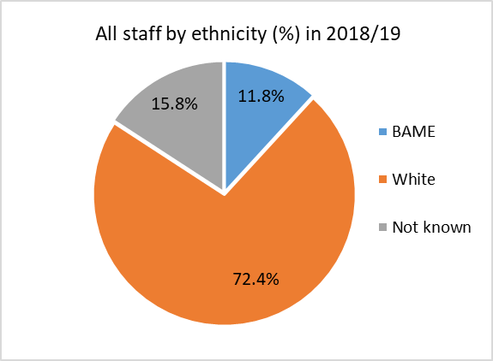
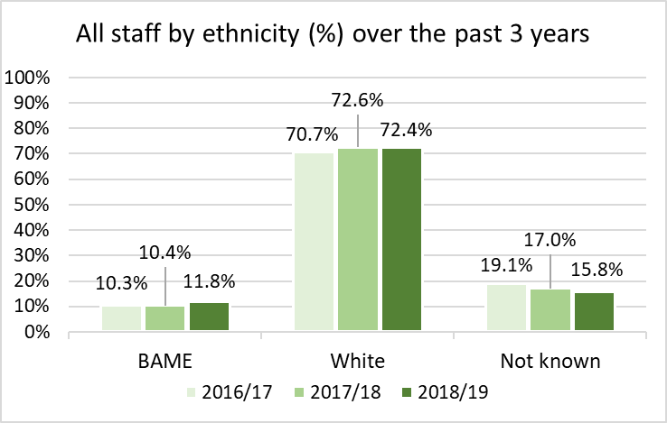
Student data
Our most recent data indicates that 17.4% of Home and 56.5% of Overseas students were BAME. These figures have increased by 2.2% and 24.9% (respectively) since 2016/17. This is lower than the proportion of BAME Home students across UK universities, which was 23.2% according to recent figures.
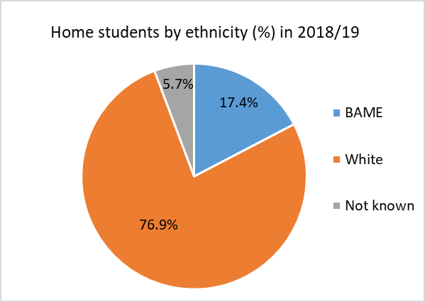
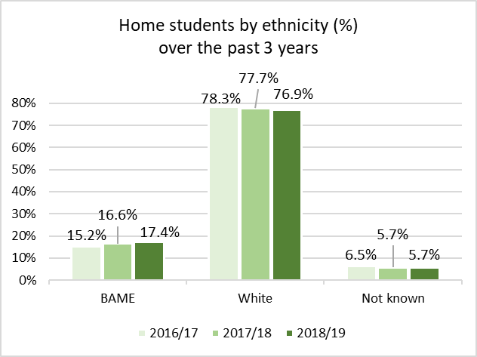

When investigating Home/EU student recruitment at Leeds we see that the gap between offers made to BAME and white students dropped by 11% between 2013/14 and 2017/2018, compared with a sector gap that closed by 9% across the same period. This gap is wider at UG level (19.8%) than PGT (8.8%) and PGR (13.8%).
Our most recent data indicates an awarding gap of 12.7% between BAME and white Home / EU UG students achieving a 2:1 or First degree. This gap widens to 25.9% between black and white students. The UK HE sector reported a BAME UG awarding gap of 13.2%.⁶

We define BAME, in line with HESA recording, where all categories except “white”, “gypsy or traveller” and “I prefer not to answer” are classed as BAME. White minority groups are included within the white category.
Data is taken at a 31.10.19 snapshot
Advance HE, Staff statistical report 2019. Calculation of % includes staff whose ethnicity is unknown
ONS Crown Copyright Reserved (Annual Population Survey, data from July 2018 - June 2019, estimated at 95% confidence level)
Data reflects students who registered during the 2018/19 academic year.
Advance HE, Students statistical report 2019. Calculation of % includes students whose ethnicity is unknown
Data reflects the proportion of Home/EU students at all degree levels who were offered a place, from the total number who applied, during the 2013/14 and 2017/18 academic year.
Data reflects students who completed an undergraduate (UG) course during the 2017/18 academic year

