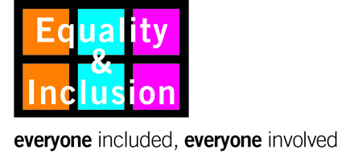

Equality Impact Assessment Form

Section 1: Contact details
Please complete your details and contact information in the spaces provided.

EIA Author:
Partners/decision-makers:
Job title:
Faculty/Service Area:
Email:
Submission date:

Section 2: About the policy
Please describe what you are impact assessing and who it applies to.

Title:
Aims/description/purpose:
People it applies to: | ☐ Staff | ☐ Students | ☐ Visitors | ☐ General public

Section 3: Gathering data and evidence
Have you identified relevant evidence (qualitative and quantitative) to establish whether this policy could potentially affect some equality groups more than others?

Have you analysed equality data for each of the groups identified in Section 2? | ☐ Yes | ☐ No
Have you identified/researched anecdotal or alternative evidence? | ☐ Yes | ☐ No
Have you attached the evidence to this impact assessment? | ☐ Yes | ☐ No

Section 4: Assessing the impact
Based on your evidence, which equality groups might this policy affect more or less than others (if any)?

Age | ☐ | Race | ☐
Disability | ☐ | Religion and belief (including no belief) | ☐
Gender reassignment | ☐ | Gender | ☐
Marriage and civil partnership | ☐ | Sexual orientation | ☐
Pregnancy and maternity | ☐ | Caring responsibilities | ☐

Using examples from the evidence you have collected, please describe the impact (positive, negative or neutral) on the equality groups you have identified above.

Section 5: Addressing any impact: action planning
Please describe any actions you will undertake as a result of undertaking this assessment – include the timescale for each and who is responsible.

 | Action | Timescale | Responsibility
1
2
3
4
5

Section 6: Involvement and Consultation
What involvement/consultation activity has been undertaken or is planned in relation to this policy?

 | Involvement/consultation activity | Results / Feedback
1
2
3

Section 7: Approval & Publishing

Signature of EIA author:

Date:

Sent to Equality Policy Unit for publication

Date:

‘Policy’ refers here to policies, procedures and practices – see guidance notes.

